DMAGIC: Mobile Creative Collaboration
an app by
Benji Hill, Michael Millan, Jake Trower

Change History:
- 2/25/2014 – Initial Draft of Requirements Document
- 2/26/2014 – Added functional and non-functional requirements
- 2/28/2014 – Added Table of Contents and started analysis
- 3/10/2014 – Added Diagrams and finished analysis
- 3/16/2014 – Fixed non-functional requirements and added activity diagrams

Table of Contents
1. Introduction...................................................................2
2. Glossary of Terms..............................................................2
3. Project Description............................................................2
4. User Requirements..............................................................3
4.1. Functional Requirements................................................3
4.2. Non-functional Requirements............................................3
5. Analysis.......................................................................4
5.1. Architecture Diagram...................................................4
5.2. Use Case Diagrams......................................................5
5.3. Activity Diagrams......................................................7

1. Introduction
DMAGIC (Drawing, Music, Art, Game, and Idea Creator) (Codename: Kitty Paint) is an android application aimed for users who wish to have the ability to create simple creative projects together on the go. For this project we are aiming to create an interface for image editing—with the possibility of adding drag and drop music composition, and animation editing—that allows users to connect and edit the same project simultaneously. Users should be able to save their visual, audio, or multimedia creations in formats natively useable by android, and also in raw formats that can be shared with others to edit or remix at a later time.
2. Glossary of Terms
- Android: a software stack for mobile devices that includes an operating system, middleware and key applications.
- Android SDK: the software development kit that provides tools and APIs necessary to begin developing applications on the Android platform using the Java programming language.
- Application framework: framework that enables reuse and replacement of components
- Framework: an abstraction in which software providing generic functionality can be selectively changed by user code, providing application specific software.
- API: application programming interface, a particular set of rules and specifications that software programs can follow to facilitate interaction.
- HTML/CSS: HTML(Hyptertext Markup Language) and CSS (Cascading Style Sheets) are two language specifications for creating the structure of and styling web pages or web applications.
- HTML5: The fifth revision of the HTML standard which added a lot of functionality for dynamic canvas image creation and display, and dynamic audio playing as well.
- Javascript: a dynamic computer programming language, used primarily for adding client-side interactivity to web pages or web applications.

3. Project Description
We will be implementing this system primarily using the Android WebView extension of Android's View class. We chose to do this in order to write the app using primarily HTML, CSS, and JavaScript. The nature of the project requires that we have a manipulable canvas for image creating/presentation, and also the ability to have this canvas be manipulated by more than one user through network connections. The abilities of JavaScript and HTML5 allow us to do this. On top of this, if we are going to be able to also complete the music composition part of the project, we will need a way to play structured semidynamic audio. Another added benefit to using Android's WebView extension and HTML/Javascript is the ease of translating our application to other platforms, as iOS also has its own WebView like extension (UIWebView), and we can also quickly modify our code to be used online to be accessed from PC browsers.

4. Requirements
Functional Requirements | Non-Functional Requirements

1. The app must present the user with the option of choosing the visual canvas or the music canvas on the menu/splashscreen when the app starts. | The app should be able to run on android devices as low as API level 8.
2. The visual canvas must users to select brush color and brush size, and allow users to draw on the canvas by draggin their finger over the screen. | There must be documentation explaining to users how to edit the visual or music canvases and for how to connect to shared canvases and make friends. This information will be displayed on the app download page and also within the app itself.
3. The music canvas must allow the composition of semidynamic music by displaying a grid represented as an empty music staff that lets users place specific sounds at specific pitches at specific time units on the staff. | The source code of the app will be open source and is shared at https://github.com/cs-495/cs495-project
4. The music canvas must allow playback of the composed music by cycling through the grid and playing back the correct sounds at the correct pitches at the given tempo. | The sounds used for the music composition and playback will be a combination of open source sounds from existing sources and synthesized sounds made ourselves.
5. The app must allow the drawing/music on the canvas to be saved as a format that can be later edited by the app, and also as a typical image/song format (png, jpg, bmp; mp3). | The functionality of the app must be able to be reproduced online so that non-android users can draw or compose together through web browsers.
6. The app must allow for real time editing of a shared image or sound composition. Users will work on a single shared canvas that is mutually updated as quickly as the network connection allows. | In order to connect, users will connect to a room hosted on an online server separate from the application itself. Both users are connected to this server and send their canvas information to it, and it sends the combined version to both.
7. The app must allow other users to connect so that the collaboration feature above be feasible. Users should have “friend codes” so that they can add “friends” for easy connection. Users can also make friends through local android beaming
5. Analysis

5.1 Architecture of Application
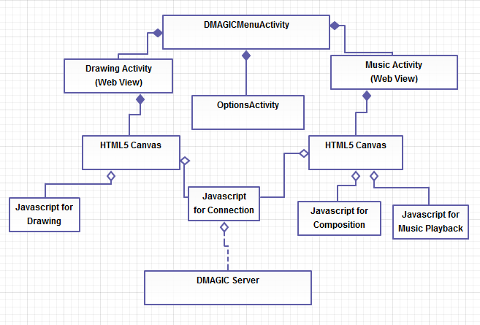
Figure 1. High level Architecture Diagram of Application

The user upon starting the app, will have the ability to choose between the Drawing Activity, the Music Activity, or the Options Activity. The Options Activity will be a simple android menu, allowing the toggling of some app related features that will probably be decided as we create the application. Both the Drawing Activity and the Music Activity will be implementing the Android Web View layout, which will allow us to build the functionality of the canvas interactivity using a HTML5 Canvas and specific javascript code for each. Along with specific javascript code for the canvas interactivity, both activities will have javascript code to allow connecting to the server (which itself will either be a python or a php process running online).
5.2 Interaction Use Case Diagrams

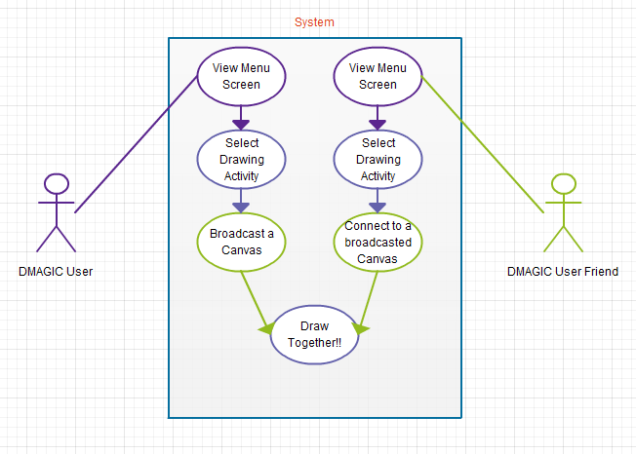
Figure 2. Two users drawing on a shared canvas.

If a user wishes to draw with a friend, both the user and the friend must first select the drawing activity option from the splash screen. After that, the user who begins drawing will broadcast their drawing to an available server room. The users friend may view the server rooms that his friend is working on, and connect up to the server room. Then, the server will take the drawing information from one user's canvas, and update the canvas of the friend, and vice versa for the friend's canvas to the user's canvas.
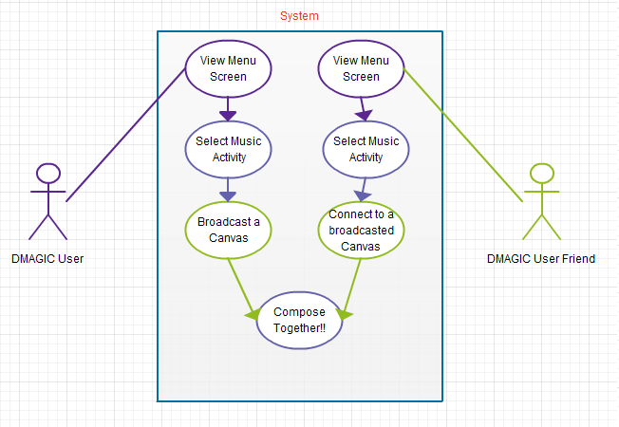
Figure 3. Two users composing on a shared canvas.
The process of working together on a music composition is very similar to working together on a drawing canvas. However, instead of drawing freely on a canvas by dragging your finger, a user will select the sound that they wish to put on the canvas, and then tap an empty music staff to assign a certain sound of a certain pitch onto the music staff. The music staff will be updated simultaneously between both of the users' phones. Then each user must individually playback their cooperatively composed song without forcing the other's phone to playback the sound.

5.3 Activity Diagrams

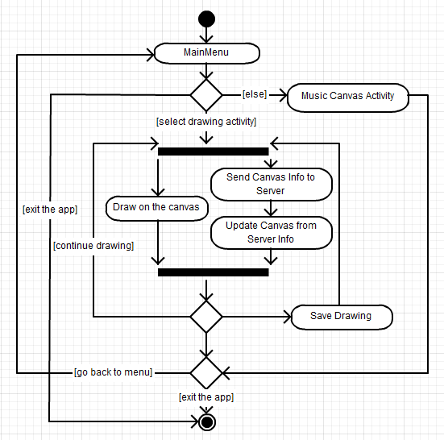
Figure 4. Selecting the Drawing Activity and drawing on the canvas

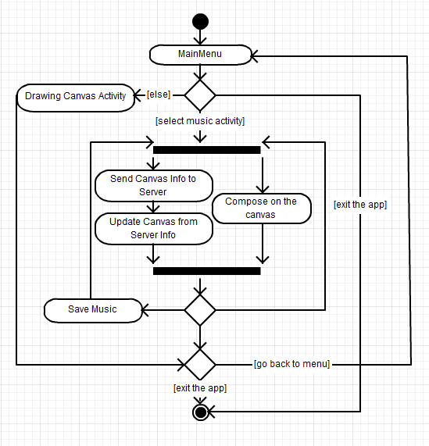
Figure 5. Selecting the Music Activity and composing on the canvas

