Regno: -224002745 Umurerwa Belyse

-224014348 Nsengimana Gilbert

School Management System Project Report

1. Introduction
The School Management System is a desktop application developed to manage student information efficiently. The system allows adding, updating, searching, and deleting student records stored in a database.

2. Objectives
• Manage student records
• Apply Object-Oriented Programming
• Connect Java to database using JDBC
• Perform CRUD operations
• Implement login authentication

3. Technologies Used
- Java
- Apache NetBeans IDE,
- MySQL Database
- JDBC
- Java Swing

4. System Design
Abstract Class: Person (firstname, lastname, email)
Interface: DatabaseOperations (add, delete, update, search)
Student class extends Person and implements DatabaseOperations.

5. Database
Database Name: sms
Table: student (id, firstname, lastname, course, marks)
Users(id, firstname, lastname, email, password)

6. Features
- Add Student
- Update Student
- Delete Student
- Search Student
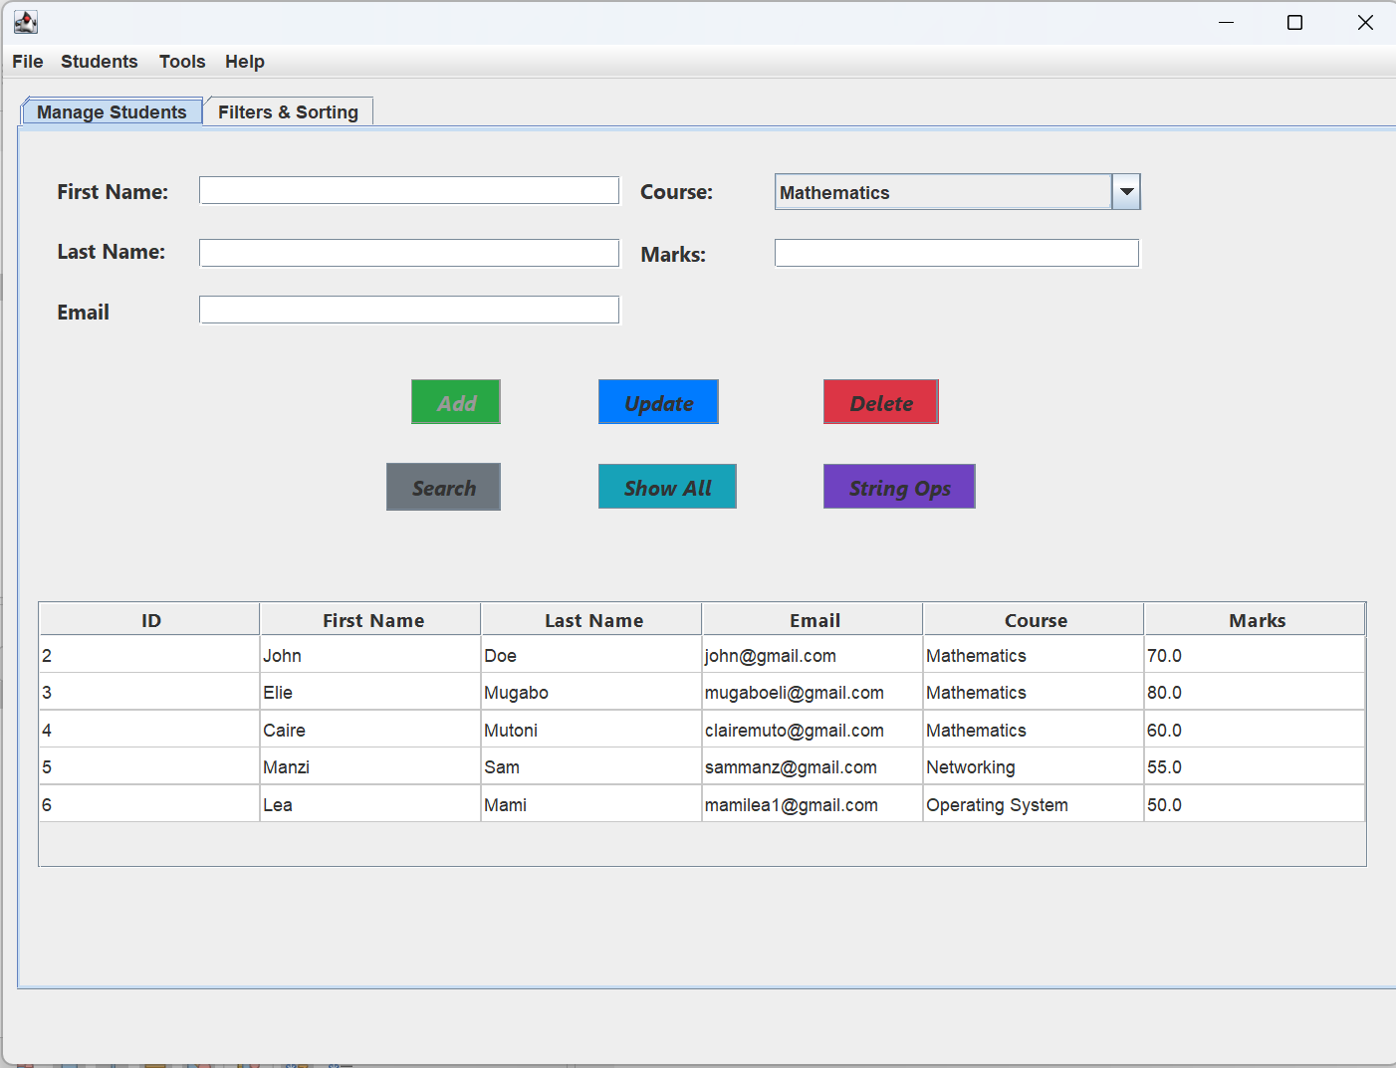
- Input Validation

- Login page
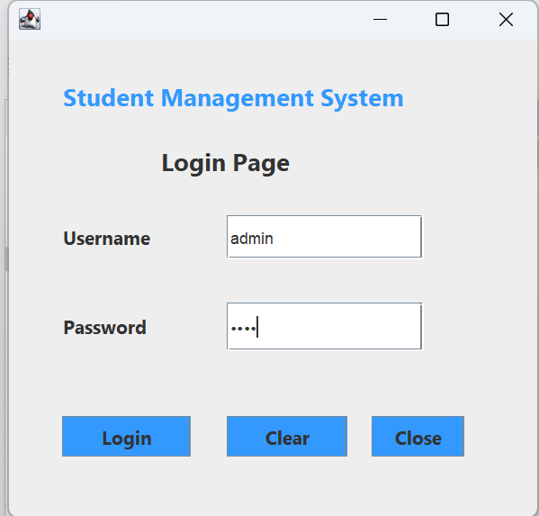

7. Project Structure
sms.model
sms.dao
sms.view
sms.controller
sms.database

8. Workflow
User opens application → Login → Dashboard → Manage students → Data stored in MySQL

9. Challenges
Database connection errors, DAO implementation issues, login verification problems.

10. Conclusion
The project demonstrates how Java applications interact with databases using JDBC and GUI systems.
11. GitHub Repository: The full project source code, commit history and team collaboration can be viewed at:https://github.com/nsgilbert23/School-Management-System/tree/master

