- Introduction to DevOps

- Software Development Life Cycle

- Models (Waterfall, Agile)

- What is DevOps?

- Tools

- Version Control System

- Types of VCS

- Architecture of VCS

- Installation of Git Bash and Git

- How Git Works

- Branching

- Merging

- Merge Conflict

- Connecting Git with GitHub

- Concepts of Git

- Git Reset

- Git Restore

- Containers

- Types of Containers

- Docker Installation

- Launching a Container

- Docker Architecture

- Docker Hub

- Docker Commands

- Dockerfile

- Container Orchestration Tool

- Architecture of Kubernetes

- Components of Control Plane and Data Plane

- What is a POD?

- Launching a Kubernetes Cluster

- Resources/Objects in Kubernetes

- How Declarative Works

- Mini Kubernetes Cluster

- Controller Manager in Kubernetes

- Launching a Replica Set

- Deployment

- AWS CLI Installation

- Kubernetes EKS Launch Cluster

- Kubernetes Networking

- DevOps Interview Questions

**Introduction to DevOps**

**Introduction to DevOps:**

DevOps is a set of practices, cultural philosophies, and tools that integrate software development (Dev) and IT operations (Ops) to enhance the software development lifecycle. It aims to improve collaboration, automation, and continuous delivery to build, test, and release software faster and more reliably.

**Key Aspects of DevOps:**

1. Collaboration & Communication – Bridges the gap between developers and operations teams.
2. Automation – Automates repetitive tasks like testing, deployment, and monitoring.
3. CI/CD (Continuous Integration & Continuous Deployment) – Ensures faster and reliable code releases.
4. Infrastructure as Code (IaC) – Manages infrastructure using code (e.g., Terraform, Ansible).
5. Monitoring & Logging – Helps detect and resolve issues early using tools like Prometheus and ELK Stack.
6. Security (DevSecOps) – Integrates security within the DevOps pipeline.

**Benefits of DevOps:**

* Faster software delivery with reduced time-to-market.
* Higher reliability through automated testing and monitoring.
* Scalability & flexibility for cloud-based applications.
* Enhanced security by integrating security measures within CI/CD pipelines.

**Popular DevOps Tools:**

* CI/CD: Jenkins, GitHub Actions, GitLab CI
* Configuration Management: Ansible, Puppet, Chef
* Containerization & Orchestration: Docker, Kubernetes
* Monitoring & Logging: Prometheus, Grafana, ELK Stack
* Cloud Services: AWS, Azure, GCP

**Why DevOps is Important?**

With modern applications requiring fast and frequent releases, DevOps helps organizations stay competitive, agile, and scalable, ensuring that software is delivered efficiently and with high quality.

*Final Answer (Short Version for Interviews)*

*"DevOps is a culture and set of practices that integrate development and operations teams to automate and streamline software delivery. It focuses on CI/CD, automation, monitoring, and infrastructure as code, leading to faster releases, higher reliability, and improved security. Key tools include Jenkins, Docker, Kubernetes, and cloud platforms like AWS and Azure."*

**Software Development Life Cycle [ SDLC ]**

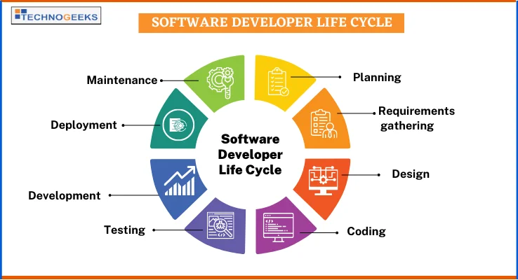

**Software Development Life Cycle (SDLC) – Explanation for DevOps Engineer Interview**

**What is SDLC?**

The Software Development Life Cycle (SDLC) is a structured process for developing, testing, deploying, and maintaining software efficiently. It ensures that the software meets business requirements, quality standards, and security while being delivered within time and budget constraints.

**Phases of SDLC**

1. Requirement Gathering & Analysis – Understanding business needs, functional & non-functional requirements.
2. Planning – Defining project scope, timelines, cost, and risks.
3. Design – Creating architectural and technical design, including database models and system structure.
4. Development (Implementation) – Writing and integrating code as per design specifications.
5. Testing – Ensuring functionality, security, and performance using automation/manual testing.
6. Deployment – Releasing software in production using CI/CD pipelines for automation.
7. Maintenance & Monitoring – Ensuring performance, handling bug fixes, updates, and monitoring system health.

**SDLC & DevOps Integration**

In DevOps, SDLC is enhanced by automation, continuous integration, and continuous deployment (CI/CD), ensuring fast and reliable software delivery.

Traditional SDLC vs. DevOps-Driven SDLC:

| Aspect | Traditional SDLC | DevOps SDLC |
| --- | --- | --- |
| Deployment | Manual & periodic | Continuous & automated |
| Testing | Late-stage testing | Continuous testing & automation |
| Collaboration | Dev & Ops work separately | Dev & Ops work together |
| Infrastructure | Managed manually | Infrastructure as Code (IaC) |

**DevOps Engineer Interview Questions on SDLC**

**Basic SDLC Questions:**

1. **What is SDLC? Explain its importance.**
   * SDLC is a structured approach to software development that includes planning, designing, developing, testing, deploying, and maintaining software. It ensures quality, security, and efficiency in software projects.
2. **What are the different phases of SDLC?**
   * The main phases are Requirement Gathering, Planning, Design, Development, Testing, Deployment, and Maintenance.
3. **Which SDLC model is best for DevOps? Why?**
   * The Agile Model is best for DevOps as it promotes continuous integration, delivery, and collaboration between teams, enabling faster releases and feedback loops.

**DevOps-Specific SDLC Questions:**

1. **How does DevOps fit into SDLC?**
   * DevOps enhances SDLC by automating development, testing, deployment, and monitoring through CI/CD pipelines, Infrastructure as Code (IaC), and real-time feedback mechanisms.
2. **What are the challenges of traditional SDLC, and how does DevOps solve them?**
   * Traditional SDLC faces slow deployments, lack of collaboration, and late-stage testing. DevOps solves these by implementing CI/CD, automation, early testing, and real-time monitoring.
3. **How do CI/CD pipelines enhance the SDLC process?**
   * CI/CD automates code integration, testing, and deployment, reducing manual errors, ensuring faster releases, and maintaining software quality across environments.

**Advanced DevOps SDLC Questions:**

1. **How does Infrastructure as Code (IaC) impact the SDLC?**
   * IaC automates infrastructure provisioning, making deployments consistent, scalable, and efficient, reducing human errors, and improving SDLC speed.
2. **How do you ensure security in SDLC with DevOps (DevSecOps)?**
   * By integrating security tools into CI/CD pipelines, performing automated security scans, and following secure coding practices.
3. **How does containerization (Docker, Kubernetes) impact SDLC?**
   * It ensures consistency across environments, improves scalability, and simplifies deployment and rollback processes.
4. **Which DevOps tools do you use for different SDLC phases?**

* Requirement Gathering: Jira, Confluence
* Development: Git, GitHub, GitLab
* Testing: Selenium, JUnit, SonarQube
* Deployment: Jenkins, GitHub Actions, Terraform
* Monitoring & Maintenance: Prometheus, Grafana, ELK Stack

**Final Answer (Short Version for Interviews)**

*"SDLC is the structured process for developing and maintaining software. It includes phases like requirement gathering, design, development, testing, deployment, and maintenance. In DevOps, SDLC is enhanced through CI/CD automation, Infrastructure as Code (IaC), and continuous monitoring. This accelerates software delivery, improves quality, and ensures faster issue resolution."*

**Models (Waterfall, Agile)**

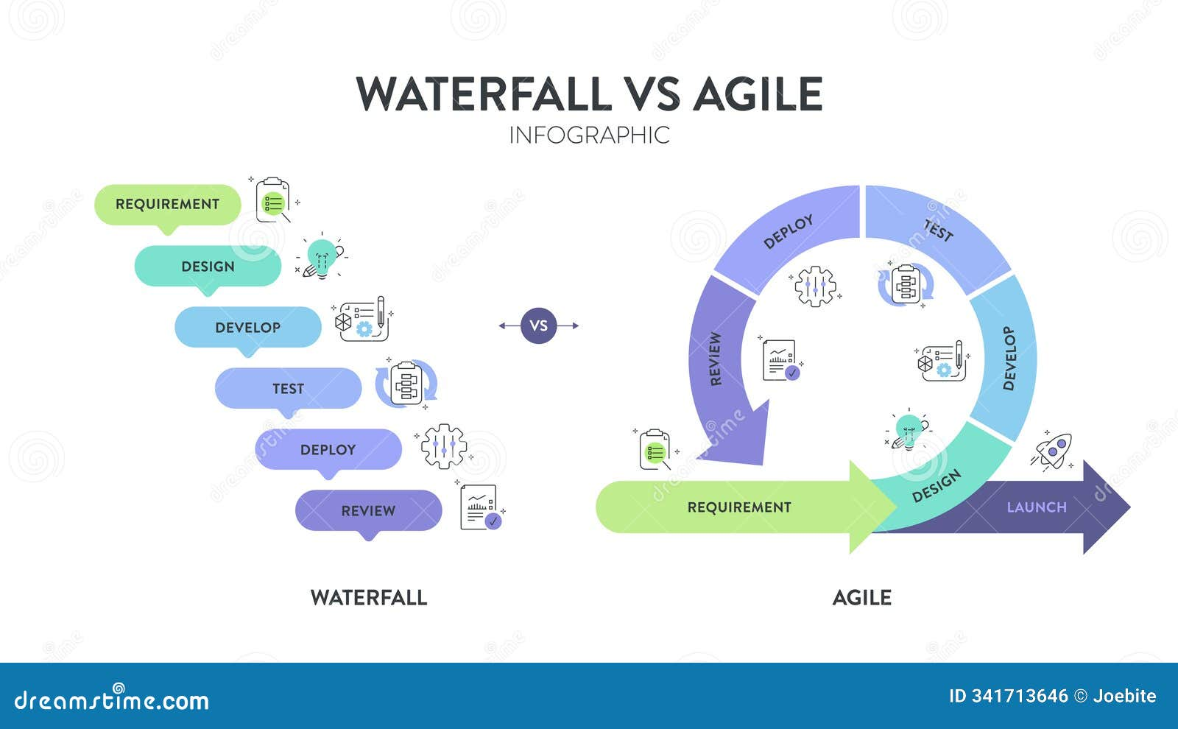

**SDLC Models – Waterfall vs. Agile (For DevOps Engineer Interview)**

**1. Waterfall Model**

The **Waterfall Model** is a traditional, sequential SDLC approach where each phase is completed before moving to the next. It follows a **linear structure** with strict documentation and well-defined stages.

**Phases of the Waterfall Model:**

1. **Requirement Gathering** – Detailed documentation of project requirements.
2. **System Design** – Architectural and technical design.
3. **Implementation (Development)** – Writing the actual code.
4. **Testing** – Validating functionality and fixing defects.
5. **Deployment** – Releasing the final product to users.
6. **Maintenance** – Bug fixes and updates after deployment.

**Advantages:**

✅ Simple and easy to manage.  
✅ Well-documented with clear phases.  
✅ Works well for small or well-defined projects.

**Disadvantages:**

❌ Rigid, does not allow changes in requirements.  
❌ Late testing, leading to delayed defect detection.  
❌ Not suitable for complex or evolving projects.

**2. Agile Model**

The **Agile Model** is an iterative and flexible approach where software is developed in small, incremental releases called **sprints** (typically 2-4 weeks). Agile promotes **continuous collaboration**, **feedback**, and **adaptability** to changing requirements.

**Phases of the Agile Model (Scrum Framework):**

1. **Concept & Requirement Analysis** – Gather high-level requirements.
2. **Sprint Planning** – Define features for the next sprint.
3. **Development & Testing (Iterative)** – Code, test, and review within sprints.
4. **Demo & Feedback** – Showcase working software to stakeholders.
5. **Deployment & Maintenance** – Continuous releases with updates.

**Advantages:**

✅ Highly flexible and adaptable to changes.  
✅ Faster time to market with continuous delivery.  
✅ Improved collaboration between teams (Dev, Ops, QA, Business).

**Disadvantages:**

❌ Requires strong team coordination and communication.  
❌ Difficult to estimate time and cost accurately.  
❌ May lead to scope creep if not managed properly.

**Waterfall vs. Agile – Key Differences**

| **Aspect** | **Waterfall Model** | **Agile Model** |
| --- | --- | --- |
| **Approach** | Sequential (Step-by-Step) | Iterative & Incremental |
| **Flexibility** | Rigid, changes are difficult | Highly flexible to changes |
| **Delivery** | Final product at the end | Continuous small releases |
| **Testing** | Performed after development | Continuous testing in every sprint |
| **Risk Handling** | High risk due to late testing | Low risk due to early feedback |
| **Collaboration** | Limited between teams | Strong DevOps collaboration |
| **Use Case** | Small, well-defined projects | Large, evolving projects |

**DevOps Engineer Interview Questions on Waterfall & Agile**

**Basic SDLC Model Questions:**

1. **What is the Waterfall Model? When is it used?**
   * *The Waterfall Model is a sequential software development approach where each phase is completed before moving to the next. It is used for simple projects with well-defined requirements.*
2. **What is the Agile Model? Why is it preferred in DevOps?**
   * *The Agile Model is an iterative approach that delivers software in small, continuous increments. DevOps prefers Agile because it promotes faster releases, automation, and continuous feedback.*

**DevOps-Specific Questions on Agile vs. Waterfall:**

1. **Why is the Waterfall Model not suitable for DevOps?**
   * *Waterfall lacks flexibility, has late testing phases, and does not support continuous integration or deployment, making it incompatible with DevOps principles.*
2. **How does Agile align with DevOps?**
   * *Agile and DevOps both emphasize collaboration, automation, continuous testing, and rapid releases, making them complementary for modern software development.*
3. **What are the key Agile methodologies used in DevOps?**
   * *Scrum, Kanban, and SAFe (Scaled Agile Framework) are commonly used Agile methodologies in DevOps.*

**Advanced DevOps Agile Model Questions:**

1. **What is a sprint in Agile, and how does it help in DevOps?**
   * *A sprint is a short development cycle (2-4 weeks) in Agile that focuses on delivering a working feature. In DevOps, sprints align with CI/CD to automate and release software frequently.*
2. **How do CI/CD pipelines improve Agile development?**
   * *CI/CD automates code integration, testing, and deployment, ensuring continuous delivery and minimizing manual effort in Agile workflows.*
3. **What tools are used to implement Agile in DevOps?**
   * *Jira (for Agile project management), Jenkins/GitHub Actions (for CI/CD), Selenium (for automated testing), and Docker/Kubernetes (for deployment).*

**Final Answer (Short Version for Interviews)**

*"Waterfall is a linear, step-by-step SDLC model suited for small, well-defined projects, but it lacks flexibility and adaptability. Agile, on the other hand, is an iterative and incremental model that enables rapid software releases, collaboration, and continuous integration. DevOps prefers Agile as it aligns with automation, continuous delivery, and iterative improvements."*

**What is DevOps**

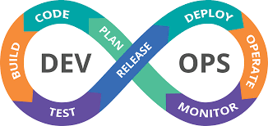

**Introduction to DevOps**

**DevOps** is a **culture, methodology, and set of practices** that integrate **Development (Dev)** and **Operations (Ops)** teams to automate and streamline the software development lifecycle (SDLC). The goal of DevOps is to enable **faster, more reliable software delivery** through **continuous integration, continuous deployment (CI/CD), automation, and collaboration**.

**Key Principles of DevOps**

1. **Collaboration & Communication** – Bridging the gap between development and operations.
2. **Automation** – Automating repetitive tasks like testing, deployment, and monitoring.
3. **Continuous Integration & Continuous Deployment (CI/CD)** – Ensuring fast and reliable releases.
4. **Infrastructure as Code (IaC)** – Managing infrastructure through code (Terraform, Ansible).
5. **Monitoring & Feedback** – Using real-time monitoring to improve system performance.
6. **Security (DevSecOps)** – Integrating security within the DevOps lifecycle.

**DevOps Lifecycle & Stages**

1. **Plan** – Define project scope and roadmap (Jira, Confluence).
2. **Develop** – Write and integrate code (Git, GitHub, GitLab).
3. **Build** – Compile and package code (Maven, Gradle).
4. **Test** – Automate testing for bugs and performance (Selenium, JUnit).
5. **Release** – Manage version control and approvals (GitHub Actions, GitLab CI).
6. **Deploy** – Deploy applications automatically (Docker, Kubernetes, Terraform).
7. **Monitor & Operate** – Track system performance and errors (Prometheus, Grafana).

**Benefits of DevOps**

✅ **Faster Deployment:** Reduces time-to-market with automation.  
✅ **Higher Reliability:** Automated testing and monitoring ensure fewer failures.  
✅ **Scalability:** Supports cloud-native and microservices architectures.  
✅ **Cost Efficiency:** Reduces infrastructure costs through optimization.  
✅ **Security & Compliance:** Implements security checks in CI/CD pipelines.

**DevOps Tools & Technologies**

| **Category** | **Popular Tools** |
| --- | --- |
| **Version Control** | Git, GitHub, GitLab, Bitbucket |
| **CI/CD** | Jenkins, GitHub Actions, GitLab CI/CD |
| **Configuration Management** | Ansible, Puppet, Chef |
| **Containerization** | Docker, Kubernetes |
| **Infrastructure as Code (IaC)** | Terraform, AWS CloudFormation |
| **Monitoring & Logging** | Prometheus, Grafana, ELK Stack |
| **Security (DevSecOps)** | SonarQube, Snyk, Trivy |

**DevOps Engineer Interview Questions & Answers**

**Basic DevOps Questions:**

1. **What is DevOps? Why is it important?**
   * *DevOps is a culture and set of practices that combine development and operations to improve software delivery. It enables faster releases, automation, and collaboration, ensuring high-quality software deployment.*
2. **How is DevOps different from traditional IT operations?**
   * *Traditional IT operations follow a siloed approach with long release cycles, while DevOps integrates teams, automates processes, and enables continuous software delivery.*
3. **What are the key benefits of DevOps?**
   * *Faster releases, improved collaboration, automation, cost efficiency, and enhanced security.*

**DevOps Lifecycle & CI/CD Questions:**

1. **What is CI/CD in DevOps?**
   * *Continuous Integration (CI) is the practice of frequently merging code changes, while Continuous Deployment (CD) automates software release to production.*
2. **What are the key stages of a CI/CD pipeline?**
   * *Code, Build, Test, Release, Deploy, Monitor.*
3. **Which CI/CD tools have you worked with?**
   * *Jenkins, GitHub Actions, GitLab CI/CD, CircleCI.*

**DevOps Tools & Automation Questions:**

1. **What is Infrastructure as Code (IaC)? Why is it important?**
   * *IaC allows managing infrastructure using code, making it automated, scalable, and consistent. Examples: Terraform, Ansible.*
2. **How do you manage configuration in DevOps?**
   * *Using tools like Ansible, Puppet, and Chef to automate configuration management.*
3. **What is containerization, and how does it help DevOps?**
   * *Containerization packages applications and dependencies into isolated environments, ensuring consistency across development, testing, and production. Tools: Docker, Kubernetes.*

**Advanced DevOps & Security (DevSecOps) Questions:**

1. **What is DevSecOps, and why is it important?**

* *DevSecOps integrates security into DevOps workflows by automating security checks and vulnerability assessments throughout CI/CD.*

1. **How do you monitor applications in DevOps?**

* *Using tools like Prometheus, Grafana, ELK Stack for performance monitoring, logging, and alerting.*

1. **How do you handle failures in a DevOps pipeline?**

* *Implement rollback strategies, automate error detection, and use observability tools to detect and fix issues quickly.*

**Final Answer (Short Version for Interviews)**

*"DevOps is a culture that integrates software development and operations to enhance collaboration, automate workflows, and improve software delivery. It emphasizes CI/CD, Infrastructure as Code (IaC), containerization, and real-time monitoring to ensure faster, more reliable, and scalable software releases."*

**Tool**

***DevOps Tools – Categories & Popular Choices***

*DevOps relies on a variety of tools to* ***automate, monitor, and streamline*** *the software development lifecycle (SDLC). Below is a list of key DevOps tools categorized by their functionalities.*

***1. Version Control Tools (Track changes in code and collaborate effectively)***

| ***Tool*** | ***Description*** |
| --- | --- |
| ***Git*** | *Distributed version control system for tracking source code.* |
| ***GitHub*** | *Cloud-based Git repository with collaboration features.* |
| ***GitLab*** | *Provides CI/CD pipelines along with version control.* |
| ***Bitbucket*** | *Integrates with Jira and provides Git repository management.* |

***2. Continuous Integration / Continuous Deployment (CI/CD) Tools (Automate code integration, testing, and deployment)***

| ***Tool*** | ***Description*** |
| --- | --- |
| ***Jenkins*** | *Open-source CI/CD automation server.* |
| ***GitHub Actions*** | *CI/CD automation directly within GitHub.* |
| ***GitLab CI/CD*** | *Built-in CI/CD functionality in GitLab.* |
| ***CircleCI*** | *Cloud-based CI/CD platform.* |
| ***Travis CI*** | *Simple CI/CD tool for GitHub projects.* |

***3. Configuration Management Tools (Manage infrastructure and system configurations as code)***

| ***Tool*** | ***Description*** |
| --- | --- |
| ***Ansible*** | *Agentless configuration management and automation.* |
| ***Puppet*** | *Automates configuration and state management.* |
| ***Chef*** | *Infrastructure automation using Ruby-based DSL.* |
| ***SaltStack*** | *Manages large-scale infrastructure automation.* |

***4. Infrastructure as Code (IaC) Tools (Provision and manage infrastructure using code)***

| ***Tool*** | ***Description*** |
| --- | --- |
| ***Terraform*** | *Declarative IaC tool for provisioning cloud infrastructure.* |
| ***AWS CloudFormation*** | *Automates AWS infrastructure setup.* |
| ***Pulumi*** | *IaC using standard programming languages like Python, TypeScript.* |

***5. Containerization & Orchestration Tools (Package and manage applications in lightweight containers)***

| ***Tool*** | ***Description*** |
| --- | --- |
| ***Docker*** | *Creates, manages, and runs containers.* |
| ***Kubernetes*** | *Orchestrates containerized applications.* |
| ***Podman*** | *Alternative to Docker for managing containers.* |
| ***OpenShift*** | *Enterprise Kubernetes platform.* |

***6. Monitoring & Logging Tools (Track system performance, logs, and alerts)***

| ***Tool*** | ***Description*** |
| --- | --- |
| ***Prometheus*** | *Monitoring and alerting for applications.* |
| ***Grafana*** | *Visualizes data from Prometheus and other sources.* |
| ***ELK Stack*** | *(Elasticsearch, Logstash, Kibana) for centralized logging.* |
| ***Datadog*** | *Cloud monitoring and analytics.* |
| ***New Relic*** | *Application performance monitoring.* |

***7. Security & DevSecOps Tools (Integrate security within the DevOps pipeline)***

| ***Tool*** | ***Description*** |
| --- | --- |
| ***SonarQube*** | *Code quality and security analysis.* |
| ***Snyk*** | *Detects vulnerabilities in dependencies.* |
| ***Trivy*** | *Container security scanning.* |
| ***OWASP ZAP*** | *Security testing for web applications.* |

***8. Cloud & DevOps Platforms (Host and manage DevOps infrastructure on the cloud)***

| ***Cloud Provider*** | ***DevOps Services*** |
| --- | --- |
| ***AWS*** | *AWS CodePipeline, AWS Lambda, AWS ECS, AWS EKS* |
| ***Microsoft Azure*** | *Azure DevOps, Azure Kubernetes Service* |
| ***Google Cloud*** | *Google Kubernetes Engine (GKE), Cloud Build* |

***9. Communication & Collaboration Tools (Enhance teamwork and issue tracking)***

| ***Tool*** | ***Description*** |
| --- | --- |
| ***Slack*** | *Real-time communication tool for DevOps teams.* |
| ***Jira*** | *Project management and issue tracking.* |
| ***Trello*** | *Kanban board for tracking DevOps workflows.* |
| ***Confluence*** | *Documentation and knowledge-sharing platform.* |

***Summary of DevOps Toolchain***

| ***Category*** | ***Key Tools*** |
| --- | --- |
| ***Version Control*** | *Git, GitHub, GitLab* |
| ***CI/CD*** | *Jenkins, GitHub Actions, GitLab CI/CD* |
| ***Configuration Management*** | *Ansible, Puppet, Chef* |
| ***IaC*** | *Terraform, AWS CloudFormation* |
| ***Containers & Orchestration*** | *Docker, Kubernetes, OpenShift* |
| ***Monitoring & Logging*** | *Prometheus, Grafana, ELK Stack* |
| ***Security & DevSecOps*** | *SonarQube, Snyk, Trivy* |
| ***Cloud Providers*** | *AWS, Azure, Google Cloud* |
| ***Collaboration*** | *Slack, Jira, Trello* |