# COMP 353: Homework 1

## 2022-10-12

## Collaborators

* Anshul Narang:
  + Worked on all 6 queries
  + Organized a meeting to work on unsolved queries/review solved queries
* Nick Shannon:
  + Worked on queries 3 and 6; reviewed remaining 4
  + Gathered outputs and created report

## Queries

1. Query 1:

/* Question 1 */  
select co.songcode,s.songTitle, tracknumber from composedof co ,song s   
where s.songcode = co.songcode and cdcode = (  
 select cdcode from topcds where year = 2003 and rating = 1  
 )  
order by tracknumber

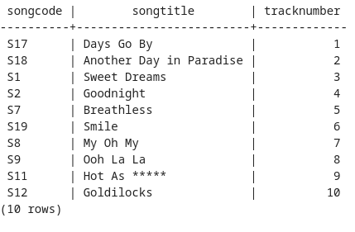

q1-out

1. Query 2:

/* Question 2 */  
select mg.groupcode,groupname,count(*) as numberOfTop10CDs  
from musicalgroup mg, cd c, topcds tc  
where mg.groupcode = c.groupcode and c.cdcode = tc.cdcode and tc.rating <= 10  
group by mg.groupcode, mg.groupname  
order by numberOfTop10CDs desc

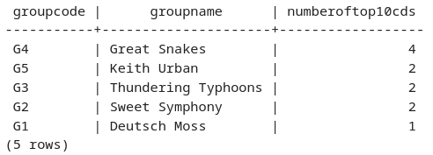

q2-out

1. Query 3:

/* Question 3 */  
select c.year, max(subquery.numberoftracks) as maxNumber,  
min(subquery.numberoftracks) as minNumber,  
avg(subquery.numberoftracks) as avgNumber  
from cd c,  
 (select cdcode, count(*) as numberoftracks  
 from composedof  
 group by cdcode) subquery  
where year >= 2000 and c.cdcode = subquery.cdcode  
group by c.year  
order by c.year

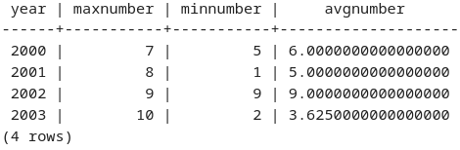

q3-out

1. Query 4:

/* Question 4 */  
select mg.groupcode, mg.groupname, cd.labelid,   
rl.labelname, sum(cd.numbersold) as totalNumberSold   
from musicalgroup mg, cd, recordinglabel rl  
where mg.groupcode = cd.groupcode and cd.labelid = rl.labelid  
group by mg.groupcode,mg.groupname, cd.labelid,rl.labelname  
order by totalNumberSold DESC

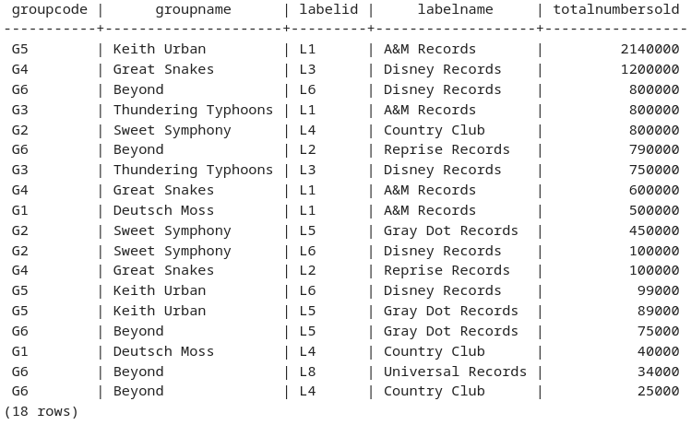

q4-out

1. Query 5:

/* Question 5 */  
select distinct wr.artistid, art.firstname,art.lastname,art.yearborn   
from artist art,writtenby wr, member mb, topsongs ts   
where art.artistid = wr.artistid  
and ts.songcode = wr.songcode  
and ts.rating <=5 and not exists (select *   
 from member   
 where wr.artistid = member.artistid and member.todate = 0  
)

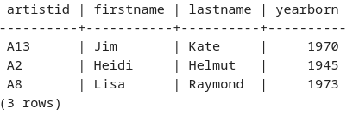

q5-out

1. Query 6:

/* Question 6 */  
select m.groupCode, m.groupName  
from musicalgroup m, cd c, recordinglabel r  
where m.groupcode = c.groupcode and c.labelid = r.labelid and r.labelName = 'Country Club'  
group by m.groupcode, m.groupName  
intersect  
select m.groupCode, m.groupName  
from musicalgroup m, cd c, recordinglabel r  
where m.groupcode = c.groupcode and c.labelid = r.labelid and r.labelName = 'Gray Dot Records'  
group by m.groupcode, m.groupName  
intersect  
select m.groupCode, m.groupName  
from musicalgroup m, cd c, recordinglabel r  
where m.groupcode = c.groupcode and c.labelid = r.labelid and r.labelName = 'Disney Records'  
group by m.groupcode, m.groupName  
order by groupname

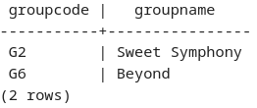

q6-out