1. To test whether all the front-end components are working, we can use the Simulator. To run the Simulator, press the ‘arrow’ button in the top left. If the build succeeds you will see:
2. If the build fails, it is most likely because of errors in different files. To test using the Simulator even if there are errors, right-click on the files with the errors, click on Delete and then select ‘Remove Reference to Files.’
3. If the Simulator renders everything properly, go ahead and click on the ‘Sign Up’ or ‘Sign In’ which should lead you to the respective screens. Also make sure the back-buttons on each page work (they should lead back to the landing page).
4. A very common error that can occur is when the Simulator doesn’t detect a landing page so it cannot open the Storyboards. To fix this go to the Storyboards file and then make sure that your preferred screen is the ‘initial view controller.’:
5. On the ‘Sign In’ or ‘Sign Up’ page, make sure that you can write in the text fields. You should be able to click in the fields and a keyboard should appear. (Will put image when this functionality if added).
6. Clicking on the buttons on this individual screen leads to:
7. There are several interactions on this page. Firstly, make sure that the carousel works. You should be able to swipe horizontally to the left on the ‘cards’ shown right below History. (Will add image when this functionality is added).
8. The navbar at the top has different sections each of which should be highlighted when pressed on. (Will add image when this functionality is added).
9. Clicking on the ‘Enroll’ button allows users to save that course for a later time. Ideally a message should pop-up stating that the course has been added to the user’s saved courses. (Will add image when this functionality is added).
10. The navbar at the bottom should lead to the different pages in this app. Clicking on the ‘Enrolled’ part will lead to:
11. Like the previous screen, the navbar at the top should highlight different sections when clicked on. (Will add image when this functionality is added). Clicking on ‘All’ leads to this screen:

The enroll button should work exactly like it does on the previous screen. The navbar should also work exactly like it does on the previous screen.

1. On the previous screen, pressing on the ‘Resume’ button should lead to the videos that the user can watch.
2. Pressing the cross button at the top of the screen leads back to the enrolled courses page.
3. Clicking on the navicon opens up another navbar that has all the different topics and videos.

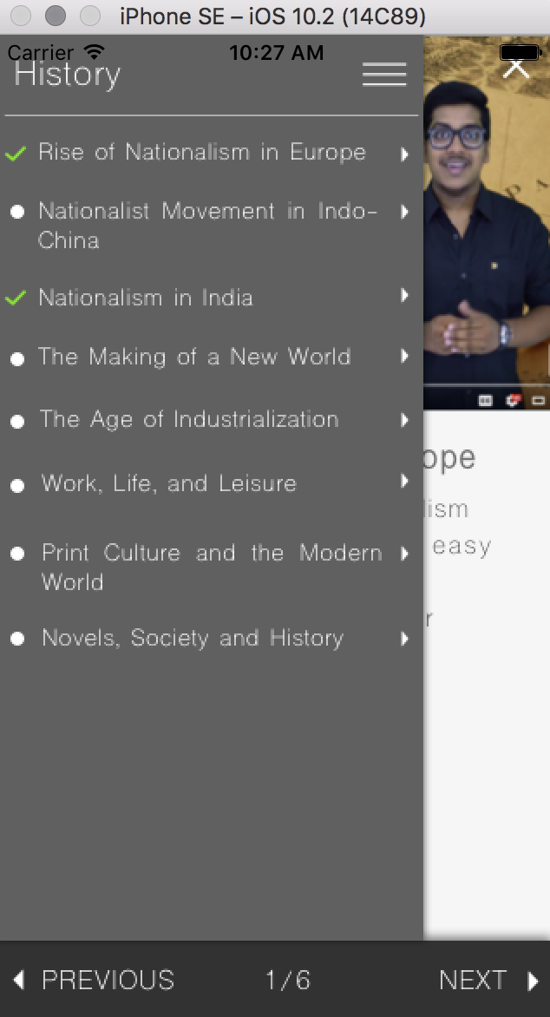

1. Pressing on each topic should create a tree-view navbar in that the next level with all the videos should show. Pressing the back-button leads back to the previous level.

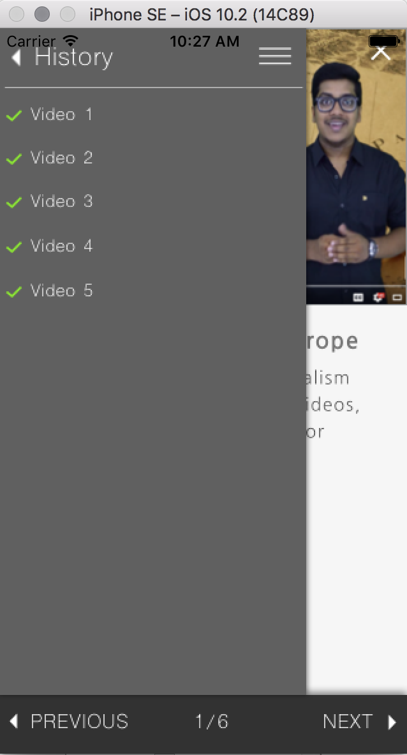

1. Pressing on the navicon again closes this navbar.
2. Clicking on the Log Out button in the navbar at the bottom should lead back to the landing page (once we have connected the models, ideally all the user data that is stored is wiped).