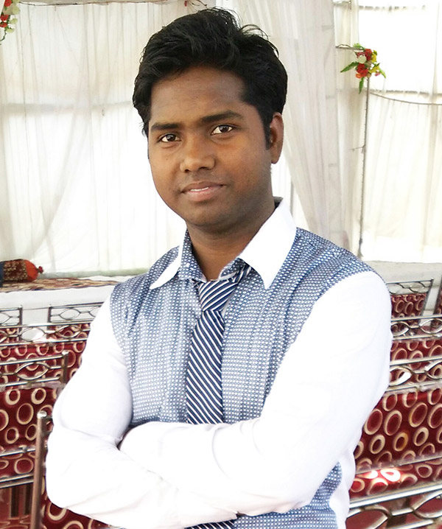
CURRICULUM VITAE

Web Designer

MD. AFTAAB
Address: W-49/F-7 Block, House No-150,
Sultanpuri, Delhi-110086.
Mobile Number: +91 9871096533 / 8178960164
Email Id: md.yash99@gmail.com

Career Summary:

To obtain a challenging position in a dynamic organization and be an integral part of growth oriented company.

Skill Set:

- Designing Software: Adobe Photoshop, Adobe Illustrator
- Web Designing: Adobe Dreamweaver, HTML5, CSS3, Java scripting
- Data base: PHP, MY SQL
- Operating System: XP, Windows-7,8,10
- Office Software: MS-Word, MS-Excel

Work Experience:

1 Year Experience in Bapu Technologies [Mar 2014 to Apr 2015].

1 Year Experience in Influxive Technologies [Apr 2015 to May 2016].

1 Year 6 Months Experience in Cyberworx Technologies [July 2016 to Feb 2018].

0 Year 7 Months Experience in Askme Technologies [Feb 2018 to Sep 2018].

0 Year Experience in Cyberworx Technologies [Sep 2018 to Present].

Work Knowledge:

- Designing Websites in Photoshop, Dreamweaver and CSS3 and HTML5.
- Editing Images.
- Banner Designing
- Poster Designing
- Logo Designing
- Responsive Web Design
- SEO Services
- Word Press 4
- OpenCart 3.0.2.0
- Bootstrap v4.0
- Website Optimizing
- Magento 1.9.3

Skills:

- Dreamweaver cc
- HTML5/CSS3
- Photoshop cc
- Illustrator
- Basic Jquery
- SEO
- WordPress 4
- Basic JavaScript
- Social Media
- Bootstrap v4.0
- Basic PHP
- MySQLi
- OpenCart 3.0.2.0
- Website Optimizing at:- gtmetrix and developers.google
- Magento 1.9.3

Professional Details:

- Diploma in Web Designing (2014) from Bapu Graphics in Pitampura.

Academic Details:

- Graduation (B.Com) from Delhi University 2th DIVISION (2015).
- Senior Secondary School Examination from C.B.S.E. (2012).

My Projects:

[In Bapu Technologies]

- www.bapugraphics.com
- www.baputechnologies.com
- www.cloud9hotelmarketing.com/hotelsandresort
- www.breeze.co.in/cloud9hotel
- www.snjaywebdesigner.com
- www.genprompt.com
- http://saidelhitutors.com
- www.websourcesolution.com

[In Influxive Technologies]

- www.xedign.com
- www.influxive.com
- www.21roses.com
- www.jimsindia.org
- www.pujanayyar.com
- http://gietdesignpartners.com
- http://www.secrettcurves.com
- http://www.influxive.com/work/specs

[In Cyberworx Technologies]

- https://www.cyberworx.in/
- educationinsta.io/
- http://www.sellersolution.in/
- http://habibgroup.co.in/
- http://www.elitesgrid.com/
- http://ankganit.in/
- http://www.kiryanaworld.com/
- http://theimperialcord.in/
- http://www.impostoglobal.com/
- http://supreme-india.com/
- http://transorg.com/
- http://www.hans.org.in/
- http://rostfreisteels.com/
- http://www.reveco.in/
- http://www.honestandyoung.com.au/
- http://www.dspublishers.com/
- http://lasostashop.com/
- http://www.frommansi.com/
- https://www.wittybae.com/
- http://www.tfsmed.com/
- http://fctecnrgy.com/
- http://funonwheels.in/
- http://www.investeurs.com/
- http://citystylemart.com/
- http://urostonelab.com/
- http://www.tanco.in/
- https://www.beam.co.in/
- http://www.bhutan-tourpackages.com/
- http://www.neelyogijourneys.com/
- https://www.wittybae.com/
- http://www.v2retail.com/
- http://pexpo.in/
- http://www.edificelegal.com/
- http://www.eapro.in/
- https://www.fusioncorp.in/
- http://www.honestandyoung.com.au/
- http://www.allwynbikes.com/
- http://multicolorsteel.com/
- https://www.medrev.in/
- http://www.masubrakes.com/
- http://www.flirtatious.in/
- http://cyberworxindia.com/decorcurios/
- http://vrfmills.com/
- http://www.7-phere.com/
- http://www.iusstf.org/ http://cyberworxindia.com/iusstf
- http://mitrabistro.com/
- http://www.avenue37.in/
- http://superoverseas.com/
- http://www.seftech.in/
- http://www.letschangefinance.com/
- http://deventurehotel.com/
- http://www.zorin.co.in/
- http://acrotech.in/
- http://adgsquare.com/
- http://berzeri.com/

[In Askme Technologies]

- http://askmetechnologies.com/
- http://compal.pt/
- http://freshbunch.in/
- http://www.oasiscare.com/
- http://www.dillitereishqmein.com
- https://www.dev-basket.com
- http://www.influxive.com/new/
- http://askmetechnologies.com/maakamakhya/
- http://www.thefunrepublic.com/
- https://reallove.com.br/
- https://scraplovely.dmcommerce.com.br/
- http://www.indidzine.com/
- http://www.eswanky.com/
- http://www.askmetechnologies.com/jewellery/
- http://jaiswalvaishdelhi.com

Hobbies:

Playing Video Game, Listening Music, Traveling.

Personal Details:

Date of Birth: 02th Feb 1991

Father’s Name: Md. Navi Hasan

Sex: Male

Marital Status: Married

Languages: Hindi, English

Place: Delhi (MD. AFTAAB)

Date: 8 – 20 - 2018

