**SERVICES**

1.**IMMIGRATION CONSULTANCY & VISA SERVICES.**

Securing a visa and its application processing is one task most applicant do not want to undertake due to its sensitivity, expertise needed in it and professionalism. In TRAVEL TEAM RWANDA, we assure our clients that our migration consultants are the best in providing professional assistance at any stage of visa application process. We assist by giving a thorough assessment of our clients’ documental qualification based on a one-on-one encounter with our clients in identify the type of visa they need, clarify various visa requirements and restrictions, apply for or renew a visa, deal with visa refusals or expirations, solve other issues such as citizenship or residency all over the world.



Want to know more about eligibility for a VISA?

**2. TRAVEL MANAGEMENT**

The core function and one of the main service our agencyy has engaged even before the start of the company. We organize PERSONAL, BUSINESS, and GROUP travel. This area of services includes the management and reservation of FLIGHT TICKETS, searches for ACCOMMODATIONS, CAR RENTALS, ACCOMMODATION IN SHORT- AND LONG-TERM BASIS, TOUR OPERATOR, SAFARIS etc.

We also do passenger assistance in repatriation due to illness, accident or emergency, lost luggage or documents, etc.



WANT TO VISIT RWANDA? ASK US FOR A QUOTE

3. **EDUCATIONAL CONSULTANCY**

Travel Team Educational Consultants,

Travel Team has over the years built a very strong educational consultants and academic professionals who work for schools and independently with clients. We advise students about career, training and educational problems and opportunities. For example, we help student/students choose a college major or help parents locate scholarships. We also have team of qualified tutors with bachelor’s degree in teaching, education or counseling.

Travel team Rwanda is a member of professional organizations that assist in career development and networking opportunities.

Travel Team Rwanda also provide college educational consultations to students by applying their specialized expertise and knowledge to help reach goals in the areas of academics, college admission, standardized testing and extracurricular activities.

We have an already assembled team of professionals who assist in advice, counselling, tutoring, applications and mentorship into International recognized institutions through paid and scholarship schemes. We organize international exams: IELTS, CAMBRIDGE, SAT, TOEFL, DUOLINGO.

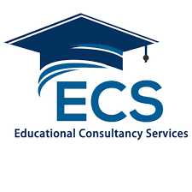

WANT TO STUDY ABROAD ON SCHOLARSHIP??????? CALL OR WHATSAPP……………

**REAL ESTATE MANAGEMENT**:

When it comes to the business of managing land and buildings, including activities such as keeping buildings in good condition and organizing the renting of such properties, Travel Team Rwanda is the choice and will always be the choice.

Travel Team Rwanda as a management company helps manage the daily operations of the rental property or portfolio of properties on your behalf as a landlord. We manage, oversees rental operations as well as the upkeep of the property and coordinates the buying and selling of a property with a real estate agent.

We also engage in other short term rental activities such as AIR B&B, short term apartment booking and reservations, Apartment leasing, renting and leasing of bungalows, duplex etc.



WANT A QUOTE OR ADVICE ON PROPERTIES IN RWANDA???????

**CARGO HANDLING & COURIER SERVICES:**

At TRAVEL TEAM RWANDA, we carry and delivers mail, messages, and packages to any part of the world. We are an affiliate agent with reputable and international courier handling companies like DHL SKYNET etc. We also handle cargos and freight services to and from West African countries.

We deliver whenever & wherever. 

WHATSAPP OR CALL FOR A PRECISE QUOTE.

**EVENT ORGANIZERS:**

Having an event full of glamour and class is always the dream of a host, while attending an event full of elegancy remains the expectations of the guest and that’s why at TRAVEL TEAM RWANDA, we strive to be the best in event organizing and management.

Event planning, also known as event coordination or event specialization comes with a lot of responsibilities in organizing and managing every aspect of an event, and that’s why in our company, we have a team of specialists in event packaging. We conceptualize theme ideas, planning budgets, booking venues, liaising with suppliers and clients, managing logistics, and presenting post-event reports.

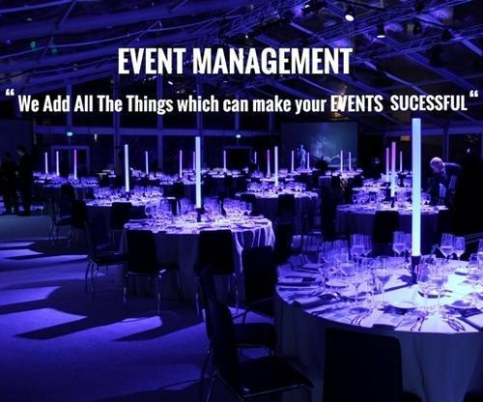

**DOCUMENTATION & SPECIALIZED OFFICE SUPPORT ACTIVITIES:**

At Travel Team Rwanda ltd, we provide documents and documentation services to individuals and companies. With our qualified team of secretaries and secretariat services agents and workers, we assist our valuable clients in obtaining any type of document legally in Rwanda and any part of the world.

We are an accredited agent with the Rwandan government online document and payment gateway IREMBO.

