Ticket Tracker Black Box Test Plan

Document Author(s): Michelle Lemons and Nikhil Shirsekar

Date: 10-20-16

Introduction

This plan will test that the program works correctly and handles errors and files in the way that it should. You should start the program by opening up eclipse and right clicking on the TicketTrackerGUI class and clicking “Run as Java Application”. The program is a system used by the help desk that will keep track of help tickets and their stages through the process to be resolved.

Test ID | Description | Expected Results | Actual Results
Test 1: test creating a new ticket list  (Michelle Lemons) | Preconditions: GUI has loaded  Select “Add New Ticket”  Record Results.  Click Cancel.  Record results | GUI loads. Ticket List field should be empty. All buttons above should be able to be pressed above.  A new window pops up asking for Ticket Title and Submitter name.  After clicking cancel, you are returned to the original window with the Ticket List still empty | GUI loads. Ticket List field should be empty. All buttons above should be able to be pressed above.  A new window pops up asking for Ticket Title and Submitter name.  After clicking cancel, you are returned to the original window with the Ticket List still empty
Test 2: Test exception when there is no submitter  (Michelle Lemons) | Preconditions: GUI has loaded  Select “Add New Ticket”  Enter “lol dude” as the title and leave the Ticket Submitter field empty.  Record results.  Click OK on the dialog and then add “mklemons” as the submitter for the ticket. And “Just testing” as the notes.  Click “Add Ticket to List”  Record results. | A dialog appears stating “invalid Ticket Information”.  You are returned to the original page of the GUI with the Ticket List. There is now a Ticket there with ID #1, State of “New” and Title ”lol dude”. | An error message appears with title “Message” stating “Invalid ticket information”  You are returned to the homepage of the GUI. In the Ticket List, there is now a ticket with ID #1, State “New” and title “lol dude”
Test 3: Test filter by submitter  (Michelle Lemons) | Preconditions: Test 2 has passed  Select “Add New Ticket”  Enter “Wifi help” as the title and “lwinner” as the Ticket Submitter and “just testing” as the notes  Click “Add Ticket to List”  Record results.  Type in “mklemons” into the text box by the “Filter List by Submitter” button on the home window.  Record results | The ticket list now has 2 tickets. Both have the title State of “New” but the second one has ID #2 and title “Wifi help”.  After clicking the “Filter List by Submitter”, the Ticket List should only have the one ticket with ID #1 and title “lol dude”. | The ticket list now has 2 tickets. Both have the title State of “New” but the second one has ID #2 and title “Wifi help”.  After clicking the “Filter List by Submitter”, the Ticket List only shows 1 ticket, with ID number 1, state New, and title “lol dude”
Test 4: Test Assign Ticked  (Michelle Lemons) | Preconditions: Tests 2 and 3 have passed. You have clicked “Show All Tickets” to return to the screen with both tickets on it.  Select the first ticket (ID #1).  Click “Edit Selected Ticket”  In the owner field, enter “jep” as the Owner id. Enter “jep” as the Note Author. Enter “You can handle this dude” into the Note Text field.  Click “Assign”  Record Results  Type “jep” into the field next to the button for “Filter List by Owner”. Click the button.  Record Results | On the home window, you should still have both Tickets. The first (ID #1) has State “Assigned”. The second (ID #2) has State “New”. | Ticket 1 with ID#1 now has a state of “Assigned”. Ticket 2 still is in the “New” State.  The same ticket #1 is in the TicketList with state Assigned.
Test 5:  Test change to Working State and Closed  (Michelle Lemons) | Preconditions: Tests 2 – 4 have passed.  Click on “Show All Tickets” button.  Select the first Ticket (ID #0). Select “Edit Selected Ticket”.  When the new window appears, select the Flag “Inappropriate” from the drop down menu in the middle of the screen.  Add to the note section “jep” as the Note Author and “This is an inappropriate ticket with no request for help” in the Note text box.  Select “Close”.  Record Results | You are redirected back to the main window after clicking “Close”.  The Ticket List still has 2 tickets, the first with State “Closed” and title “lol dude”, the second with State “New” and title “Wifi help”. | You are redirected to the main page.  Ticket 1 now has the State “Closed” and title “lol dude” and the second one still has the State “New” and title “Wifi help”
Test 6:  Test Quit/Save File (Michelle Lemons) | Preconditions: Tests 2-5 have passed  Click “File” on the top left-hand corner. From the drop-down menu, select “Quit”.  A file browser will appear. Name the file “foobar.xml” and save to the test-files folder in the TicketTracker System.  Click Save.  Open the test-files folder in Eclipse and view its contents  Record Results. | The test-files folder should have one file inside named foobar.xml  The file has 2 tickets inside. | Test-files folder has a file inside named foobar.xml.  After opening the file it looks like:  When you click the arrow next to Tickets it shows 2 tickets inside.
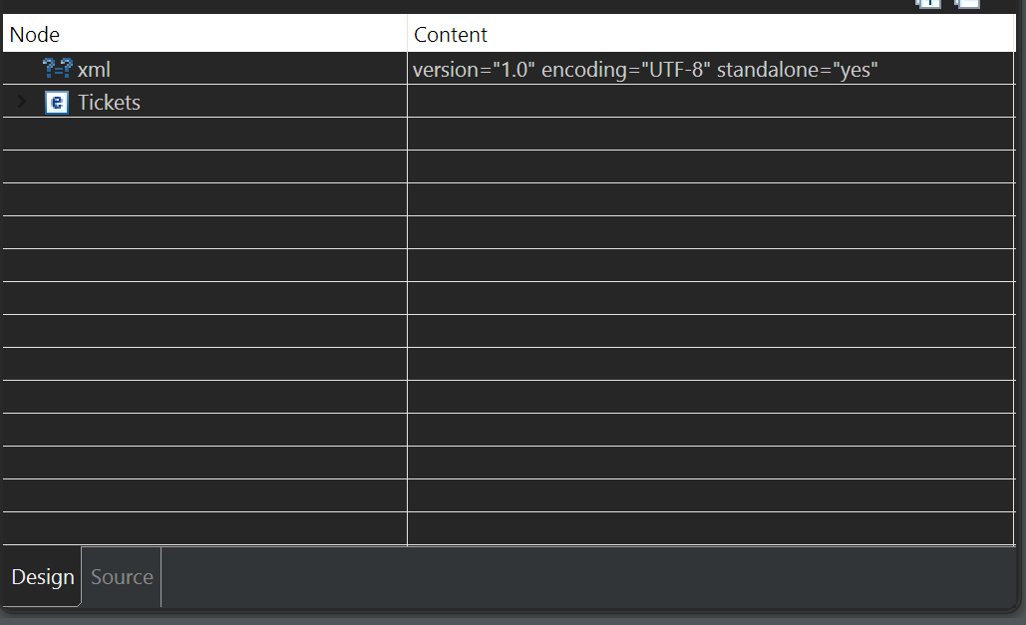

Document Revision History

Date | Author | Change Description
10-20-16 | Michelle Lemons | - Wrote 6 tests that test adding and some state transitions.
11-2-16 | Michelle Lemons | - Added actual results of the tests

