Hoang Sy Nguyen

CS373

Assignment 5.

1) Additional method created during this assignment:

HitRecord checkIntersection(Ray ray): return a hit record that records the hit of ray to the closest shapes

Color3f colorMult(Color3f a, Color3f b): return a multiplication of 2 colors.

I also applied the regular sampling method to the ray generating method, so that there would be xsample*ysample ray in 1 pixel instead of only 1 ray through the center of pixel. The generated picture look smoother after applying sampling method.

2) _Ball_arealight.scene: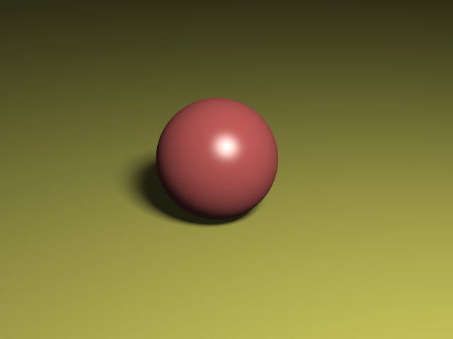

_Ball_glass.scene:

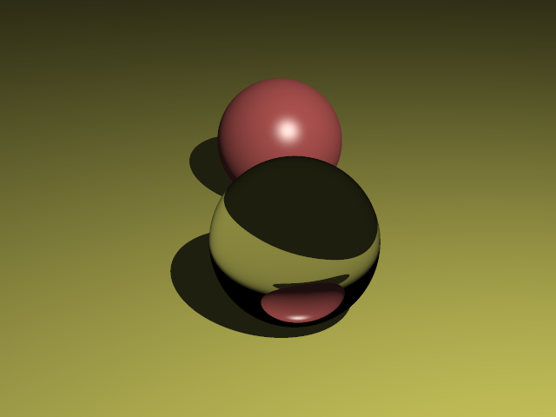

_Ball _mirror.scene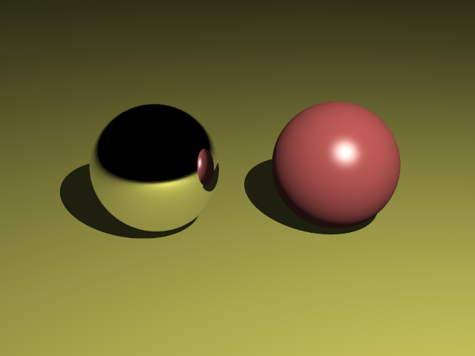

_Ball_pointlight.scene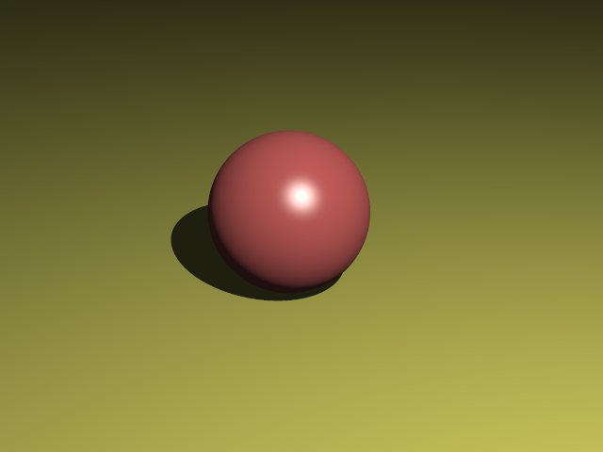

_Ball_spotlight.scene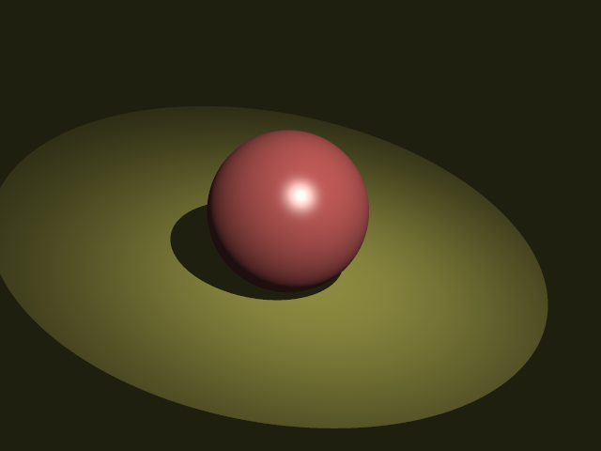

Head.scene 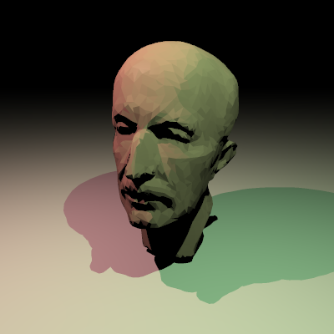

Triangle_pointlight.scene: