|  |
| --- |
| Sonata Software Limited, Microsoft Corporation and DAISY Consortium |
| Trouble Shooting Guidelines for Open XML to DAISY XML Translator |
| Troubleshooting Guidelines |

Contents

[1 Introduction 3](#_Toc225337263)

[2 Error During Installation of Add-In 4](#_Toc225337264)

[3 Troubleshooting Issues with word 2007 5](#_Toc225337265)

[3.1 Issue 1: The Add-in is Disabled in Microsoft Office Word 2007 5](#_Toc225337266)

[3.2 Issue 2: The Com Add-in does not load while opening the Office Application. 8](#_Toc225337267)

[3.3 .NET Programmability SUPPORT FOR Word 2007 12](#_Toc225337268)

[4 Troubleshooting Issues with word 2003/XP 16](#_Toc225337269)

[4.1 The Add-in is Disabled in Microsoft Office Word 2003/XP. 16](#_Toc225337270)

[4.2 Issue 2: The Com Add-in does not load while opening the Office Application. 18](#_Toc225337271)

[4.3 “.NET Programmability Support for Word 2003 20](#_Toc225337272)

[5 Enabling .Net Framework 3.0 in Windows Vista OS: 25](#_Toc225337273)

[6 Error while generating Full Audio books 27](#_Toc225337274)

# Introduction

This document provides guidance around issues that could be commonly encountered when installing the Open XML to DAISY XML Translator Add-In. Please document any additional issues that you encounter on the project site and we will address them as soon as possible.

# Error During Installation of Add-In

Error may occur during installation of Word Add-In

For issues with following error attempt below mentioned steps.

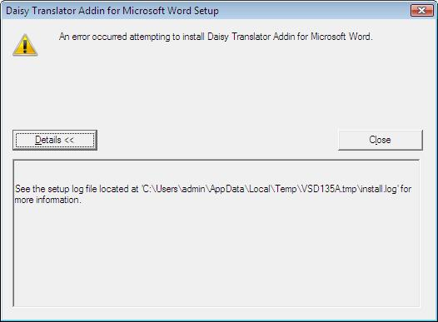

Step 1: Uninstall the previously installed Add-In from Add or Remove programs.

Step 2: Again install new Add-In from the setup.

# Troubleshooting Issues with word 2007

You do not see, or cannot find, the “Save as DAISY” option.

This may be caused by:

* The Add-in is disabled in Microsoft Office Word.
* The Com Add-in is not loading while Microsoft Office Word launches.

## Issue 1: The Add-in is Disabled in Microsoft Office Word 2007

For the issues with a Disabled Add-in attempt the following steps.

Step 1: Click on the Office Button (ALT + F)

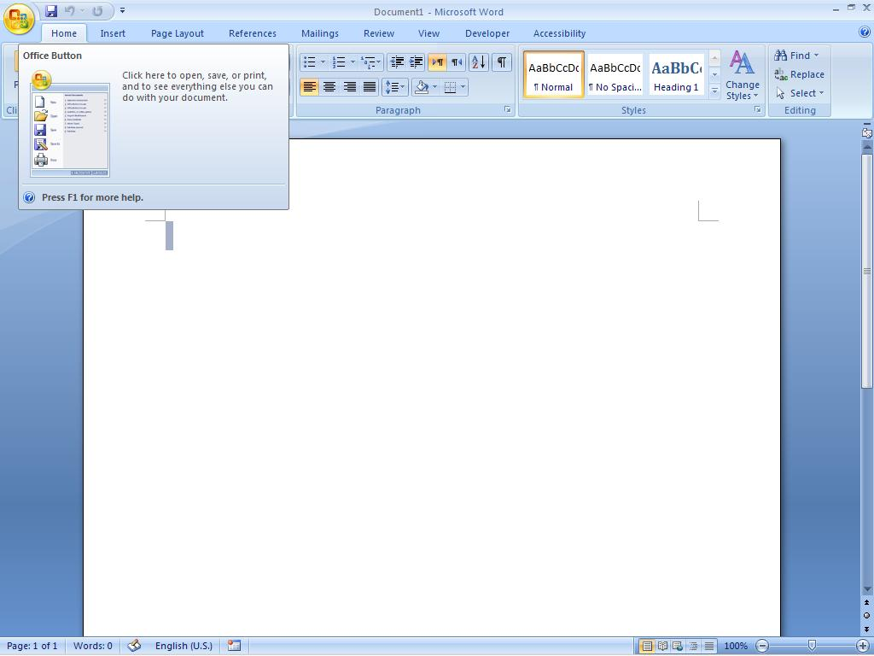

Step 2: if the “Save As DAISY” button is not located within the contents of the office button drop down, click on “Word Options” which is also reached by clicking on the Office button and is located in the lower right of the drop down. The keyboard shortcut for navigating to the “Word Options” menu is: ALT, F, I.

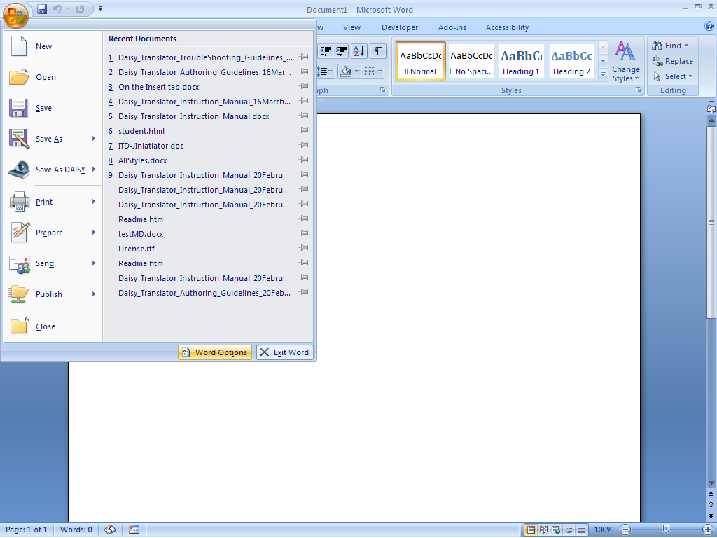

Step 3: Click on Add Ins tab and then from the manage option at the bottom, select Disabled Items option and hit “Go” button.

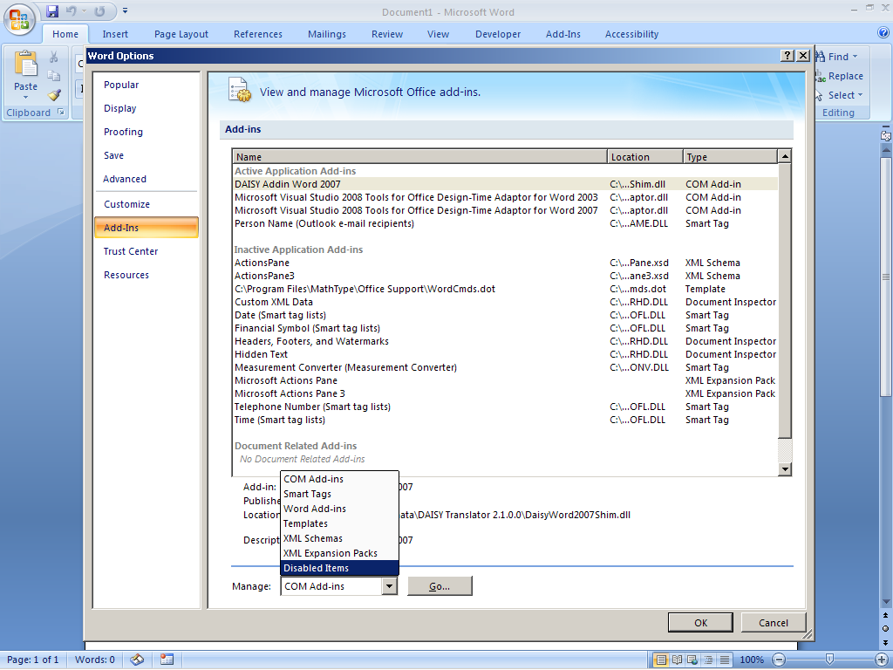

Step 4: Clicking on Go button (this was done in the previous step for keyboard users) will open a new window, which gives information about the Disabled items.

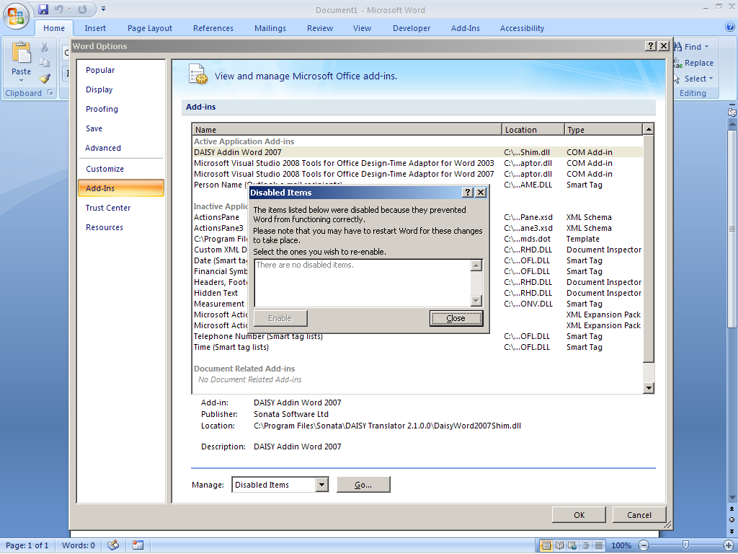

If there is an option of Word Add-in then click on it and click on Enable button. You can do this via keyboard by tabbing into the disabled items list then tabbing back to enable and pressing enter.

## Issue 2: The Com Add-in does not load while opening the Office Application.

Follow the steps below to resolve this issue:

Step 1: Click on Office button or press ALT + F.



Step 2: If “Save As DAISY” tab is not contained in the Office dropdown, click on “Word Options” which can be reached by clicking on Office button and can find the “Word Option” at the lower right of the dropdown. The keyboard shortcut for navigating to the “Word Options” menu is: Alt F, I.



Step 3: Click on Add Ins tab and then from the manage option at the bottom, select COM Add-ins option and hit “Go” button. This can be done on the keyboard by pressing the down arrow six times once inside of the Word Options menu, pressing tab four times and then press enter.

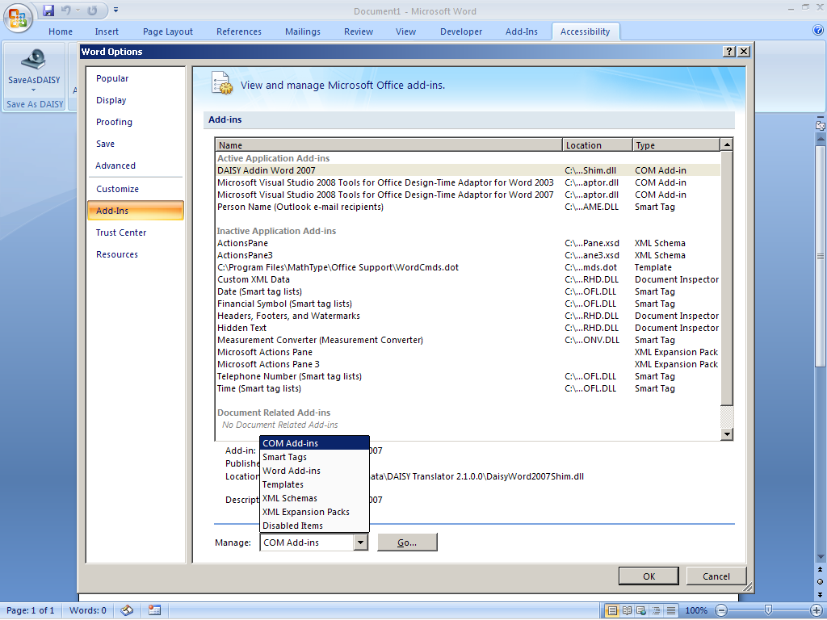

Step 4: Clicking on go button will take you to the following window

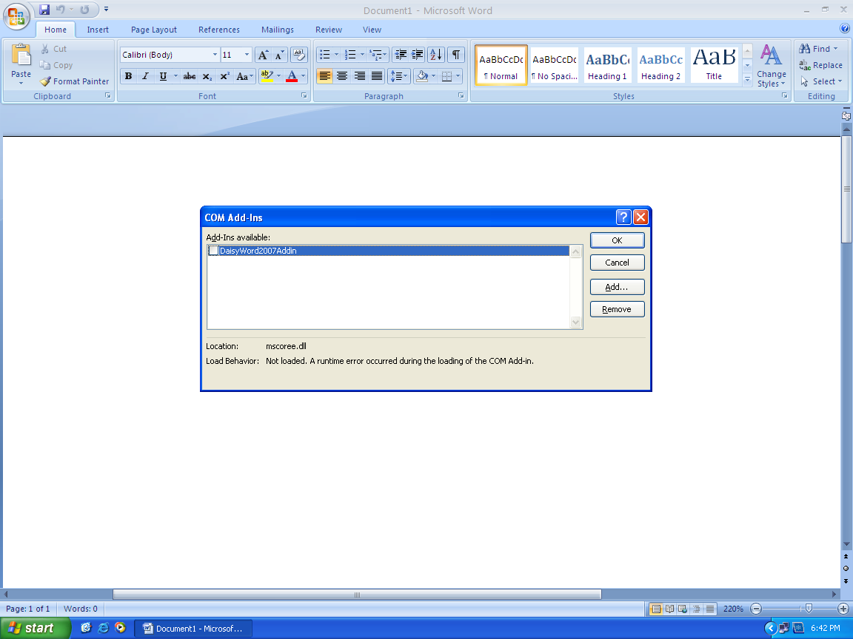

If the window shows The Load Behavior as “Not Loaded runtime error occurred during the loading of COM Add-in “at the bottom of the small window, then Uninstalling and Reinstalling Office may resolve the issue.

Even after following the above steps, if the ADDIN is not Loaded then follow these steps:-

**Step 1:** Uninstall DAISY add-in.

**Step 2:** Repair Office 2007 by adding the feature “.NET Programmability Support” for ‘MS WORD’.

Following are the Screenshots showing how to repair Word 2007 using “**.NET Programmability Support**”

## .NET Programmability SUPPORT FOR Word 2007

Following screenshot shows the option for Add or Remove Features.

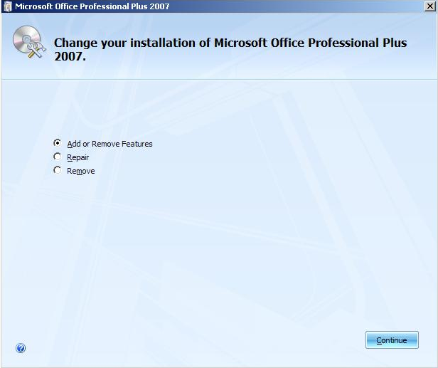

* Select Add or Remove feature and click on continue button.
* Clicking on continue button will give Installation options in next window as shown below.

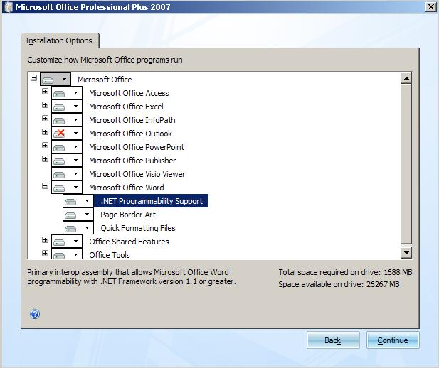

* Expand Microsoft office word and select “.NET Programmability Support” option.
* Click on “.NET Programmability Support” and choose “Run from My Computer” option and click on continue button.

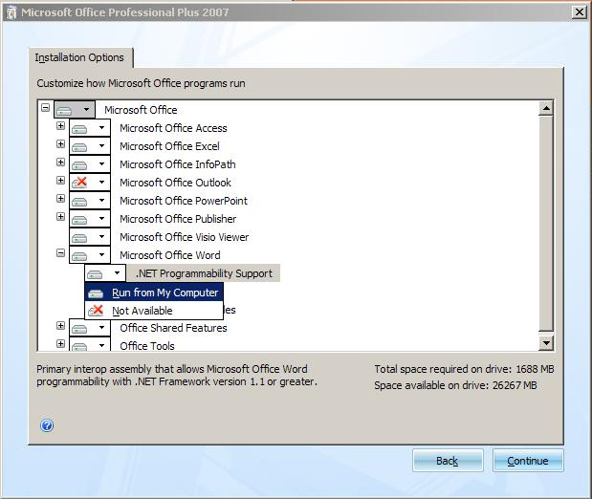

# Troubleshooting Issues with word 2003/XP

You do not see, or cannot find, the “Save as DAISY” option.

This may be caused by:

* The Add-in is disabled in Microsoft Office Word.
* The Com Add-in is not loading while Microsoft Office Word launches.

## The Add-in is Disabled in Microsoft Office Word 2003/XP.

For the issues with a Disabled Add-in attempt the following steps.

**Step 1:** Click on Help button and select the options “About Microsoft Office Word”. The keyboard shortcut for navigating to the “Help Options” menu is (ALT+h).

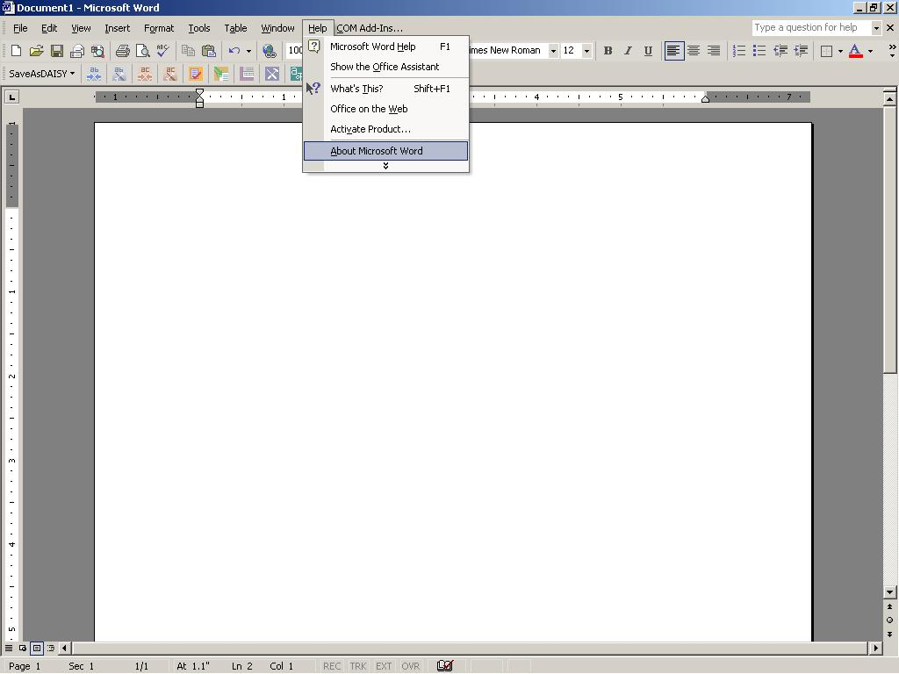

Step 2: The following window appears, which at the bottom right will give an option for Disabled Item, click on “Disabled Item “option.

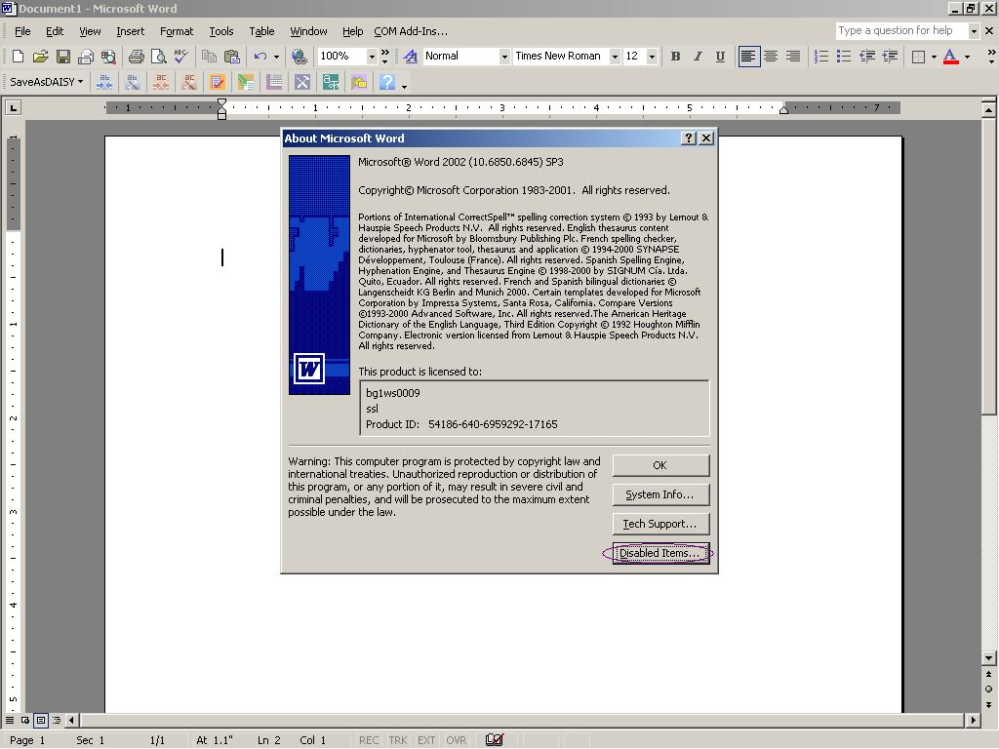

Step 3: This will open ‘Disabled Item’ dialog box which lists out the disabled Add-ins. If you see “DaisyTranslatorWord2003Addin” in the list box, select the item and click on Enable button and press close button.

Click on “OK” button in “About Microsoft Office Word” window.

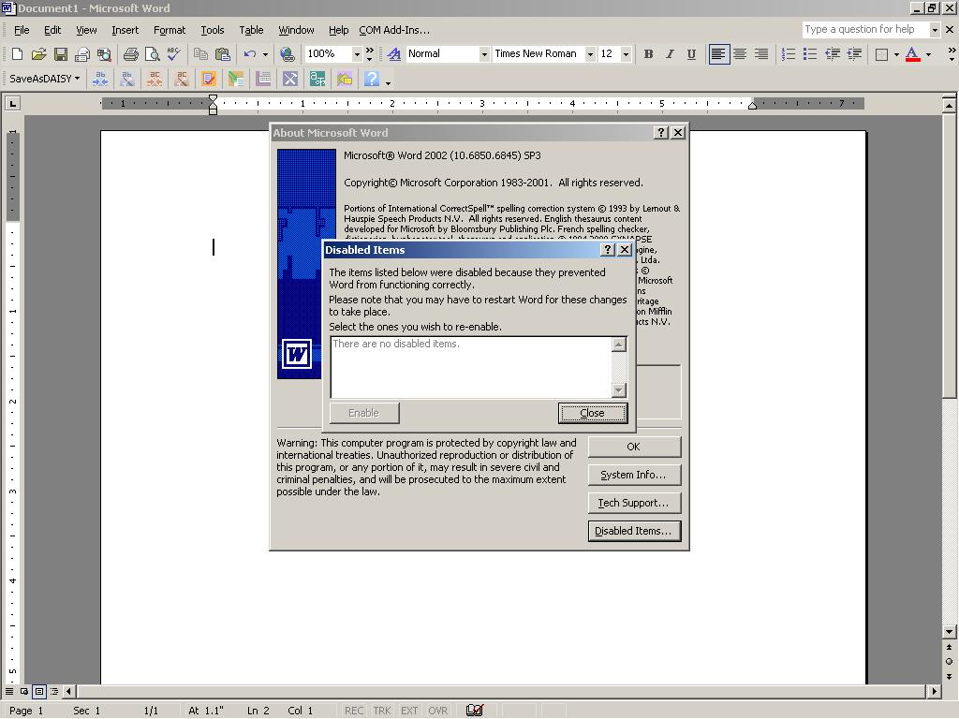

## Issue 2: The Com Add-in does not load while opening the Office Application.

Follow the steps below to resolve this issue:

Step 1: Please check for the Com Add-in option in the tool bar, click on the COM Add-in and check whether “DaisyTranslatorWord2003Addin” is listed out in the dialog box. If “DaisyTranslatorWord2003Addin” is listed out, check whether the check box is checked. If the check box is not checked, there might be loading issue, also look at the Load behavior mentioned in the bottom of the dialog box.

If you get "Not Loaded. A runtime error occurred during the loading of the COM Add-in" error you may need to update your Office 2003 installation with office2003-KB907417-FullFile-ENU.exe which can be found at: http://www.microsoft.com/downloads/details.aspx?familyid=1B0BFB35-C252-43CC-8A2A-6A64D6AC4670&displaylang=en”.

If the option of COM Add-in is not present, follow below steps.

Step 2: Follow these steps to enable com Add-in.

Click on Tools and select the option “Customize”. The keyboard shortcut for navigating to the “Tools option” is (ALT+ T). For keyboard options navigate to “customize “option using arrow keys.

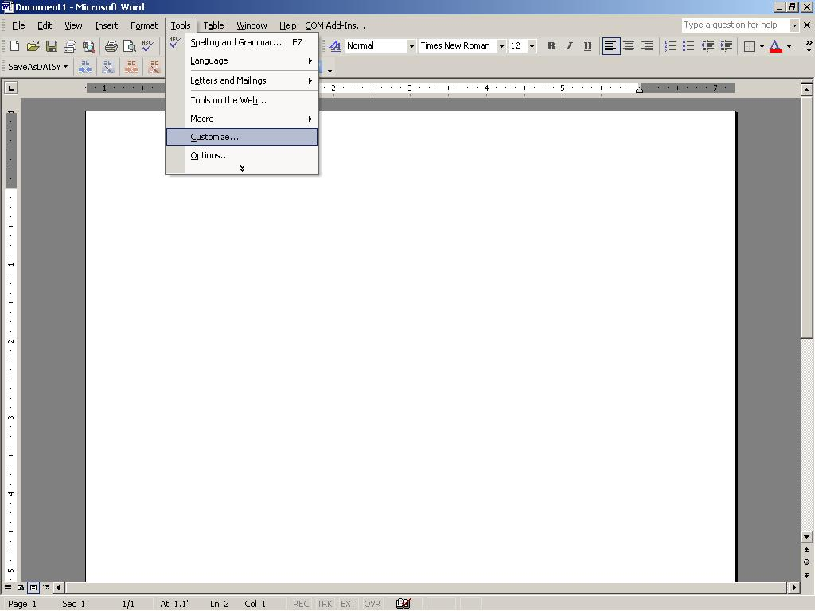

Step 3: This will open a Customize window, select the Tool option from the left pane, after selecting Tools option, COM Add-in appears in the right pane.

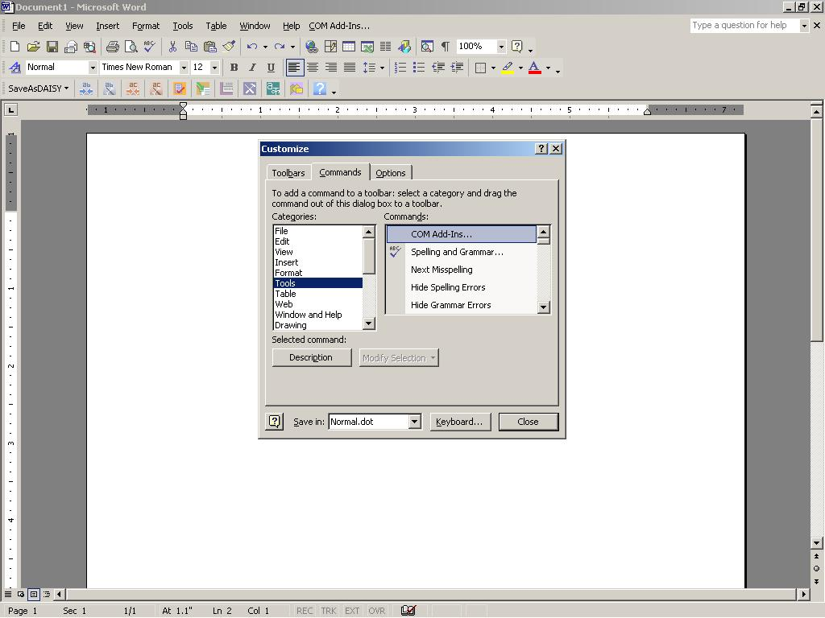

Step 4: Select COM Add-in and drag and drop the “COM Add-in “option to the Tool bar.

## “.NET Programmability Support for Word 2003

Following are the Screenshots showing how to repair Word 2003 using “.NET Programmability Support”

* Select Add or remove Features from Maintenance mode for word 2003 and click on Next button.

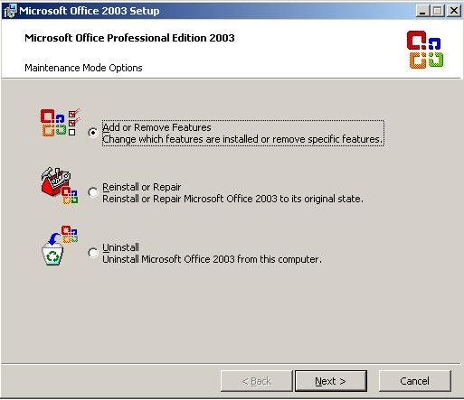

* A new window will appear giving custom setup option, select word from these options. Also put a checkmark on “Choose advanced customization of application” from the same Window.

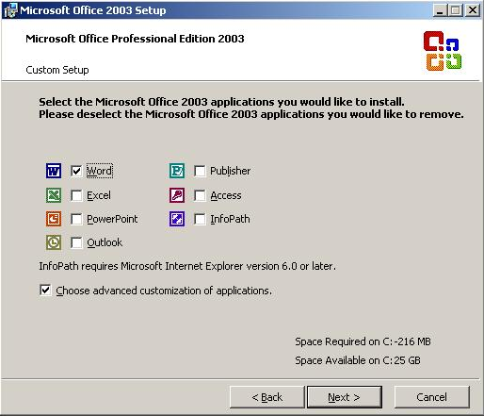

* Click on Next button.

This opens up a new window which provides Advanced Customization option, select “.NET Programmability Support”.

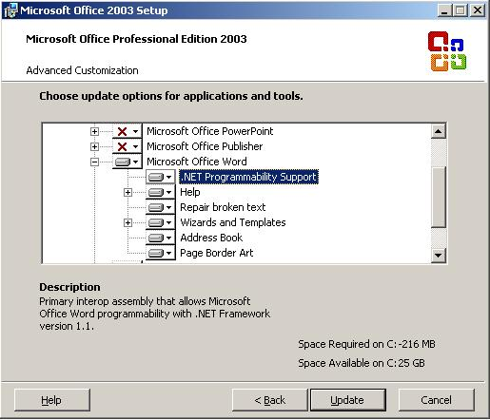

* Selecting “.NET Programmability Support” will give an option “Run from My Computer” select and click update button.

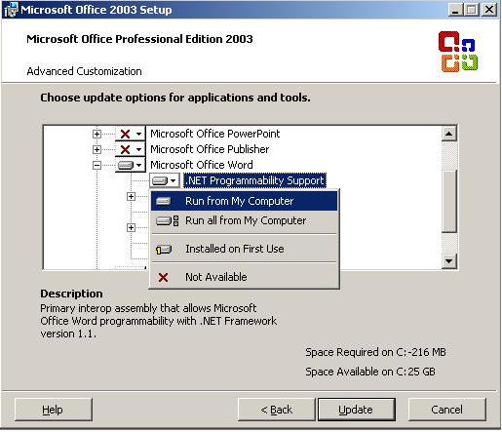

* Click on Update button.

Step 3: Reinstall DAISY add-in.

# **Enabling .Net Framework 3.0 in Windows Vista OS:**

Follow the below steps to enable .Net Framework 3.0 in Windows Vista operating system,

1. Click on "Windows" button and type "Programs" in the run prompt as shown below. Then select "Programs and Features" from the list.

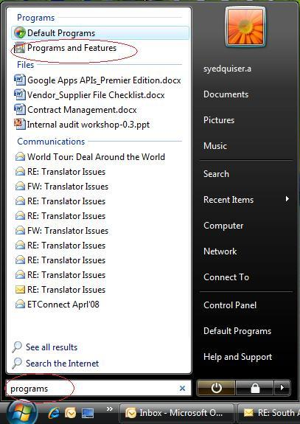dhtmled0:Vista_1.JPG

1. Click on "Turn Windows Features on or off" on the left pane shown to the user, this will open "Windows Features" form.
2. Select the checkbox "Microsoft .Net Framework 3.0" and all the child components:
   * Windows Communication Foundation HTTP Activation.
   * Windows Communication Foundation Non-HTTP Activation.
   * XPS Viewer

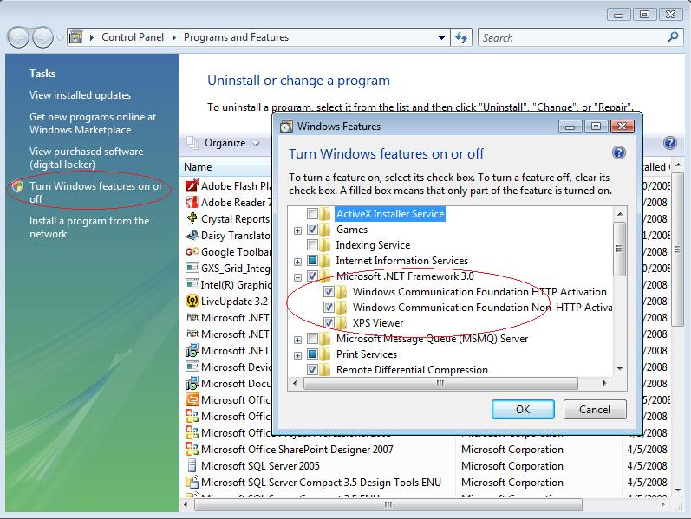

 Then, click on "Ok" button to enable .Net Framework 3.0.

# **Error while generating Full Audio books**

1. **Unexpected Error:**

When errors occurred during the generation of audio books, the user can access the detailed message log by pressing the "Details" button of the "Pipeline Job Failed" dialog.

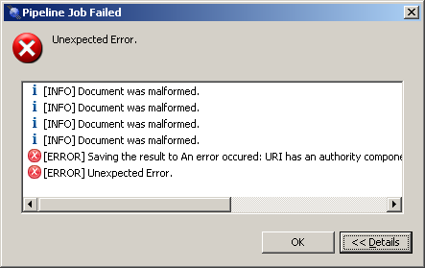

These messages may contain information that can help the user to pinpoint the cause of the problem.

If the user has trouble interpreting these messages, he is invited to search or ask for assistance in the DAISY Pipeline forum hosted by the DAISY Consortium: <<http://forums.daisy.org/viewforum.php?f=16>>

Note that the content of the message list displayed in the Pipeline results dialogs can be selected, copied and pasted, via a contextual menu or the standard keyboard shortcuts (Ctrl-A / Ctrl-C / Ctrl-V).

Additionally, the user can browse the bugs and feature requests trackers available on the Pipeline development site hosted by Source Forge:

1. Bugs Tracker <<http://sourceforge.net/tracker/?group_id=134191&atid=729299>>
2. Feature Requests Tracker: <<http://sourceforge.net/tracker/?group_id=134191&atid=729302>>
3. **Cannot locate the installation Directory of Design Science MathDAISY:**

MathDAISY is software for processing mathematics notation into an accessible format. If the document has mathematical equations, it may give error while creating full audio book as shown below.

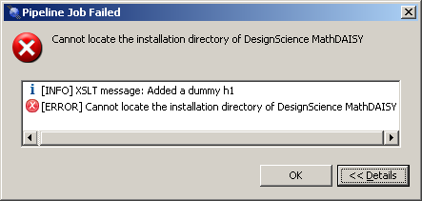

Before creating full audio books for the document with Mathematical equations, you need to install MathDAISY software. For further information on installing MathDAISY software, please visit the following link. <http://www.daisy.org/projects/pipeline/other-add-ins.shtml>

1. **Temporary Directory Name with Non-Western Characters**

A bug in the Java Runtime Environment on Windows makes it impossible to launch third-party executables on file paths containing non-western characters. This problem occurs for instance when the Pipeline Lite Narrator delegates the mathematical formulas processing to a third-party plugin (such as Design Science MathDAISY).

To circumvent this limitation, the Pipeline Lite copies any file that needs to be processed by a third-party executable to a temporary directory, by default the user's temporary directory defined by MS Windows. Because this default directory is usually located under the user's home directory, its path may contain unsafe non-western characters (for instance if the user name contains such characters). In such a case the user can override the default and specify a safe temporary directory by editing the following lines in the file "pipeline.user.properties" located in the Pipeline Lite installation directory:

**<!-- directory to store temporary files in -->**

**<entry key="pipeline.tempDir">C:\\Path\\To\\Custom\\Dir</entry>**

(Note that backslash path separators must be doubled.)