Open Smart Grid Platform

Introduction to the Open Smart Grid Platform

The Open Smart Grid Platform (OSGP) is an open, generic, scalable and independent 'Internet of Things' platform, which enables various connected smart objects in the public space to be easily controlled and monitored. Our platform allows the use of any (web)application and with any IP communication infrastructure.

Our goal is to stimulate the development of smart and sustainable solutions. Smart devices and smart apps play a central role in the development of smart grids and smart societies. The open smart grid platform software enables you to connect to thousands of devices, control them, and monitor their performance. This is done in an open and secure way, so you can use it for your own applications and devices, thereby reducing the time to market and decreasing development costs.

Using the platform

- A user or operator uses one or more (web) applications to monitor and/or control devices
- The applications connect to the open smart grid platform via several web services which are divided into functional domains, i.e. Public Lighting, Smart Metering, Power Quality, etc. Third party developers can use the web services for the development or integration of new applications
- The platform handles all these application requests in a secure way and uses various functions and services to do so (e.g. authorization, authentication, device management, logging)
- For the 'translation' and communication of user/operator commands to the various smart devices, the platform uses multiple (open) protocols
- The platform supports various IP based data telecommunication technologies and protocols to communicate with the devices

More technical and user information about the open smart grid platform can be found in this document.

Example use case for the open smart grid platform

Use cases of the open smart grid platform are only limited by your imagination. Here are some examples:
- Adhoc and scheduled Switching of Public Lighting
- Electrical Transportation
- Smart Metering
- Traffic Control (LED/matrix signs, traffic lights)
- Flexible load management ( solar energy and wind energy)
- Power Quality monitoring

The basic architecture

Layered architecture

The Open Smart Grid Platform environment consists of five layers:

1. Web services layer
2. Domain logic layer
3. Open Smart Grid Platform Core layer
4. Protocol layer
5. Device layer

Web services layer

In this layer the web services are exposed to the outside world. Applications can connect to the web services to implement the required functionality of the open smart grid platform. The web services are divided into functional domains, i.e. Public Lighting, Smart Metering, Power Quality, etc. Additional functional domains can be created.

Domain logic layer

Every functional domain has a separate set of web services and a corresponding domain logic block. In the domain logic block the business logic of that functional domain can be found. This is where a functional command will be translated into a generic intermediate format. For example, in the case of public lighting the command "Turn light on" will be translated into a command like "set switch(1) in closed position". In this layer it could also be decided that one functional command results in multiple commands to a device. The domain logic is closely related to the web services layers and can be added as well.

Open Smart Grid Platform core layer

In the core of the Open Smart Grid Platform the following generic functions are found:

Device management
Time synchronization
Firmware management
Workflow engine
Device installation services
Scheduler
Device status monitoring
Routing of device commands to appropriate device protocol

Protocol layer

The different protocol adapters are found in this layer. Here the generic intermediate format of a command for a specific device will be translated into the protocol message the device understands. This message will be sent to the device. A retry mechanism has been implemented to prevent communication failure in the case that the receiving end is temporarily unavailable. The listeners for messages initiated by a device are implemented here. Examples are the DLMS/COSEM protocol adapter for smart meters.

Devices

Any device in the public space with an Internet connection may be connected to the platform. The platform is independent of the device used, therefore this part of the setup is not part of the platform.
Architecture Principles

This chapter gives an overview of the principles used defining and implementing the architecture. The following principles were applied:

Layering
Domain driven design
Dependency inversion principle
Behavior driven development

Layering

The use of layers improves the separation of responsibilities. Each application contains the following layers:

Presentation layer: responsible for providing information to users (persons and/or systems) and the handling of user requests
Application layer: responsible for executing system tasks including authorisation control
Domain layer: responsible for the representation of the problem domain.
Infrastructure layer: responsible for technical matters supporting other layers. For instance persistence, messaging, etc

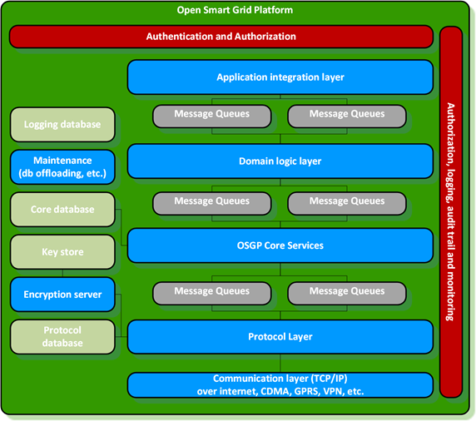

Domain driven design (DDD)

Domaindriven design focuses on the problem domain. DDD's starting point is creating an optimal model for a specific problem domain by having a common language and constructive collaboration between technical and domain experts.

DDD uses the following building blocks:

Entity: An object not identified by its attributes but by its own identity.
Value Object: an object with attributes but has no own identity.
A collection of objects surrounding a specific root entity (or aggregate root). To ensure consistency objects in the aggregate can only be addressed through the aggregate root.
Service: Contains instructions not related to a specific object.
Repository: Serves as a collection for fetching and saving objects. Creates an abstraction for actual persistent implementations.
Factory: Contains methods to create domain objects.

Dependency inversion principle

The dependency inversion principle promotes an independent connection by inverting dependency relations. This ensures that the domain model can be very 'clean' without knowledge of the underlying infrastructure (POJO classes). The Spring framework is used to implement the Dependency Inversion principle.

Behavior driven development (BDD)

Behavior driven development is a way of programming that first describes behavior in user stories and then implements this in code. The user stories contain scenarios with acceptation criteria that can be automated. This creates a complete test suite for the whole system.

For the application of BDD the following frameworks are used:

- Cucumber and Gherkin, automated acceptance testing, based on scenarios from stories.

Nonfunctional view

The nonfunctional view is an overview of the most significant nonfunctional demands.

The identified nonfunctional demands are:

Time Behavior
Extensibility
Internationalisation and localisation
Security
Scalability

Time Behavior

Time behavior is mainly important in the Flexovl application when a lot of devices have to be addressed in a short period of time over a wireless network. Both latency and limited bandwidth have to be taken into consideration while demanding the coordinated on and off switching of the lighting, since we want to avoid the Christmas tree effect.

Time synchronization: devices periodically register with the platform and receive a time.
Protocol: because of the limited bandwidth an efficient protocol "protobuf" was selected.

Points of interest:

Light metering messages
When the SSLD's are disabled the PSLDs cannot be addressed

Because of these points of interest we use message queueing combined with a retry mechanism of delayed delivery.

The platform and devices use UTC time. The OSLP protocol between platform and devices uses UTC time as well.

Scalability

The Open Smart Grid Platform is designed and built for scalability and reliability

- Messages will never get lost, In the worst case scenario, a message will be sent to the dead letter queue.
- Any layer of the platform can be independently scaled up and down
- Adding servers can be done runtime
- It can run in an activeactive setup over multiple servers and data centers. In our cloud hosted setup even over sets of data centers in different countries.

Image

adsfasdfaf

Security

The following security measures can be used in a hosted environment:

Cloud security

- DDOS protection
- IPSEC VPN connections
- IP whitelisting

Most cloud environments support these features.

Operating System
- Hardened operating systems (according to Center of Internet Security)

Platform security
- Communication over TLS
- Firewalls between all servers and layers
- Certificates from a recognized Certificate Authority (CA)
- Audit trail on all actions throughout the platform
- Role based authorizations on specific functions of devices
- Access control
- Unique device identification

For every major release there will be a mandated security test initiated by Alliander.

In cooperation with the European Network of Cyber Security (ENCS) state of the art security measures were implemented.

- Security per device
- Security per application
- Security Certificates per Organisation and per device
- All communication is encrypted

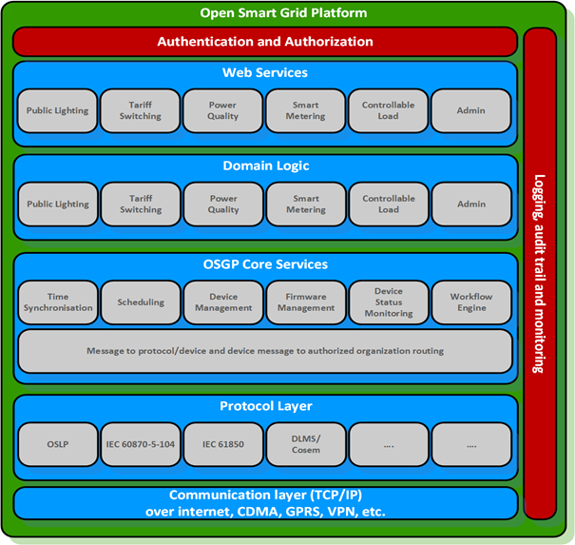

Security measures:

1. Firewall in defined zone
2. Operating System Hardening
3. DDOS protection
4. Replay attack prevention
5. Private encryption key per device
6. Certificates from a Certificate Authority
7. Encryption via Elliptic Curve DSA
8. IPSEC VPN for CDMA and GPRS
9. Unique device identification
10. Unique CDMA modem number
11. Role based authorizations on functions and devices

Encryption

An analysis of safety aspects has led to the decision that the safety of the whole system will be realized by proven technology based on asymmetrical coding (also known as publickey encryption).

Authentication of web applications

Twoway SSL will be used between web applications and the Open Smart Grid Platform to verify the identities for both client and server. User organisations are responsible for the administration of the identity of and access to their web applications. The web applications feature a login page. After successful login the user is linked to an organisation. Passwords will be stored with encryption. The organisation ID will be sent in each message to the Open Smart Grid Platform and will be verified by the SSL certificate.

Algorithms

Only public encryption Algorithms will be used. Due to performance limitations (of the devices) and recommendations from The European Network for Cyber Security (ENCS) Elliptic Curve DSA with 256bitkeys was selected. This improves the security and efficiency over the 1024 bit RSA algorithm. Messages can be smaller and less processor capacity is needed. The key length of Elliptic Curve DSA is similar to the 3072 bit key length of RSA.

Note: Even though the open smart grid platform uses ECDSA to secure the OSLP, other encryptions may be used as well. The RSA Algorithm is still supported if preferred. This is a flexible configuration option.

Private APN

A private APN is used for linking to mobile data communication infrastructures.
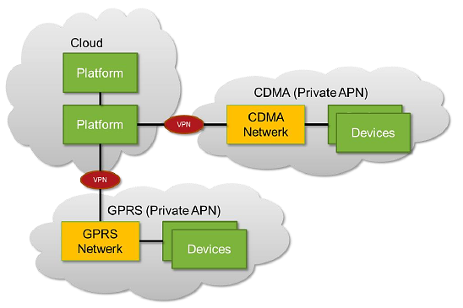

Logging

- Every action to and from devices is logged in the audit trail
- Messages from unknown devices will be denied (and logged)

Redundancy

This part describes the possibilities of a redundant set up of the Open Smart Grid Platform. The Platform is designed to run in a High Available (or HA) environment, and to prevent data loss due to unexpected failures. Each component of the Platform is designed to be stateless. Components communicate with each other using message queues, which are processed in an asynchronous way.

Activeactive
In an activeactive setup, multiple instances of each component (eg. Web Services, Core, Protocol Adapter) process the data at the same time. Traffic is equally distributed across the instances. In case of a defect in one instance the traffic is automatically processed by the remaining instance(s).
The Open Smart Grid Platform is designed to run in such a set up, and thus preventing down time in case of a failing server. Each component of the Platform can run in an independent, redundant and scalable way.

Database
The Open Smart Grid Platform uses a PostgreSQL database. PostgreSQL supports multiple database servers. For example, a slave and master node, where the slave node continuously replicates the master node. In case the master node fails, the slave mode is triggered and will stop replicating from the master node, execute a recovery and will become the master node.

ActiveMQ
The components of the Platform communicate with each other through a Message Queue. The Open Smart Grid Platform uses Apache Active Message Queue, which makes asynchronous communication possible between components. The components can register to the queues as consumers. In case a consumer (e.g. a server running a component of the platform) is down, the message will still be consumed by the remaining consumer(s). The Message Brokers can be used as a MasterSlave. In case the Master message broker is down, you get immediate failover to the slave without loss of messages.

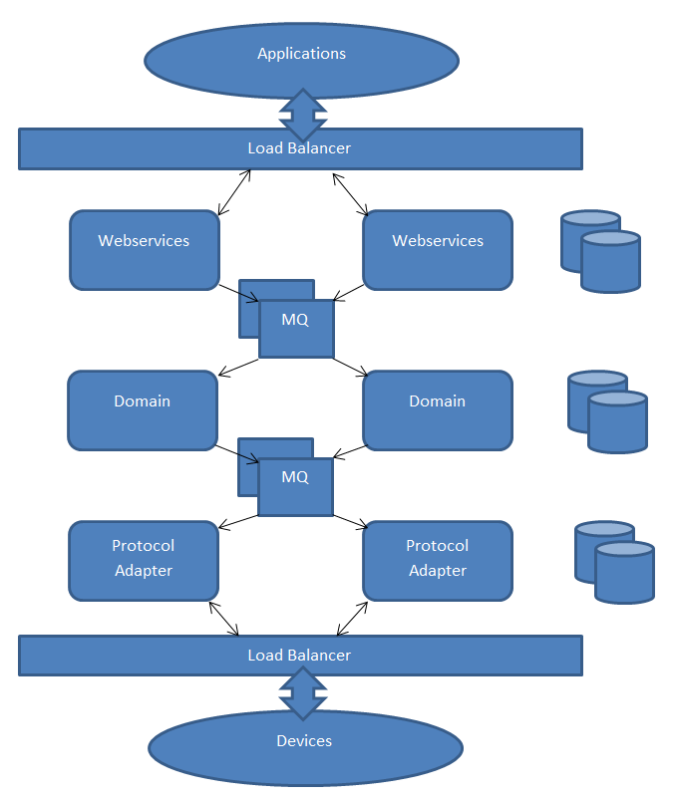

Description of the individual platform components

Application Layering

The use of layers improves the separation of responsibilities. Each application contains the following layers:

- Presentation layer: responsible for providing information to users (persons and/or systems) and the handling of user requests
- Application layer: responsible for executing system tasks including authorization control
- Domain layer: responsible for the representation of the problem domain.
- Infrastructure layer: responsible for technical matters supporting other layers. For instance persistence, messaging, etc

Layers:

Authentication and authorization

The web server is configured with a SSL certificate to encrypt the incoming and outgoing communication. The SOAP Web service (Spring Framework web service) uses a Java Keystore and a certificate for each organization. Only organizations that are known within the platform are authorized to use the web service.

Application integration layer

For the several functional domains separate SOAP Web services are offered. This separation offers authorization per functional domain. Each of the web service components send a queue message to the corresponding domain component.

WSDL
A separate WSDL is implemented for each functional cluster. All SOAP operations have a request object parameter and return a response object. For Synchronized Web Services the result is immediately included in the response.
For asynchronous web services the response contains a correlation ID. This Correlation ID is to be used by the requester to receive the actual result from the platform. The following diagram is an example of such an asynchronous request.

![Web request example](./asyncwebservicerequest.png "ASync Web Service Request")

Furthermore each SOAP message has a header which contains the user's organisation ID. This table displays an overview of the WSDL's including operations and fields in the request and response objects.

SOAP vs. REST

SOAP is chosen in the open smart grid platform web services over REST for the following reasons:
- REST is resources/data oriented (put, get, delete) while the open smart grid platform is function/method oriented
- SOAP has the advantage of having a contract (WSDL)
- SOAP has extensive security features that are being used in the open smart grid platform to meet the high security demands/requirements requested by e.g. the energy utilities
- Energy companies are generally not progressive in terms of technology. SOAP is acceptable for energy companies and REST is sometimes seen as new and insecure.

Domain logic layer

For each functional domain business logic is implemented using a separate domain component. Common functionality like authorization should be abstracted to a shared component. Domain components receive queue messages from web service components and send queue messages to the open smart grid platform core component.

Open Smart Grid Platform Core Services

The open smart grid platform core component receives queue messages from domain components. These messages from domain components are forwarded to a protocol adapter project. The open smart grid platform core component also offers logic for a protocol adapter project to send the response of a smart device back to a domain project.
The Core component routes messages from domain adapter components to protocol adapter components and vice versa. The core layer also contains a workflow engine.

The internal database model in the core layer:

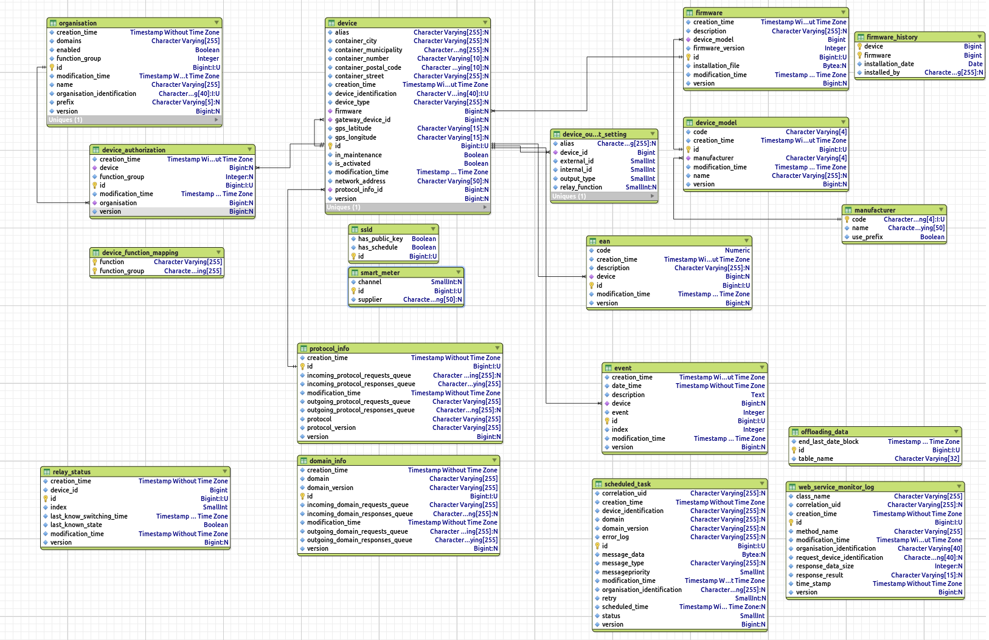
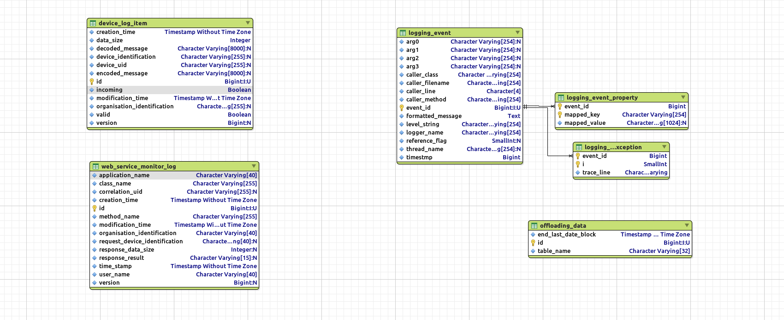

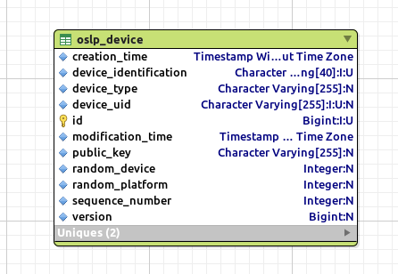

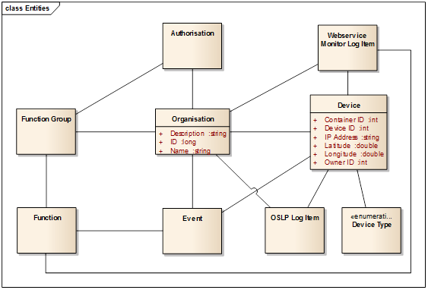

Protocol Layer

The open smart grid platform supports multiple protocols.

- OSLP (Open Street Light Protocol)
- DLMS/COSEM
- IEC61850

The protocols can use one of the security layers:
- TLS (Transport Layer Security encryption)
- SSL (Secure Sockets Layer encryption)

Other protocols can be easily added to the platform. If possible, we prefer protocols based on open standards.

Protocol specific device attributes are stored in the protocol adapter DB

Queues
Open smart grid platform components connect to each other through message queues.

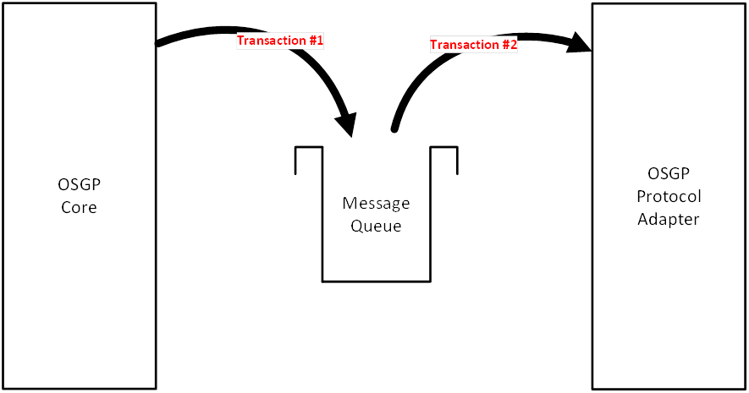

- Transactions on messages to and from the queues
Messages are persisted on the queues
- Queues are clustered for reliability and speed
- By using queues, the open smart grid platform can be stateless

Smart devices

The open smart grid platform can connect to any device that supports one of the supported protocols. Smart devices can receive messages from or send messages to protocol adapter components. In case of SSLD's this is done using TCP/IP over mobile internet connections (e.g. GPRS, CDMA, etc.). The communication is encrypted using public key cryptography.

Technical Overview

Technical Architecture

This chapter gives a more technical overview. It describes each layer of the platform by giving an overview of its packages and the code it contains. Furthermore it describes how a message proceeds through the platform. If you are planning on adding your own Domain Adapter or Protocol Adapter, it will be useful to read this chapter to get a feeling of how the Platform has been built.

A Request through the Platform

The picture below depicts an example of a request (OSLP SetLight request) proceeding through the platform to a device.
![alt text](./pictures/OsgpSetLightFlow.PNG)

A web request enters the platform at its EndPoint, which in turns calls the RequestService. The RequestService checks if the organisation in the request is authorized, creates the request message and sends it to the MessageSender which in turn puts it on the queue of the Domain Adapter.
In the Domain Adapter, the incoming message is processed in the MessageProcessor, which in turn calls the Request Service. Here the message is converted to a DTO object. The CoreRequestMessageSender puts the message on the Core Queue.
The MessageListener in Core receives the message. The DeviceRequestMessageService contains generic functionality such as Authorization, Validation, etc. Once these procedures are completed, the message is routed to the appropriate protocol adapter.
In the Protocol Adapter the message is received by the MessageListener. It is processed through the MessageProcessor and OslpDeviceService. The request eventually ends up in the OslpChannelHandler, where the actual Protocol Request to the device is made.

For a detailed description of each layer, please take a look at a more detailed description of each layer in this chapter.

Configuration files
The Platform uses property files for certain settings (such as JMS settings, Persistence settings, etc.). These files are stored in property files which can be found in the Config repository on Github. These files are sym linked to /etc/osp/, where the Platform (through reference in context.xml) looks for the property files.

Core Layer

The Core layer of the Open Source Grid Platform is responsible for Validation, Translation, Authorisation and Routing of request messages. It also contains all the Domain Objects.

The core layer consists of two components:

- osgpdomaincore: Shared Domain objects, services, repositories, etc. These classes are used through the entire platform.
- osgpcore: Logic for routing domain requests, scheduling, retrying, etc.

General Package structure: osgpdomaincore

- entities: Defines the entities used for persistence.
- exceptions: Domain specific exceptions reside here.
- repositories: Repositories that contain logic for persisting entities.
- services: Domain services that reference a repository.
- specifications: Interfaces that define specifications for Devices and Events.
- validations: Validators and constraints.
- valueobjects: Definitions of the Domain Objects.

General Package structure: osgpcore

application
- config: Contains the configuration files for the Component. Uses the property files in /etc/osp/.
- ApplicationContext
- OsgpCoreInitializer
- DomainMessagingConfig
- PersistenceConfig
- ProtocolMessagingConfig
- SchedulingConfig
services: Services that process device requests/ responses. Checks for authorization, and if the request is supported by the platform, it will be routed to the appropriate protocol adapter.
tasks: Contains task scheduler logic.

domain.model
These packages contain interfaces for the Services.
- domain: Interfaces for the Domain services.
- protocol: Interfaces for the Protocol services.

infra.jms
- domain: Contains Messages, MessageListeners and MessageProcessors for Domain related messaging.
- protocol: Contains Messages, MessageListeners and MessageProcessors for Protocol related messaging.

Domain Adapters

The Domain Adapters are responsible for receiving requests from the Web Services layer, and delivering them to the Core layer. The Domain Layer mainly contains MessageProcessors and Services for request handling.

The Core/Admin components contains the shared functionality, while the Domain components contain additional domain specific functionality.

At the moment the Platform uses the following Domain Adapters:

Generic
- Core osgpadapterdomaincore: Contains Core (common) functionality; AdHocManagement, FirmwareManagement, etc.
- Admin osgpadapterdomainadmin: Contains Admin functionality, e.g. DeviceManagement.

Domain
- Public Lighting osgpadapterdomainpubliclighting: Contains functionality for the Public Lighting Domain.
- Smart Metering osgpadapterdomainsmartmetering: Contains functionality for the Smart Metering Domain.
- Tariff Switching osgpadapterdomaintariffswitching: Contains functionality for the Tariff Switching Domain.
- Microgrids osgpadapterdomainmicrogrids: Contains functionality for the Micro Grids domain.
- Distribution Automation osgpadapterdomaindistributionautomation: Contains functionality for the Distribution Automation domain.

General Package structure

application
- config: Contains the configuration files for the Component. Uses the property files in /etc/osp/. ApplicationContext DomainAdapterInitializer MessagingConfig PersistenceConfig
- mapping: Custom Orika converters for mapping to/from DomainObjects/DTO Objects.
- services: Contains most of the domain logic, related to the specific services of the adapter. The service classes converts DTO objects to Domain objects (or vice versa), and put the request on the Core queue through the JMS classes.

infra
- jms.core: Inbound/outbound messages from/to the Core layer.
- This package contains Messages, MessageListeners, MessageSenders and MessageProcessors for sending requests to the Core Queue, or receiving and processing responses from Core.
- jms.ws: Inbound/outbound messages from/to the web services layer.
This package contains Messages, MessageListeners, MessageSenders and MessageProcessors for sending requests to the Web Services Queue, or receiving and processing responses from the web services layer.

Protocol Adapters

The Protocol Adapters are responsible for the actual communication to and from a device. They usually operate in a certain domain, and might use common/ generic functions from the platform.

The Open Smart Grid Platform currently has the following protocol adapters:
- ProtocolAdapterDLMS: Smart Metering
- ProtocolAdapterIEC61850: Public Lighting, Micro Grids and Distribution Automation
- ProtocolAdapterOSLP: Public Lighting and Micro Grids

General package structure

application
- config: Contains the configuration files for the Component. Uses the property files in /etc/osp/. ApplicationContext MessagingConfig OsgpProtocolAdapterOslpInitializer OslpConfig OslpPersistenceConfig
- mapping: Custom Orika converters.
- services: Contains the (functional) services that control communication from (and to) the device. Also persists requests and responses, and deals with security. Actual communication is done through the classes in the infra package.

device
Contains the Protocol Adapter Objects used for the Protocol Adapter.
- requests: Objects representing the requests that are supported by this adapter.
- responses: Objects representing the responses that are supported by this adapter.

domain
- entities: Entities used for persistence.
- repositories: Repositories used for persistence.

- Exceptions:Contains the exceptions that might be thrown while communication with a device, e.g. ValidationException, MessageRejectedException, etc.

infra

This package contains all the code for communication through JMS (Platform) and Networking (Device).
- messaging: Contains the JMS Messages, MessageListeners, MessageSenders and MessageProcessors.
- networking: Contains the classes that are responsible for connecting to a device using a certain protocol.
- Services: Services used to check the request status.

Web Services

The Web Services layer contains the web services that are used to communicate with the Platform. The Open Source Smart Grid Platform uses the Simple Object Access Protocol or SOAP to expose its interfaces. The Web Services Adapter receives requests and sends those to the Domain Adapter. An incoming request is converted to a Domain Object, and put on the MessageQueue of the Domain layer. The Web Services layer also has a queue for incoming responses from the Domain adapter.

Each domain of the Platform has its own web services:

Generic
- Core osgpadapterwscore: Contains the Core (common) web services.
- Admin osgpadapterwsadmin: Contains the Admin web services.
- Shared osgpadapterwsshared: Contains shared endpoints, such as header authorization
- Database osgpadapterwsdb: Contains repositories for persistence.

Domain
- Public Lighting osgpadapterwspubliclighting: Contains the Public Lighting web services.
- Smart Metering osgpadapterwssmartmetering: Contains the Smart Metering web services.
- Tariff Swithcing osgpadapterwstariffswitching: Contains the Tariff Switching web services.
- Microgrids osgpadapterwsmicrogrids: Contains the Micro Grids web services.
- Distribution Automation osgpadapterwsdistributionautomation: Contains the Distribution Automation web services.

For a description of the WSDL's see the [Domain Chapter](../../Domains/README.md).

General Package structure
A description of the general package structure of a web service component.

application
- config: Contains the configuration files for the Component. Uses the property files in /etc/osp/. ApplicationContext AdapterInitializer MessagingConfig PersistenceConfig WebServiceConfig
- exceptionhandling: Exceptions are defined here.
- mapping: Custom Orika converters.
- services: Contains services used by the domain, such as AdHocManagement. These are called by the end points and convert the request to a Domain Object and put the request on the domain message queue using the JMS classes.

endpoints
EndPoints for the web services: contain a reference to a service that proceeds with handling the request.

infra
jms: contains the JMS classes such as:
- MessageSender(s)
- MessageType
- ResponseMessageFinder

webapp
The WSDL and schema definitions can be found under main/webapp/WEB_INF/wsdl.

Tools and technology used

Platform
- Apache ActiveMQ: Open source messaging server, used to relay messages between components of the open smart grid platform. ActiveMQ is an open source message broker written in Java and a full Java Message Service (JMS) client. It provides "Enterprise Features" which in this case means fostering the communication from more than one client or server.
- Apache HTTP server: Web server, used as front for Apache Tomcat.
- Apache Tomcat: Provides a "pure Java" servlet container for Java code to run in.
- pgAdminIII: PostgreSQL administration and management tools.
- Protobuf (Google Protocol Buffers): A languageneutral, platformneutral, extensible way of serializing structured data for use in communications protocols, data storage, and more.
- Flyway: Agile database migration framework for Java
- HikariCP: JDBC connection pool
- Hibernate: Object/Relational mapping
- Netty: Network application framework for protocol servers & clients
- OpenMUC: Library implementing the IEC61850 and DLMS/COSEM communication standard
- Orika: Java bean mapping
- Spring: Application development framework. Several Spring libraries are used, including Spring Data, Spring Security and Spring WS.
- Puppet: Application for Automatically delivering, operating and securing your infrastructure

Development
- Bower: Package manager for Javascript packages. Web applications consist of various components; frameworks, libraries, assets, utilities, and rainbows. Bower manages all these things for you.
- Eclipse: IDE for developing software.
- FileZilla: FTP application.
- Git: Version control system.
- NodeJS: Tooling suite with various Javascript tools.
- NPM: Package manager for the NodeJS Javascript applications.
- Putty: A free and opensource terminal emulator, serial console and network file transfer application.
- Vim: Source code editor.
- Apache Maven: Software project management tool.
- GIT & GitHub: Source code management.

Testing &QA
- Apache JMeter: Application designed to load test functional behaviour and measure performance.
- Cucumber: automated acceptance testing framework.
- Gherkin: DSL for acceptence testing framework.
- Sonarqube: Quality management platform.
- SoapUI: Functional testing tool for testing web services.
- JUnit: Unit testing.
- Mockito: A Mock framework for Unit testing.
The following table presents an overview of the components and the most important technical choices per component.
Component | Technology
Open Smart Grid Platform | Java, Spring Framework, Hibernate, Netty
Demo application | Java, Spring Framework, Spring MVC
Web services | SOAP, WSDL
OSLP Protocol | Google Protocol Buffers

Component (not open source) | Technology
OSGP Management application | Java, Spring Framework, Spring MVC
NetManagement application | Java, Spring Framework, JAXRS, AngularJS
Liander Installatie application | Java, Spring Framework, JAXRS, AngularJS

