DCIT 403 — Semester Project Report
University of Ghana

Crop Disease Intelligent Agent

TABLE OF CONTENTS
1. Introduction
2. System Analysis
3. Architectural Design
4. Interaction Design
5. Detailed Design
6. Implementation
7. Conclusion
8. References

1. INTRODUCTION

1.1 Problem Statement
Crop diseases are responsible for an estimated 10–16% annual loss in global agricultural production, costing billions of dollars and threatening food security. Smallholder farmers—who produce over 70% of the world's food—are disproportionately affected because they lack timely access to expert plant pathologists. By the time a farmer visually identifies a disease, significant yield damage may have already occurred.
The Crop Disease Intelligent Agent addresses this by providing instant, AI-powered diagnosis of crop diseases from leaf images.

1.2 Why an Agent-Based Approach?
An agent-based approach is ideal for this problem because the system must demonstrate autonomy, reactivity, proactiveness, and goal-directed behaviour—properties that distinguish agents from traditional software applications.
Agent Property | How It Applies
Autonomy | The agent independently processes images and produces diagnoses without human intervention
Reactivity | It reacts to new image inputs (percepts) from the environment in real time
Proactiveness | It pursues the goal of accurate diagnosis and can escalate uncertain cases
Goal-directed | It has clear goals: maximise diagnostic accuracy, provide actionable treatment plans, and flag uncertain results

2. SYSTEM ANALYSIS

2.1 Goal Specification
The agent is driven by top-level goals and sub-goals structured in a hierarchy.
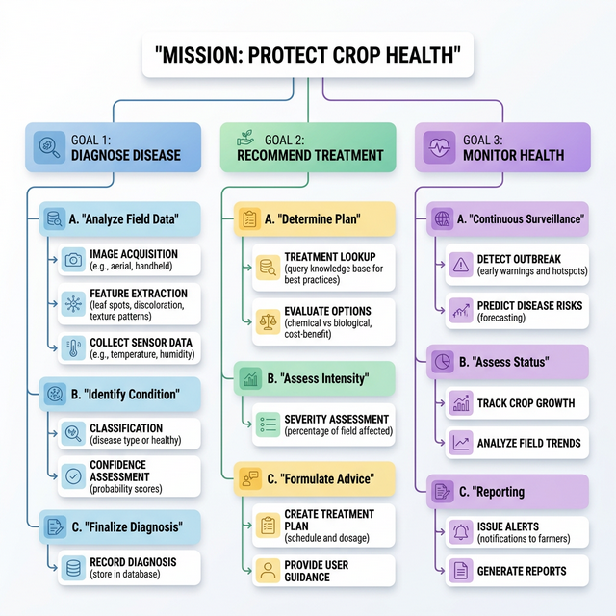
Figure 1: Goal Hierarchy Diagram

2.2 Functionalities
The system provides Image Intake, Disease Identification, Confidence Reporting, and Field Monitoring.

2.3 Usage Scenarios
Scenario 1: Farmer uploads a diseased leaf for diagnosis.
Scenario 2: Healthy crop confirmation.
Scenario 3: Low-confidence results escalated to an expert.

3. ARCHITECTURAL DESIGN

3.1 Agent Type Selection
The system uses a single BDI agent with specialized capabilities.

3.2 Capability Grouping
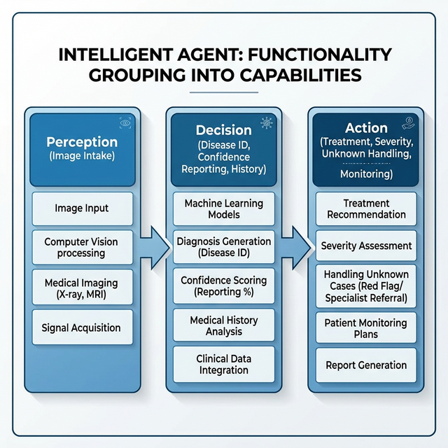
Figure 2: Functionality Grouping Diagram

3.3 Acquaintance Diagram
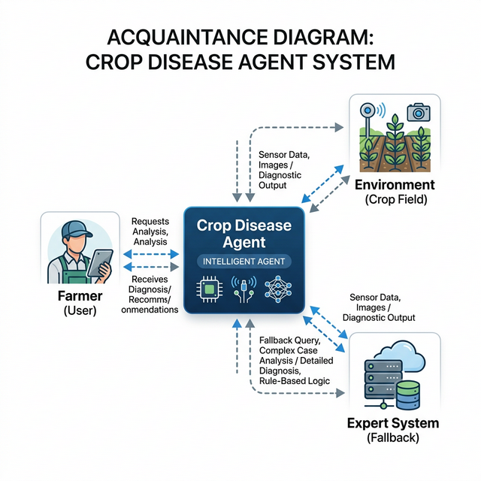
Figure 3: Acquaintance Diagram

4. INTERACTION DESIGN

4.1 Interaction Diagrams
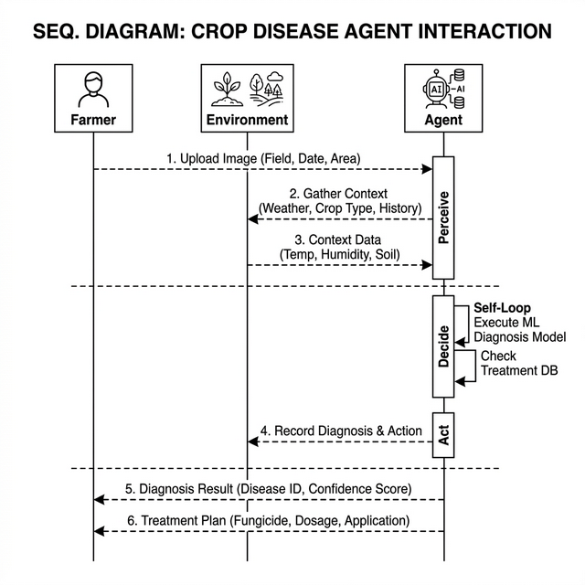
Figure 4: Sequence Interaction Diagram

5. DETAILED DESIGN

5.1 Capabilities
Perception, Classification, Treatment Recommendation, and Monitoring.

5.2 Plans
DiagnoseSingleImage, HandleLowConfidence, BatchMonitoring, and HandleUnknownDisease.

6. IMPLEMENTATION
The agent is implemented in Python using PyTorch for the CNN model and Gradio for the UI. A full BDI loop (Perceive-Decide-Act) is used for decision making.

7. CONCLUSION
The Crop Disease Intelligent Agent successfully demonstrates the application of the Prometheus methodology to a real-world problem, providing farmers with autonomous and reliable diagnostic tools.

