

NOAA NESDIS
CENTER for SATELLITE APPLICATIONS and RESEARCH

SOFTWARE DOCUMENTATION

Fractional Snow Cover

Donald Cline, NOAA/NWS/NOHRSC
Thomas Painter, UCAR/University of Utah
Christopher Bovitz, UCAR/NOHRSC
Kelley Eicher, UCAR/NOHRSC
Andrew Rost, NOAA/NWS/NOHRSC

Version 1.0.2

June 17, 2010

Table of Contents
1 PREFACE 7
1.1 Purpose of This Document 7
1.2 Who Should Use This Document 7
1.3 Inside Each Section 7
1.4 Related Documents 8
1.5 Revision History 8
2 INTRODUCTION 8
2.1 Overview 8
2.2 Physical and Mathematical Basis 9
2.3 Implementation Concepts: Models and Model Types 11
2.4 Endmember Memory 12
3 FILES 13
3.1 Overview 13
3.2 Configuration Files 13
3.2.1 Overview 13
3.2.2 SPECLIBS 14
3.2.3 speclib.z##.sli 15
3.2.4 MODELTYPES 15
3.2.5 #em.name.models 17
3.2.6 CONSTRAINTS 18
3.2.7 EMTYPES 19
3.2.8 GSTABLE 19
3.3 Input Files 20
3.3.1 Overview 20
3.3.2 File Formats 20
3.3.3 Surface Reflectance Data 21
3.3.4 Land-Water Mask 22
3.3.5 Cloud Mask 23
3.3.6 Solar Zenith Angle 23
3.3.7 Sensor Zenith Angle 23
3.3.8 Longitude 23
3.3.9 Latitude 24
3.4 Output Files 24
3.4.1 Overview 24
3.4.2 File Formats 24
3.4.3 Snow Fraction 24
3.4.4 Vegetation Fraction 24
3.4.5 Rock Fraction 25
3.4.6 Other Fraction 25
3.4.7 Shade Fraction 25
3.4.8 Snow Grain Size 25
3.4.9 RMS 25
3.4.10 Quality 26
3.5 Endmember Memory File 27
3.5.1 Overview 27
3.5.2 File Format 27
4 OPERATOR INSTRUCTIONS 28
4.1 Overview 28
4.2 Command Line Inputs 29
4.3 Suggested Implementation Strategies 30
4.4 Error Handling 31
4.5 Killing scag 31
5 PRACTICAL CONSIDERATIONS 32
5.1 Overview 32
5.2 Numerical Computation Considerations 32
5.3 Programming and Procedural Considerations 33
5.4 Quality Assessment and Diagnostics 33
5.5 Exception Handling 34
6 ASSUMPTIONS AND LIMITATIONS 34
6.1 Overview 34
6.2 Gross Assumptions 34
6.3 Assumed Sensor Performance 35
6.4 Pre-Planned Product Improvements 35
6.5 Limitations 36
7 PROGRAMMER’S REFERENCE 36
7.1 Overview 36
7.2 Programming Language 37
7.3 Makefile 38
7.4 Included Files 38
7.5 Variable Definition Macros 38
7.6 Programming Style 41
7.7 Program Outline and Flowchart 42
7.8 Functions 49
7.8.1 input_file_io 49
7.8.2 output_file_io 50
7.8.3 model_types_io 50
7.8.4 next_field 51
7.8.5 next_blank 51
7.8.6 spectral_library_io 51
7.8.7 initialize_models 52
7.8.8 next_comma 52
7.8.9 mixture 52
7.8.10 scag_process_thread 53
7.8.11 fraction 53
7.8.12 fit_constraints 53
7.8.13 shade_normalize 53
7.8.14 signal_handler 53
7.8.15 help 54
8 REFERENCES 54

ACRONYMS AND ABBREVIATIONS

ABI (A)dvanced (B)aseline (I)mager
ACM (A)BI (C)loud (M)ask
ACMA (A)BI (C)loud (M)ask (A)lgorithm
AIT (A)lgorithm (I)ntegration (T)eam
ATBD (A)lgorithm (T)heoretical (B)asis (D)ocument
AWG (A)lgorithm (W)orking (G)roup
EM (E)lectro(M)agnetic
F&PS (F)unction and (P)erformance (S)pecification
FSC (F)ractional (S)now (C)over
FSCA (F)ractional (S)now (C)over (A)lgorithm
GDAS (G)lobal (D)ata (A)ssimilation (S)ystem
GOES-R (G)eostationary (O)perational (E)nvironmental (S)atellite (R)
I/O or io (I)nput / (O)utput
MRD (M)ission (R)equirements (D)ocument
NCEP (N)ational (C)enters for (E)nvironmental (P)rediction
NEDT (N)oise (E)quivalent (D)elta (T)emperature
NOAA (N)ational (O)ceanic and (A)tmospheric (A)dministration
RMSE (R)oot (M)ean (S)quared (E)rror
RTM (R)adiative (T)ransfer (M)odel
SCAG or scag (S)now (C)over (A)nd (G)rain-size
SD (S)oftware (D)ocumentation
SNR (S)ignal to (N)oise (R)atio
TRR (T)echnical (R)eadiness (R)eview

LIST OF FIGURES

Figure 1 Basic flowchart of core FSCA elements implemented in scag.c 37
Figure 2 Basic outline of scag.c 42
Figure 3 Flowchart of scag.c's main body 43
Figure 4 Flowchart of scag.c's main body component of FSC retrieval logic 45
Figure 5 Basic flowchart of processing threads' FSC retrieval logic 46
Figure 6 Detailed flowchart of processing threads' FSC retrieval logic 47

LIST OF TABLES

Table 1 GOES-R ABI channels used by the FSCA 10
Table 2 Header file format 20
Table 3 Surface Reflectance Bands 22

PREFACE

Purpose of This Document

The Fractional Snow Cover (FSC) Algorithm (FSCA) Software Documentation (SD) provides a) a detailed description of each FSCA product, b) high level operator instructions for the execution of the Snow Cover And Grain-size (SCAG or scag) program and c) a detailed programmer’s reference on the design and implementation of the FSCA as expressed in the scag.c source file. This version documents the offline version of the FSCA as delivered to the GOES-R program office prior to the Technical Readiness Review (TRR).

Please refer to the FSCA Theoretical Basis Document (ATBD) for a) a high level description of and b) the physical and mathematical basis for the retrieval of the snow covered fraction for each pixel of image data acquired by the Advanced Baseline Imager (ABI) instrument proposed for the GOES-R series of NOAA geostationary meteorological satellites.

The FSC products provide estimates of snow cover, as a fraction of each ABI pixel area, for image regions not obscured by clouds or heavy forest cover. Additional products include the non-snow endmember type and fraction, snow grain size, retrieval quality and goodness of fit measures, and estimates of cloud cover based on snow gain size. The FSC products will be made available to a variety of Algorithm Working Group (AWG) products that have indicated a dependency on a priori knowledge of the presence of snow. FSC, a GOES-R program office option one product, has been identified as a critical GOES-R end user product.

Who Should Use This Document

The intended readers of this document are those interested in a) understanding how to utilize the outputs of the FSCA program (scag) for their particular applications, b) understanding how to successfully execute the FSCA program scag and c) understanding the design and implementation of the FSCA as expressed in the source code file scag.c.

This document also provides information useful to anyone involved with maintaining or modifying the original algorithm and its implementation.

Those interested in the physical and mathematical basis of spectral mixture analysis, as applied to FSC retrievals, and further information on how to utilize the outputs of the FSC program for a particular application should refer to the FSCA ATBD.

Inside Each Section

This document is broken down into the following main sections:

- Introduction: Provides a brief introduction to the physical and mathematical basis of the FSCA and its implementation in the scag program.

- Files: Provides a detailed description of each FSCA input and output file including its format and content.

- Operator Instructions: Provides detailed instructions for the operation (execution) of the FSCA program scag.

- Practical Considerations: Provides an abbreviated overview of the issues involved in implementing the FSCA.

- Assumptions and Limitations: Provides an overview of the current assumptions and limitations of the FSCA.

- Programmer’s Reference: Provides detailed reference to the design and implementation of the FSCA as expressed in the scag.c source file.

Related Documents

This document currently does not relate to any other document outside of the specifications of the GOES-R Ground Segment Functional and Performance Specification (F&PS), the GOES-R Mission Requirements Document (MRD) 3, the FSCA ATBD and the specific documents referenced therein, and the FSCA Validation Plan. We anticipate that the FSCA SD and ATB may ultimately relate to other GOES-R AWG SDs and ATBDs, especially the ABI Cloud Mask Algorithm (ACMA) SD and ATBD.

Revision History

Version 1.0 of this document was created by Donald Cline, NOAA/NWS/NOHRSC; Thomas Painter, UCAR/University of Utah; Christopher Bovitz, UCAR/NOHRSC; Kelley Eicher, UCAR/NOHRSC; and Andrew Rost, NOAA/NWS/NOHRSC on July 16, 2009. Its intent is to accompany the delivery of version 1.0 of the FSCA code set to the GOES-R AWG Algorithm Integration Team (AIT).

All revisions to this SD include author of the revision, description of the revision, motivation for the revision, and the revision number and date.

INTRODUCTION

Overview

The purpose of the FSCA is to retrieve sub-pixel, or fractional estimates, of snow cover.
The physical and mathematical basis for the FSCA is expressed in a program named scag whose source code is contained in a file named scag.c. This document is intended to provide useful information to the FSCA programmers, operators and product users. This document is divided into a number of sections, many of which might be of marginal utility depending upon the interest of the reader. Each section will express its purpose and indicate which readers should pay particular attention to its content.

Physical and Mathematical Basis

This section should be of interest primarily to the FSCA programmers and the FSCA program operators. The FSCA product users should feel free to skip this section. The purpose of this section is to provide a brief introduction to the physical and mathematical basis of the FSCA. For a detailed description please refer to the FSCA ATCB.

FSC is often referred to in the literature as sub-pixel estimates of snow cover. Since the FSCA is based upon the spectral characteristics of snow in the visible and near-visible portions of the energy spectrum, which, in turn, vary, by the crystalline characteristics of the snow pack’s surface, the FSCA also calculates snow grain size retrievals. Among other uses, a) snow grain size alone and/or b) rapid changes in snow grain size in the temporal domain can be used to infer the presence of clouds in ABI imagery.

The FSCA is based on spectral mixture analysis. Briefly stated, spectral mixture algorithms extract from the spectrum measured by a sensor for a single pixel the proportions of the individual spectra of the constituent materials (which we refer to as endmembers; e.g., snow, vegetation, rock) observed by the sensor instrument. The measured spectrum is proportionally decomposed into the individual endmember spectra by straightforward matrix inversion between the spectrum observed by the instrument and a library of a priori known, pure spectra. Refer to A Survey of Spectral Unmixing Algorithms (Keshava, 2003) for a concise description of the technique.

Spectral mixture analysis is based on a set of simultaneous linear equations that make up the components of the pixel-averaged ABI surface reflectance:
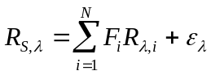
F_{i} is the fraction of endmember i, R_{λ,i} is the hemispherical-directional reflectance factor of endmember i at wavelength λ, N is the number of spectral endmembers, and ε_{λ} is the residual error at λ for the fit of the N endmembers. The least-squares fit to F_{i} can be solved by several standard methods. The residual error is a rearrangement of the linear mixture model:
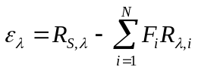
The root mean squared error provides a spectrum-wide measure of fit for a mixture model:
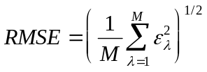
M is the number of imaging spectrometer bands used. The RMSE is a useful fundamental metric for optimizing selection of model results in the multiple endmember spectral mixture analysis (Dennison and Roberts, 2003).
The estimate of subpixel snow-covered area comes from the shade-normalized snow fraction f_{S}:
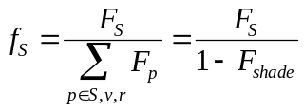
F_{s} is the snow spectral fraction, F_{p} are the physical spectral fractions (non-shade), and F_{shade} is the spectral fraction of photometric shade. Normalizing by the additive complement of the shade fraction, accounts for topographic effects on irradiance. The estimates of subpixel vegetation cover, rock cover, and other surface cover are determined with equation (4) as well.
FSC will be produced for each non-ocean pixel observed by the GOER-R ABI. The FSCA is dependent upon the spectral surface characteristics of the snow pack, as a function of snow grain size, in the visible and near-visible portion of the energy spectrum. Table 1 summarizes the ABI channel sub-set used by the GOES-R implementation of SCAG. Unless the design specification of the GOES-R ABI instrument changes, the final channel subset used by the FSCA is not expected to evolve as the algorithm is developed and validated.

It should be noted that since the FSCA is based on the spectral signature of snow at the surface, the algorithm would perform best when using surface reflectance corrected data generated by a rigorous Radiative Transfer Model (RTM).

Table 1 GOES-R ABI channels used by the FSCA

Channel | Wavelength (μm) | Upper Limit of Dynamic Range | NEDT/SNR | Used in the FSCA
1 | 0.45 – 0.49 | 625 W/m²/sr/μm | 300:1 | ✓
2 | 0.59 – 0.69 | 515 W/m²/sr/μm | 300:1 | ✓
3 | 0.8455 – 0.8845 | 305 W/m²/sr/μm | 300:1 | ✓
4 | 1.3705 – 1.3855 | 114 W/m²/sr/μm | 300:1
5 | 1.58 – 1.64 | 77 W/m²/sr/μm | 300:1 | ✓
6 | 2.225 – 2.275 | 24 W/m²/sr/μm | 300:1 | ✓
7 | 3.8 – 4 | 400K | 0.1K | ✓
8 | 5.77 – 6.6 | 300K | 0.1K
9 | 6.75 – 7.15 | 300K | 0.1K
10 | 7.24 – 7.44 | 320K | 0.1K
11 | 8.3 – 8.7 | 330K | 0.1K
12 | 9.42 – 9.8 | 300K | 0.1K
13 | 10.1 – 10.6 | 330K | 0.1K | ✓
14 | 10.8 – 11.6 | 330K | 0.1K
15 | 11.8 – 12.8 | 330K | 0.1K
16 | 13 – 13.6 | 305K | 0.3K

Implementation Concepts: Models and Model Types

This section should be of interest primarily to the FSCA programmers. The FSCA program operators and the FSCA product users should feel free to skip this section. The purpose of this section is to describe key concepts inherent in the design of the FSCA as expressed in the scag.c source file.

As stated above, the FSCA is based on a least squares fit between the mixed spectra observed by the sensor instrument and solar-zenith-angle-specific libraries of a priori measured pure endmember spectra. Each of the spectral libraries delivered with SCAG include the spectra for 110 snow endmembers (by grain size radii from 10 to 1100 microns) and 54 additional spectra for various vegetation, rock/bare-ground and ice/other endmember types.

Given enough bands of input data (and raw processing power) it is technically possible to calculate any desired number of endmember fractions for a given pixel. However, this implementation of the FSCA is constrained by the relative small number of available spectral bands on the GOES-R ABI instrument and the execution-time performance requirements set forth in the MRD. Consequently, this implementation of the FSCA is limited to a maximum of two endmembers.

The easiest and perhaps most important FSCA solution is the pure pixel case (i.e., the entire pixel is covered by a single endmember). Therefore, while we’re limited to two endmembers per pixel, we also test the one endmember solutions.

For practicality’s sake, we’ve grouped the 164 endmembers into four groups: snow, vegetation, rock (including bare ground) and other. While the FSCA keeps track of the specific endmember combinations, the output is generalized into one of these four endmember groups. Working with these limitations the outputs from this implementation are generalized into endmember group combinations as follows:

- Pure snow;
- Pure vegetation;
- Pure rock;
- Pure other;
- Snow fraction plus vegetation fraction;
- Snow fraction plus rock fraction;
- Snow fraction plus other fraction;
- Vegetation fraction plus rock fraction;
- Vegetation fraction plus other fraction and
- Rock fraction plus other fraction.

Both physically and mathematically, the FCSA has to account for photometric shade (zero reflectance for each band in the spectrum). For each of the 10 generalized endmember group combinations listed above there is actually an implicit additional endmember (expressed explicitly in the computations, of course) to account for shade. The calculated shade fraction is normalized out of the final solution by dividing the non-shade endmember fractions by one minus the shade fraction.

At this point it is appropriate to introduce the concept of models and model types. In order to calculate the FSC solution we have to compare the spectrum measured by the sensor instrument at the pixel against each possible one and two endmember fractional combinations of the 164 spectral library spectra. These combinations are referred to as models. The model (combination of endmember spectra) yielding the best least squared fit is selected as the optimal solution for that pixel.

The concept of model types addresses two issues. Firstly, as mentioned above, the 164 specific endmembers are generalized into one of four general endmember groups and 10 combinations of those groups. The concept of model types is used to order the large number of possible individual endmember combinations into the 10 generalized endmember group combinations listed above.

The second purpose of model types is to address the issue of model constraints. Only in the very rarest of circumstances will the measured spectrum perfectly match a specific model. Normally there are model residuals to consider. Only when the model residuals and RMSE fall below threshold levels is a model considered acceptable. In addition to grouping and combining models, model types are used to associate varying levels of model fit constraints to each combination of endmember groups. In this FSCA implementation we consider two levels of model fit constraints: loose and tight. The tight constraints are characterized by small acceptable model RMSE and model residual requirements, while the loose constraints relax these requirements.

In the FSCA the model types are ordered by priority as follows:

- 1st priority: One endmember model with tight constraints;
- 2nd priority: Two endmember model with tight constraints;
- 3rd priority: One end member model with loose constraints and
- 4th priority: Two endmember model with loose constraints.

One should quickly realize that each endmember model has the potential for being calculated twice: once with tight constraints and once with loose constraints.

When retrieving the FSC for a given pixel the algorithm loops through the potential models (endmember combinations) by model type in the order of priority listed above. As mentioned above, the optimal model for a given pixel is that which mostly closely meets the model constraints (smallest RMSE and residuals). In order to limit needless calculations, once we discover an acceptable solution for a given pixel at given priority level we exhaustively examine the remaining models for that priority level but skip all of the models associated with lower priority levels. For instance, if a pixel meets the constraints for priority one, there is no point in examining the models associated with priorities two, three, or four.

Endmember Memory

This section should be of interest primarily to the FSCA programmers. The FSCA program operators and the FSCA product users should feel free to skip this section. The purpose of this section is to describe a key concept inherent in the design of the FSCA as expressed in the scag.c source file.

It’s clear that with 165 endmembers and four model types that there are many hundreds of potential endmember models for each pixel. Even when performing a one-time initialization for each model prior to looping through the image pixels, this represents a significant computational burden when one considers that there are millions of pixels in a typical GOES-R ABI image.

One way to reduce this burden is to exploit the fact that the non-snow endmember is relatively (if not entirely) stable. If one could “remember” the non-snow endmembers from image to image, the computational load can be reduced dramatically by limiting the algorithm to only those models that contain that endmember.

This implementation of the FSCA incorporates the concept of endmember memory. Since the non-snow endmember often is not entirely stable (e.g., harvested crop lands) we refresh the memory for each pixel once a day at that pixel’s local solar noon.

FILES

Overview

The FSCA is expressed in a program named scag (the source code is named scag.c). There are three types of files associated with the scag program:

- Configuration files;
- Input files;
- Output files and
- Endmember memory file.

Their purpose, content and format are described in the following sections. The configuration and endmember memory files are of interest primarily to the FSCA programmers. The input files are of interest primarily to the FSCA program operators. And the output files are of interest primarily to the FSCA product users. The following sections will attempt to be sensitive to the needs of these various audiences.

Configuration Files

Overview

This section should be of interest primarily to the FSCA programmers. The FSCA program operators and the FSCA product users should feel free to skip this section. The purpose of this section is to describe the files intrinsic to the design of the FSCA as expressed in the scag.c source file.

The FSCA configuration files contain data that either a) control the flow of the FSCA execution or b) contain static data required by the FSCA. It is through these files that future modification of many of the performance characteristics associated with the algorithm can be altered without modifying the source code itself. All configuration files are expected by the scag program to reside in a single directory.

Under no circumstances should these files be altered by the FSCA program operators. Their content not only directs the flow of the FSCA program, but also affects its results. Under certain circumstances, incorrect modification of their content could either a) yield unpredictable erroneous results or b) result in runtime errors. Consequently, the contents of these files should fall within the domain of the FSCA programmers. All configuration parameters that are of interest to the FSCA operators are contained in the program’s command line arguments (see section 4.2 below) and can be captured within script files.

SPECLIBS

Purpose

The purpose of the SPECLIBS file is to define the configuration of the FSCA’s spectral library input files (see #define FILE_SPECLIBS in the scag.c source code). This file is read once by scag to determine the location and characteristics of the spectral libraries available to the FSCA.

Content

This file identifies:

- The name of each spectral library file;
- The nominal solar zenith angle for which the file’s contents are valid;
- The number of endmember spectra contained in the file;
- The number of spectra wave lengths contained in the file;
- The gain applied to each spectrum value and
- The endmember location in the file for the photometric spectrum.

The gain value is the divisor to be applied to the library spectrum data to align them with the expected range of sensor input data. The current range of library spectrum data is 0 to 10,000. The expected range of sensor input data is 0 to 1,000. Hence the gain value should be set to 10.0 for each entry in the SPECLIBS file. The gain value is closely related to the scag.c #defined variable DATA_SCALAR. The current value of DATA_SCALAR is 1000.0, which scales the range of the input sensor data from 0 to 1 to 0 to 1,000. When altering either the gain or the DATA_SCALAR, make sure the other is altered appropriately.

Format

The SPECLIBS file contents are ASCII. There is one header record describing the contents of the file. Record fields are space delimited. For example:

# (filename) (solar zenith angle) (number of end members) (number of bands) (gain) (shade location)
speclib.z30.sli 30 165 7 10.0 0
speclib.z45.sli 45 165 7 10.0 0
speclib.z60.sli 60 165 7 10.0 0

speclib.z##.sli

Where ## refers to the solar zenith angle.

Purpose

The purpose of the speclib.z##.sli files is to store the a priori measured solar-zenith-angle-specific pure spectral signature for each possible endmember. These files are read once by scag and held in memory.

Content

These files contain:

- The spectral signature for the photometric shade endmember;
- The spectral signatures for the snow endmembers by ascending grain size and
- The spectral signatures for the non-snow endmembers.

All of these files should contain the same number of spectra and bands. The location of endmember spectra should be the same in each file.

The current library files contain spectra for the following wavelengths:

- 0.469 μm;
- 0.555 μm;
- 0.645 μm;
- 0.858 μm;
- 1.240 μm;
- 1.640 μm and
- 2.130 μm.

Format

The speclib.z##.sli files are binary. There are no header records. Each record contains the a priori measured spectral signature for one pure endmember. The signatures are stored as 4-byte floating point values; one value for each wave length.

MODELTYPES

Purpose

The purpose of the MODELTYPES file is to define the configuration of the FSCA’s workflow by defining the model types (see #define FILE_MODEL_TYPES in the scag.c source code). This file identifies the files containing the definitions of endmember group combinations, identifies the two and three endmember (including photometric shade) model types and their model file constraint levels, and defines the prioritized order that the model types should be executed. This file is read once by scag to determine the order in which the other FSCA configuration files should be read into memory and subsequently processed.

Content

This file identifies:

- The name of the model type;
- The number of endmembers (including photometric shade) in the model type;
- The number of models defined by the model type;
- The priority of the model type [from 0 (the highest) to n (the lowest)] and
- The model type model fit constraint level (0 tight VS 1 loose).

Note that each model type is listed twice: once with a tight constraint level and once with a loose constraint level. Relative to order of priority, for a given model type, the tight constraints should precede the loose constraints. Relative to order of priority, the two endmember model types should precede the three endmember model types.

Format

The MODELTYPES file contents are ASCII. There is one header record describing the contents of the file. Record fields are space delimited. For example:

# (scag model type) (number of end members) (number of models) (sorting weight) (tight/loose, 0/1)
basic 2 164 0 0
basic 2 164 2 1
gr 3 660 1 0
gr 3 660 3 1
met 3 440 1 0
met 3 440 3 1
till 3 220 1 0
till 3 220 3 1
vlc1 3 660 1 0
vlc1 3 660 3 1
vlc2 3 660 1 0
vlc2 3 660 3 1
vlc3 3 330 1 0
vlc3 3 330 3 1
veg1 3 660 1 0
veg1 3 660 3 1
veg2 3 660 1 0
veg2 3 660 3 1
veg3 3 660 1 0
veg3 3 660 3 1
veg4 3 220 1 0
veg4 3 220 3 1
gr_veg 3 120 1 0
gr_veg 3 120 3 1
met_veg 3 80 1 0
met_veg 3 80 3 1
vlc_veg 3 120 1 0
vlc_veg 3 120 3 1
lkice 3 330 1 0
lkice 3 330 3 1

#em.name.models

Where # refers to the number of end members and name refers the model type name.

Purpose

The purpose of the #em.name.models files is to define the FSCA‘s retrieval models and the endmember group combination component of the model type definitions (the other component being the model constraints; see section 3.2.6 below). These files are read once by scag and held in memory.

Content

These files contain the two-endmember model endmembers and the three-endmember model end member pairings as part of the model type definitions. Recall that the FSCA model type definitions are comprised of two parts: the combining of endmember groups and the assignment of model fit constraints.

Format

The MODELTYPES file contents are ASCII. There are no header records. Record fields are space delimited where needed. For example:

1 or 1 113
2 2 113
3 3 113
: :
: :
162 108 116
163 109 116
164 110 116

The numbers are the numerical identifiers for endmembers. The numbers 1 to 110 correspond to the snow endmembers with grain sizes measuring from 1 to 1100 microns in radii (in 10 micron increments). The remaining identifiers are variously distributed among vegetation, rock, bare ground, and lake ice endmembers.

CONSTRAINTS

Purpose

The purpose of the CONSTRAINTS file is to assign model good of fit thresholds to the loose and tight two- and three-endmember model types (see #define FILE_CONSTRAINTS in the scag.c source code). This file is read once by scag held in memory.

Content

This file contains:

- The number of endmembers in the model type for which the constraints apply;
- The constraint level - either loose or tight;
- The minimum and maximum acceptable calculated endmember fraction;
- The threshold maximum model RMSE;
- The threshold maximum residual for a spectral signature band and
- The maximum number of successive wavelength-ordered bands that are allowed to exceed the threshold maximum residual.

If, for any model, any of these constraints are exceeded, that model is rejected. The accepted model is that which meets these constraints with the minimum RMSE after all models within its priority level have been tested. Once all models within a priority level have been tested and an acceptable model has been identified, further modeling for a pixel is unnecessary (i.e., lower priority models are ignored).

Format

The MODELTYPES file contents are ASCII. There is one header record describing the contents of the file. Record fields are comma and space delimited. For example:

# (num of EMs) (tight|loose, 0|1) (frac min/zero/max pairs, 1pr / EM) (rms thresh) (rthresh) (rcount)
2, 1, -0.01 0.10 1.01, -0.01 0.10 1.01, 30.0, 30.0, 3
2, 0, -0.01 0.10 1.01, -0.01 0.10 1.01, 15.0, 15.0, 3
3, 1, -1.01 0.10 2.01, -1.01 0.10 2.01, -1.01 0.10 2.01, 50.0, 50.0, 3
3, 0, -0.01 0.10 1.01, -0.01 0.10 1.01, -0.01 0.10 1.01, 15.0, 15.0, 3

EMTYPES

Purpose

The purpose of the EMTYPES file is to assign endmembers to an endmember group (see #define FILE_EMTYPES in the scag.c source code). This file is read once by scag held in memory.

Content

This file contains the endmember group associated with each endmember. Group zero is snow. Group one is vegetation. Group two is rock and bare ground. Group three is other or, in this case, lake ice.

Format

The EMTYPES file contents are ASCII. There are no header records. Each record contains a single value, which is the endmember group identifier (0-3) as described above. The first record identifies the endmember group identifier for endmember one. The second record identifies the endmember group identifier for endmember two. And so on.

GSTABLE

Purpose

The purpose of the GSTABLE file is to assign a snow grain size radius (in microns) to each endmember (see #define FILE_GSTABLE in the scag.c source code). This file is read once by scag held in memory.

Content

This file defines the snow grain size radius (in radians) for each endmember. This file differs from many of the other configuration files in that it includes an entry for the photometric shade endmember.

Format

The GSTABLE file contents are ASCII. There are no header records. Each record contains a single value, which is the snow grain size (radius in microns) for a particular endmember. The first record defines the grain size for photometric shade and should have a value of zero. The next 110 records contain the grain sizes for the snow endmembers and should range, in increasing value, from 10 to 1100. The remaining records define the snow grain sizes for the remaining endmembers (all non-snow) and should have a value of zero.

Input Files

Overview

This section should be of interest primarily to the FSCA programmers and the FSCA program operators. The FSCA product users should feel free to skip this section. The purpose of this section is to describe the FSCA input files.

All of the non-configuration inputs to the FSCA are of a single basic format. While the contents of the files may vary in data type, dimension and spatial and temporal location (as expressed in their header files), these differences are handled by scag.c’s file I/O subsystem. This modular subsystem, as it currently exists, is designed to handle the file format described in this section. However, due to its modular nature, the I/O subsystem can easily be extended to accommodate additional formats.

The current inputs to scag are made up of two components: a binary header file and a flat binary raster data file. The format of each file is described immediately below. Specific file contents are the topic of subsequent subsections.

File Formats

Header File Format

The contents of the binary header files are as follows:

Table 2 Header file format

Byte Offset | Data Type | Value | Default | Required
0 | Unsigned char | Data type |  | ✓
1 | double float | Data scalar | 1.0 | ✓
9 | double float | Data intercept | 0.0 | ✓
17 | double float | Minimum data value | DBL_MAX
25 | double float | Maximum data value | -DBL_MAX
33 | double float | No data value |  | ✓
41 | double float | X-axis resolution | 0.0
49 | Unsigned long | Number of file columns |  | ✓
53 | Unsigned long | Number of bytes per row |  | ✓
57 | double float | Minimum x-axis coordinate | DBL_MAX
65 | double float | Maximum x-axis coordinate | -DBL_MAX
73 | double float | Y-axis resolution | 0.0
81 | Unsigned long | Number or file rows |  | ✓
85 | double float | Minimum y-axis coordinate | DBL_MAX
93 | double float | Maximum y-axis coordinate | -DBL_MAX
101 | double float | Data nominal time |  | ✓
109 | double float | Data minimum time | DBL_MAX | ✓
117 | double float | Data maximum time | -DBL_MAX | ✓

The data types are as follows:

- 1 : signed char;
- 2 : double float;
- 3 : float;
- 4 : long;
- 5 : short;
- 6 : unsigned char;
- 7 : unsigned long and
- 8 : unsigned short

Data scalar and intercept can be used to compress the data:

actual_value = data_intercept + file_value * data_scalar

One should note that the no-data value is as it exists in the file, not the uncompressed actual value.

Other than the extension, the header file should have the same name as the data file. Header files must have a .hdr extension.

Data File Format

The data files are flat binary files in which the pixels are arranged in columns by rows as defined in the accompanying header file (see section 3.3.2.1 above). The size of the file is dictated by the data type, number of columns and number of rows.

Other than the extension, the data file should have the same name as the header file. Data files must have a .dat extension.

Surface Reflectance Data

The FSCA program (scag) is currently configured to retrieve FSC from GOES-R ABI surface reflectance values. Future modifications to the FSCA will employ two additional bands from the thermal range of the electromagnetic (EM) spectrum to assist in the discrimination of snow from playa in desert regions (see the FSCA ATBD and Table 1 above).

The scag program has two operating modes (Table 3), each of which requires MODIS surface reflectance data as inputs. In the first mode, the operations or GOES-R ABI simulation mode, five bands of MODIS data are used as proxy data to simulate FSC retrievals from GOES-R data. In the second mode, the validation mode, seven bands of MODIS data are used to validate the simulated ABI retrievals against the FSC retrieval performance measures known, through rigorous experimentation and validation, for the MODIS instrument (see the FSCA ATBD).

MODIS surface reflectance data are available from two sources:

- The MODIS MOD09 product (several days of latency) or
- The MODIS MOD09_SPA program which uses near real time MOD03, MOD02_QKM, MOD02_HKM, MOD02_1KM and NCEP GDAS data as inputs to a radiative transfer model.

The surface reflectance values recorded in these files are floating point fractional values ranging from zero to one. They are scaled to become aligned with the spectral library files (see #define DATA_SCALAR in the scag.c source code).

Table 3 Surface Reflectance Bands

ABI Band | Wavelength | MODIS Band | Wavelength | Operations Mode | Validation Mode
1 | 0.45–0.49 μm | 3 | 0.46–0.48 μm | ✓ | ✓
 |  | 4 | 0.54–0.56 μm |  | ✓
2 | 0.59–0.69 μm | 1 | 0.62–0.67 μm | ✓ | ✓
3 | 0.85–0.88 μm | 2 | 0.84–0.88 μm | ✓ | ✓
 |  | 5 | 1.23–1.25 μm |  | ✓
5 | 1.58–1.64 μm | 6 | 1.63–1.65 μm | ✓ | ✓
6 | 2.22–2.28 μm | 7 | 2.10–2.16 μm | ✓ | ✓

Land-Water Mask

The land-water mask is used by the FSCA to restrict FSC retrievals to land pixels. The mask is used as a filter. Currently, the FSCA does not process pixels which are over ocean (see #define DEEP_OCEAN_VALUE, #define MODERATE_OCEAN_VALUE, and #define SHALLOW_OCEAN_VALUE in the scag.c source code)

Future versions of the FSCA may allow the algorithm to process ocean pixels.

The land-water mask values are interpreted as follows:

- 0 : Shallow ocean;
- 1 : Land;
- 2 : Coast/shore lines;
- 3 : Shallow inland water;
- 4 : Intermittent/ephemeral water;
- 5 : Deep inland water;
- 6 : Moderate/continental ocean and
- 7 : Deep ocean

Cloud Mask

The cloud mask is used by the FSCA to qualify the algorithm’s grain size dependent cloud retrievals in its quality output file (see section 3.4.10 below). The FSCA does not mask out clouds. Rather, it takes advantage of the fact that clouds are actually snow crystals of very small radii suspended in the atmosphere. As such, from the FSCA perspective, snow retrievals below a certain grain size threshold are mapped as clouds (see #define CLOUD_GRAIN_SIZE in the scag.c source code). The FSCA cloud retrievals are indexed through the cloud mask and reported in the algorithm’s quality output file.

The cloud mask currently employed by the FSCA is the first byte of the MODIS MOD35_L2 product. The first bit in the byte, bit zero, indicates whether or not cloud cover was determined for a pixel: 0 – cloud cover undetermined, 1 – cloud cover determined. The next two bits’ values, bits one and two, are interpreted as follows:

- 0 : Confident cloudy;
- 1 : Probably cloudy;
- 2 : Probably clear and
- 3 : Confident clear

Solar Zenith Angle

The solar zenith angle file is used by the FSCA to select the correct spectral signature library for a given pixel’s FSC retrieval. And to filter out pixels that are either too bright or too dim for processing (see #define MAX_SOLAR_ZENITH_ANGLE and #define MIN_SOLAR_ZENITH_ANGLE in the scag.c source code). The solar zenith angle ranges from zero degrees (the sun is immediately above) to 90 degrees (the sun is on the horizon) to 180 degrees (the sun is below the horizon. The currently acceptable range of solar zenith angles is 0 to 67.5 degrees.

Sensor Zenith Angle

Similar to solar zenith angle, the sensor zenith angle (view angle) is a measure of the GOES-R ABI sensor position relative to a given pixel. A value of zero indicates that the sensor is immediately above. The sensor zenith angle is used by the FSCA to filter out pixels that are too far away from nadir (see #define MAX_SENSOR_ZENITH_ANGLE and #define MIN_SENSOR_ZENITH_ANGLE in the scag.c source code). These limb pixels, due to their position relative to the instrument, are distorted beyond usefulness. The currently acceptable range of sensor zenith angles is 0 to 55 degrees.

Longitude

The longitude file contains the longitudinal position of each pixel at datum. It does not account for distortions due to parallax. The longitude file is used to keep track of non-snow endmember “memory” (see section 3.5 below).

Latitude

The latitude file contains the latitudinal position of each pixel at datum. It does not account for distortions due to parallax. The latitude file is used to keep track of non-snow endmember “memory” (see section 3.5 below).

Output Files

Overview

This section should be of interest primarily to the FSCA programmers and the FSCA product users. The FSCA program operators should feel free to skip this section. The purpose of this section is to describe the FSCA output files.

All of the outputs from the FSCA are of a single basic format. While the contents of the files may vary in data type, dimension and spatial and temporal location (as expressed in their header files), these differences are handled by scag.c’s file I/O subsystem. This modular subsystem, as it currently exists, is designed to handle the file format described above (see section 3.3.2 above). However, due to its modular nature, the I/O subsystem can easily be extended to accommodate additional formats.

The current outputs to scag are made up of two components: a binary header file and a flat binary raster data file. The format of each file is described above. Specific file contents are the topic of subsequent subsections.

File Formats

The output file format is the same as the input file format (see section 3.3.2 above). The data type for each output file is float. The universal no data value, largely for display purposes, is -0.01 (see #define NDV in the scag.c source code).

Snow Fraction

The snow endmember fraction retrieved by the FSCA. The range in values is 0.0 to 1.0. The sum of fractions (snow, vegetation, rock and other) should not exceed 1.0. If below a specified grain size threshold (currently a radius of 40 microns; see #define CLOUD_GRAIN_SIZE_THRESHOLD in the scag.c source code) the retrieval can be assumed to be cloud rather than snow (see the FSCA ATBD).

The string snow_fraction.hdr and snow_fraction.dat for the header and data files will be appended to the output file base pathname provided by the operator.

Vegetation Fraction

The vegetation endmember fraction retrieved by the FSCA. The range in values is 0.0 to 1.0. The sum of fractions (snow, vegetation, rock and other) should not exceed 1.0.

The string vegetation_fraction.hdr and vegetation_fraction.dat for the header and data files will be appended to the output file base pathname provided by the operator.

Rock Fraction

The rock and bare ground endmember fraction retrieved by the FSCA. The range in values is 0.0 to 1.0. The sum of fractions (snow, vegetation, rock and other) should not exceed 1.0.

The string rock_fraction.hdr and rock_fraction.dat for the header and data files will be appended to the output file base pathname provided by the operator.

Other Fraction

The “other” endmember fraction (not snow, vegetation or rock; in this case lake ice) retrieved by the FSCA. The range in values is 0.0 to 1.0. The sum of fractions (snow, vegetation, rock and other) should not exceed 1.0.

The string other_fraction.hdr and other_fraction.dat for the header and data files will be appended to the output file base pathname provided by the operator.

The pixel has been identified as existing in inland water, a further investigation of the snow and other (ice) fractions is done. If no snow nor ice exists on such a pixel, it is coded as water, with an appropirate setting of the pixel's snow value (0.0) in snow_fraction.dat file and the pixel's quality value in quality.dat

Shade Fraction

The photometric shade endmember fraction retrieved by the FSCA. The range in values is 0.0 to 1.0. The shade fraction is used to normalize the non-shade endmembers by dividing their fractions by one minus the shade fraction. In essence the shade fraction is proportionally distributed among the non-shade endmembers.

The string shade_fraction.hdr and shade_fraction.dat for the header and data files will be appended to the output file base pathname provided by the operator.

Snow Grain Size

This is the grain size radii (in microns) for the snow endmembers. Snow which has a grain size falling below a specified gain size threshold (currently a radius of 40 microns; see #define CLOUD_GRAIN_SIZE_THRESHOLD in the scag.c source code) can be assumed to be cloud rather than snow (see the FSCA ATBD).

The string grain_size.hdr and grain_size.dat for the header and data files will be appended to the output file base pathname provided by the operator.

RMS

The calculated root mean squared error for the FSCA retrievals.

The string rms.hdr and rms.dat for the header and data files will be appended to the output file base pathname provided by the operator.

Quality

This file contains the quality flag associated with each FSCA retrieval.

- 0.00 : if the no data value was encountered in any of the inputs, or
- 1.00 : if the pixel falls on water, or
- 2.00 : if the solar zenith angle is too small, or
- 3.00 : if the solar zenith angle is too large, or
- 4.00 : if the pixel could not be modeled, or
- 5.00 : if the pixel had bad source data, or
- 6.00 : if the pixel has bad horizonal location (latitude or longitude) metadata, or
- 7.00 : if the pixel has an unreasonable sensor angle value, or
- 8.00 : if the pixel has an unreasonable solar zenith angle, or
- 10.00 : if the pixel could be modeled but is snow free, or
- 2f.ff : if the pixel could be modeled and has snow (where f.ff is the snow fraction), or
- 3f.ff : if the pixel could be modeled and has shaded snow (zero grain size) (should be physically impossible but is mathematically feasible) (where f.ff is the snow fraction), or
- 4f.ff :if the pixel could be modeled and has cloud by grain size (where f.ff is the cloud fraction).

The flags may be modified by the FSCA for cloud masking as follows:

- Add 100.00 if cloud masked, or
- Add 200.00 if probably cloud masked, or
- Add 300.00 the cloud mask is undetermined,

The flags may be modified by the FSCA for the following second-most prominent non-snow endmember in a modeled pixel:

- Add 1,000.00 if the most prominent non-snow endmember is vegetation, or
- Add 2,000.00 if the most prominent non-snow endmember is vegetation, or
- Add 8,000.00 if the most prominent non-snow endmember is other, or
- Add 9,000.00 if the most prominent non-snow endmember is photometric shade

The flags may be modified by the FSCA for the following condition:

- Add 10,000 if the pixel was modeled but beyond the sensor angle threshold

(See the following in the scag.c source code:

- #define BAD_DATA_FLAG
- #define BAD_LATLON_FLAG
- #define BAD_SENSOR_FLAG
- #define BAD_SOLAR_FLAG
- #define CLOUD_MASKED_FLAG;
- #define CLOUD_MASK_UNDETERMINED_FLAG;
- #define MODELED_CLOUD_BY_GRAIN_SIZE_FLAG,;
- #define MODELED_SHADED_SNOW_FLAG;
- #define MODELED_SNOW_FLAG;
- #define MODELED_SNOW_FREE_FLAG;
- #define NDV_FLAG;
- #define NOT_MODELED_FLAG;
- #define PROBABLY_CLOUD_MASKED_FLAG;
- #define SECOND_EM_OTHER_VALUE;
- #define SECOND_EM_ROCK_VALUE;
- #define SECOND_EM_SHADE_VALUE;
- #define SECOND_EM_VEG_VALUE;
- #define TOO_BRIGHT_FLAG;
- #define TOO_DARK_FLAG;
- #define TOO_FAR_FLAG and
- #define WATER_FLAG.)

The string quality.hdr and quality.dat for the header and data files will be appended to the output file base pathname provided by the operator.

Endmember Memory File

Overview

This section should be of interest primarily to the FSCA programmers. The FSCA program operators and the FSCA product users should feel free to skip this section. The purpose of this section is to describe the FSCA end member memory file.

The endmember memory file keeps track of the last endmember combination observed for longitude-latitude coordinate pairs. Image-to-image memory of last observed endmembers allows the FSCA to execute very rapidly by avoiding needless calculations associated with pointless retrieval models. This is possible by taking advantage of the fact that the non-snow endmember is often stationary, or nearly so.

Needless to say, it is important that the endmember memory file not be deleted or altered in any way.

File Format

The endmember memory file is a header-less flat binary file containing endmember combination data at evenly spaced latitude-longitude coordinate pair locations (rows by columns). The file’s dimensions are defined by the following self-documenting variables in the scag.c source code:

- #define MAP_RESOLUTION_SECONDS;
- #define MAP_HEIGHT_DEGREES;
- #define MAP_NDV;
- #define MAP_WIDTH_DEGREES;
- #define MAP_X_ORIGIN (upper left-hand corner; pixel center);
- #define MAP_Y_ORIGIN (upper left-hand corner; pixel center) and
- #define SNOW_ENDMEMBER

One should select a map resolution that can accommodate the minimum pixel spacing of the unevenly spaced image pixels. Otherwise multiple image pixels may be mapped to the same map pixel.

The SNOW_ENDMEMBER variable is a convenience variable that is used to generalize all of the many snow endmembers (they vary by grain size; see section 3.2.8 above) into a single endmember ID value in the map. Make sure that this variable is set to a value that does not conflict with the non-snow endmembers.

Four one-byte, interleaved values are stored at each map location:

- The solar zenith angle to the nearest degree;
- The sensor zenith angle to the nearest degree;
- The first endmember ID. If snow is a model endmember it will be identified in this byte and
- The second endmember ID. If the best fitting model is a two endmember (including photometric shade) “pure” model, both the first and second endmember ID will be set to the same value.

OPERATOR INSTRUCTIONS

Overview

This section should be of interest primarily to the FSCA program operators. The FSCA programmers and the FSCA product users should feel free to skip this section. The purpose of this section is to describe the FSCA’s execution.

The FSCA is expressed in a program named scag. For a cursory review of scag’s purpose and implementation please refer to the introduction to this document. For a more detailed review of the physical and mathematical basis for scag one is encouraged to read the FSCA ATBD and its listed references.

The scag program is designed to accommodate two modes of operation:

- The operational mode whereby scag generates output products from five bands of GOES-R ABI input data (or their proxies) and

- The validation mode whereby scag generates output products from seven bands of MODIS input data.

Until the launch of the GOES-R mission, the scag program will use five bands of MODIS data as proxy GOES-R ABI data (see section 3.3.3 above).

The validation mode is used to assess the performance characteristics of the FSCA. The seven band MODIS implementation of the FSCA, through rigorous experimentation and validation, has known performance characteristics (see the FSCA ATBD) that can be related back to the operational mode. Analytical comparisons between the five and seven band modes’ output can be used to validate the GOES-R ABI implementation of the FSCA (refer to the FSCA Validation Plan).

This section will omit descriptions of scag’s input and output data requirements. These are covered in detail in the FILES section above.

It should be reemphasized that the FSCA, as expressed in scag, is capable of making cloud cover retrievals. This is made possible by exploiting that fact that clouds are essentially snow crystals of small grain size suspended in the atmosphere. Since the physical and mathematical basis of the FSCA account for grain size, cloud discrimination (and therefore retrieval) is an artifact of the process.

Since both the snow and cloud algorithms refer to one another as dependents (required inputs), we offer suggested implementation strategies for the FSCA in this section. Further refinement of scag’s implementation of the FSCA will be required to optimally solve these interdependencies. However, we expect these refinements to be relatively trivial from a software design perspective. They may, however, significantly impact the computational load and therefore, from an operational implementation perspective, require consideration beyond the scope of this document.

Command Line Inputs

Command line inputs to scag consist of several arguments most of which are followed by an option. They are as follows:

- –h : Reports scag help information on stdout. This argument is optional;

- –m : Run scag in validation mode using MODIS data as inputs. This argument requires, as an option, the number of input bands to process; either 7 or 9. Presently the only valid option is seven visible bands. Future versions will augment the seven visible bands with two thermal bands. This argument is required if the –g option is not provided;

- –g : Run scag in operational mode using GOES-R ABI data (or their proxies) as inputs. This argument requires, as an option, the number of input bands to process; either 5 or 7. Presently the only valid option is five visible bands. Future versions will augment the five visible bands with two thermal bands. This argument is required if the –m option is not provided;

- -# : Identifies the input surface reflectance file pathnames. One argument is required for each of the bands identified by the –m or –g arguments. The argument -1 is used to identify the first band’s pathname; -2 the second; and so on. Each argument is followed by a single option identifying the pathname for the input data appropriate for its band number. The pathname should not include the extension for the header (.hdr) or data (.dat) file. These will be appended by the scag program. Surface reflectance input files should be ordered in ascending wavelengths (see table 3 above). This argument is required – one for each of the bands indicated by the –m or –g option;

- –w : Identifies the input land-water mask file pathname. This argument is followed by a single option identifying the pathname for the input data. The pathname should not include the extension for the header (.hdr) or data (.dat) file. These will be appended by the scag program. This argument is required;

- –c : Identifies the input cloud mask file pathname. This argument is followed by a single option identifying the pathname for the input data. The pathname should not include the extension for the header (.hdr) or data (.dat) file. These will be appended by the scag program. This argument is required.;

- –z : Identifies the input solar zenith angle file pathname. This argument is followed by a single option identifying the pathname for the input data. The pathname should not include the extension for the header (.hdr) or data (.dat) file. These will be appended by the scag program. This argument is required;

- –s : Identifies the input sensor zenith angle file pathname. This argument is followed by a single option identifying the pathname for the input data. The pathname should not include the extension for the header (.hdr) or data (.dat) file. These will be appended by the scag program. This argument is required;

- –x : Identifies the input longitude file pathname. This argument is followed by a single option identifying the pathname for the input data. The pathname should not include the extension for the header (.hdr) or data (.dat) file. These will be appended by the scag program. This argument is required;

- –y : Identifies the input latitude file pathname. This argument is followed by a single option identifying the pathname for the input data. The pathname should not include the extension for the header (.hdr) or data (.dat) file. These will be appended by the scag program. This argument is required;

- –b : Identifies the base output file pathname. This argument is followed by a single option identifying the base pathname for the output data. The pathname should not specifically identify output products. Product names will be appended by the scag program (see section 3.4 above). Nor should the pathname include the extension for the header (.hdr) or data (.dat) file. These will be appended by the scag program. This argument is optional. The default is the current directory with not base file name. Note that if unique pathnames are not provided between executions, existing output files will be overwritten;

- –e : Identifies the output endmember file pathname. This argument is followed by a single option identifying the pathname for the output endmember memory file. This argument is required. Note that this pathname should be constant between executions;

- –f : Identifies the configuration file directory. This argument is followed by a single option identifying the directory containing the configuration files. This argument is optional. The default is the current directory; And

- –n : Identifies the number of processing threads. This argument is followed by a single option identifying the number of processing threads in addition to the main thread. This argument is optional. The default number is 1.

The number of processing threads should factor in the number of CPU cores available on one's computer and the number of competing processes. There is no advantage to setting the argument artificially high. Depending upon one's situation, the overhead associated with an artificially high number may work to one's detriment given the overhead associated with each thread.

Suggested Implementation Strategies

An example of a script for executing scag might look something like this:

scag -g 5 \
-1 ../data/1kmSurfaceReflectanceBand3.P2009095.1820 \
-2 ../data/1kmSurfaceReflectanceBand1.P2009095.1820 \
-3 ../data/1kmSurfaceReflectanceBand2.P2009095.1820 \
-4 ../data/1kmSurfaceReflectanceBand6.P2009095.1820 \
-5 ../data/1kmSurfaceReflectanceBand7.P2009095.1820 \
-w ../data/LandSeaMask.P2009095.1820 \
-c ../data/CloudMask.P2009095.1820 \
-z ../data/SolarZenith.P2009095.1820 \
-s ../data/SensorZenith.P2009095.1820 \
-x ../data/Longitude.P2009095.1820 \
-y ../data/Latitude.P2009095.1820 \
-b ../data/test \
-e ../data/non_snow_map \
-f ../config/ \
-n 8

In this example it is assumed that the ACMA precedes the FSCA and that the ACMA proceeds without the benefit of any snow map. Both the ACMA and the FSCA would rely on scag’s quality output file to reflect a synthesis of each algorithm’s assessment of clouds. In essence, scag’s quality file is a cloud mask of sorts (see section 3.4.10 above).

Alternatively, the FSCA could be modified to not require a cloud mask as input. The scag program would pass snow cover and grain size dependent estimates of cloud cover to the ACMA. This would require a FSCA algorithm post processor that would modify the snow cover outputs after the cloud cover algorithm ran.

A final alternative would be to merge both the FSCA and the ACMA into a single multi-threaded application.

Error Handling

The scag program includes exhaustive error checking logic. Error checking occurs at every point that user or runtime error can be assessed. In the event of an error a concise error message is issued to stderr. The error messages indicate the nature of the error and where it occurred. In the event that there are multiple possible occurrences for a given error in a section of code, the error message will indicate which of the occurrences failed. Lastly, where applicable, scag’s error messages are supplemented by system generated error message using the strerror function.

Killing scag

The scag program is multi-threaded. Therefore special care needs to be taken when using the kill command to terminate scag.

Muti-threaded programs, when executed, consist of several processes (PID’s): the main process and one process for each thread. Since the thread processes may be (and in the case of scag are) infinite loops, killing the main process (without in turn killing each thread processes) will result in memory leaks and escalating system loads.

Built into the scag program are specially designed signal handlers to address this problem. The proper way to kill scag when running it manually from the system prompt is with control C (or SIGINT). The proper way to kill scag otherwise is to send a SIGTERM signal to scag’s main thread via kill. Each of these will gracefully terminate scag’s main thread and its related processing threads. A sure kill, kill -9 or SIGKILL, will only terminate the main thread (leaving its related threads to continue running indefinitely).

PRACTICAL CONSIDERATIONS

Overview

This section should be of interest to the FSCA programmers, the FSCA program operators and the FSCA product users. The purpose of this section is to provide an overview of the issues involved in implementing the FSCA from a software perspective. Please refer to the FSCA ATBD and Validation Plan for in depth discussions of all of the FSCA’s practical considerations.

Numerical Computation Considerations

The FSCA relies on two primary inputs:

- Parallax corrected surface reflectance values for GOES-R ABI channels 1, 2, 3, 5 and 6 and
- An a priori calculated cloud mask.

Some would argue that snow, from a spectral analysis perspective, behaves like a low-altitude, large-particle cloud. It is possible to leverage the spectral mixture analysis for FSC and the rapid GOES-R image acquisition schedule to assist the AWG Cloud Team’s ACM product. Temporal signatures of grain size can provide an additional capability for cloud masking as short terms changes in grain size indicate cloud presence. Since the FSCA (which depends on a cloud mask) and the cloud mask algorithm (which depends on a snow mask) are interdependent, it seems reasonable to pursue synergies between the two algorithms.

FSCA as expressed in GOESRSCAG relies on linear transformations to decompose a pixel’s spectral signature into its constituent spectra. GOESRSCAG employs (or will employ) several strategies to reduce its computational load:

- Limit the number of possible endmembers to two (snow and a single non-snow endmember from a limited list of possibilities) plus shade. GOESRSCAG retrieves, for example, combinations of snow and vegetation or snow and bare ground. But it does not retrieve combinations of snow and vegetation and bare ground. Since the primary aim is the determination of FSC (as opposed to the identity and proportion of the non-snow constituents), this limit minimizes the dimensions of the matrices (Status: Done);

- Limit the number of possible snow grain size spectra (Status: Nearly done);

- Limit the number of spectra within a possible non-snow endmember spectrum library (Status: Done);

- Integrate (and then optimize) spectrum mixing analysis modeling with the final endmember sorting/selection logic execute a FSC retrieval with as few matrix operations as possible (Status: Done) and

- Buffer repetitive, intermediate calculations between time sequential GOES-R ABI images (e.g., the identity of the non-snow endmember for a given pixel) (Status: Done)

Programming and Procedural Considerations

The GOESRSCAG FSCA is a pixel by pixel algorithm that could benefit by running on time sequential images (see section 5.2 above). The algorithm is reliant on matrix operations that impact program design and implementation. While this reliance impacts programming considerations, we addressed strategies for its mitigation in section 5.2 above.

Additionally, we recognize that the GOES-R satellite will not be deployed for several years. With that in mind, rather than adopting a more traditional single-threaded architecture, we elected to implement the FSCA as a multi-threaded application more suitable to the multiprocessor computers anticipated for the near future.

Quality Assessment and Diagnostics

The following procedures are recommended for diagnosing the performance and in, some cases, real time validation of the FSCA:

- Monitor the percentage of specific endmembers in regional areas where these values should be nearly constant after snow cover reaches 100 percent during accumulation in the fall or snow cover reaches 0 percent during ablation in the spring;

- Assess persistence/consistency of fractional snow cover by pixel. There should be no rapid oscillations in FSC and grain size for a given pixel. FSC for a given pixel should vary smoothly in the temporal domain;

- Assess errors of confusion between cloud cover and snow cover;

- Assess fractional snow cover retrievals with high spatial resolution, polar-orbiting sensors such as the Landsat Thematic Mapper;

- Assess fractional snow cover retrievals with physically based, energy- and mass-balanced snow models;

- Periodically review the individual test results to look for artifacts or non-physical behaviors;

- Maintain a close collaboration with the other teams using the FSC in their product generation and

- Maintain a close collaboration with the cloud teams to resolve issues associated with snow/cloud discrimination.

Exception Handling

The FSCA will include checking the validity of each required channel before executing its retrievals. FSCA also expects the Level 1b processing to flag any pixels with missing spectral data, geolocation or viewing geometry information.

The following additional pixel-by-pixel exceptions will be identified and flagged by the FSCA in its output:

- Missing data in any of the input files;
- Clouds identified by grain size and/or the cloud mask algorithm;
- Water identified by the water mask;
- Pixels below the solar zenith angle threshold;
- Pixels which are saturated;
- Pixels missing surface reflectance RTM correction and
- Pixels too close to limb.

In these cases an appropriate flag will be set to indicate that no FSC retrieval was made for that pixel (see section 3.4.10 above).

ASSUMPTIONS AND LIMITATIONS

Overview

This section should be of interest to the FSCA programmers, the FSCA program operators and the FSCA product users. The purpose of this section is to provide an overview of the current assumptions and limitations involved in implementing the FSCA from a software perspective. Please refer to the FSCA ATBD for an in depth discussion of all of the FSCA’s assumptions and limitations.

Gross Assumptions

The following assumptions have been made in developing and estimating the performance of the FSC. The following list contains the current assumptions and proposed mitigation strategies:

- Background snow-free surface reflectances will be available. Otherwise use pre-computed reflectances stored as function of surface type, black body correction, or other suitable alternative;

- Horizontal displacement distortions removed by parallax correction. Otherwise relax constraints on solar angle-geometry calculations and accept the fact that the resultant product will be limited value due incorrect geolocation data (i.e., water due to snow melt might flow uphill);

- The processing systems allows for ingest of previous output for application of the temporal tests. Otherwise allow for reduced performance of the FSCA and give up FSCA cloud analysis and

- High quality cloud maps are available. Otherwise calculate cloud mask within the FSCA.

Assumed Sensor Performance

We assume the sensor will meet its current specifications. However, the FSCA will be dependent on the following instrumental characteristics:

- Unknown spectral shifts in some channels will cause biases in the clear-sky surface reflectance calculations that may impact the performance of the FSCA;

- Errors in navigation from image to image will affect the performance of the temporal tests;

- Any saturation in the visible wavelength channels will effect performance of mixture analysis;

- Loss of a band can degrade performance of GOESRSCAG. In particular, loss of ABI band 5 would lose leverage for grain size retrieval and in turn cloud masking capability; and

- Temporal analysis in FSC will be critically dependent on the amount of striping in the data.

Pre-Planned Product Improvements
The FSC performance needs to be optimized for the Land Application Team, Cloud Team and Hydrology Team algorithms. We therefore intend to allow for feedback and to incorporate any suggestions from them to improve the FSCA. In particular, we feel that the interdependence between the FSCA and the cloud mask algorithm requires special attention and coordination, perhaps through the AIT.

The FSCA serves many other applications. Its development is therefore tied to the development and feedback from the other algorithms. At this point, it is therefore difficult to predict what the future modifications will be.

Additionally, we would like to cooperate with the AIT to pursue:

- RTM driven surface reflectance correction and
- Parallax correction for horizontal displacement distortions.

Limitations

Note that FSC retrievals can only be made where snow is visible to the sensor. Snow under trees can not be retrieved once snow falls off of the canopy. This can be partially mitigated by keeping track of forested areas during the snow free season and tracking canopy intercepted snow and carrying it through subsequent images.

PROGRAMMER’S REFERENCE

Overview

This section and its subsections should be of interest to the FSCA programmers. The FSCA program operators and the FSCA product users should feel free to skip this section. The purpose of this section is to describe the FSCA’s software design and implementation.

The FSCA is expressed in a binary executable program named scag (the source code file is named scag.c). For a cursory review of scag’s purpose and implementation please refer to the introduction to this document. For a more detailed review of the physical and mathematical basis for scag one is encouraged to read the FSCA ATBD and its listed references. An excellent introduction to the concepts captured in the FSCA is provided in A Survey of Spectral Unmixing Algorithms (Keshava, 2003).

The basic outline for the scag program is illustrated in the flowchart depicted in figure 1. The remainder of the section will devoted to describing, in detail, the implementation of the FSCA in the scag.c source code.

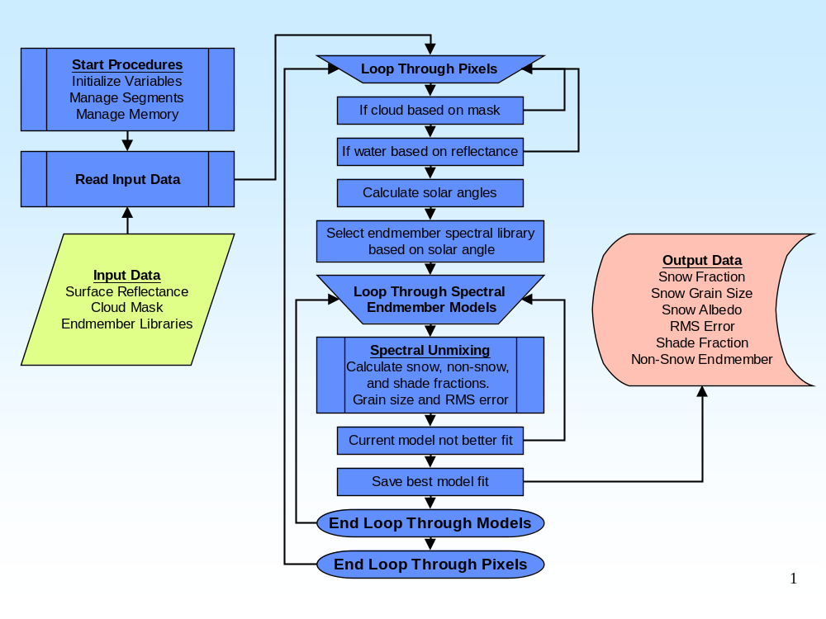
Figure 1 Basic flowchart of core FSCA elements implemented in scag.c

Programming Language

The scag.c program is written in POSIX C using declared variable types intended for a 32-bit compilation. This program can be compiled and executed on a 64-bit computer. However, its Makefile must first be edited to include the –m32 compiler flag (see section 7.3 below).

The FSCA is heavily dependent on algorithmic solutions involving repeated matrix cross products. While several strategies for mitigating this computational burden are incorporated into scag.c, one in particular has an impact on programming language considerations. Namely, scag.c is designed for multi-threading. The scag program’s main thread orchestrates all I/O while each of the remaining threads calculates FSC retrievals at the pixel level (each thread being responsible for all of the calculations required to retrieve FSC for its current pixel).

Makefile

For ease of management, all of scag’s source code is contained in a single source code file (scag.c). Consequently, scag.c’s is relatively simple and contains only the following lines:

CC=gcc
CFLAGS=-Wall –Wshadow –Wpointer -arith –ansi –pedantic –D_REENTRANT -O3
LDFLAGS=-lm –lpthread
OBJECTS=scag.o

default : scag

scag : $(OBJECTS)
$(CC) $(CFLAGS) $(LDFLAGS) $(OBJECTS) –o $@

clean :
rm –f *.o scag

For 64-bit compilation add the –m32 flag at the end of CFLAGS.

Included Files

The following files are included in scag.c:

- #include <errno.h>;
- #include <fcntl.h>;
- #include <getopt.h>;
- #include <math.h>;
- #include <pthread.h>;
- #include <signal.h>;
- #include <stdio.h>;
- #include <stdlib.h>;
- #include <string.h>;
- #include <sys/stat.h>;
- #include <sys/types.h>;
- #include <unistd.h> and
- #include <values.h>.

Variable Definition Macros

The following variable definition macros are defined in scag.c:

- #define BAD_DATA_FLAG 5.0 : The quality flag for bad source data;

- #define BAD_LATLON_FLAG 6.0 : The quality flag for bad latitude or longitude data;

- #define BAD_SENSOR_FLAG 7.0 : The quality flag for bad sensor angle data;

- #define BAD_SOLAR_FLAG 8.0 : The quality flag for bad solar zenith angle data;

- #define CLOUD_GRAIN_SIZE_THRESHOLD 40.0 : The threshold grain size radius for cloud in microns. A snow grain size of at least this radius can be considered cloud ;

- #define CLOUD_MASKED_FLAG 100.0 : Value added to the FSCA quality flag to indicate definite ACMA clouds;

- #define CLOUD_MASK_UNDETERMINED_FLAG 300.0 : Value added to the FSCA quality flag to indicate that the ACMA was unable to determine clouds;

- #define DATA_SCALAR 1000.0 : Scalar applied to surface reflectance data align them with the spectral library data;

- #define DEEP_INLAND_WATER_VALUE 5.0: Deep-ocean water value in the land-water mask;

- #define DEEP_OCEAN_VALUE 7.0: Deep-ocean water value in the land-water mask;

- #define FILE_CONSTRAINTS "CONSTRAINTS" : Name of the FSCA constraints file;

- #define FILE_EMTYPES "EMTYPES" : Name of the FSCA endmember types file;

- #define FILE_GSTABLE "GSTABLE" : Name of the FSCA snow grain size file;

- #define FILE_MODELTYPES "MODELTYPES" : Name of the FSCA model types file;

- #define FILE_SPECLIBS "SPECLIBS" : Name of the FSCA spectral library configuration file;

- #define MAP_RESOLUTION_SECONDS 30.0 : Resolution of the endmember memory file in seconds;

- #define MAP_HEIGHT_DEGREES 49.0 : Height of the endmember memory file in degrees;

- #define MAP_NDV UCHAR_MAX : Endmember memory file no data value;

- #define MAP_WIDTH_DEGREES 103.0 : Width of the endmember memory file in degrees of longitude;

- #define MAP_X_ORIGIN -168.0 : Upper left-hand corner x-axis origin of the endmember memory file (pixel center) in longitude;

- #define MAP_Y_ORIGIN 71.0 : Upper left-hand corner y-axis origin of the endmember memory file (pixel center) in latitude;

- #define MAX_CONFIG_PATH_LENGTH 245 : Maximum command line length for the FSCA configuration file directory name;

- #define MAX_INPUT_PATH_LENGTH 252 : Maximum command line length for the FSCA input file names;

- #define MAX_MAP_PATH_LENGTH 256 : Maximum command line length for the FSCA endmember memory file name;

- #define MAX_OUTPUT_PATH_LENGTH 233 : Maximum command line length for the FSCA output file names;

- #define MAX_SENSOR_ZENITH_ANGLE 55.0 : Maximum acceptable sensor view angle;

- #define MAX_SOLAR_ZENITH_ANGLE 67.5 : Maximum acceptable solar zenith angle;

- #define MIN_SOLAR_ZENITH_ANGLE 0.0 : Minimum acceptable solar zenith angle;

- #define MODELED_CLOUD_BY_GRAIN_SIZE_FLAG 40.0 : FSCA quality flag value indicating clouds were mapped by grain size;

- #define MODELED_FLAG 0.0 : Initial FSCA quality flag value;

- #define MODELED_SHADED_SNOW_FLAG 30.0 : FSCA quality flag value indicating shaded snow was mapped;

- #define MODELED_SNOW_FLAG 20.0 : FSCA quality flag value indicating snow was mapped;

- #define MODELED_SNOW_FREE_FLAG 10.0 : FSCA quality flag indicating that no snow nor clouds was mapped;

- #define MODERATE_OCEAN_VALUE 6.0 : Moderately-deep (continental shelf) ocean water value in the land-water mask;

- #define NDV -.01 : Universal output no data value;

- #define NDV_FLAG 0.0 : FSCA quality flag indicating that an input no data value was encountered;

- #define NOT_MODELED_FLAG 4.0 : FSCA quality flag indicating the pixel was not modeled;

- #define PROBABLY_CLOUD_MASKED_FLAG 200.0 : Value added to the FSCA quality flag to indicate probable ACMA clouds;

- #define SECOND_EM_OTHER_VALUE 8000.0 : Value added to the FSCA quality flag to indicate the most prominent nonsnow endmember was something else;

- #define SECOND_EM_ROCK_VALUE 2000.0 : Value added to the FSCA flag to indicate the most prominent nonsnow endmember was rock;

- #define SECOND_EM_SHADE_VALUE 9000.0 : Value added to the FSCA quality flag to indicate the most prominent nonsnow endmember was shade;

- #define SECOND_EM_VEG_VALUE 1000.0 : Value added to the FSCA quality flag to indicate the most prominent nonsnow endmember was vegetation;

- #define SHALLOW_INLAND_WATER_VALUE 3.0 : Shallow ocean water value in the land-water mask;

- #define SHALLOW_OCEAN_VALUE 0.0 : Shallow ocean water value in the land-water mask;

- #define SNOW_ENDMEMBER 0 : Endmember memory file snow endmember value;

- #define THREAD_WAIT_SECONDS 60 : Number of seconds to wait on thread before assuming thread problem;

- #define TOO_BRIGHT_FLAG 2.0 : FSCA quality flag indicating that the pixel is too bright;

- #define TOO_DARK_FLAG 3.0 : FSCA quality flag indicating that the pixel is too dark;

- #define TOO_FAR_FLAG 10000.0 : Value added to the FSCA quality flag to indicate that the pixel is too far off nadir;

- #define WATER_FLAG 1.0 : FSCA quality flag indicating that the pixel falls on water and

- #ifdef __linux__ : definition of NULL.
#undef NULL
#define NULL 0
#endif.

Programming Style

The scag.c source code, with minor exceptions, adheres to the requirements set forth in the NOAA/NESDIS/STAR C programming standards and guidelines. Most of our deviations are stylistic in nature (e.g., indentation, size of subroutines).

It’s appropriate to underscore a few points relating related our programming style:

- We limit our use of goto statements to error handling. Since scag.c checks for all possible errors and is both threaded and makes liberal use of memory allocation, we felt it prudent to clean up in the event of user and runtime errors. The most efficient and unobtrusive (from a reader’s perspective) manner for dealing with errors is the consistent and limited use of the go to statement;

- Since the scanf function does not allow for much opportunity to check for file content errors, we felt it prudent to avoid its use. The scag.c program reads several ASCII files whose contents, if incorrect, will result in erroneous and unpredictable results. The content of these files are carefully scrutinized by the code;

- While multi-threaded programs are extremely efficient, they also require very deliberate coding practices to handle runtime errors. Most notably, the proper joining of thread processes prior to termination. One should not overlook the possibility of premature termination by a KILL signal. The scag.c program includes a critical signal handling subroutine to ensure against memory leaks and orphaned processes resulting from the control c and terminate signals. Note that sure kill signals can not be intercepted by interrupt handlers and should therefore be avoided and

- The FSCA algorithm was encoded using several functions. For the sake of simplicity and ease of management, the code is delivered as a single source file. We took liberty with the coding standards when it comes to the size of subroutines. It is our feeling that arbitrarily limiting the size of subroutines breaks the flow of concentration while reading the code.

Program Outline and Flowchart

The figures included in this section outline the organization of scag.c and flowchart its major elements. The following sections will describe the individual components of scag.c in greater detail.

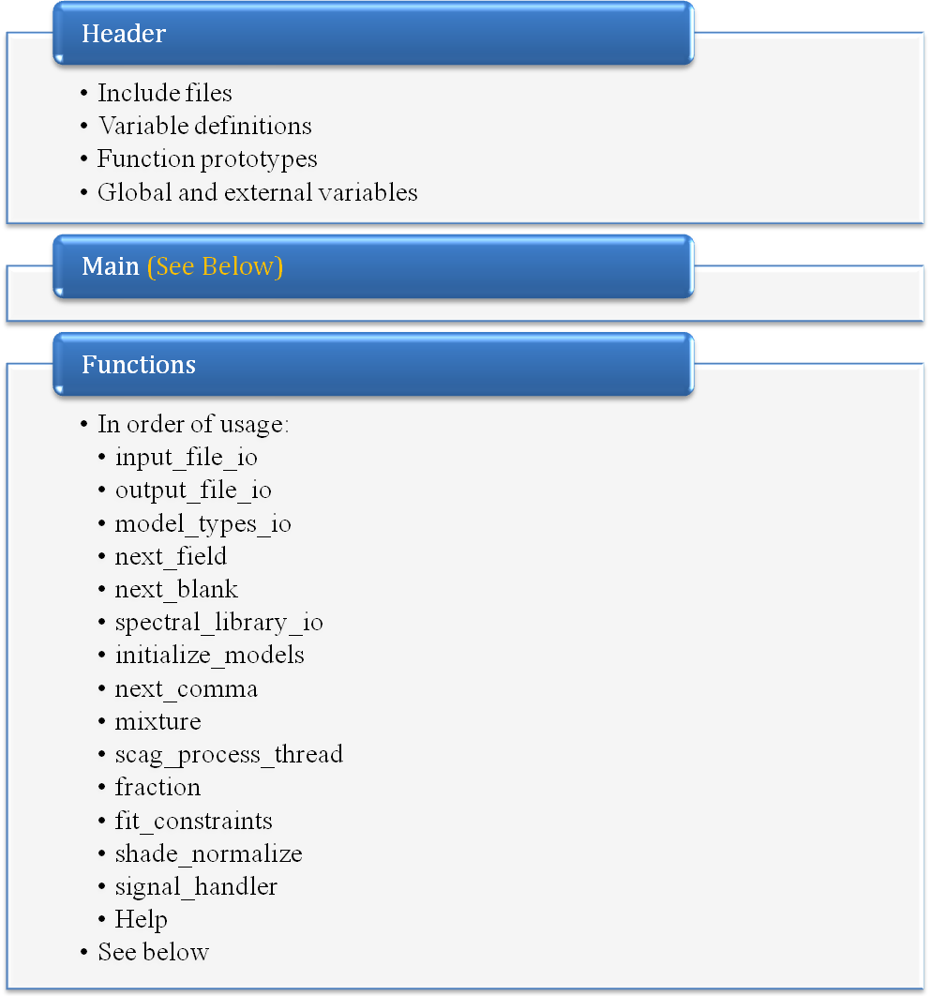
Figure 2 Basic outline of scag.c

Figure 2 outlines the basic structure of scag.c. The header includes included files, variable definition macros, function prototypes, and global and external variables. The variable definition macros (see section 7.5 above) may be used to further configure (beyond the configuration files) or refine the implementation of the FSCA. Every effort was made to capture all variables, which impact the overall performance of the program in these definitions. The programmer should be confident that manipulating only these variables (and not the code) would yield the desired results (e.g., the size, resolution, and orientation of the endmember memory file).

The header is followed by the main body of the program, which handles user inputs, performs file management and I/O and orchestrates the general flow of the program (see figure 3 below).

The main body is followed by several functions, which contain the specific logic required of main’s tasks and, most importantly, capture the physics and mathematics of the FSCA (see the remaining sections of this document).
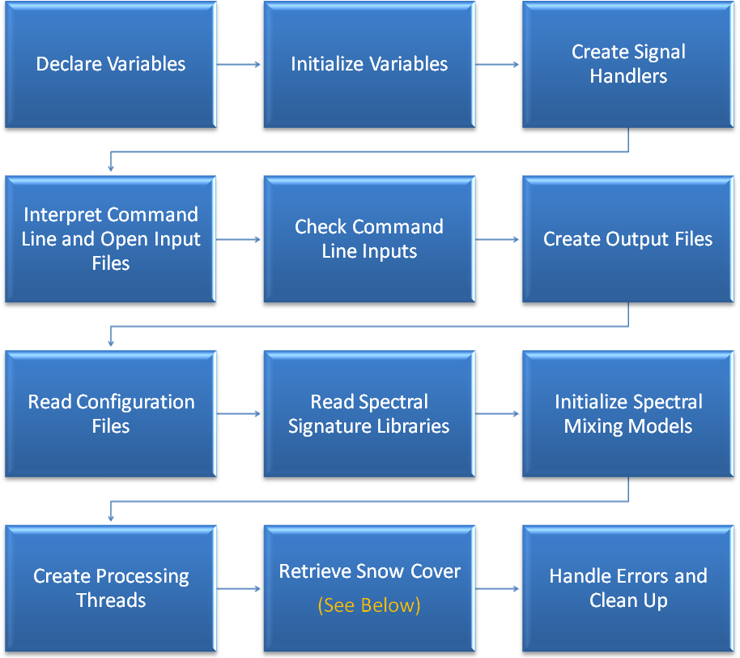
Figure 3 Flowchart of scag.c's main body

The flowchart for the scag.c’s main body is presented in figure 3. Briefly:

- Declare variables: Declares variables that local to the main body;

- Initialize Variables: Initializes both global and local variables. Initialization of global variables is critical for proper synchronization of the processing threads;

- Create Signal Handlers: These should be created as soon as possible to ensure that critical code segments are handled as gracefully as possible in the event of unexpected termination;

- Interpret Command Line and Open Input Files: Interprets and checks user inputs for errors then opens input files;

- Check Command Line Inputs: Verifies that all required inputs were provided and are consistent with one another;

- Create Output Files: All required output files are created. The output files are allowed to be over written. The endmember memory file, if it already exists, is read into memory. Otherwise it is created and initialized;

- Read Configuration Files: Configuration files are read into memory and organized for greatest processing efficiency;

- Read Spectral Signature Libraries: Endmember spectra are read into memory and coordinated with memory resident configuration file contents;

- Initialize Spectral Mixing Models: Pre-calculate those portions of the model solutions that would otherwise be redundant;

- Create Processing Threads: Create processing threads, mutexes, and thread condition variables;

- Retrieve Snow Cover: This scag.c’s main processing loop. It reads input data, coordinates the processing threads and writes output data. See figure 4; and

- Handle Errors and Clean Up: At this point processing threads are files are properly terminated and joined, files closed and allocated memory freed.

The flowchart for scag.c’s main processing loop is presented in figure 4. Up to this point each of the processing threads has been instructed to remain idle and to await further instruction from the main body of the program which current has control. The main processing loop begins by reading one row of input from each of the surface reflectance files and the accompanying rows from the static input data files. The loop proceeds by informing the process threads that they should begin the FSC retrieval model calculations for their current pixels (see figure 5). At this point in the loop, the main body of the program suspends itself (yielding control to its process threads) while waiting on the process threads as they coordinate their activities until all of the pixels on the current row have been exhausted. When the last pixel has been processed, the main body of the program receives a broadcasted thread condition signal indicating that the current row of output data is ready to be written out to disk. While the outputs are written and the next row of input is read, the individual process threads have returned to their idle states until informed to begin processing again.

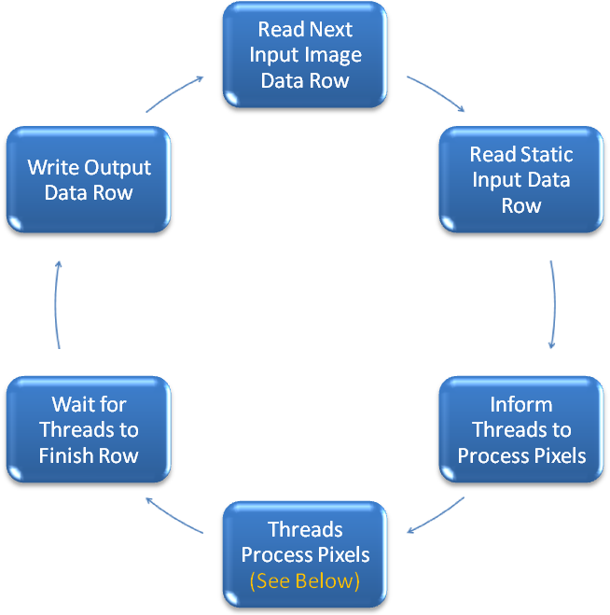

Figure 4 Flowchart of scag.c's main body component of FSC retrieval logic

The basic flowchart for each process thread is presented in figure 5. Each thread is essentially an infinite loop containing three basic elements:

- The first element determines overall condition of scag’s execution. If it determines that an error has occurred in another thread or in main it exits the loop. If it determines that an interrupt signal has been intercepted it exists the loop. If it determines that the last row of input has been processed it exists the loop. If it determines that the next row of input is not yet ready it continues to the top of the loop. Otherwise, the thread coordinates with all other threads to determine which pixel it’s to work on next;

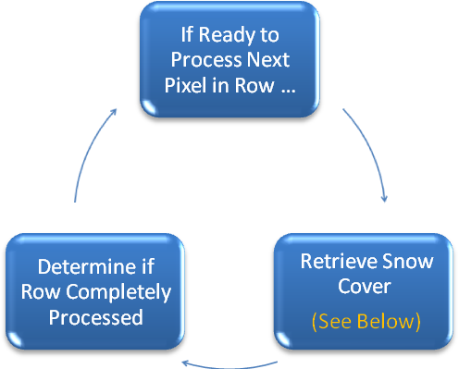
Figure 5 Basic flowchart of processing threads' FSC retrieval logic

- The second element performs all necessary calculations required to model a FSC retrieval on the thread’s current pixel (see figure 6); and

- The last element of the loop contains the logic necessary to determine whether or not the last pixel of the current row has been successfully processed. If so, the thread broadcasts that information to main in the form of a thread condition signal. At that point the main body of the program regains control while the process threads are suspended in an idle mode.

A detailed flowchart of the second element of each thread’s processing loop is presented in figure 6. This is the heart of the FSCA’s implementation. It coordinates all of the FSC retrieval activities surrounding the physics and mathematics of the FSCA. The physics and mathematics are captured in subroutines that will be discussed in subsequent sections. The purpose for this section of code is to ensure that all of the proper conditions for modeling FSC retrievals for the current pixel have been met and to orchestrate the retrieval process with maximum efficiency. (One should please reacquaint oneself with section 2.3 above if necessary).

A brief description of the elements in figure 6 is as follows:

- Skip Pixels with Missing Data: Pixels missing any of the input data and pixels with coordinates not contained within the limits of the endmember memory file are not modeled for FSC retrievals. They are represented in the output files with the no data value and the indicated with the no data flag in the quality file;

- Skip Water Pixels: Pixels that are associated with water in the land-water mask are not modeled for FSC retrievals. They are represented in the output files with the no data value and the indicated with the water flag in the quality file;

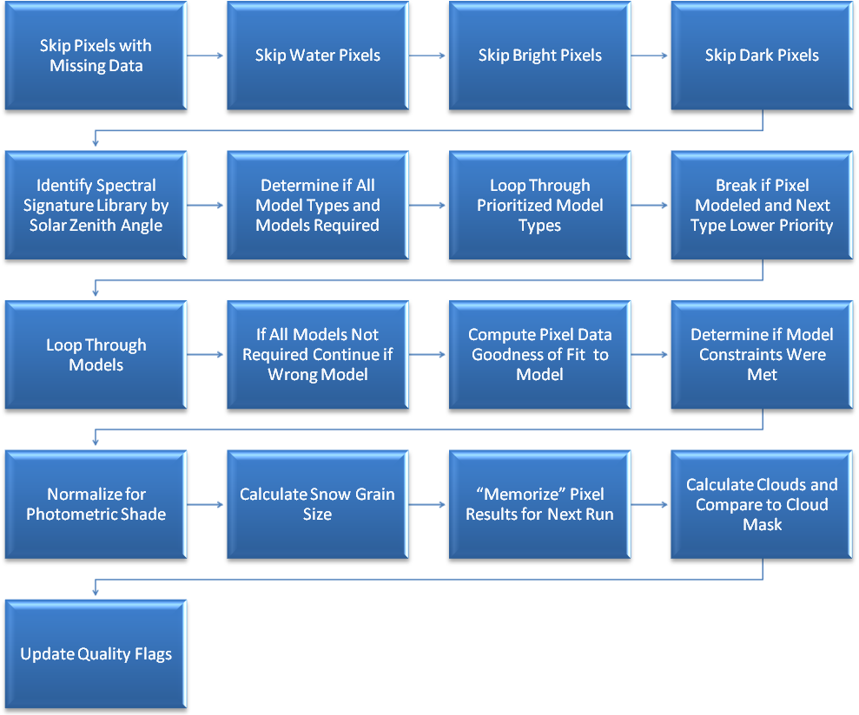
Figure 6 Detailed flowchart of processing threads' FSC retrieval logic

- Skip Bright Pixels: Pixels that are too bright (high solar zenith angle) are not modeled for FSC retrievals. They are represented in the output files with the no data value and the indicated with the solar zenith angle too small flag in the quality file;

- Skip Dark Pixels: Pixels that are too dark (low solar zenith angle) are not modeled for FSC retrievals. They are represented in the output files with the no data value and the indicated with the solar zenith angle too large flag in the quality file;

- Identify Spectral Signature Library by Solar Zenith Angle: Determine, based on the pixel’s solar zenith angle, which of the spectral signature libraries, is the most appropriate to use. Each spectral signature library contains endmember spectra for a fixed solar zenith angle. That library with the solar zenith angle nearest the pixel’s solar zenith angle is the correct one to use;

- Determine if All Model Types and Models Required: Since the non-snow endmembers are relatively static it is not necessary to analyze each possible spectral mixing model if knowledge of the non-snow endmembers is retained from image to image. The endmember memory file discussed in section 3.5 above retains this knowledge. Since the non-snow endmembers do gradually change it is important to periodically test each possible mixing model for a given pixel. The scag program tests each model for each pixel at its local solar noon. It also tests each model if:

  - It’s never seen a non-snow endmember for the pixel;
  - The solar zenith angle has decreased or
  - The sensor zenith angle has decreased.

The later three cases should rarely occur and are probably limited to the first few executions of the program. At this point in the program a flag is set if it is not necessary to test all models;

- Loop Through Prioritized Model Types: As discussed in section 2.3, the scag program executes several prioritized spectral mixing models types. The scag program executes these models types in descending order of priority. If a mixture model meets the constraints for a given model type priority level, there is no need to test mixture model types of lesser priority;

- Break if Pixel Modeled and Next Type Lower Priority: See (7) above;

- Loop through Models: Each spectral mixing model type consists of several spectral mixing models that vary by endmember composition and snow grain size. At this point in the program we loop through each possible model within the current spectral mixing model type;

- If All Models Not Required Continue if Wrong Model: As mentioned above, for a given pixel we can skip spectral mixing models that have an endmember consistency that does not match the endmembers that were observed the last time scag ran. Item (6) above notes the possible exceptions. If it was determined in (6) above that it is not necessary to examine each model and the current model’s endmember consistency does not match the last observed non-snow endmembers, the program at this point continues to the next model;

- Compute Pixel Data Goodness of Fit to Model: At this point a solution is calculated for the current spectral mixing model. The solution consists of the best fit between the pixel’s observed spectrum and the a priori measured endmember spectra of the model. The solution yields:

a) The fractional composition best-fit to the model’s endmembers;
b) The RMSE goodness of fit measure and
c) The model residual for each band;

- Determine if Model Constraints Were Met: A set of model fit constraints is associated with each of the prioritized spectral mixing model types. A pixel is considered modeled only if these model constraints have been met. Of course several models within a model type [assuming all models have to be examined – see (6) and (10) above] may meet these constraints for a given pixel. That model with the smallest RMSE is the one that is retained for the pixel. If no model meets the constraints for a given pixel, that pixel is flagged as such in the quality file. Remember, if the constraints are met for a spectral mixing model within the current model type, the spectral mixing models in model types of lower priority are not evaluated;

- Normalize for Photometric Shade: Each spectral mixing model actually accounts for an additional end member – photometric shade. The calculated fraction of shade is proportionally reallocated among the non-shade endmembers;

- Calculate Snow Grain Size: There are 110 snow endmembers in each spectral mixing model type. Each of the 110 snow endmembers is associated with a snow grain size. At this point a grain size is associated with the snow endmember if one exists;

- “Memorize” Pixel Results for Next Run: Record the endmember composition, solar zenith angle and sensor zenith angle for the current pixel in the endmember mask. This information will be used during the next scag execution as described in (6) and (10) above;

- Calculate Clouds and Compare to Cloud Mask: If snow if determined to exist on the current pixel and its grain size meets or falls below a specified radius, it is considered be cloud and indicated as such in the quality file. Cloud based on snow grain size is compared against the ACM and various cloud comparison qualifiers are indicated in the quality file; and

- Update Quality Flags: The quality flag is updated to indicate whether or not the pixel is close enough to nadir.

Functions

input_file_io

The input_file_io function handles all input file I/O. The input_file_io function has four modes of operation. Their purpose and a brief outline of their structure are as follows:

- Terminate I/0 – Frees memory allocated for input file I/O;

- Open input file – Opens an input file:

  - Check arguments;
  - Read binary header file;
  - Check binary header file contents;
  - Open binary data file and
  - Allocate memory for input file I/O;

- Read input file data – Reads a row of data from an input file:

  - Check arguments;
  - Seek file position;
  - Read data;
  - Scale and shift data as necessary and
  - Convert data into doubles (to reduce code complexity) and

- Close input file – Closes and input file.

output_file_io

The output_file_io function handles all output file I/O. The output_file_io function has three modes of operation. Their purpose and a brief outline of their structure are as follows:

- Create output file – Creates an output file:

  - Check arguments;
  - Create binary header file and
  - Create binary data file and return data file descriptor;

- Write output file data – Writes a row of data to an output file:

  - Check arguments;
  - Seek file position and
  - Write data and

- Close output file – Closes an output file.

model_types_io

The model_types_io function reads spectral unmixing model configuration file data into memory. These data are held in memory for the duration of the program. The configuration file data are organized with the spectral library data by the initialize_model function (see section 7.8.7 below). The model_types_io function has three modes of operation. Their purpose and a brief outline of their structure are as follows:

- Terminate option – Systematically free all memory allocated for the spectral unmixing model configuration data; and

- Read spectral unmixing model configuration file data:

  - Check arguments;
  - Read spectral unmixing model types configuration file data;
  - Sort spectral unmixing model types into descending order of priority. This will improve the efficiency of the scag_process thread function (see section 7.8.10 below);
  - Read the model endmember types into memory;
  - Read the snow grain size lookup table into memory and
  - Read the model endmembers into memory;

next_field

In order to ensure exact configuration file contents scag.c uses its own ASCII file parsing logic (fscanf has limited error checking opportunities). The next_field function uses simple logic to locate the subscript of the first character of the next data field in a string.

next_blank

In order to ensure exact configuration file contents scag.c uses its own ASCII file parsing logic (fscanf has limited error checking opportunities). The next_blank function uses simple logic to locate the subscript of the next occurrence of a blank in a string.

spectral_library_io

The spectral_library_io function reads the spectral library configuration file, allocates memory to retain the spectral library contents for the duration of the scag program, reads the spectral libraries into memory and calculates the best spectral library to use for a given pixel’s solar zenith angle. The spectral_library_io function has three modes of operation. Their purpose and a brief outline of their structure are as follows:

- Terminate option – Systematically free all memory allocated for the spectral libraries;

- Read spectral libraries into memory option – Read the spectral library configuration file and load the spectral libraries into memory:

  - Check the arguments;
  - Loop through the configuration file records. There is one record for each spectral library;
    - Parse the configuration file record variables and retain in memory and
    - Read the next spectral library and retain in memory and

- Calculate best spectral library option – Based on a pixel’s solar zenith angle, calculate the most appropriate spectral library to use in the spectral unmixing calculations:

  - Loop through the spectral library solar zenith angles;
    - Calculate the absolute value of the difference between the pixel’s solar zenith angle and the next spectral library’s solar zenith angle and
    - If the pixel’s angle is closer to this library’s angle than previous libraries’ angles retain the distance and the library’s index (for use in spectral unmixing calculations).

initialize_models

The initialize_models function reads the model constraints configuration file into memory, allocates spectral unmixing model memory, and organizes configuration file and spectral library file data in preparation for FSC retrievals. These data are held in memory for the duration of the program. Lastly, it calls the mixture function (see section 7.8.9 below) for a one time only initialization of matrices for all of the unmixing models. The initialize_model function has two modes of operation. Their purpose and a brief outline of their structure are as follows:

- Terminate option – Systematically free all memory allocated for the spectral unmixing models; and

- Initialize spectral ummixing models – Read the model constraint configuration file into memory, allocate spectral unmixing model memory, organize configuration file and spectral library data for models, and initialize the models:

  - Check the arguments;
  - Read the model constraints file into memory;
  - Relate the spectral unmixing model types with their associated constratints;
  - Allocate memory for each spectral unmixing model;
  - Organize configuration file and spectral library file data into spectral unmixing model memory and
  - Initialize each spectral unmixing model using the mixture function (see section 7.8.9 below).

next_comma

In order to ensure exact configuration file contents scag.c uses its own ASCII file parsing logic (fscanf has limited error checking opportunities). The next_comma function uses simple logic to locate the subscript of the next occurrence of a comma in a string.

mixture

The mixture function initializes the matrices used to calculate the endmember fractions and goodness of fit metrics [RMSE and per band model residuals used by the fit_constraints function (see 7.8.12 below)] yielding the best fit between the spectrum of sensor measured surface reflectance for a pixel and the a priori measured pure endmember spectra of a spectral unmixing model. The matrices for the unmixing models are used in the fratction function (see 7.8.11 below). The mathematical basis and details are presented in section 2.2 above.

scag_process_thread

Refer to the detailed description accompanying figure 5 in section 7.7 above for an outline of the scag_process_thread function.

fraction

The fraction function calculates the endmember fractions and goodness of fit metrics [RMSE and per band model residuals used by the fit_constraints function (see 7.8.12 below)] yielding the best fit between the spectrum of sensor measured surface reflectance for a pixel and the a priori measured pure endmember spectra of a spectral unmixing model. The matrices for the unmixing models are initialized in the mixture function (see 7.8.9 above). The mathematical basis and details are presented in section 2.2 above.

fit_constraints

The fit_constraints function determines whether or not the results of the spectral unmixing model fit the constraints associated with its mixing model type. There are three tests:

- Check to see if the model’s RMSE exceed the model type’s threshold RMSE;
- Check to see if the modeled endmember fractions exceed the model type’s minimum or maximum threshold fractions; and
- Check to see if the model residuals for N consecutive input surface reflectance bands exceed the model type’s threshold residual (where N is a configuration varaiable).

shade_normalize

Each of the spectral mixing model types (one- and two-endmember model types) actually model and additional endmember – photometric shade. The modeled shade fraction is proportionally redistributed among the non-shade endmembers. The math is straight forward and requires no further description.

signal_handler

The signal_handler function handles the intercepted SIGINT and SIGTERM signals. While not critical for memory or file handling, it is extremely critical for process thread handling. Unless process threads are correctly terminated and joined, there is the potential for memory leaks and orphaned processes.

The signal_handler flowchart is as follows:

- Only process the first signal. Ignore repeated signaling;
- Unlock locked mutex;
- Set flag that informs processing threads to exit;
- Join all process threads; Wait for them to exit before proceeding;
- Free process thread resources;
- Close open input files;
- Free input file I/O resources;
- Close output files;
- Close enmember memory file;
- Free endmember memory file memory;
- Close configuration file and
- Free model, spectral library, and configuration memory.

help

The help function prints an exact duplicate of the help information contained in scag.c’s header to stdout. Help information sections are broken up with calls to the getchar function.

REFERENCES

Keshava, N (2003). A Survey of Spectral Unmixing Algorithms. Lincoln Laboratory Journal, Volume 14, Number 1, 55 – 78.

