Technical Design Document

Project name: **BusNama**

Team Name: *Samarpan*

* Aditi Singh(46003244)
* Anshu Kumar(46001796)
* Mohammad Masharib Hussain (46000001)
* Vikas Singh(46001755)

**Introduction:**

BusNama is created to meet the needs of online bus reservation system, with 2 actors: Admin and Customer. The architecture implemented is Spring Boot Micro services.

**Functional Requirements:**

The functional requirements of the project are:

**For the Admin:**

* Add a Bus
* Delete/Cancel a Bus
* View Buses
* View Users

**For the User:**

* Login/Register
* Search Buses
* Create Booking
* Make Payment
* View Bookings
* View Booking Details
* Cancel Booking
* Give Feedback

**Micro-Services**

The different micro-services in which this project is divided into are:

* **Bus Service:** Insert a new bus, cancel or delete an existing bus
* **User Service:** Register a new account and login (as a customer) and login (as the admin)
* **Booking Service:** Create a new booking, cancel an existing booking, download ticket
* **Search and View Service:** View customers (as the admin), view all buses (as the admin), explore buses (as a customer), view existing bookings, view booking details
* **Payment Service:** Make a payment for the booked tickets after validating credentials
* **Feedback Service:** Provide rating and feedback (as a customer)

**Overall Architecture Diagram:**

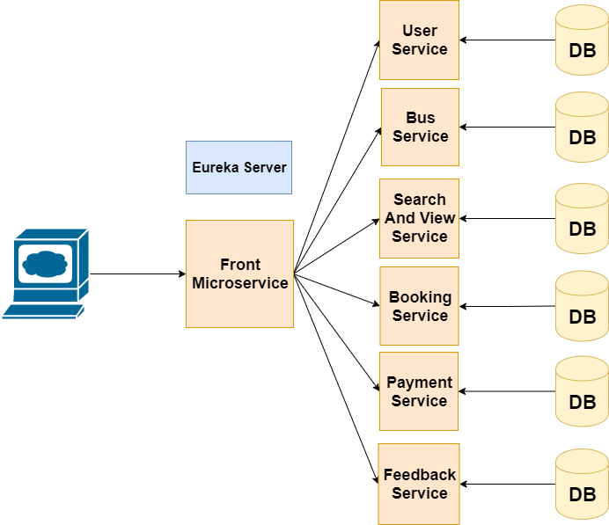

**Overall Entity Relationship Diagram:**

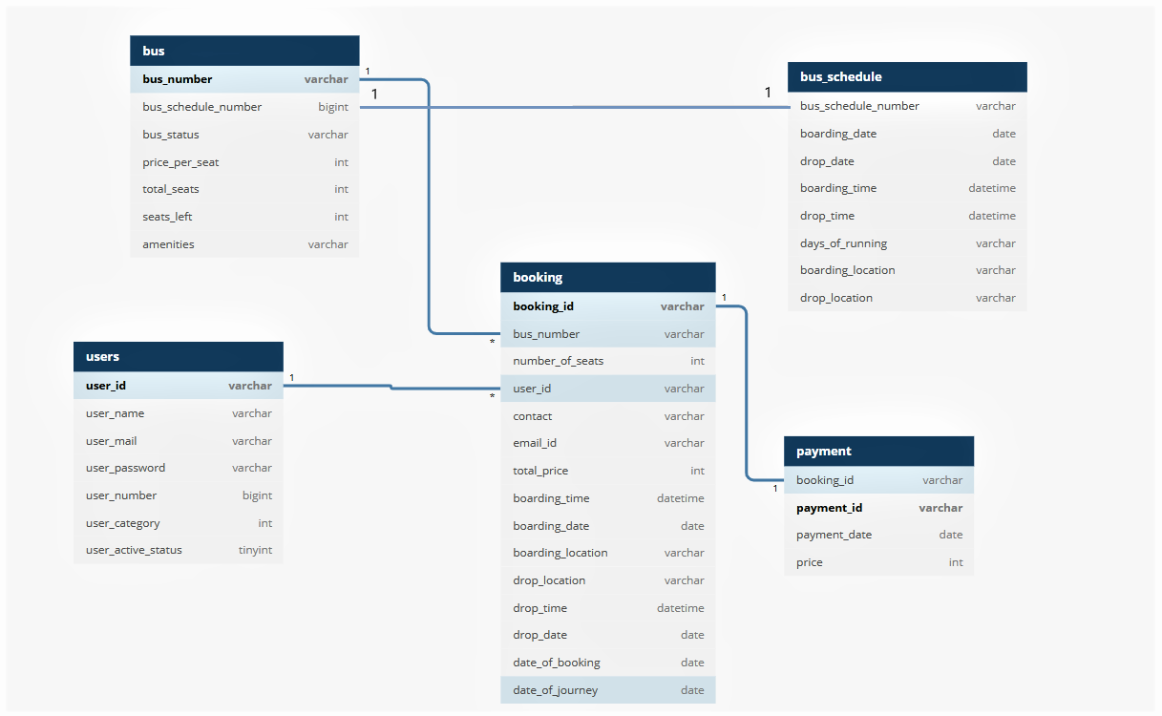

**Sequence Diagrams**

**User Service:**

**Login -**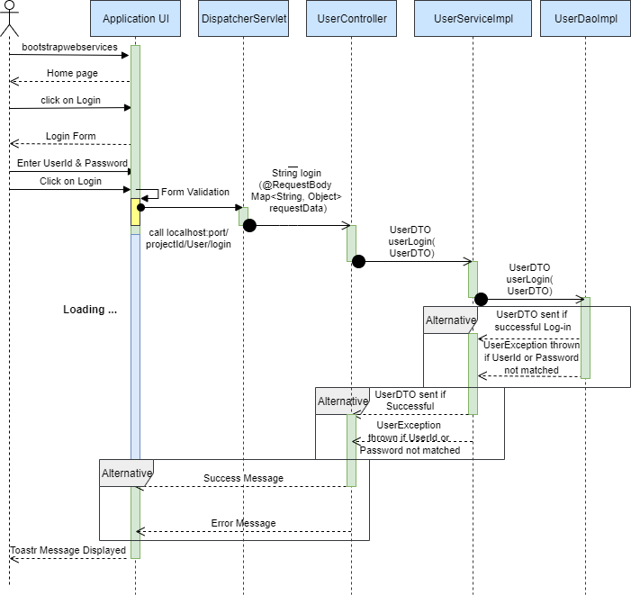

**Registration of new User -**

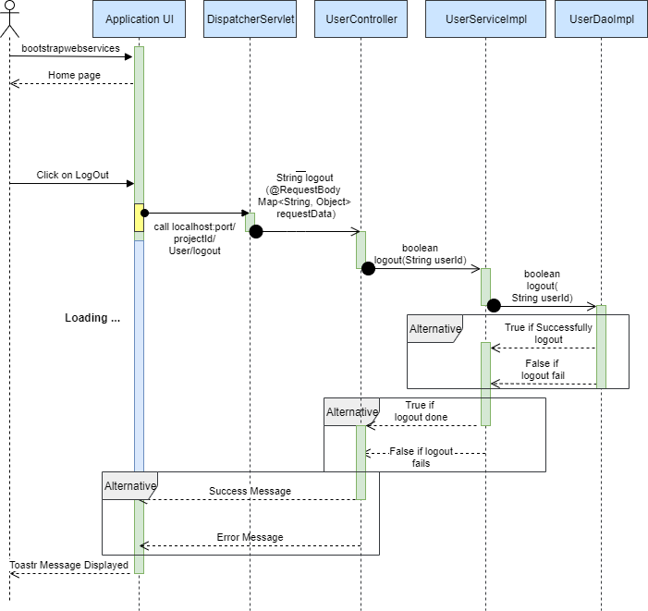

**Logout -**

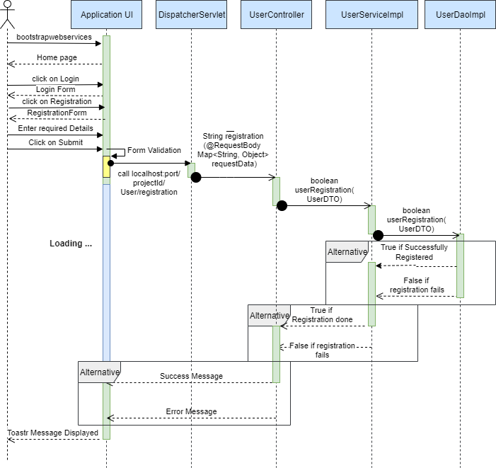

**Bus Service:**

**Insert and Delete Bus:**

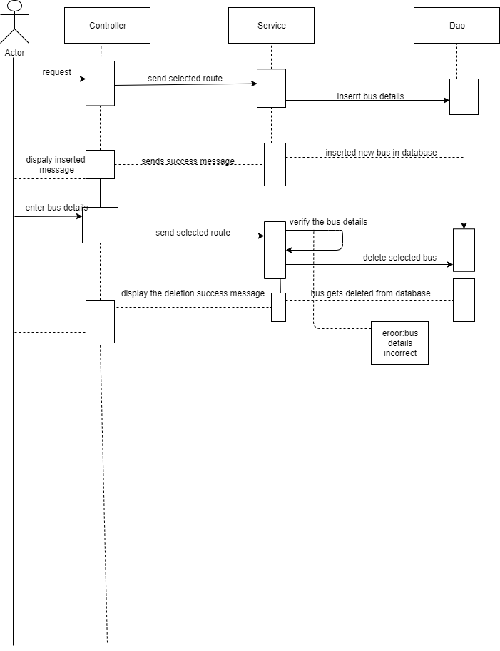

**Booking Service:**

**Create booking, cancel booking, and download ticket:**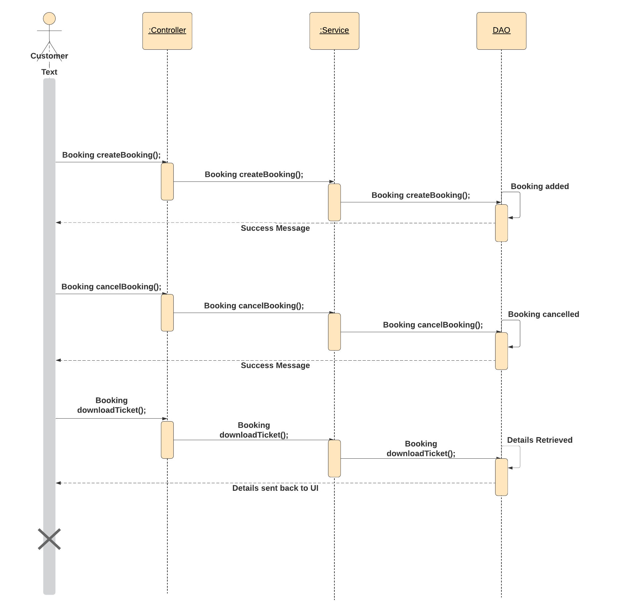

**Search and View Service:**

**For the Admin:**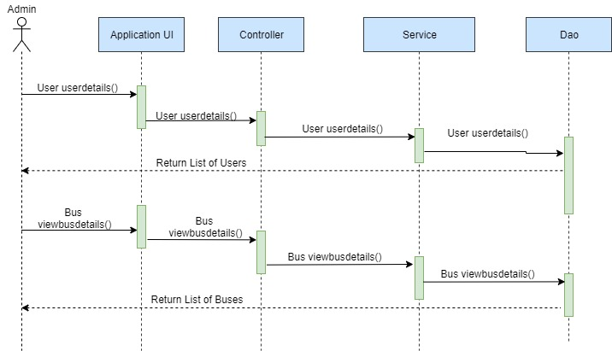

**For the customer:**

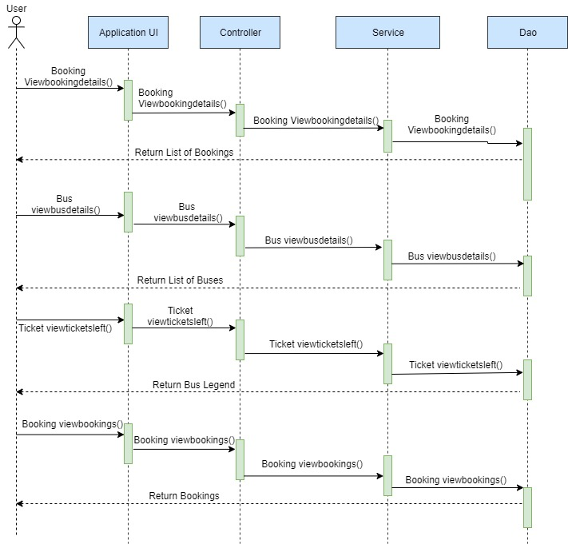

**Class Diagrams**

User Service:

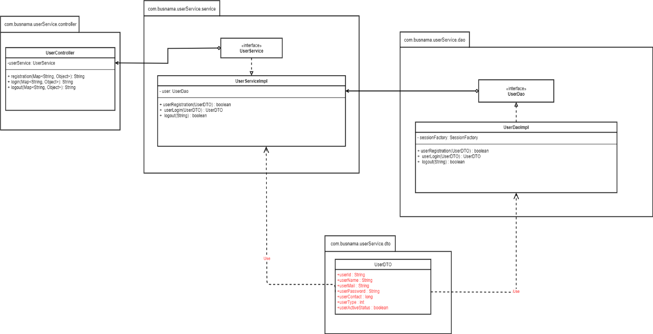

Bus Service:

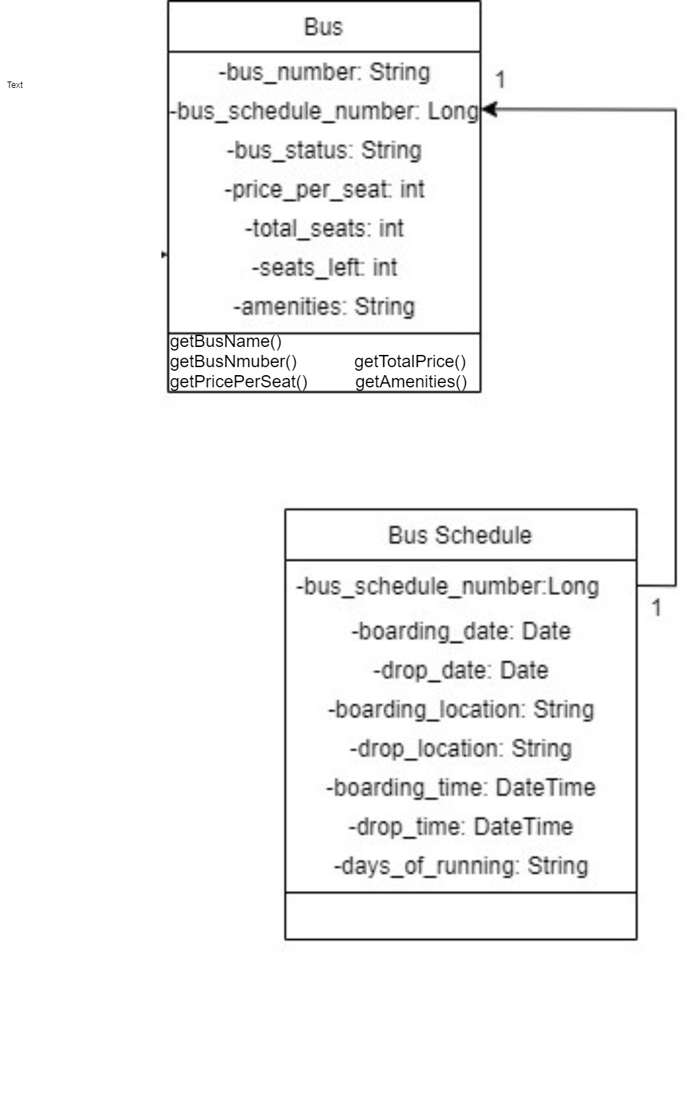

Booking Service:

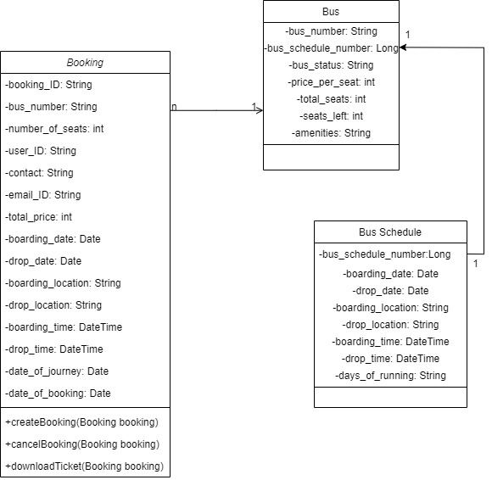

Search and View Service:

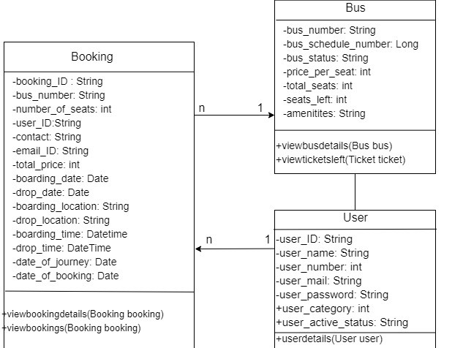

**Activity Diagrams**

User Service:

**Login:**

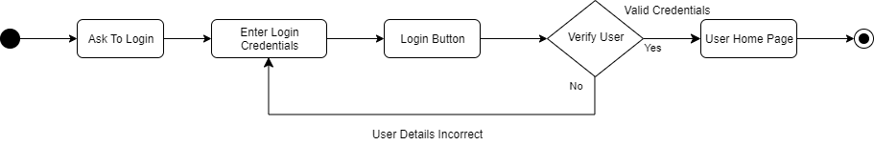

**Registration:**

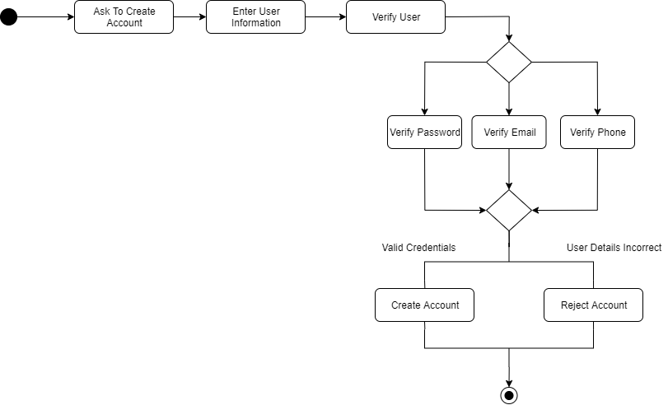

Booking Service:

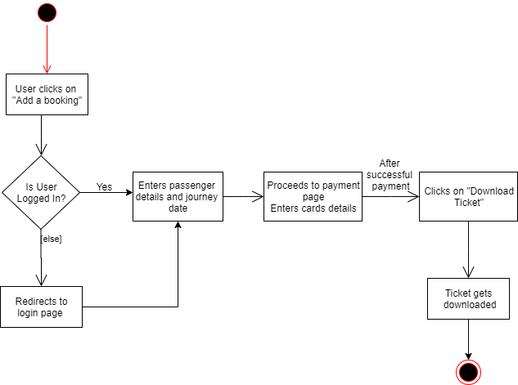

Search and View Service:

**View Users:**

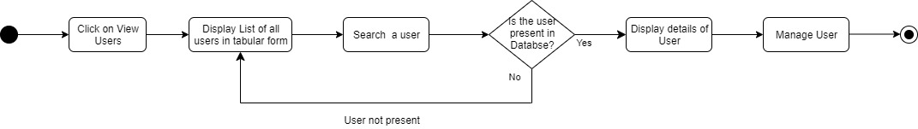

**View Bus Details:**

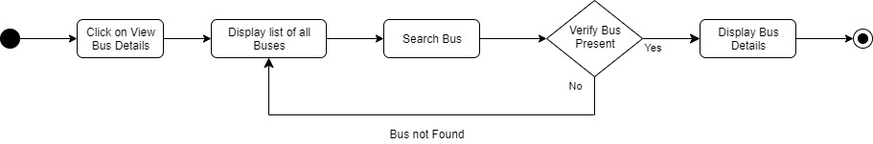

**View tickets left**:

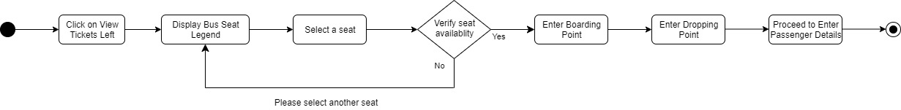

**Wireframes**

User Service:

**Customer Login:**

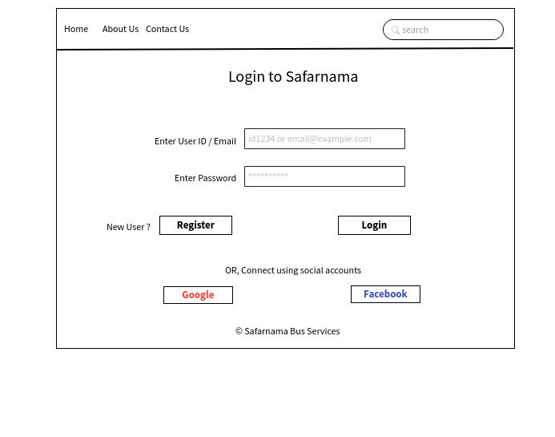

**Admin Login:**

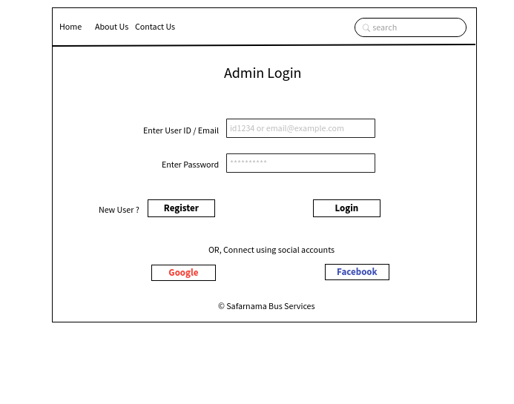

**Customer Registration:**

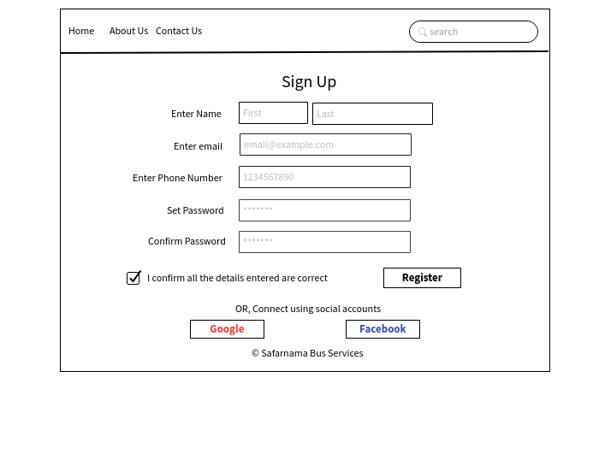

**Admin Registration:**

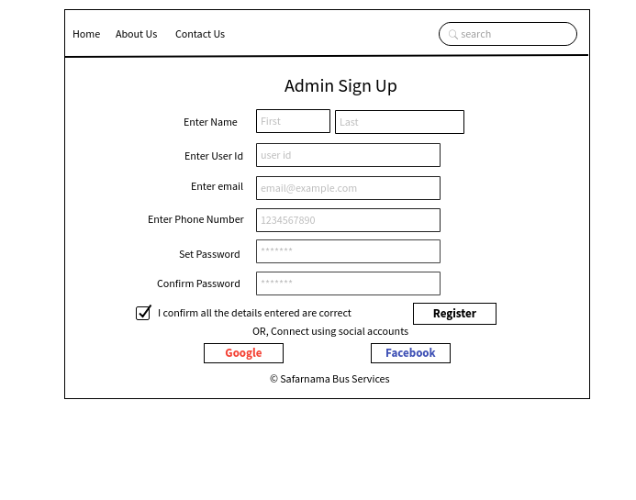

Bus Service:

**Insert Bus:**

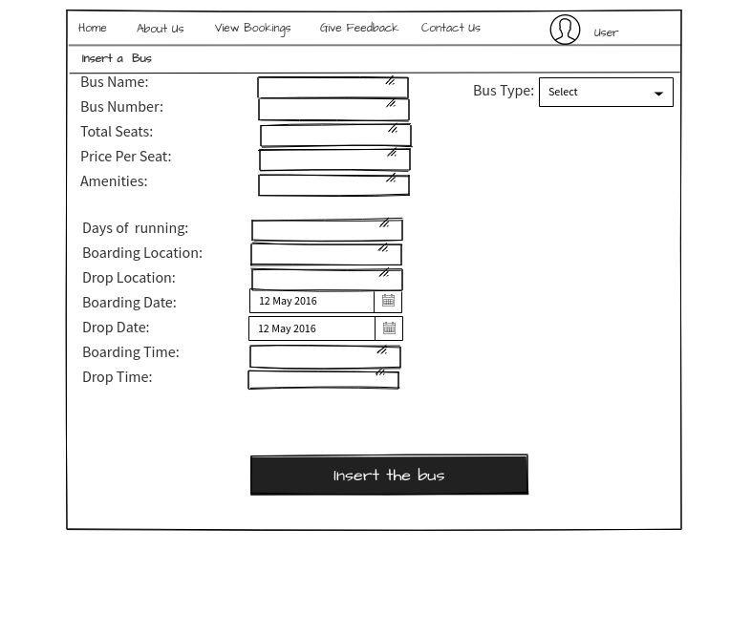

**Delete Bus:**

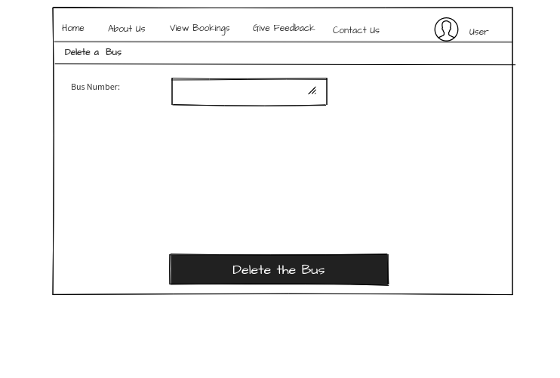

Booking Service:

**Create Booking:**

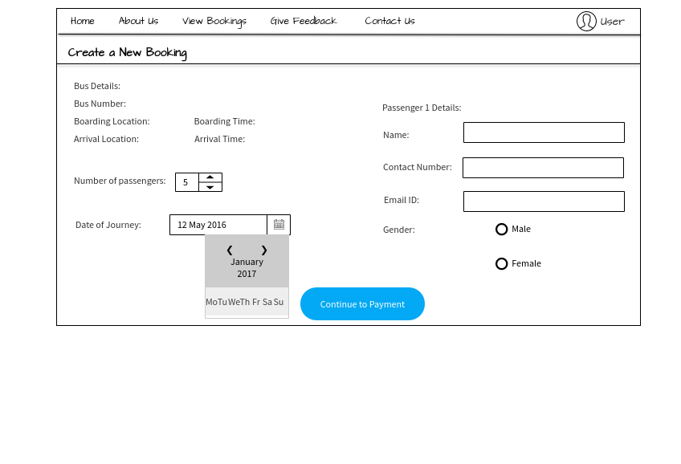

**Payment:**

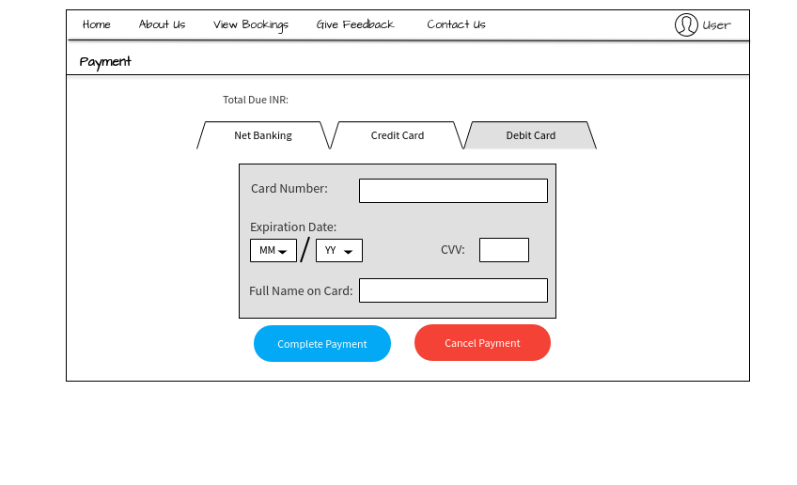

View and Search Service:

**View Users (Admin):**

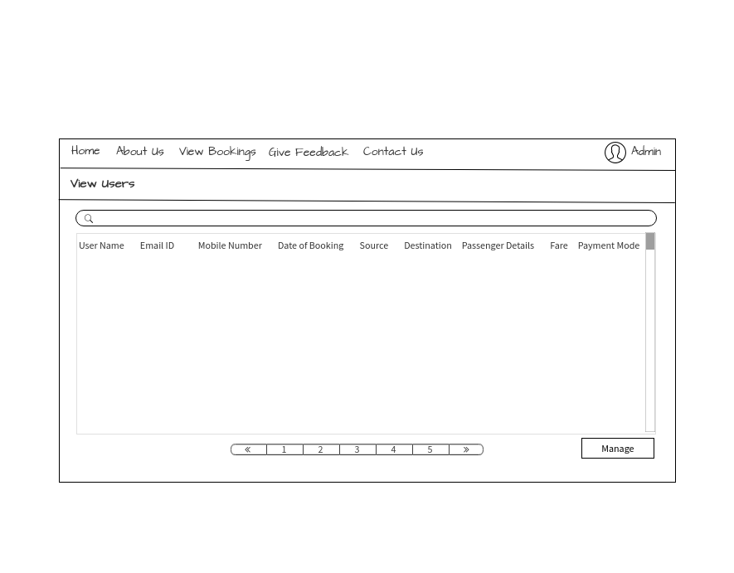

**Explore Buses (Admin):**

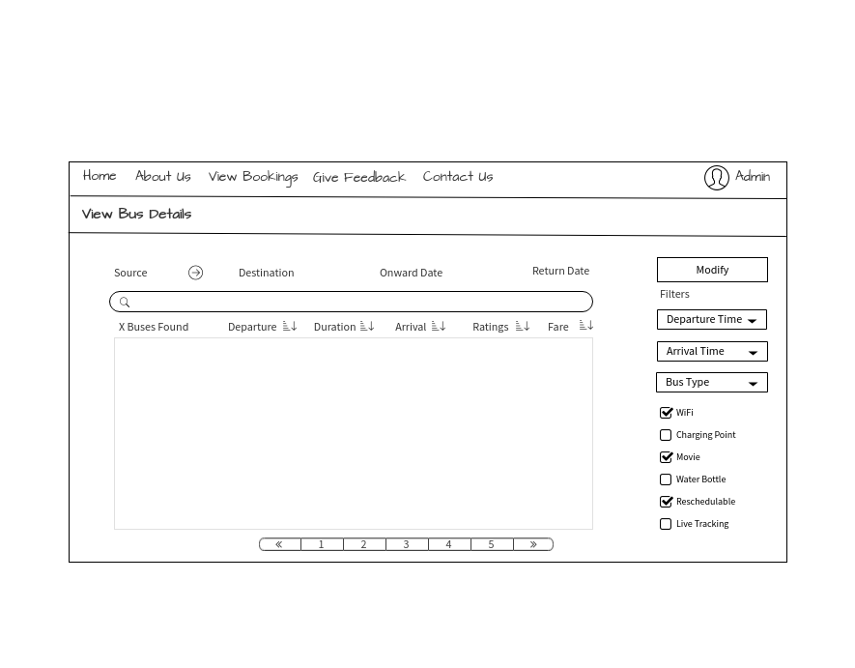

**Explore Buses (User):**

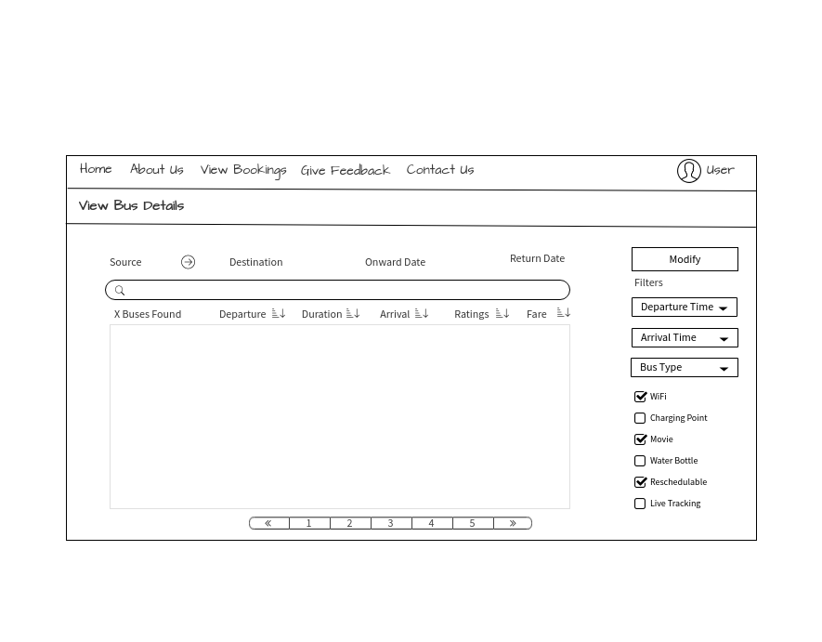

**View Tickets Left:**

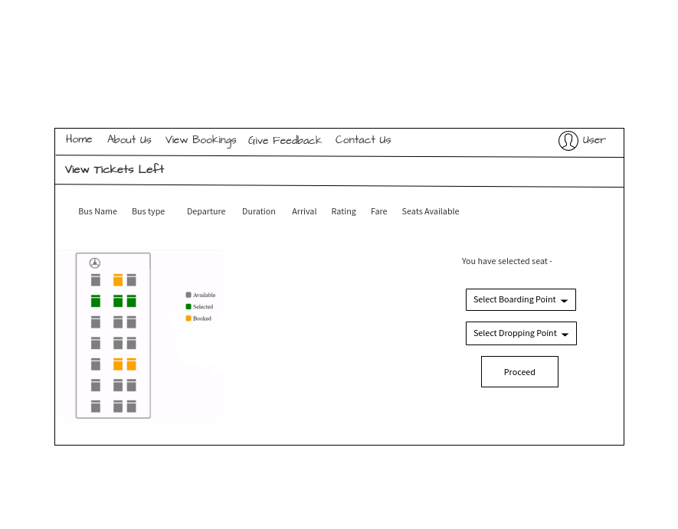

**View Bookings:**

