

SIF Change Proposal: Financial

Submitted by: NSIP Team
Version: v0.3
Date Submitted: July 2015

Table of Contents

Change Proposal 3
Rationale for Change 3
Business Case 3
Time Line 3
Potential Object Changes 3
Change Plan 4
Object Dependencies and Relation Map 4
Changes to Other Objects 4
Infrastructure Changes 4
Object Definitions 4
Invoice 7
FinancialAccount 9
ChargedLocationInfo 10
PaymentReceipt 12
PurchaseOrder 14
VendorInfo 16
Journal 18
Debtor 19
EquipmentInfo 20
Codeset changes 21
AUCodeSetsAddressTypeType 21

Draft Specification Document Version Control
Version | Date: | Author/Organization: | Comments
V0.1 | 18/07/2015 | Nick Nicholas/NSIP | Initial Document
V0.2 | 26/07/2015 | Nick Nicholas/NSIP | Feedback from Anthony Yaremenko
V0.3 | 29/07/2015 | Nick Nicholas/NSIP | Feedback from Anthony Yaremenko
V0.4 | 12/08/2015 | Nick Nicholas/NSIP | Feedback from Linda Marshall
V0.5 | 19/08/2015 | Nick Nicholas/NSIP | Change of FinancialClass to FinancialClassification
V0.6 | 31/08/2015 | Nick Nicholas/NSIP | Minor fixes
V0.7 | 07/09/2015 | Nick Nicholas/NSIP | Feedback from SEQTA; eliminated FinancialClassification

Change Proposal

Rationale for Change
There is growing interest in using SIF AU to exchange data in support of financial processes in the school sector. This proposal repurposes existing financial objects in the SIF US model for the Australian context. It adds one object (Journal) to support reconciliation of accounts, and one object (Debtor) to capture general information about debtors.

Payroll and financial statements are not covered by this proposal.

Business Case
Interest in exchanging financial objects through SIF AU has been expressed by DET ACT, CEO Melbourne, and various independent schools.

Time Line
This change will be in the SIF Implementation Specification (Australia) 1.4 timeline.

Potential Object Changes

Proposed Data Object Changes
Object | Element | Attribute | Reason for including
Invoice (SIF US: Billing) | New object
FinancialAccount | New object
ChargedLocationInfo (SIF US: LocationInfo) | New object
PaymentReceipt (SIF US: Payment) | New object
PurchaseOrder (SIF US: Purchasing) | New object
VendorInfo | New object
Journal | New object
Debtor | New object
EquipmentInfo | InvoiceRefId | O | Purchase order for the equipment

The following are the main differences between the SIF AU and the SIF US financial objects:

- Payroll objects have not been included.
- The Debtor and Journal objects have been added.
- Financial statement objects have not been included.
- The FinancialClass object has not been included. Instead, the FinancialClass/ClassType element is folded into FinancialAccount, as a first-level classification of accounts.
- The FinancialTransaction object has not been included. Information about actual account credit and debit transactions can always be inferred from the Journal, Invoice and PaymentReceipt objects.
- Fiscal Year has been treated as an element rather than a distinct object.
- AccountingPeriod has been treated as an element rather than a distinct object. The local identifier for the accounting period is assumed to be informative enough, without specifying an explicit start and end date as object elements.
- The join object FinancialAccountAccountingPeriodLocationInfo has been left out. Rather than couple location and account, the SIF AU object assumes that locations, if required, will have their own subaccounts, and FinancialAccount is optionally associated with a specific ChargedLocationInfo object. Where necessary, AccountingPeriod and FinancialAccount are referenced separately, rather than in a single join object.
- Requisitions are not supported in Purchasing.
- Financial accounts can have subaccounts, reflecting a tree structure of accounts. This tree structure can be used to represent simple or complex hierarchies reflecting an organization’s chart of accounts structure.
- Invoice can be used, with debit amounts, for credits to external parties unrelated to purchase of goods and services, commonly referred to as ‘credit notes’.
- Tax rate information (GST) is included where appropriate in Debtor/Creditor Purchasing, Invoice, and Payments, General Ledger receipts/payments and journals.
- PurchaseOrder can be updated to reflect how much of an order has been fulfilled.
- Invoice has creator and approver attributes added.
- The PaymentReceipt object can be used for general ledger transactions, with no associated Invoice object.

Change Plan

Object Dependencies and Relation Map
There are no changes in object dependencies

Changes to Other Objects
There are no anticipated changes to other objects.

Infrastructure Changes
There are no anticipated infrastructure changes

Object Definitions
The following diagram illustrates the relations between the proposed objects. The original US data model is given first; then the proposed Australian data model is shown, with the additions for the Australian data model in red.

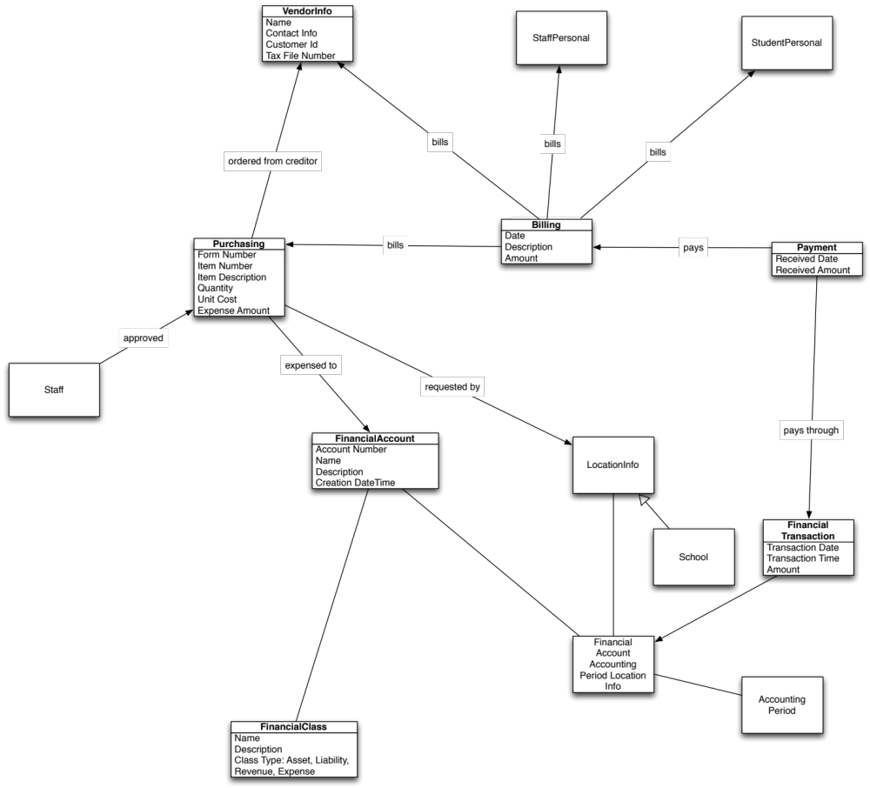

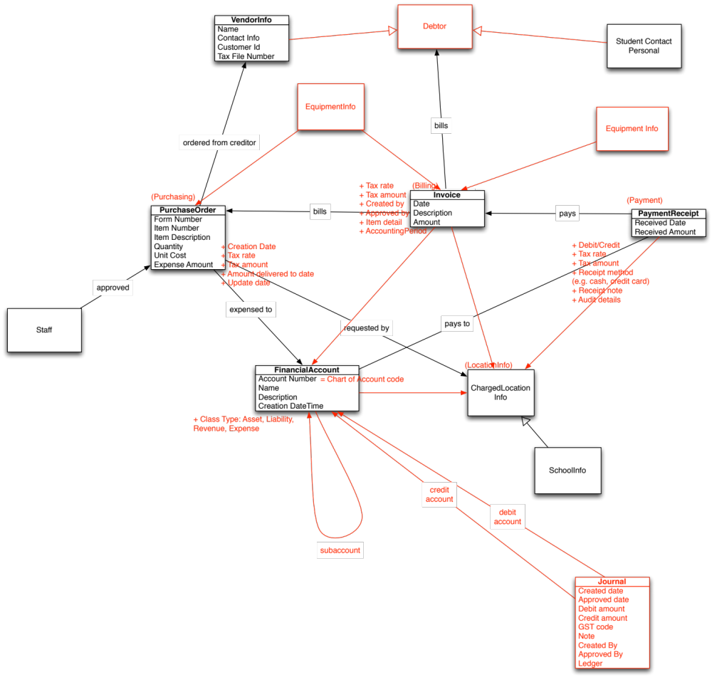

- PurchaseOrder is a request from a school authority to a Vendor for goods or services. It may specify an account to be billed, which implies a commitment to pay the Vendor out of that account.
- Invoice is a request for money to be paid. It may issued by a Vendor to the school authority in response to a request for goods or services (PurchaseOrder). It may be issued by the school authority to a Debtor (a family, or a sundry debtor such as the YMCA), as a request for the Debtor to pay the school. (e.g. for families the invoicing of class fees, or class materials; or for sundry debtor, for the hire of the school hall)
- PaymentReceipt is an assertion that money has been received or paid out, and is used to reflect either outbound funds (typically in order to fulfill the request for money captured in Invoice, if a creditor invoice), or to reflect funds received (to indicate payments received from debtors, e.g. parent payment of schools fees). PaymentReceipt optionally nominates the specific accounts used for the payment. The nominated accounts may be different from the accounts nominated in the associated PurchaseOrder.
- Journal requests a transfer of money between two accounts, which is realized through two balanced transactions. The net effect of a journal is always $0.00 as funds are simply being transferred from one account to another account. Journals are typically used to correct coding errors in the original invoice or other transaction.

Invoice
This object contains an amount to be billed to an outside entity. This object can include school fees. The object is also used for payments to an outside entity (using debit amounts), where those payments are not for goods and services (PurchaseOrder object): e.g. credit notes, reimbursements, rebates.

This object is based on the SIF US Billing object

 | Element/@Attribute | Char | Description | Type
 | Invoice |  | This object contains an amount to be invoiced to an outside entity (typically a creditor or debtor).
@ | RefId | M | GUID for this transaction. The application that owns this object is responsible for generating this unique Id. | RefIdType
 | InvoicedEntity | M | Id of the entity being billed for this billing activity. | IdRefType
@ | SIF_RefObject | M | SIF object referenced by Invoiced Entity. | values:  Debtor  PurchaseOrder
 | FormNumber | O | Invoice number assigned locally by the system issuing the invoice. | LocalId
 | BillingDate | M | Date of the transaction. | xs:date
 | TransactionDescription | M | Description of the transaction. | xs:normalizedString
 | BilledAmount | M | Gross amount to be billed, including any tax. Can be credit (e.g. for family credit notes, reimbursements, rebates). | MonetaryAmountType
@ | Type | M |  | values:  Debit  Credit
 | Ledger | M | The associated ledger for this transaction. | values:  Creditor  Family  Sundry
 | ChargedLocationInfoRefId | O | Id of the location billed for this billing activity. | IdRefType
 | NetAmount | O | Net amount billed, excluding any tax. Should be BilledAmount minus TaxAmount. | MonetaryAmountType
 | TaxRate | O | Rate of tax included in the billed amount | xs:decimal
 | TaxType | O | Tax type (e.g. G11 vs NP6) | xs:normalizedString
 | TaxAmount | O | Amount of tax included in the billed amount | MonetaryAmountType
 | CreatedBy | O | Authority or person who created the invoice | xs:normalizedString
 | ApprovedBy | O | Authority or person who approved the invoice | xs:normalizedString
 | ItemDetail | O | Details of items invoiced (free text) | xs:normalizedString
 | DueDate | O | Due date for payment | xs:date
 | FinancialAccountRefIdList | O |  | List
 | FinancialAccountRefIdList/ FinancialAccountRefId | O | The chart of account codes associated with the invoice. | IdRefType
 | AccountingPeriod | O | The accounting period against which the transaction is billed. | LocalId
 | RelatedPurchaseOrderRefId | O | An invoice purchase order related to this invoice (e.g. an invoice raised for the delivery of goods on a purchase order). | IdRefType
 | PurchasingItems | O | Listing of line items from original purchase order. Included to indicate any variation between the items, item cost, or item quantity ordered, and what has been delivered. | List
 | PurchasingItems/PurchasingItem | MR | Contains information about the item delivered.
 | PurchasingItems/PurchasingItem/  ItemNumber | O | Vendor item number. | xs:normalizedString
 | PurchasingItems/PurchasingItem/  ItemDescription | M | Description of the item. | xs:normalizedString
 | PurchasingItems/PurchasingItem/  Quantity | O | Quantity delivered. | xs:normalizedString
 | PurchasingItems/PurchasingItem/  UnitCost | O | Unit cost of the item. | MonetaryAmountType
 | Voluntary | O | Whether the billing is voluntary (applies to some school fees) | AUCodeSetsYesOrNoCategoryType
 | SIF_Metadata | O |  | SIF_Metadata
 | SIF_ExtendedElements | O |  | SIF_ExtendedElements

Issues
- The following elements have been added to the SIF US object:
  - ChargedLocationInfoRefId
  - NetAmount
  - Ledger
  - Tax rate
  - Tax type
  - Tax amount
  - Created by
  - Approved by
  - Item detail
  - Due date
  - FinancialAccountRefIdList (so that invoices can be associated with one or more chart of account codes)
  - AccountingPeriod (so that invoices can be associated with a specific accounting period)
  - RelatedPurchaseOrderRefId
  - PurchasingItems
  - Voluntary
  - InvoicedEntity (renamed from BilledEntity)
- The values of InvoicedEntity@SIF_RefObject have been expanded to include: Debtor. Instead of referencing party entities directly, as the SIF US object does (StudentPersonal, VendorInfo, StaffPersonal), the SIF AU object references a Debtor object, which contains billing-specific names and addresses, and references the party object.
- Creditors are referenced via the PurchaseOrder object, or via the Debtor object for debit BilledAmount values.
- Credit BilledAmount values are permitted for family credit notes, and are expected to be associated to a normal debit invoice via RelatedInvoiceRefId.
- Credit BilledAmount values are also permitted for rebates to families. These will not be associated with a normal debit invoice.
- Credit BilledAmount values are permitted for reimbursements to vendors, and are expected to be associated to a normal debit invoice via RelatedInvoiceRefId (the original vendor invoice). Payments to vendors for goods and services should instead be done via the PurchaseOrder object, and associated with a purchase order.
- The object currently allows for only a single transaction per invoice. It may need to be changed if it is felt necessary to cover multiple transactions under the one invoice, e.g. to support a many–to–many mapping of invoices to purchase orders.

Privacy Impact
- The object is tagged HIGH

XML Example

<Invoice RefId="CA12345847DEA97463FEB238759FD123">
<InvoicedEntity SIF_RefObject="Debtor">
BA497254965FDA48965ABCE4589EA421
</InvoicedEntity>
<BillingDate>1999-10-12</BillingDate>
<TransactionDescription>Activity Fees</TransactionDescription>
<BilledAmount Type="Debit" Currency="AUD">50.00</BilledAmount>
<TaxRate>10.0</TaxRate>
<TaxAmount Currency="AUD">5.00</TaxAmount>
<CreatedBy>Peter Rabbit</CreatedBy>
<ApprovedBy>Fred Flintstone</ApprovedBy>
<ItemDetail>5 Widgets</ItemDetail>
<FinancialAccountRefIdList>
<FinancialAccountRefId>
AE109F1AC2DE41E49DF5C418F3DF18A8
</FinancialAccountRefId>
</FinancialAccountRefIdList>
<AccountingPeriod>200004</AccountingPeriod>
</Invoice>

FinancialAccount
This object communicates information about a financial account.

 | Element/@Attribute | Char | Description | Type
 | FinancialAccount |  | This object communicates information about a financial account.
@ | RefId | M | GUID that identifies this financial account. | RefIdType
 | SubAccountRefId | O | Identifier of a subaccount of the account. Can be used to construct a tree of nesting accounts, e.g. “Revenue”—“Revenue–Grant”—“Revenue–Grant–Commonwealth”. | IdRefType
 | ChargedLocationInfoRefId | O | Location associated with the account. | IdRefType
 | AccountNumber | M | Account number used for ledger. | xs:normalizedString
 | Name | M | Name of the account. | xs:normalizedString
 | Description | O | Description of the account. | xs:normalizedString
 | ClassType | M | The class of the account. | values:  Asset  Liability  Revenue  Expense
 | CreationDate | M | Account creation date. | xs:date
 | CreationTime | M | Account creation time. | xs:time
 | SIF_Metadata | O |  | SIF_Metadata
 | SIF_ExtendedElements | O |  | SIF_ExtendedElements

Issues
- The following elements have been added to the SIF US object:
  - SubAccountRefId
  - ChargedLocationInfoRefId
  - ClassType (from FinancialClass/ClassType)
- The AccountNumber element is used for the chart of account code in the ledger; it does not necessarily correspond to the account number of a financial institution.
- The ClassType element is used instead of a reference to a FinancialClass element.

Privacy Impact
- The object is tagged HIGH

XML Example

<FinancialAccount RefId="EEC8FC128D2C4EE394A86C5395024EDE">
<AccountNumber>9990001</AccountNumber>
<Name>Purchased Foods</Name>
<Description>Purchased Foods</Description>
<ClassType>Asset</ClassType>
<CreationDate>2003-01-01</CreationDate>
<CreationTime>04:32:23-08:00</CreationTime>
</FinancialAccount>

ChargedLocationInfo
ChargedLocationInfo represents a location in a school system. It can be used to associate accounts and purchase orders with particular schools or other cost centres.

This object is based on the SIF US LocationInfo object

 | Element/@Attribute | Char | Description | Type
 | ChargedLocationInfo |  | ChargedLocationInfo represents a location in a school system.
@ | RefId | M | The SIF unique identifier for the location. | RefIdType
 | LocationType | M | Defines whether the location is a school or a non-school location. | values:  School  NonSchool
 | SiteCategory | M | Specific site category.  Examples  Prep Site  Satellite  Central Kitchen  Warehouse  Storage  Central Office  Other | xs:normalizedString
 | Name | M | Text name of the location | xs:normalizedString
 | Description | O | Description about the location. | xs:normalizedString
 | LocalId | M | The locally-assigned identifier for this location. | LocalId
 | StateProvinceId | O | The state-assigned identifier for this location. | StateProvinceId
 | ParentChargedLocationInfoRefId | O | A ChargedLocationInfo instance could be related to another ChargedLocationInfo. This element will help create that relation. | IdRefType
 | SchoolInfoRefId | O | The RefId of a corresponding SchoolInfo object. | IdRefType
 | AddressList | O | This element has the ChargedLocationInfo address information. | AddressList
 | PhoneNumberList | O | The location's phone numbers. | PhoneNumberList
 | SIF_Metadata | O |  | SIF_Metadata
 | SIF_ExtendedElements | O |  | SIF_ExtendedElements

Issues
- The object can be used to describe Cost Centres.
- The following elements are removed from the US object:
  - IdentificationInfoList
  - NCESId
  - LEAInfoRefId
  - OtherLEAs
- The SIF US attribute LocationType is made an element.

Privacy Impact
- The object is tagged LOW

XML Example

<ChargedLocationInfo RefId="D3E34B359D75101A8C3D00AA001A1652">
<LocationType>School</LocationType>
<SiteCategory>Other</SiteCategory>
<Name>Lincoln High School</Name>
<LocalId>2343LHS</LocalId>
</ChargedLocationInfo>

PaymentReceipt
This object complements the Invoice object, and contains information about the payment of a Invoice object.

This object is based on the SIF US Payment object.

 | Element/@Attribute | Char | Description | Type
 | PaymentReceipt |  | This object complements the Invoice object, and contains information about the payment of a Invoice object.
@ | RefId | M | GUID for this payment or receipt. The application that owns this object is responsible for generating this unique Id. | RefIdType
 | TransactionType | M | Type of transaction. | Values:  GL receipt  GL payment  Creditor payment  Creditor receipt  Debtor receipt  Debtor payment
 | InvoiceRefId | O | A pointer back to the Invoice object corresponding to this payment. Is omitted for general ledger transactions, creditor receipts and debtor payments. | IdRefType
 | VendorInfoRefId | O | A pointer back to the vendor associated with the Invoice object, if applicable. | IdRefType
 | DebtorRefId | O | A pointer back to the Debtor associated with the Invoice object, if applicable. | IdRefType
 | ChargedLocationInfoRefId | O | Id of the location billed for this transaction. | IdRefType
 | TransactionDate | M | Date transaction was made. | xs:date
 | TransactionAmount | M | Amount received. | MonetaryAmountType
@ | Type | M |  | values:  Debit  Credit
 | ReceivedTransactionId | M | Memo transaction Id from other vendor software. | xs:normalizedString
 | FinancialAccountRefIdList |  |  | List
 | FinancialAccountRefIdList /FinancialAccountRefId | O | GUID for the FinancialAccount associated with this payment. | IdRefType
 | TransactionDescription | O | Description of the transaction. | xs:normalizedString
 | TaxRate | O | Rate of tax included in the billed amount | xs:decimal
 | TaxAmount | O | Amount of tax included in the billed amount | MonetaryAmountType
 | TransactionMethod | O | Method through which transaction was made (e.g. cash, credit card). If a receipt is made using two receipt methods (e.g. $20 in cash and $80 on credit), two PaymentReceipt objects are expected to be created, rather than a single object with mixed receipt method. | xs:normalizedString
 | ChequeNumber | O | The cheque number issued, if paying creditors by cheque. | xs:normalizedString
 | TransactionNote | O | Note about the receipt or payment | xs:normalizedString
 | AccountingPeriod | O | The accounting period against which the transaction is billed. | LocalId
 | SIF_Metadata | O |  | SIF_Metadata
 | SIF_ExtendedElements | O |  | SIF_ExtendedElements

Issues
- This object can be used to serve a number of purposes:
  - It complements the Invoice object, and contains information about the payment of an Invoice object (for example the payment by a school of a creditor invoice, or the payment by a parent to the school for a family invoice).
  - It supports the payment of funds to debtors (for example to cater for refunds to families)
  - It support the receipt of funds from creditors (for example if a creditor provides a refund to the school for warranty claims)
  - It can be used to record general ledger (GL) payments and receipts. General ledger payments are typically used to record payments by a school of bank fees or other scenarios where an invoice is not likely to be received by the school. General ledger receipts can be used to record receipts into a school’s accounts where invoices are not issued by the school – for example the recording of interest credited to the school’s bank account.
- The PaymentReceipt object only references one Invoice reference. If payment is made for multiple objects at the same time, one PaymentReceipt object should still be created for each invoice: the PaymentReceipt object represents the fulfillment of an invoice, rather than a single transfer of a funds to a vendor.
- InvoiceRefId is an element rather than an attribute, as in the SIF US object’s BillingRefId.
- InvoiceRefId is optional, rather than mandatory as in the SIF US object’s BillingRefId. InvoiceRefId should only be optional for general ledger transactions, e.g. dishonoured cheque fees or bank interest, or creditor receipts/debtor payments..
- The following elements are added to the SIF US object:
  - VendorInfoRefId (redundant, is looked up through Invoice/InvoicedEntity where Invoice/InvoicedEntity@SIF_RefObject=Debtor)
  - DebtorRefId (redundant, is looked up through Invoice/InvoicedEntity where Invoice/InvoicedEntity@SIF_RefObject=Debtor)
  - ChargedLocationInfoRefId
  - FinancialAccountRefId
  - TransactionAmount (renamed from ReceivedAmount)
  - TransactionAmount@Type
  - TaxRate
  - TaxAmount
  - TransactionMethod
  - ChequeNumber
  - TransactionNote
  - AccountingPeriod
  - TransactionDate (renamed from ReceivedDate)

Privacy Impact
- The object is tagged HIGH

XML Example

<PaymentReceipt RefId="EDF4985ABC3458FEDA75493AB3812345">
<InvoiceRefId>CA12345847DEA97463FEB238759FD123</InvoiceRefId>
<TransactionDate>1999-10-20</TransactionDate>
<TransactionAmount Currency="AUD" Type="Debit">50.00</TransactionAmount>
<FinancialAccountRefId>ED12345FDA8497275BC28AA349DD3721</FinancialAccountRefId>
</PaymentReceipt>

PurchaseOrder
This object provides information down to the line item level for purchase orders.

This object is based on the SIF US Purchasing object.

 | Element/@Attribute | Char | Description | Type
 | PurchaseOrder |  | This object provides information down to the line item level for purchase orders.
@ | RefId | M | Transaction GUID for this purchasing activity. The application that owns this object and is responsible for generating this unique Id. | RefIdType
 | FormNumber | M | Purchase order number. | xs:normalizedString
 | VendorInfoRefId | M | This object references the VendorInfo object being billed. | IdRefType
 | ChargedLocationInfoRefId | O | The location Id for this purchasing activity. | IdRefType
 | EmployeePersonalRefId | O | The employee Id for the originator of this purchasing activity. | IdRefType
 | PurchasingItems | M |  | List
 | PurchasingItems/PurchasingItem | MR | Contains information about the item being purchased.
 | PurchasingItems/PurchasingItem/  ItemNumber | O | Vendor item number. | xs:normalizedString
 | PurchasingItems/PurchasingItem/  ItemDescription | M | Description of the item. | xs:normalizedString
 | PurchasingItems/PurchasingItem/  Quantity | O | Quantity ordered. | xs:normalizedString
 | PurchasingItems/PurchasingItem/  UnitCost | O | Unit cost of the item. | MonetaryAmountType
 | PurchasingItems/PurchasingItem/  TotalCost | O | Total cost of the item. | MonetaryAmountType
 | PurchasingItems/PurchasingItem/  QuantityDelivered | O | Quantity delivered to date. | xs:normalizedString
 | PurchasingItems/PurchasingItem/  CancelledOrder | O | Indicates that the line item in the purchase order is a cancellation of a previous order, to prevent it from remaining outstanding. For example, if 10 widgets have been ordered, and only 7 widgets have been delivered, a new purchase order can be issued for 3 widgets; enabling this flag indicates that the order for the remaining 3 widgets is to be cancelled. | AUCodeSetsYesOrNoCategoryType
 | PurchasingItems/PurchasingItem/TaxRate | O | Rate of tax included in the billed amount for the item. | xs:decimal
 | PurchasingItems/PurchasingItem/  ExpenseAccounts | O |  | List
 | PurchasingItems/PurchasingItem/  ExpenseAccounts/ExpenseAccount | OR | Account that is to be charged for the item.
 | PurchasingItems/PurchasingItem/  ExpenseAccounts/ExpenseAccount/  AccountCode | M | Account code charged to this item. | xs:token
 | PurchasingItems/PurchasingItem/  ExpenseAccounts/ExpenseAccount/  Amount | M | Amount charged to this account. | MonetaryAmountType
 | PurchasingItems/PurchasingItem/  ExpenseAccounts/ExpenseAccount/  FinancialAccountRefid | O | Account being charged | IdRefType
 | PurchasingItems/PurchasingItem/  ExpenseAccounts/ExpenseAccount/  AccountingPeriod | O | Accounting period for the charge | LocalId
 | CreationDate | O | Date on which purchase order was created | xs:date
 | TaxAmount | O | Amount of tax included in the billed amount | MonetaryAmountType
 | TotalAmount | O | Total amount billed | MonetaryAmountType
 | UpdateDate | O | Date on which the object was last updated | xs:date
 | FullyDelivered | O | Flag that order has been fully delivered | AUCodeSetsYesOrNoCategoryType
 | OriginalPurchaseOrderRefId | O | Original purchase order that this purchase order updates (e.g. to cancel line items). | IdRefType
 | SIF_Metadata | O |  | SIF_Metadata
 | SIF_ExtendedElements | O |  | SIF_ExtendedElements

Issues
- Orders placed with vendors for goods and services are expressed through this object. Payments to vendors (creditors) for the fulfilment of these orders are expressed through the Invoice object.
- The object can be updated to reflect how much of the purchasing order has been satisfied to date.
- The element FormType of the SIF US object is removed: the SIF AU object does not differentiate between requisitions and purchase orders. Accordingly, the element VendorRefId is made mandatory.
- The following elements are added to the US object:
  - CreationDate
  - TaxAmount
  - TotalAmount
  - UpdateDate
  - FullyDelivered
  - OriginalPurchaseOrderRefId
  - PurchasingItems/PurchasingItem/QuantityDelivered
  - PurchasingItems/PurchasingItem/TotalCost
  - PurchasingItems/PurchasingItem/TaxRate
  - PurchasingItems/PurchasingItem/CancelledOrder
  - PurchasingItems/PurchasingItem/ExpenseAccounts/ExpenseAccount/FinancialAccountRefid
  - PurchasingItems/PurchasingItem/ExpenseAccounts/ExpenseAccount/AccountingPeriod
- The element FiscalYearRefId in the SIF US object has been suppressed.
- As EmployeeInfo has not been included in the SIF AU model, EmployeePersonalRefId is expected to refer to StaffPersonal.

Privacy Impact
- The object is tagged HIGH

XML Example

<PurchaseOrder RefId="ED12345FDA8497275BC28AA349DD3721">
<FormType>PO</FormType>
<FormNumber>00342</FormNumber>
<FiscalYear>2015</FiscalYear>
<VendorInfoRefId>BD12345FDA8497275BC28AA349DD3723</VendorInfoRefId>
<ChargedLocationInfoRefId>ED12345FDA8497275BC28AA349DD3722</ChargedLocationInfoRefId>
<EmployeePersonalRefId>AD12345FDA8497275BC28AA349DD3721</EmployeePersonalRefId>
<PurchasingItems>
<PurchasingItem>
<ItemNumber>154486</ItemNumber>
<ItemDescription>Floor Wax</ItemDescription>
<Quantity>10</Quantity>
<UnitCost Currency="AUD">7.00</UnitCost>
<ExpenseAccounts>
<ExpenseAccount>
<AccountCode>10-1100-610</AccountCode>
<Amount Currency="AUD">70.00</Amount>
</ExpenseAccount>
</ExpenseAccounts>
</PurchasingItem>
</PurchasingItems>
</PurchaseOrder>

VendorInfo
This object contains basic vendor information (commonly known as creditors).

 | Element/@Attribute | Char | Description | Type
 | VendorInfo |  | This object contains basic vendor information.
@ | RefId | M | Vendor Id. | RefIdType
 | Name | M | Name of the vendor. | xs:normalizedString
 | ContactInfo | O | Contact information. | ContactInfo
 | CustomerId | O | Account number or other Id. | xs:normalizedString
 | ABN | O | Australian Business Number. | xs:normalizedString
 | RegisteredForGST | O | The vendor is registered to collect GST | AUCodeSetsYesOrNoCategoryType
 | PaymentTerms | O | The vendors payment terms (typically expressed as number of days e.g. 14 days) | xs:normalizedString
 | BPay | O | BPay id | xs:normalizedString
 | BSB | O | Vendor’s BSB number | xs:normalizedString
 | AccountNumber | O | Vendor’s account number | xs:normalizedString
 | AccountName | O | Vendor’s account name | xs:normalizedString
 | SIF_Metadata | O |  | SIF_Metadata
 | SIF_ExtendedElements | O |  | SIF_ExtendedElements

Issues
- The following elements are removed from the SIF US object:
  - EmployeePersonalRefId
  - Send1099
  - FederalTaxId
- The following elements are added to the SIF US object:
  - ABN
  - RegisteredForGST
  - PaymentTerms
  - BPay
  - BSB
  - AccountNumber
  - AccountName

Privacy Impact
- The object is tagged LOW

XML Example

<VendorInfo RefId="AB3647C568654CF45678DD34EF564E22">
<Name>ABC School Supply</Name>
<ContactInfo>
<Name Type="04">
<LastName>Brown</LastName>
<FirstName>James</FirstName>
</Name>
<Address Type="0123">
<Street>
<Line1>23 E. 43rd St.</Line1>
</Street>
<City>Chicago</City>
<County>Cook</County>
<StateProvince>IL</StateProvince>
<Country>US</Country>
<PostalCode>60611</PostalCode>
</Address>
<EmailList>
<Email Type="Primary">jdr@ABC.com</Email>
</EmailList>
<PhoneNumberList>
<PhoneNumber Type="0096">
<Number>(312) 555-1234</Number>
</PhoneNumber>
</PhoneNumberList>
</ContactInfo>
<CustomerId>0023556</CustomerId>
<ABN>56402325367</ABN>
<RegisteredForGST>Y</RegisteredForGST>
</VendorInfo>

Journal

This object contains is used to adjust balances between accounts. It is typically used to correct chart of account coding errors (e.g. created invoices for parents against the maths chart of account code when it should have been English).

 | Element/@Attribute | Char | Description | Type
 | Journal |  | This object is used to adjust balances between accounts.
@ | RefId | M | Journal Id. | RefIdType
 | DebitFinancialAccountRefId | M | RefId of account to debit. | IdRefType
 | CreditFinancialAccountRefId | M | RefId of account to credit. | IdRefType
 | OriginatingTransactionRefId | O | RefId of the originating transaction which requires adjustment. This could be an Invoice, PaymentReceipt or PurchaseOrder | IdRefType
@ | SIF_RefObject | M |  | values:  Invoice  PaymentReceipt  PurchaseOrder
 | Amount | M | Amount to transfer between the two accounts. | MonetaryAmountType
 | GSTCodeOriginal | O | Original GST code for journal transfer (if required) | xs:normalizedString
 | GSTCodeReplacement | O | Replacement GST code for journal transfer (if required) | xs:normalizedString
 | Note | O | Note about the journal | xs:normalizedString
 | CreatedDate | O | Date on which journal was created | xs:date
 | ApprovedDate | O | Date on which journal was approved | xs:date
 | CreatedBy | O | Authority or person who created the journal | xs:normalizedString
 | ApprovedBy | O | Authority or person who approved the journal | xs:normalizedString
 | SIF_Metadata | O |  | SIF_Metadata
 | SIF_ExtendedElements | O |  | SIF_ExtendedElements

Issues
- This object is not expected to be updated: any further adjustments to transfer between accounts should be done through a new Journal object.

Privacy Impact
- The Journal object is tagged HIGH

XML Example

<Journal RefId="B5739375800AC4CC63850BB2754114AA">
<DebitFinancialAccountRefId>
8B231144301C4D3B95D48BB74C866AE1
</DebitFiancialAccountRefId>
<CreditFinancialAccountRefId>
B7A34E561C97345C0A4E11BB112B2753
</CreditFinancialAccountRefId>
<Amount Currency="AUD">7.00</Amount>
<CreatedDate>2015-02-01</CreatedDate>
<CreatedBy>Fred Flintstone</CreatedBy>
</Journal>

Debtor

This object contains is used to capture general information about debtors.

 | Element/@Attribute | Char | Description | Type
 | Debtor |  | This object is used to capture general information about debtors.
@ | RefId | M | Debtor Id. | RefIdType
 | BilledEntity | M | Id of the entity referred to by this object (e.g., student, employee, organization). | IdRefType
@ | SIF_RefObject | M | SIF object referenced by BilledEntity. | values:  StudentPersonal  StudentContactPersonal  StaffPersonal  VendorInfo
 | AddressList | O | Addresses of the debtor to be used for billing. These addresses override any addresses found in the Billed Entity | AddressList
 | BillingName | O | Name of the entity to be used for billing (e.g. company name rather than individual name) | xs:normalizedString
 | BillingNote | O | Note about billing requirements | xs:normalizedString
 | Discount | O | Any discount amount applicable to this debtor (e.g. family discount for scholarship, number of children enrolled). Is a percentage. | xs:normalizedString
 | SIF_Metadata | O |  | SIF_Metadata
 | SIF_ExtendedElements | O |  | SIF_ExtendedElements

Issues
- The SIF US Billing/BilledEntity object refers to StudentPersonal. The corresponding Debtor/BilledEntity object in SIF AU refers to either StudentPersonal or StudentContactPersonal.
- If there is no entity already in the system for BilledEntity, the VendorInfo object should be used, even if the organization does not provide goods and services to the school (e.g. is a club).

Privacy Impact
- The Debtor object is tagged LOW

XML Example

<Debtor RefId="B5739375800AC4CC63850BB2754114AA">
<BilledEntity SIF_RefObject="StudentContactPersonal">
8B231144301C4D3B95D48BB74C866AE1
</BilledEntity>
<AddressList>
<Address Type="0125">
<Street>
<Line1>23 E. 43rd St.</Line1>
</Street>
<City>Chicago</City>
<County>Cook</County>
<StateProvince>IL</StateProvince>
<Country>US</Country>
<PostalCode>60611</PostalCode>
</Address>
</AddressList>
<BillingName>Flintstone Family Trust</BillingName>
<BillingNote>Do not invoice under parent’s real name.</BillingNote>
<Discount>10.0</Discount>
</Debtor>

EquipmentInfo
The EquipmentInfo object can optionally reference an Invoice object for the invoice whereby the asset was acquired.

 | Element/@Attribute | Char | Description | Type
 | EquipmentInfo |  | This object represents any resource object that is not already described in SIF AU by an existing object (such as RoomInfo or LearningResource). It is intended for use with ResourceBooking, so it can represent any bookable resource; but it is not limited to that usage. While the obvious type of equipment described for booking purposes are things like computers and projectors, the types of equipment that can be booked depends on the educational organisation, and can easily extend to things like vehicles or animals.
@ | RefId | M | The GUID of the Object | RefIdType
 | Name | M | Name of the equipment. | xs:normalizedString
 | Description | O | Description of the equipment. | xs:normalizedString
 | LocalId | M | The Local Id of the equipment. | LocalId
 | AssetNumber | O | Asset number of the equipment; may be distinct from Local Id. | LocalId
 | InvoiceRefId | O | The SIF RefId of the invoice for the equipment. | IdRefType
 | PurchaseOrderRefId | O | The SIF RefId of the purchase order for the equipment. | IdRefType
 | EquipmentType | O | Type of equipment. | union of:  AUCodeSetsEquipmentTypeType  xs:token
 | SIF_RefId | O | The SIF RefId of the owner/location of the equipment. | IdRefType
@ | SIF_RefObject | M | The type of SIF object that the SIF_RefId element identifies. | values:  SchoolInfo  RoomInfo  LEAInfo  other
 | SIF_Metadata | O |  | SIF_Metadata
 | SIF_ExtendedElements | O |  | SIF_ExtendedElements

Issues
N/A

Privacy Impact
- The InvoiceRefId element is tagged LOW
- The PurchaseOrderRefId element is tagged LOW

XML Example

<EquipmentInfo RefId="B5739375800AC4CC63850BB2754114AA">
<Name>Overhead Projector 3</Name>
<LocalId>OHP3</LocalId>
<InvoiceRefId>8B231144301C4D3B95D48BB74C866AE1</InvoiceRefId>
<EquipmentType>OverheadProjector</EquipmentType>
<SIF_RefId SIF_RefObject="SchoolInfo">B7A34E561C97345C0A4E11BB112B2753</SIF_RefId>
</EquipmentInfo>

Codeset changes

AUCodeSetsAddressTypeType
The codeset value BillingAddress is added to the codeset.

0123 | Mailing address
0123A | Alternate Mailing address
0124 | Shipping address
0124A | Alternate Shipping address
0125 | Billing address
0765 | Physical location address
0765A | Alternate Physical location address
9999 | Other
9999A | Alternate Other address

