

SIF Change Proposal: StudentAttendanceTimeList

Submitted by: NSIP Team
Version: v0.5
Date Submitted: May 2015

Table of Contents

Change Proposal 2
Rationale for Change 2
Business Case 2
Time Line 3
Potential Object Changes 3
Change Plan 3
Object Dependencies and Relation Map 3
Changes to Other Objects 3
Infrastructure Changes 3
Object Definitions 3
StudentAttendanceTimeList 3
3.3.50 StudentAttendanceTimeList 4

Draft Specification Document Version Control
Version | Date: | Author/Organization: | Comments
V0.1 | 30/04/2015 | Nick Nicholas/NSIP | Initial Document
V0.2 | 19/5/2015 | Linda Marshall | Updated after Attendance Data Focus Group meetings
V0.3 | 20/5/2015 | Linda Marshall | Added Absence Value
V0.4 | 01/07/2015 | Nick Nicholas/NSIP | Privacy Impact
V0.5 | 08/07/2015 | Nick Nicholas/NSIP | AbsenceValue renamed to DurationValue
V0.6 | 13/07/2015 | Nick Nicholas/NSIP | DurationValue > 1.0

Change Proposal

Rationale for Change
This Object is proposed to support the NSW Use Case of recording more granular absence and attendance information to the Policy Unit.

If a student is only absent for a single contiguous block of time during the day, and only absences are recorded, then the StudentDailyAttendance object can be used as is, with DayValue = “Partial”, and only one object needs to be reported per student per day: the time for which the student was absent is recorded between TimeIn and TimeOut.

If however the student is absent for two or more discontiguous blocks of time during the day, or reporting includes both presences and absences, then a single StudentDailyAttendance object cannot track the student’s movements during the day. Multiple instances of the StudentDailyAttendance need to be sent to describe the student’s attendance, one for each time span (TimeIn to TimeOut) being tracked. For example, if a student is absent from 9:30 to 10:00, and again from 14:00 to 14:30 in the same day:

Absences Only Reported:
RefId | StudentPersonal RefId | Date | DayValue | TimeIn | TimeOut | AttendanceCode/ Code
....555CB | ....1652 | 2002-11-01 | Partial | 09:30:00 | 10:00:00 | 101
....555CB | ....1652 | 2002-11-01 | Partial | 14:00:00 | 14:30:00 | 101

Absences and Presences Reported:
RefId | StudentPersonal RefId | Date | DayValue | TimeIn | TimeOut | AttendanceCode/ Code
....555CB | ....1652 | 2002-11-01 | Partial | 09:00:00 | 9:30:00 | 100
....555CB | ....1652 | 2002-11-01 | Partial | 09:30:00 | 10:00:00 | 101
....555CB | ....1652 | 2002-11-01 | Partial | 10:00:00 | 14:00:00 | 100
....555CB | ....1652 | 2002-11-01 | Partial | 14:00:00 | 14:30:00 | 101
....555CB | ....1652 | 2002-11-01 | Partial | 14:30:00 | 15:00:00 | 100

However, this means that the daily attendance records for a student become much harder to manage. There can be multiple objects for a day, and the number of objects needed for a day can change, as the timespans that the student was present are updated. The object provider cannot issue a single update request to add a new partial absence to the day: they need to update all the partial objects impacted. For example, adding an absence between 12:00 and 12:30 above would require deleting the 10:00 to 14:00 object, and creating three new objects, 10:00–12:00, 12:00–12:30, and 12:30–14:00; alternatively the deletion of 10:00–14:00 is replaced by an update to 10:00–12:00, with two objects created, 12:00–12:30, and 12:30–14:00. Tracking state for these kinds of changes is very difficult, and it imposes a serious burden on object providers.

To deal with this challenge, we propose avoiding the StudentDailyAttendance object, which was designed for attendance information with granularity of a day or half day. The StudentPeriodAttendance object is also not an option, since its granularity is fixed to a period, and can drastically increase object traffic with an object per student per period. Instead, we propose using a distinct object, which covers a single day per student, but which can track multiple times in and out within a day.

Business Case
The requirement has arisen as a matter of urgency in the NSW DEC Data Hub integration project around attendance reporting from third party attendance package vendors. However the shift in national reporting granularity means this change is desirable for others wanting to use more granular attendance reporting.

StudentPeriodAttendance already provides a model for setting attendance granularity to the period. However period attendance is not provided universally and for both primary and secondary schooling; it is desirable to decouple partial daily attendance from school periods.

Time Line
This change will be in the SIF Implementation Specification (Australia) 1.4 timeline.

Potential Object Changes

Proposed Data Object Changes
Object | Element | Attribute | Reason for including
StudentAttendanceTimeList | New object | O | Allows multiple time spans for the same day to be reported on in a single object

Change Plan

Object Dependencies and Relation Map
There are no changes in object dependencies

Changes to Other Objects
There are no anticipated changes to other objects.

Infrastructure Changes
There are no anticipated infrastructure changes

Object Definitions

StudentAttendanceTimeList
The StudentAttendanceTimeList object is proposed to provide more detail about the student attendance spans during the day: it provides more detailed information than the single TimeIn and TimeOut elements in StudentDailyAttendance.

3.3.50 StudentAttendanceTimeList
This object provides more detail about the attendance spans for a single student during the day: it provides more detailed information than the single TimeIn and TimeOut elements in StudentDailyAttendance.
SIF_Events are reported for this object.
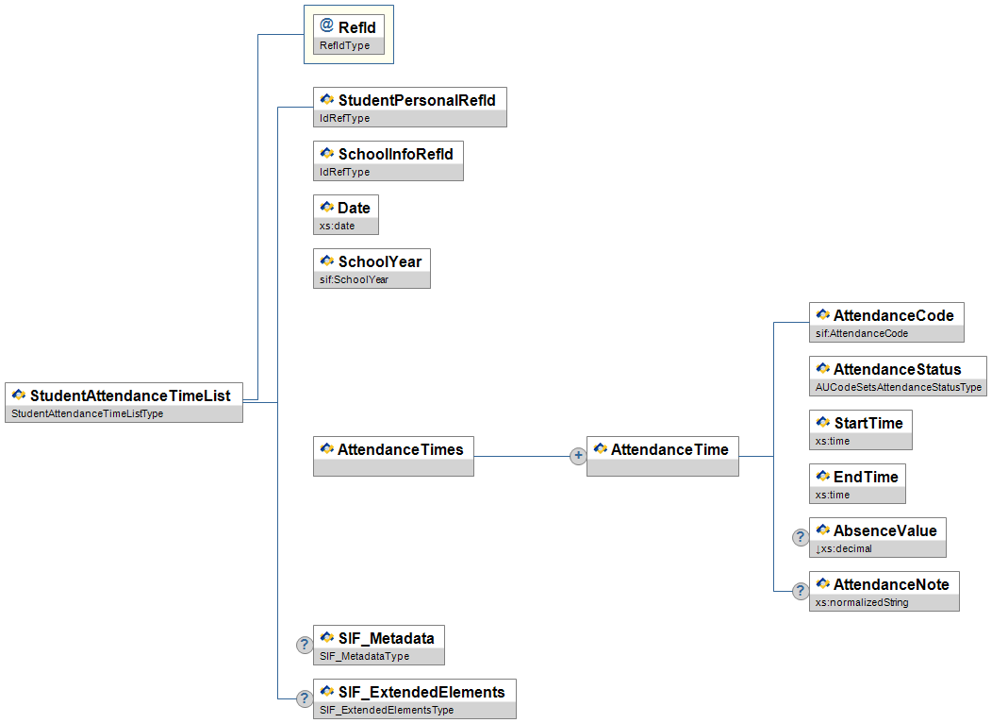
Figure 3.3.50-1: StudentAttendanceTimeList
 | Element/@Attribute | Char | Description | Type
 | StudentAttendanceTimeList |  | This object provides more detail about the attendance spans for a single student during the day: it provides more detailed information than the single TimeIn and TimeOut elements in StudentDailyAttendance.
@ | RefId | M | The ID (GUID) assigned to uniquely identify this attendance record. | RefIdType
 | StudentPersonalRefId | M | The ID (GUID) of the student for whom this attendance information is being reported. | IdRefType
 | SchoolInfoRefId | M | The ID (GUID) of the school for which this attendance information is being reported. | IdRefType
 | Date | M | The calendar date to which this attendance information relates. | xs:date
 | SchoolYear | M | School year for which this enrollment is applicable, expressed as the four-digit year in which the school year ends (e.g. 2007). | SchoolYear
 | AttendanceTimes | M | Breakdown of times that the student entered or returned to school. | List
 | AttendanceTimes/AttendanceTime | MR
 | AttendanceTimes/AttendanceTime/  AttendanceCode | M | Locally defined code for attendance. | AttendanceCode
 | AttendanceTimes/AttendanceTime/  AttendanceStatus | M | Approved or Unapproved status of this attendance code. | AUCodeSetsAttendanceStatusType
 | AttendanceTimes/AttendanceTime/  StartTime | M | The start of this particular time span. | xs:time
 | AttendanceTimes/AttendanceTime/  EndTime | M | The end of this particular time span. | xs:time
 | AttendanceTimes/AttendanceTime/  DurationValue | O | The amount of absence represented by AttendanceCode, up to three decimal places. May be greater than 1.0. | xs:decimal
  xs:minInclusive | 0
 | AttendanceTimes/AttendanceTime/  AttendanceNote | O | Note related to this particular time span. | xs:normalizedString
 | SIF_Metadata | O |  | SIF_Metadata
 | SIF_ExtendedElements | O |  | SIF_ExtendedElements
Table 3.3.50-1: StudentAttendanceTimeList

Privacy Impact
- The object is treated analogously to StudentDailyAttendance for the purposes of sensitivity.
- RefId is flagged LOW
- StudentPersonalRefId is flagged MEDIUM
- SchoolInfoRefId is flagged LOW
- Date is flagged HIGH
- SchoolYear is flagged LOW
- AttendanceTimes/AttendanceTime/AttendanceCode is flagged EXTREME
- AttendanceTimes/AttendanceTime/AttendanceStatus is flagged EXTREME
- AttendanceTimes/AttendanceTime/StartTime is flagged LOW
- AttendanceTimes/AttendanceTime/EndTime is flagged LOW
- AttendanceTimes/AttendanceTime/AbsenceValue is flagged LOW
- AttendanceTimes/AttendanceTime/AttendanceNote is flagged EXTREME
- The object overall is flagged EXTREME

XML Example

<StudentAttendanceTimeList RefId="2FFB63B4CFEF48208501E7D1E54555CB">
<StudentPersonalRefId>D3E34B359D75101A8C3D00AA001A1652</StudentPersonalRefId>
<SchoolInfoRefId>CA285746359D75101A8C36432A901A16</SchoolInfoRefId>
<Date>2002-11-01</Date>
<SchoolYear>2003</SchoolYear>
<AttendanceTimes>
<AttendanceTime>
<AttendanceCode>
<Code>200</Code>
<OtherCodeList>
<OtherCode Codeset="Local">S</OtherCode>
<OtherCode Codeset="Text">C</OtherCode>
</OtherCodeList>
</AttendanceCode>
<AttendanceStatus>01</AttendanceStatus>
<StartTime>11:00:00</StartTime>
<EndTime>12:05:00</EndTime>
<DurationValue>0.167</DurationValue>
<AttendanceNote>Left for Orthodontist appt. and returned to school afterward</AttendanceNote>
</AttendanceTime>
<AttendanceTime>
<AttendanceCode>
<Code>100</Code>
</AttendanceCode>
<AttendanceStatus>01</AttendanceStatus>
<StartTime>09:00:00</StartTime>
<EndTime>11:00:00</EndTime>
<AttendanceNote />
</AttendanceTime>
<AttendanceTime>
<AttendanceCode>
<Code>100</Code>
</AttendanceCode>
<AttendanceStatus>01</AttendanceStatus>
<StartTime>12:05:00</StartTime>
<EndTime>15:30:00</EndTime>
<AttendanceNote />
</AttendanceTime>
</AttendanceTimes>
</StudentAttendanceTimeList>

Example 3.3.50-1: StudentAttendanceTimeList Issues
- The object is intended for use instead of StudentDailyAttendance. Unlike StudentDailyAttendance, this object does not provide attendance applicable to the entire day (DayValue, AttendanceCode, AttendanceStatus, TimeIn, TimeOut, DurationValue, AttendanceNote). It is expected that the receiver of this object will calculate overall attendance data over the day, and then in turn calculate overall attendance data over a time period, which can be captured in StudentAttendanceSummary.

Codesets
Proposed new additions to SIF Validation Codes: AUCodeSetsAttendanceCodeType

NSW Code | SIF Code | Description | Comment
A | 102 | Absent – unjustified | New Code proposed
H | 613 | Shared enrolment | New Code proposed

