Hoppin Brew Social

Prepared By:
Caleb Simmons, Michael Grenon, and James Glass
Date: 4/6/2013

Database Design
Team Project 2

Table of Contents
1 Introduction 3
2 User Interface 3
2.1 Intro Page – Sortable Recipe List 3
2.2 Styles UI 4
2.3 Users UI 4
2.4 User Management UI 4
2.5 Editor UI 4
3 Application Overview 4
3.1 Implementation Overview 4
3.2 Algorithms Implementations 4
4 Database 5
5 Meeting Minutes and Distribution of Work 5

Table of Figures
Figure 1. The Transition Detection Studio User Interface. 3
Figure 2. Chi Squared algorithm. 4
Figure 3. Algorithm Block diagram 4
Figure 4. Pseudo code for ProcessImagePairs.java 5
Figure 5. Pseudo code for DetectCuts.java 5
Figure 6. Reasoning for Find Largest Gap Stop in Range 6
Figure 7. Pseudo code for Detect Cuts Filter 6
Figure 8. Pseudo code for Detect Fade Filter 8

Table of Referenced Documents
Cotsaces, C.; Nikolaidis, N.; Pitas, I.; , "Video shot detection and condensed representation. areview," Signal Processing Magazine, IEEE , vol.23, no.2, pp.28-37, March 2006

Introduction
Hoppin Brew Social is an emerging social network for beer brewing enthusiasts. Social networking is rapidly an emerging communication medium. To take advantage of the opportunities social networks offer, a concentrated approach is needed to appeal to special interest groups to succeed. Hoppin Brew Social offers enthusiasts a network promotes the sharing and rating of beer recipes. There is a large population of armature home brewers that do not have a convenient forum or organization mechanism available resulting in them not knowing the endless production possibilities they can achieve with their ingredients they have or a way to share with the world the accomplishments they have obtained. Hoppin Brew Social enables the home brewer to reach a new level in the hobby. This document briefly describes the structure of the database backing Hoppin Brew Social and the Web User Interface (WUI).
The following are three cool things about Hoppin Brew Social
- Something. Something.
- Something. Something.
- Something. Something.
There are many social network sites available but this one is better than all the others because alcohol is involved.

User Interface
Hoppin Brew Social requires an intuitive flexible UI to attract enthusiasts to use. The enthusiasts can store an image and Username to the site to represent themselves. TODO? Non users can search for beer recipe by Username to know how active people are and find users who have the same tastes for beer that they have. The site allows users to look through recipe ingredients to identify beers for which they already have the makings for. The site provides users the operations to edit and create new recipes.

Intro Page – Sortable Recipe List
Some cool information about the sortable recipe list and how you don’t even have to be logged in to see it.
Figure 1. Chi Squared algorithm.
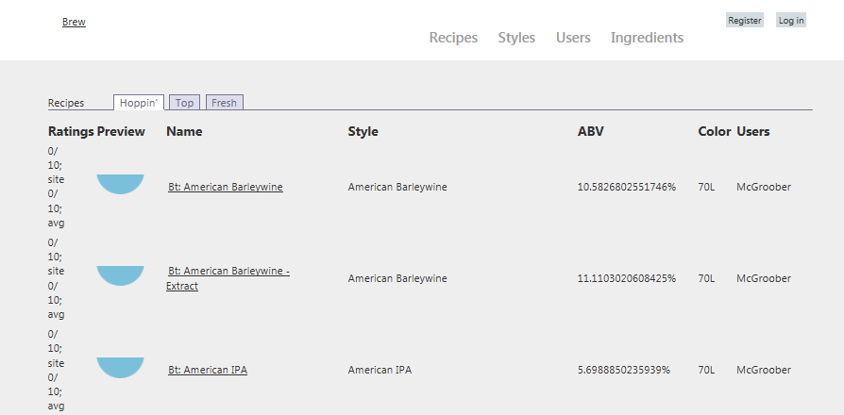

Styles UI
Some screen shots and cool stuff about the styles page.

Users UI
Some screen shots and cool stuff about the users page.

User Management UI
Some screen shots and cool stuff about the log in page and register page.

Editor UI
Some screen shots and cool stuff about the editors for hops, fermentables, yeasts, etc.

Application Overview
A short introduction to the application details.

Implementation Overview

Why Entity Framework and C# was chosen. How much I hate Microsoft and how unstable VS was. The immaturity and realized short comings of Entity Framework. The implementation is accomplished in blocks described in Figure 3.
Figure 2. Algorithm Block diagram
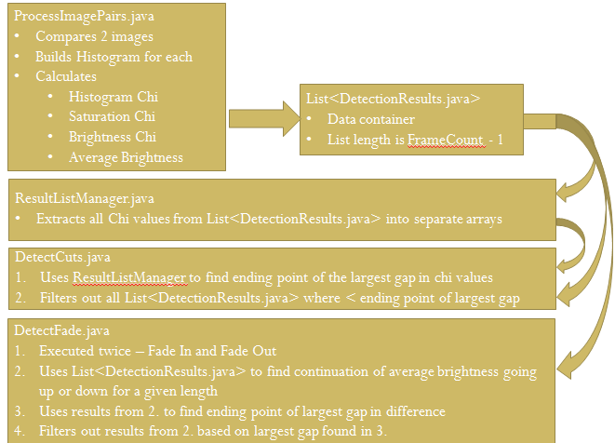

Algorithms Implementations
List out and describe the cool algorithms. Reference some figure showing pseudo code.
Figure 3. Pseudo code for ProcessImagePairs.java
Allocate Histogram Array for Image0 and Image1
Assume that Image0.size == Image1.size
brightnessChi, totalBrightness, saturationChi = 0
For x: 0 to Height

Database
A discussion of EF and some our definitions that were used to tie to the DB.

Frame Number | Detected | Noise
test0078 test0079 | True
test0148 test0149 | True

The following table lists all frames that were considered detection by the algorithm but were not by visual inspection.
Frame Number | Detected
test0003 test0004 | True
test0004 test0005 | True
test0210 test0211 | True

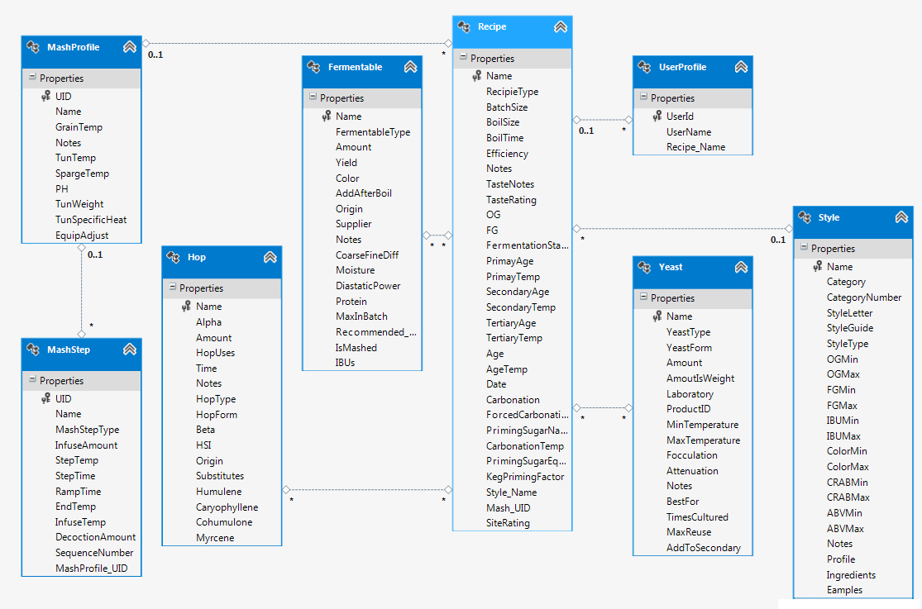

Meeting Minutes and Distribution of Work

Conclusions

