



**ZONIX**

PROJECT REPORT

**Prepared by:**

|  |  |  |
| --- | --- | --- |
| Name | Roll No | Exam No |
| Chitra Thakkar | 566 | 533 |
| Neha Jethani | 515 | 479 |
| Riddhi patel | 535 | 503 |

**Group No: 11**

Department Of Computer Science,

Faculty of Technology and Engineering

M.S.University of Baroda.





**Certificate**

This is to certify that **Chitra Thakkar,Neha Jethani & Riddhi Patel**  of B.E –IV (comp. sci & engg) have successfully completed their project under our supervision & guidance to our satisfaction for subject **“COMPUTER GRAPHICS”** for academic year 2014-2015

Date: 27/12/2014

Vadodara

Head of Computer science & Engg.

DISCRIPTION :

ZONIX is a simple game

* It is a single player game.
* In the game there are three levels.
* In the game there is a strip which has some empty space.
* It makes the two part and in each part the balls are moving.
* The player has to move the strip up and down using arrow keys.
* You have to get collected balls on one side.
* One by one as you collect balls on one side the stage will clear and the message “LEVEL COMPLETED” is shown to you.
* One by one as you increase the stages there will be increase in the number of balls in the next stage.
* If you complete all the stage then the game is finished.
* All the control keys to play are as below. \
* S – To start the game.
* H – How to play the game.

* Q – To quit the game
* Use up arrow key to move the strip up.
* Use down arrow key to move down the strip.

USE CASE DIAGRAM

|  |
| --- |
|  |

-Starting Page



-Help Menu:

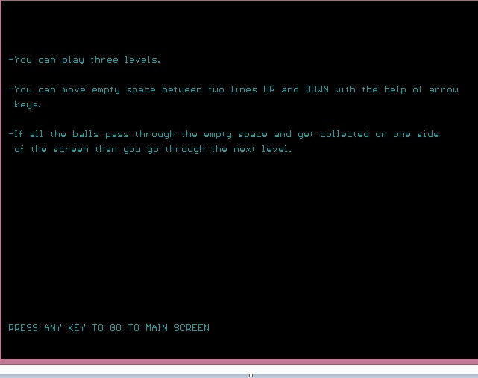

-First Level

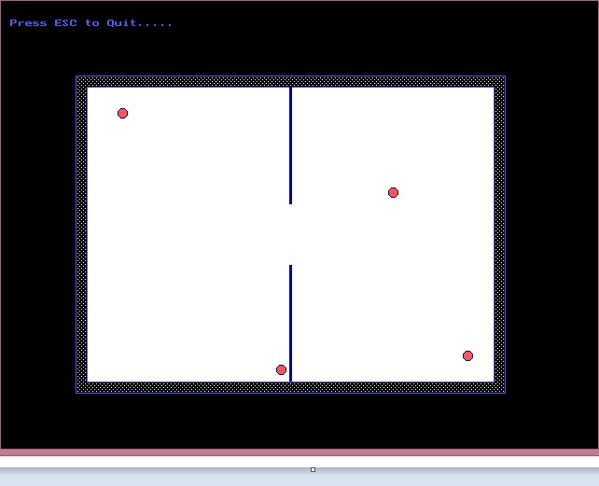

-Level completed

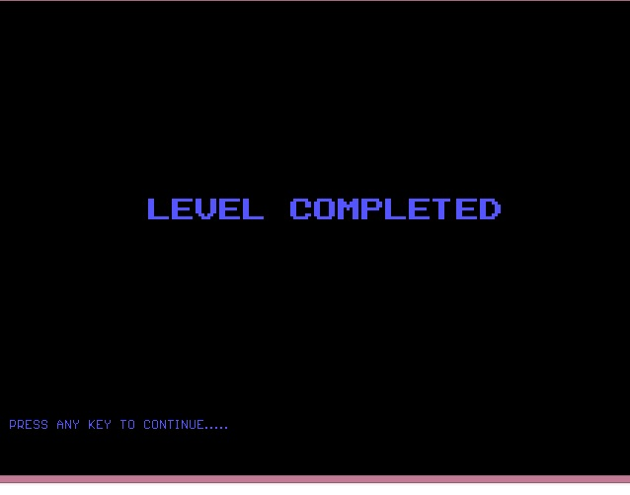

-Second Level

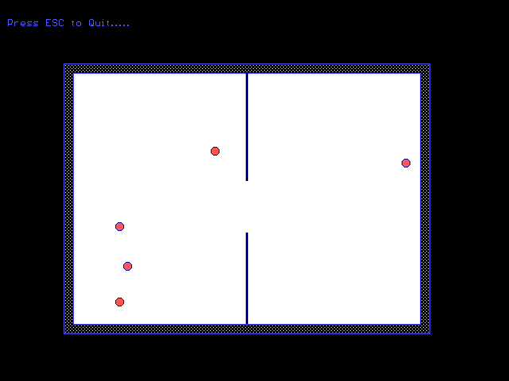

-Third level

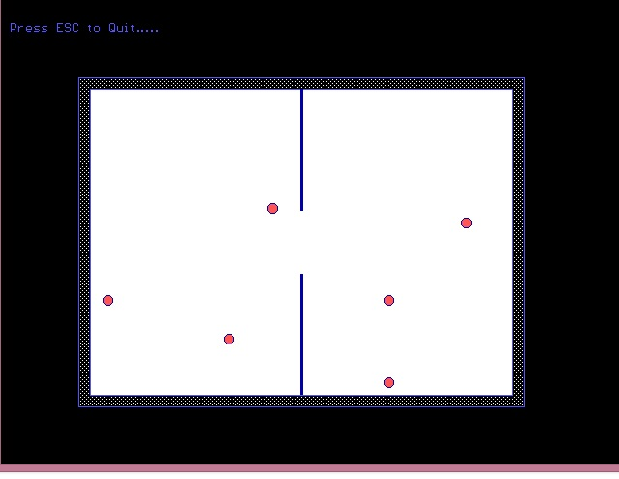

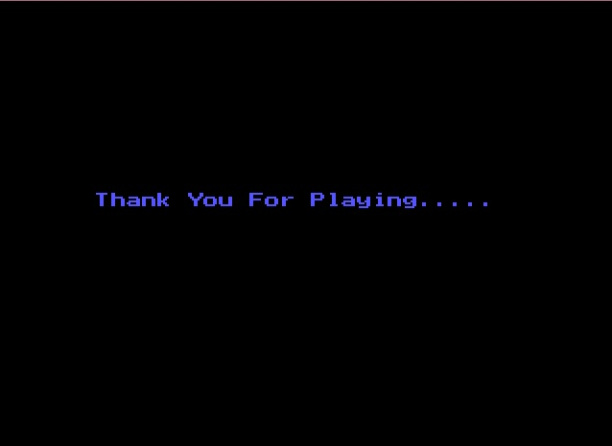

**RESOURCE REQUIREMENT:**

Turbo C, Editor-Compiler

**HARDWARE REQUIREMENTS:**

CPU : Intel Premium 4, 1.8 GB or above.

RAM : 512 MB or more.

HARD DISK : 3 GB (min).

OS : WINDOWS 98 or above