GitHub Info
GitHub Repository Link containing | https://github.com/nskabra-git/ML_Assignment2_BankMarketing
Complete source code | https://github.com/nskabra-git/ML_Assignment2_BankMarketing/tree/main/model
requirements.txt | https://github.com/nskabra-git/ML_Assignment2_BankMarketing/blob/main/requirements.txt
A clear README.md | https://github.com/nskabra-git/ML_Assignment2_BankMarketing/blob/main/README.md

Streamlit App Info
Live Streamlit App Link | https://2025aa05719-nitin-shriram-kabra-ml-assignment2.streamlit.app/

Screen Shot of BITS Virtual Lab Usage


Screen Shot of BITS Virtual Lab Usage
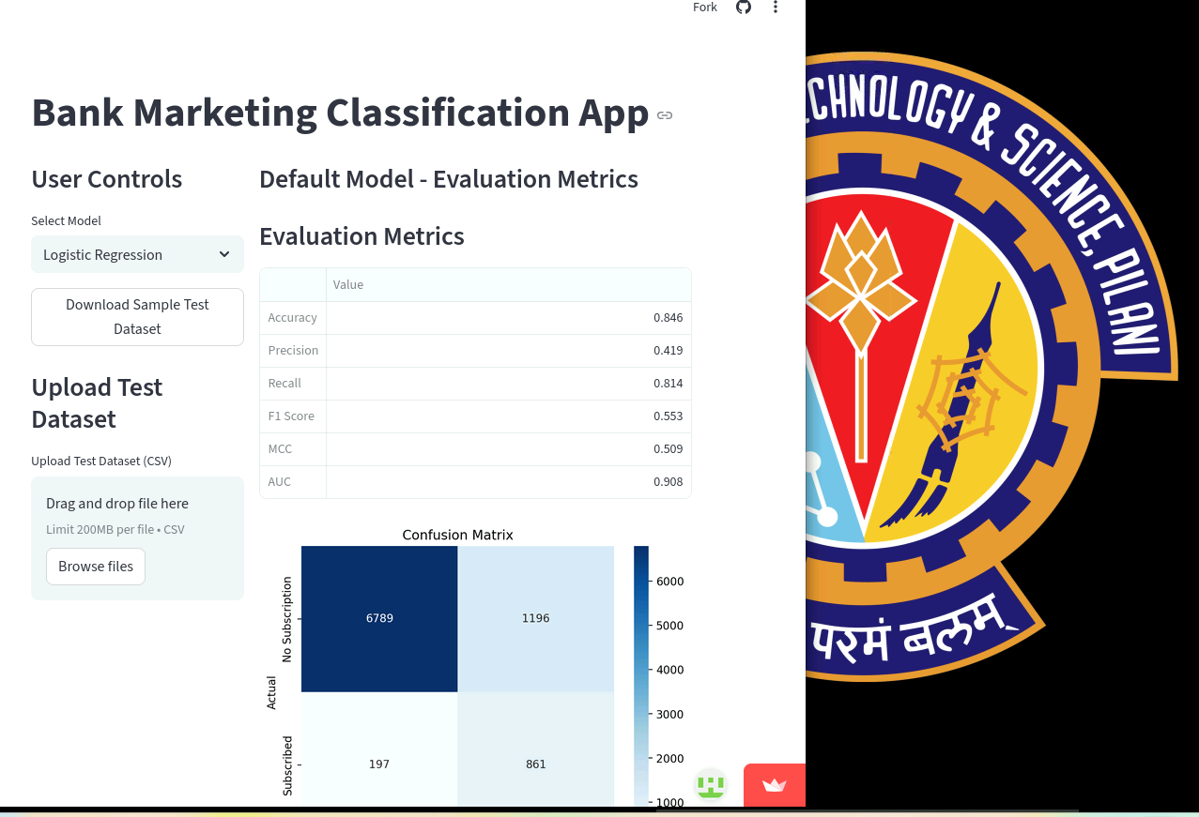

README.md

ML Assignment 2 – Bank Marketing Classification

🔍 Problem Statement
The objective of this project is to build and compare multiple machine learning models to predict whether a client will subscribe to a term deposit based on marketing campaign data.
Target variable:
y = 1 → Client subscribed to term deposit
y = 0 → Client did not subscribe

📊 Dataset
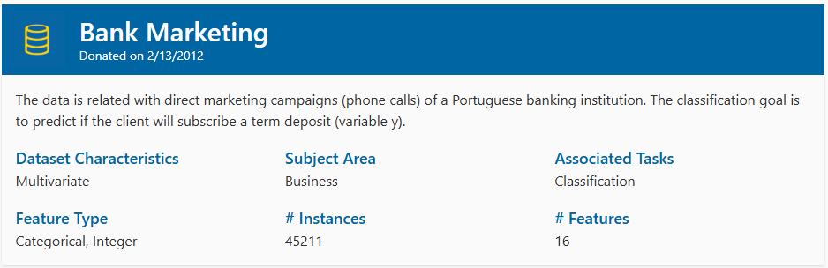
- Target: Binary classification (yes / no)
- Class imbalance:
  - No ≈ 88%
  - Yes ≈ 12%
- Source: https://archive.ics.uci.edu/dataset/222/bank+marketing
Due to class imbalance, multiple evaluation metrics were used instead of relying only on accuracy.

📁 Project Structure
ML_Assignment2_BankMarketing/
├── streamlit_app.py
├── requirements.txt
├── README.md
├── assets/
│ └── bank_marketing_dataset.png
├── data/
│ └── bank-full.csv
├── notebooks/
│ └── exploration.ipynb
├── model/
│ ├── preprocessing.py
│ ├── evaluate.py
│ ├── train_models.py
│ ├── logistic_regression_model.pkl
│ ├── decision_tree_model.pkl
│ ├── knn_model.pkl
│ ├── naive_bayes_model.pkl
│ ├── random_forest_model.pkl
│ ├── xgboost_model.pkl
│ ├── sample_test_data.csv
│ └── sample_test_with_target.csv

⚙️ Models Implemented
Six classification models were implemented and compared:
- Logistic Regression
- Decision Tree
- K-Nearest Neighbors (KNN)
- Naive Bayes
- Random Forest
- XGBoost
All models were built using a shared preprocessing pipeline.
- One-hot encoding for categorical variables
- Standard scaling for numerical variables
- Stratified train-test split (80/20)

📈 Evaluation Metrics
The following metrics were used:
- Accuracy
- Precision
- Recall
- F1 Score
- AUC (ROC)
- Matthews Correlation Coefficient (MCC)
Accuracy alone was not sufficient due to class imbalance.

🏆Model Comparison (Test Set)
Model | Accuracy | AUC | F1 Score | MCC
Logistic Regression | 0.846 | 0.908 | 0.553 | 0.509
Decision Tree | 0.878 | 0.713 | 0.488 | 0.419
KNN | 0.896 | 0.837 | 0.444 | 0.407
Naive Bayes | 0.864 | 0.809 | 0.456 | 0.380
Random Forest | 0.904 | 0.927 | 0.486 | 0.456
XGBoost | 0.908 | 0.929 | 0.561 | 0.515

📌 Key Observations
- XGBoost achieved the best overall performance across Accuracy, AUC, F1 Score, and MCC.
- Logistic Regression achieved the highest Recall, making it suitable when minimizing false negatives is important.
- Tree-based ensemble methods (Random Forest, XGBoost) handled class imbalance better than simple models.
- Accuracy alone would have been misleading due to the 88/12 class distribution.

📊 Model-wise Performance Observations
ML Model Name | Observation about model performance
Logistic Regression | Achieved strong AUC (0.908) and the highest Recall (~0.81), meaning it correctly identifies most subscribing clients. However, Precision is moderate, indicating more false positives. Suitable when minimizing missed potential subscribers is important.
Decision Tree | Shows improved Accuracy compared to Logistic Regression but relatively low AUC (0.713), indicating weaker ranking ability. Tends to overfit and does not generalize as well as ensemble methods.
KNN | Achieves high Accuracy but relatively low Recall, meaning it misses many actual subscribers. Performance is sensitive to class imbalance and feature scaling. Not ideal for this dataset.
Naive Bayes | Provides balanced but moderate performance across metrics. Assumes feature independence, which may not hold in this dataset, leading to limited predictive strength compared to ensemble models.
Random Forest (Ensemble) | Improves Accuracy and AUC significantly compared to single Decision Tree. Handles non-linear relationships well. However, Recall is lower than Logistic Regression, meaning it misses some subscribers.
XGBoost (Ensemble) | Best overall performer with highest Accuracy (0.908), AUC (0.929), F1 Score, and MCC. Provides the best balance between Precision and Recall. Most robust model for this dataset.

💻 Streamlit Application
The deployed application allows:
- Model selection via dropdown
- Downloading a sample test dataset
- Uploading a custom test dataset (CSV)
- Viewing:
  - Evaluation metrics
  - Confusion matrix (heatmap)
  - Tabulated classification report
  - Downloadable predictions

🔗 Live App:
https://2025aa05719-nitin-shriram-kabra-ml-assignment2.streamlit.app/

📦 Installation (Local Run)
pip install -r requirements.txt
python -m streamlit run streamlit_app.py

