**Java Features or Java Buzzwords**

1. Simple
2. Platform independent
3. Architecture neutral language
4. Portable
5. Robust
6. Object oriented
7. Multithreaded
8. Secure
9. Distributed
10. Compile and interpreted
11. High performance
12. Dynamic

**Java is Simple:**

* Java is easy to learn as we don’t need to have any experience in coding.
* The most of the complex features or concepts from other languages are hidden or removed by the Java. Here pointers feature is hidden.
* The program is in a human understandable form like simple English language.

**Java is a platform independent:**

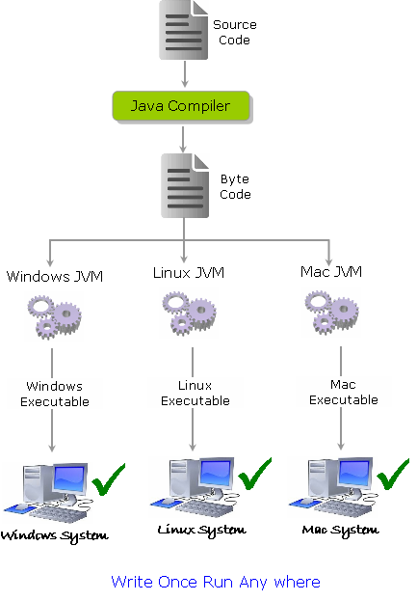

**“Write Once Run Anywhere” - WORA**

* Java is a platform independent because it works in any platform without changing the source code. This is done by the java virtual machine.
* JVM converts the byte code into machine executable form and it is responsible for execution. Here JVM is platform dependent.

**Java is an architecture neutral language:**

* If we perform any changes in the underlying architecture like changing the processor or upgrading the operating system will not affect the java program and no need to update the source code.

**Java is a portable language:**

* We can migrate java program from one platform to another platform without performing any changes in the java program.

**Java is secure:**

* All the code is converted into byte code after compilation, which is not readable by human.
* Now this code is loaded into JVM. In between these byte codes verifier is available. This verifier will check whether that byte code is valid or not if is found any illegal activity it will give the error messages.

**Java is an object oriented language:**

* Object Oriented programming is a programming style which is associated with the concepts like class, object, Inheritance, Encapsulation, Abstraction, Polymorphism. Java has all these concepts.

**Java is a multithreaded:**

* Initially any program starts execution sequentially this will leads to increases the waiting time.java has a feature that multithreading with this program can be spitted into threads and we can execute those threads parallel.
* JVM won’t do automatically we have to write program for that parallel execution. some of the thread classes are thread, runnable etc.

**Java is robust:**

Simply robust means strong. The chance of getting failed a java program is very less. This is done by the following reasons,

* Java is a strongly typed programbecause of this property any type errors will exist those errors are identified by the compiler.
* It saves the memory occupied by the unused functions by introducing the garbage collection in java which runs on the Java Virtual Machine to get rid of objects which are not being used by a Java application anymore. Hence performance (Speed) also improves.
* Java also supports an exception handling.it won’t terminate the program and It will redirect some other program when exception handling occurs.

Some of keywords are try, catch and finally.

**Java is distributed:**

* Java is distributed because it facilitates users to create distributed applications in Java. RMI and EJB are used for creating distributed applications. This feature of Java makes us able to access files by calling the methods from any machine on the internet.Because of this property it handles the following tasks,
* Load balancing
* Fail over

**Java is compiled and interpreted:**

* Here the compiler will identify all the errors occurred. Hence there is no burden on the interpreter. It just translates the byte code into machine understandable code and it will execute the code.

**Java is highperformance:**

* Java comes with an hotspot JVM feature. Here hotspot JVM means JVM with JIT compiler. This JIT compiler isresponsible for just in time operations means any operation is repeated regularly it will store that result and uses when it Is required. Hence performance improved.

**Java is dynamic:**

* Java follows load on demand technique.It loads the class files at runtime. Anything that happens at runtime is **considered**as **dynamic**.