Teacher Experience and Pay, and Student Tested Achievement

Nick Mader (nsmader@gmail.com)

# Background

This project uses public, aggregate data from Massachusetts to demonstrate the use of open-source tools including:

* the [R programming language](https://www.r-project.org/) for reading, preparing, visualizing, and analyzing data;
* [Quarto](https://quarto.org/) for formatting and generation of technical documents using principles of reproducible research; and
* [git](https://git-scm.com/), for version control.

All of the materials for producing this report, and for making use of version control in doing so, can be found on GitHub at the following link: https://github.com/nsmader/repro-research-demo.

# Literature

The education literature includes several rigorous studies of the impact of teacher experience on student achievement, including Huang & Moon (2009) and Ladd & Sorensen (2017). This analysis is not one of them. Here, we explore district aggregate patterns in Massachusetts–which entails the strong possibility of [ecological fallacy](https://en.wikipedia.org/wiki/Ecological_fallacy)–but for the sake of demonstrating the use of the tools mentioned above, while relying on publicly accessible data.

# Data

Data is drawn from the Massachusetts state Department of Education.

## District Characteristics

Univariate distribution plots show that percentages of students meeting or exceeding proficiency standards in English and Language Arts (ELA) and Mathematics, as well as the percent of teachers classified as experienced and average pay have wide distributions across the state of Massachusetts. There is a long left tail in the distribution of rates of teacher experience across districts, but there is notable variation between 75-100%.

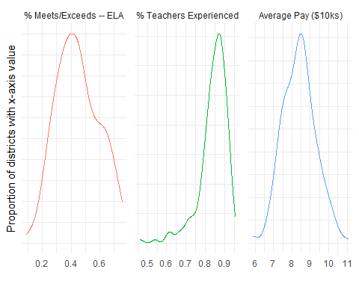

Looking at bivariate distributions between the percent of students meeting/exceeding proficiency standards for different subjects and teacher experience shows strong positive relationships.

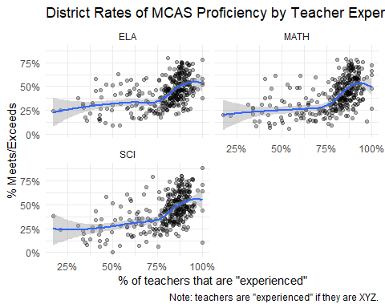

Note that districts vary widely by poverty rate. Figure 1 respectively shows district poverty rates across the state (Figure 1 (a)) and with detail in the Boston area (Figure 1 (b)).

|  |  |  |
| --- | --- | --- |
| |  | | --- | | (a) State-Wide |  |  | | --- | | (b) Metro Boston |   Figure 1: Poverty Rate for Massachusetts School Districts |

Table 1 shows a selection of district characteristics, comparing districts that are above versus below the state-wide median poverty across districts.

Table 1: District Statistics for Low vs High Poverty Districts

| **Characteristic** | **Pov < Median**, N = 103 | **Pov > Median**, N = 103 |
| --- | --- | --- |
| % Meets/Exceeds – ELA | 0.40 (0.32, 0.47) | 0.52 (0.36, 0.64) |
| % Experienced Teachers | 0.85 (0.81, 0.88) | 0.87 (0.83, 0.90) |
| Average Teacher Pay ($1000s) | 8.28 (7.54, 8.79) | 8.49 (7.98, 9.11) |
| Student-to-Teacher Ratio | 11.30 (10.60, 12.25) | 12.20 (11.60, 12.90) |

# Methods

To explore multivariate relationships, we make use of ordinary least squares, with the closed form captured in Equation 1.

# Results

Table 2 shows regression results for analysis of each student subject.

Table 2: Estimated Coefficients by Subject

| Subject | **Characteristic** | **Beta** | **SE** | **p-value** |
| --- | --- | --- | --- | --- |
| ELA | % Experienced Teachers | 1.043 | 0.095 | **<0.001** |
|  | Average Teacher Pay ($1000s) | 0.046 | 0.008 | **<0.001** |
|  | Student-to-Teacher Ratio | -0.018 | 0.005 | **<0.001** |
|  | Poverty Rate (10 pct pts) | 0.149 | 0.022 | **<0.001** |
| MATH | % Experienced Teachers | 1.134 | 0.098 | **<0.001** |
|  | Average Teacher Pay ($1000s) | 0.051 | 0.008 | **<0.001** |
|  | Student-to-Teacher Ratio | -0.012 | 0.005 | **0.023** |
|  | Poverty Rate (10 pct pts) | 0.172 | 0.023 | **<0.001** |
| SCI | % Experienced Teachers | 1.075 | 0.107 | **<0.001** |
|  | Average Teacher Pay ($1000s) | 0.037 | 0.009 | **<0.001** |
|  | Student-to-Teacher Ratio | -0.016 | 0.005 | **0.003** |
|  | Poverty Rate (10 pct pts) | 0.160 | 0.025 | **<0.001** |

# Bibliography

Huang, F. L., & Moon, T. R. (2009). Is experience the best teacher? A multilevel analysis of teacher characteristics and student achievement in low performing schools. *Educational Assessment, Evaluation and Accountability*, *21*(3), 209–234. <https://doi.org/10.1007/s11092-009-9074-2>

Ladd, H. F., & Sorensen, L. C. (2017). Returns to Teacher Experience: Student Achievement and Motivation in Middle School. *Education Finance and Policy*, *12*(2), 241–279. <https://doi.org/10.1162/EDFP_a_00194>