A6

cis 310-01

Nicole Smith

2017

1.

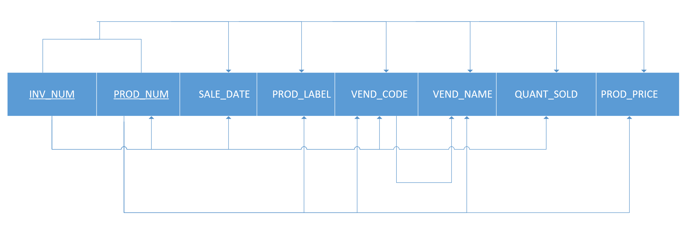

2. The table is in 1NF because all the key attributes are defined. Where each column and row intersect there is only one and only one value, therefore no repeating groups throughout the table. All attributes in the table are also dependent on the composite primary key.

3. The table is not in 2NF because it includes partial dependencies. To be in 2NF you must rid the table of partial dependencies and it must already be in 1NF.

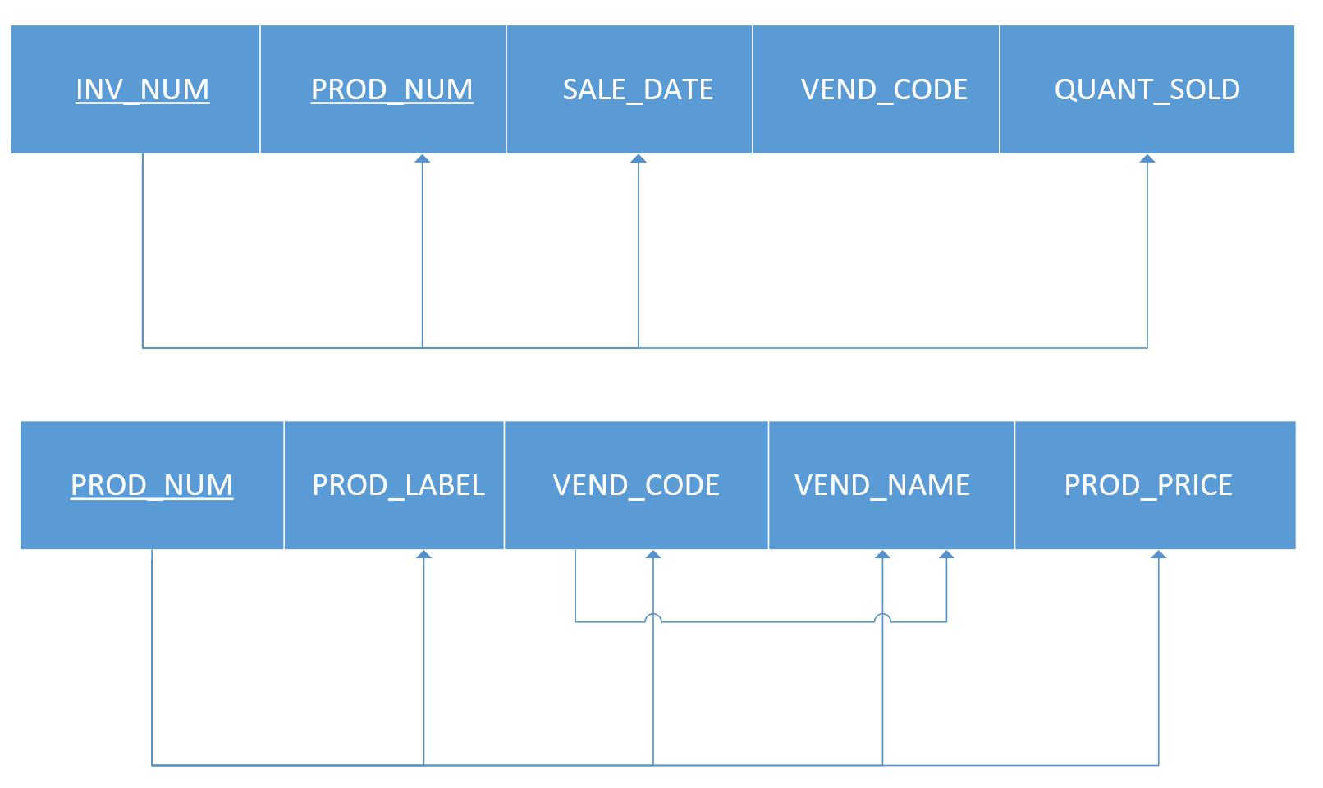

4. The table is not in 3NF because it contains a transitive dependency. To be in 3NF you must rid the table of transitive dependencies and it must already be in 2NF.

