astercc user manual v0.04

Fist login
Access your WEB-based user interface such as http://yourhost/astercc, the login page will be displayed. Use the default User name: admin and default password: admin to login.
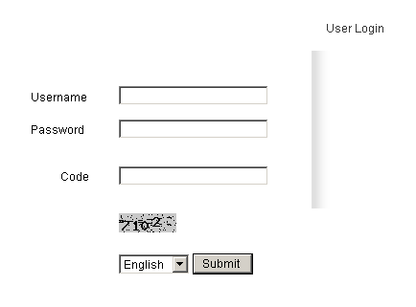
You will see all of operation item on the top of page after login, contain following item in there: Account | Account Group | Reseller Group | Report | Rate to Customer | Rate to Callshop | Rate to Reseller | Clid | Import | CDR | Logout.
You can find the functions of these items and how to use them by following content.

***Account***
This item uses to manage user login account. It would be appeared in the interface of Admin user, Reseller user and Groupadmin user. You can see an account which User name, Password and User type all be ‘admin’ when you login first as admin in this item, and we suggest you change the User name and Password of admin for system safety.
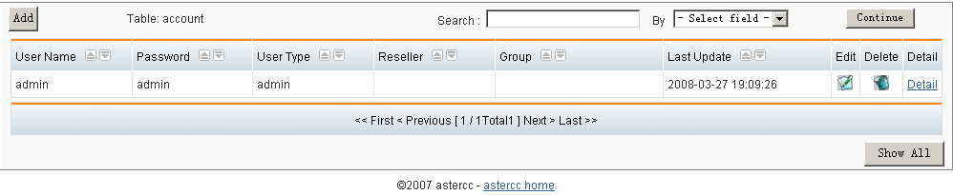
It contains four types user account, these user types are ‘Admin’, ‘Reseller’, ‘Groupadmin’ and ‘Operator’.
Add an account:
As an Admin user, you can add users with all the types.
As a Reseller user, you can add two types of user, they are groupadmin and operator.
As a Groupadmin user, you can only add one type of user, it is operator.
Click the ‘Add’ button on top left corner of account table to add a new account, and then the ‘Adding Account’ interface will be display:
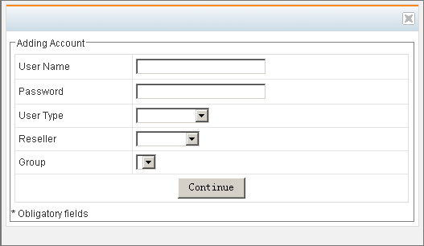
First you should fill in the User Name, Password and select User Type, and then if you want to add a Reseller user, you must select a Reseller group(It must be add in Reseller Group before you add a Reseller user) for new account, else if you want to add a Groupadmin user, you must select a Reseller and a Group (they must be add in Reseller Group and Account Group before you add a Groupadmin user, and the account group belong to the reseller group) for new account, the last step, just click the Continue button to finish adding.

Search:
You can search the account in this table, fill the content you want to search in the blank fields following the ‘Search:’, and select the field of search by, click the continue button to search and display result.

Other operation:
You can edit, delete and view the account in Account interface by corresponding button at the end of account row which you want to operate.
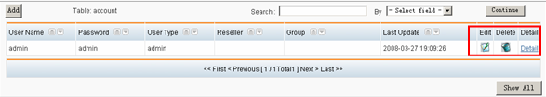

***Account Group***
This item uses to manage account group.
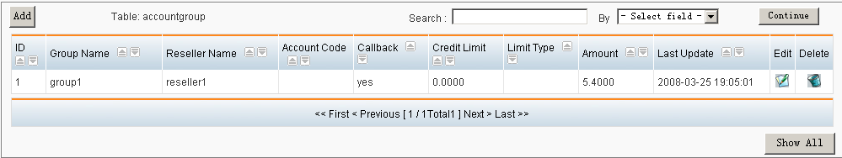
Add an account group:
Click the ‘Add’ button on top left corner of accountgroup table to add a new account group, and then the ‘Add group’ interface will be display:
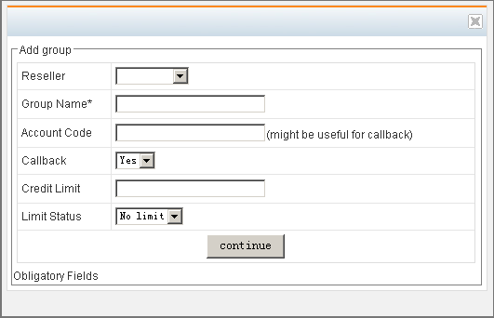
Reseller: which Reseller group the new account group belongs to, at least there is a reseller group can be selected, this field can not be blank.
Group Name: give a name for new account group, this field can not be blank.
Account Code:
Callback: select if the new account group can use callback, default is ‘yes’.
Credit Limit: define the credit limit of new account group. It’s would be no limit if it’s blank.
Limit Status: select the limit status of new account group is ‘Prepaid’ or ‘Postpaid’ or ‘No limit’.
Select and fill the fit content and click continue button to finish adding.

Search:
You can search the account group in this table, fill the content you want to search in the blank fields following the ‘Search:’, and select the field of search by, click the continue button to search and display result.

Other operation:
You can edit and delete the account group in Account Group interface by corresponding button at the end of account group row which you want to operate.
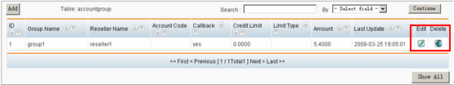
***Reseller Group***
This item uses to manage reseller.
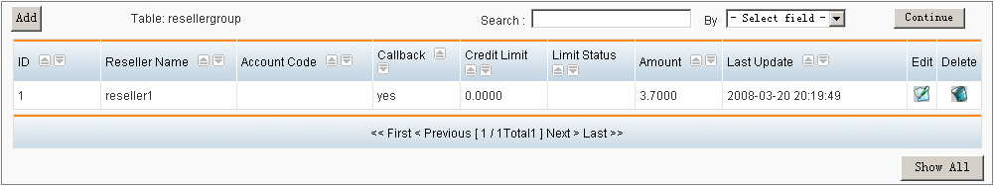
Add a reseller:
Click the ‘Add’ button on top left corner of resellgroup table to add a new reseller, and then the ‘Add group’ interface will be display:
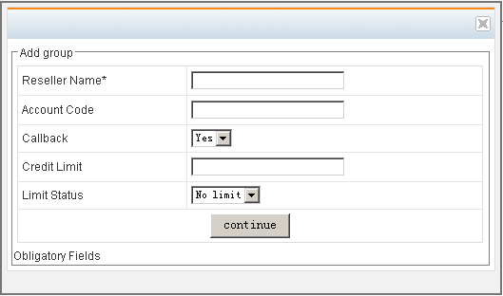
Reseller Name: give a name for new reseller, this field can not be blank.
Account Code:
Callback: select if the new reseller can use callback, default is ‘yes’.
Credit Limit: define the credit limit of new reseller. It’s would be no limit if it’s blank.
Limit Status: select the limit status of new reseller is ‘Prepaid’ or ‘Postpaid’ or ‘No limit’.
Select and fill the fit content and click continue button to finish adding.

Search:
You can search the reseller in this table, fill the content you want to search in the blank fields following the ‘Search:’, and select the field of search by, click the continue button to search and display result.

Other operation:
You can edit and delete the reseller in Reseller Group interface by corresponding button at the end of reseller row which you want to operate.
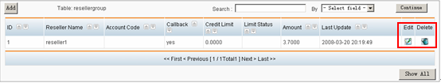
***Report***
This item uses to check out Amount, Callshop cost and Reseller cost.
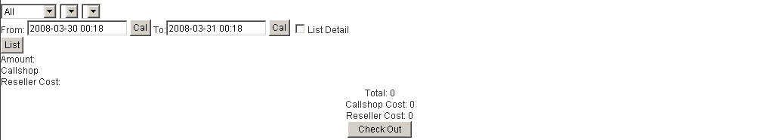
You can see three drop-down list boxes on the first line, the first box use to select the reseller, the second box use to select the account group, and the last one use to select the clid or callback. You can select the period of list on the second line, and if you haven’t checked the check box of List Detail, you will see the all of amount, callshop cost and reseller cost which meet you prescribed conditions (see the figure ‘List A’), else if you checked that box, you will see the detail record lines, and then you can check each line you need and click the ‘Check Out’ button to check out the cost you need, or check the box ‘All’ to check out all cost of records (see the figure ‘List B’).

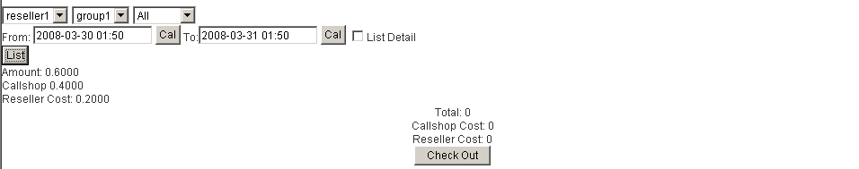
List A
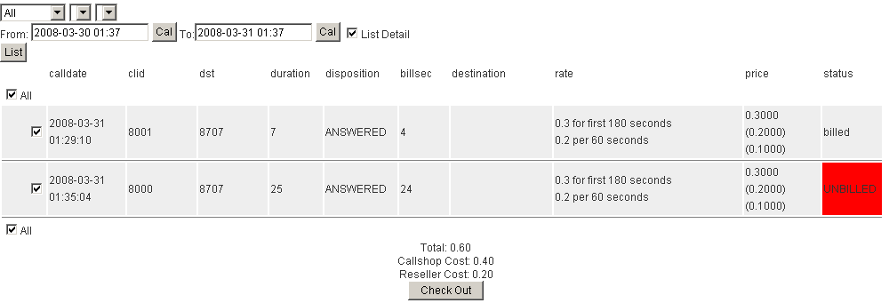
List B
***Billing police of system***
Before you add a rate sheet, you must learn the billing police of this system.
There are three rate tables in system: myrate, callshoprate and reseller rate. When someone is making a call, the billing system will search the myrate table at first, if there is a rate line which matched by prefix or number length in myrate, that would billing the call by this rate line; if there isn’t a rate line can be matched by prefix or length in myrate, then would billing the call by default rate line in myrate, but if there is not a default rate line in myrate, well then the billing system will search the callshoprate table to billing the call, if there is a rate line which matched by prefix or number length in callshoprate, that would billing the call by this rate line; if there isn’t a rate line can be matched by prefix or length in callshoprate, then would billing the call by default rate line in callshoprate, but if there is not a default rate line in callshoprate, well then the billing system will search the resellerrate table to billing the call, if there is a rate line which matched by prefix or number length in resellerrate, that would billing the call by this rate line; if there isn’t a rate line can be matched by prefix or length in resellerrate, then would billing the call by default rate line in resellerrate, but if there is not a rate line in system, then can’t billing the call.

***Rate to Customer***
This item uses to define the rate of customer.
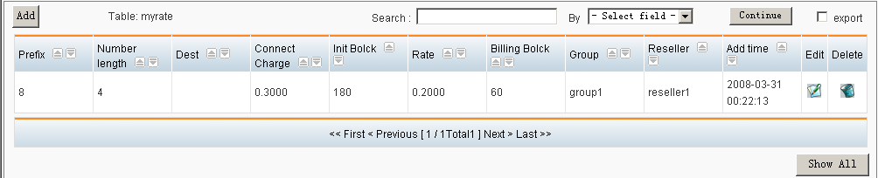

Add a new customer rate
Click the ‘Add’ button on top left corner of myrate table to add a new customer rate, and then the ‘add rate’ interface will be display:
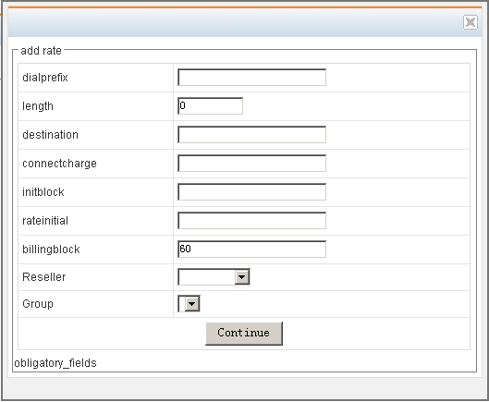
Dialprefix: define the prefix of destination number for this rate; if you want to set this rate to be a default rate, you should fill ‘default’ in this blank field.
Length: define the length of destination number, the default is ‘0’, all length will be matched if it be ‘0’.
Destination: describe dials to which country or area uses this rate.
Connectcharge: define the connection charge, it rate for initblock.
Initblock: define length of init block it works with connectcharge.
Rateinitial: define the based rate per billingblock, it rate for a calling except initblock.
Billingblock: define the length of billingblock, it works with rateinitial.
Reseller: define this rate using in which reseller.
Group: define this rate using in which group (call shop) that belong to reseller define in this interface.
Select and fill the fit content and click continue button to finish adding.

Search and export:
You can search the rate in this table, fill the content you want to search in the blank fields following the ‘Search:’, and select the field of search by, click the continue button to search and display result. If you have checked the export check box, the result will be exported to your local machine as a CSV file.

Other operation:
You can edit and delete the rate by corresponding button at the end of rate row which you want to operate.
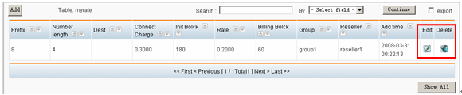

***Rate to Callshop***
This item uses to define the rate of callshop.
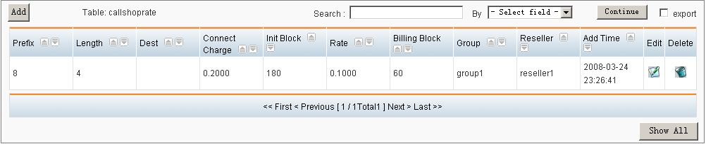

Add a new callshop rate
Click the ‘Add’ button on top left corner of callshoprate table to add a new rate, and then the ‘add rate’ interface will be display:
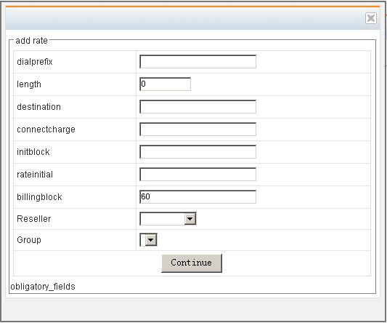
Dialprefix: define the prefix of destination number for this rate; if you want to set this rate to be a default rate, you should fill ‘default’ in this blank field.
Length: define the length of destination number, the default is ‘0’, all length will be matched if it be ‘0’.

Destination: describe dials to which country or area uses this rate.
Connectcharge: define the connection charge, it rate for initblock.
Initblock: define length of init block it works with connectcharge.
Rateinitial: define the based rate per billingblock, it rate for a calling except initblock.
Billingblock: define the length of billingblock, it works with rateinitial.
Reseller: define this rate using in which reseller.
Group: define this rate using in which group (call shop) that belong to reseller define in this interface.
Select and fill the fit content and click continue button to finish adding.

Search and export:
You can search the rate in this table, fill the content you want to search in the blank fields following the ‘Search:’, and select the field of search by, click the continue button to search and display result. If you have checked the export check box, the result will be exported to your local machine as a CSV file.

Other operation:
You can edit and delete the rate by corresponding button at the end of rate row which you want to operate.
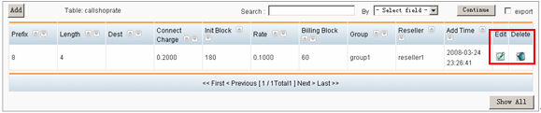

***Rate to Reseller***
This item uses to define the rate of reseller.
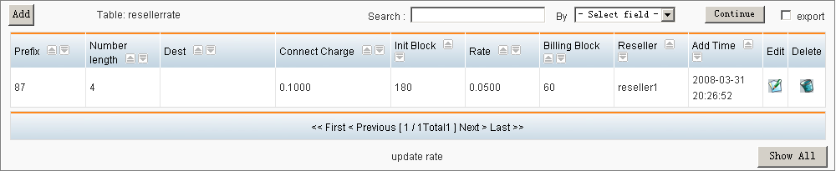
Add a new reseller rate
Click the ‘Add’ button on top left corner of resellerrate table to add a new rate, and then the ‘add rate’ interface will be display:
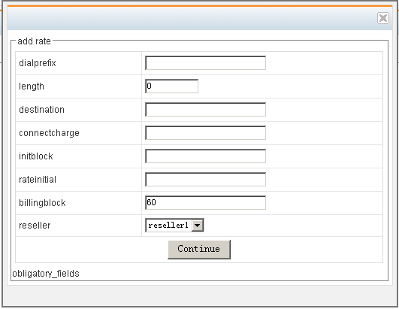
Dialprefix: define the prefix of destination number for this rate; if you want to set this rate to be a default rate, you should fill ‘default’ in this blank field.
Length: define the length of destination number, the default is ‘0’, all length will be matched if it be ‘0’.
Destination: describe dials to which country or area uses this rate.
Connectcharge: define the connection charge, it rate for initblock.
Initblock: define length of init block it works with connectcharge.
Rateinitial: define the based rate per billingblock, it rate for a calling except initblock.
Billingblock: define the length of billingblock, it works with rateinitial.
Reseller: define this rate using in which reseller.
Select and fill the fit content and click continue button to finish adding.

Search and export:
You can search the rate in this table, fill the content you want to search in the blank fields following the ‘Search:’, and select the field of search by, click the continue button to search and display result. If you have checked the export check box, the result will be exported to your local machine as a CSV file.

Other operation:
You can edit and delete the rate by corresponding button at the end of rate row which you want to operate.

***Clid ***
This item uses to manage clid.
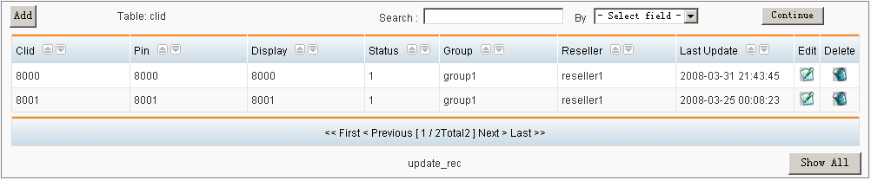
Add a reseller:
Click the ‘Add’ button on top left corner of resellgroup table to add a new reseller, and then the ‘Add group’ interface will be display:
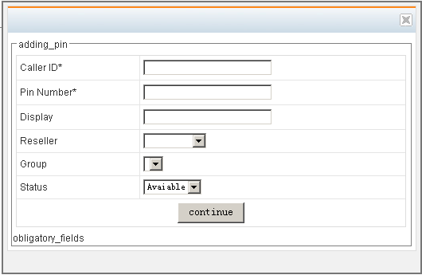
Call ID: define the clid id, it must be an account in asterisk and this account would be billing as a user of callshop.
Pin Number: it is account id of clid, and it’s also the password for clid login.
Display: define the name which display in booth box.
Reseller: select which reseller this clid belong to.
Group: select which group this clid belong to.
Status: select if this clid be available or locked.
Select and fill the fit content and click continue button to finish adding.

Search:
You can search the clid in this table, fill the content you want to search in the blank fields following the ‘Search:’, and select the field of search by, click the continue button to search and display result.

Other operation:
You can edit and delete the clid in this interface by corresponding button at the end of reseller row which you want to operate.
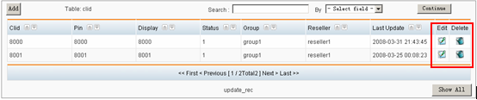

***Import***
This item uses to import the rate sheet.
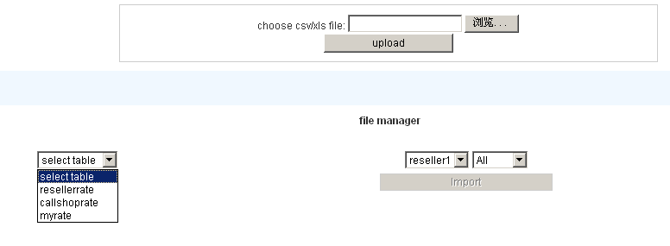
Upload your rate sheet:
The rate sheer must be a CSV or xls file, and the file path must be all English word;
For example, there is one rate record in yourrate.xls, such as:
Upload this file and you will see the page turn to following figure:
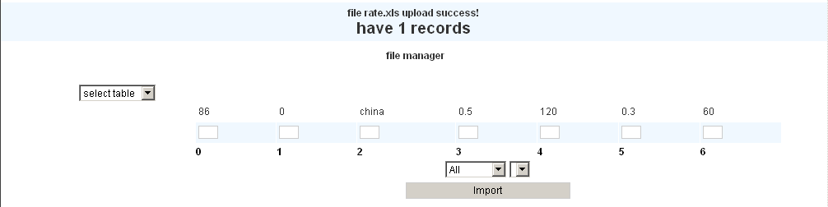
When the file has been uploaded, you should select the table name from selecttable box, the number and content of field of the table you selected will display, and then fill the corresponding number of field in the corresponding blank field under the content of new record you upload.
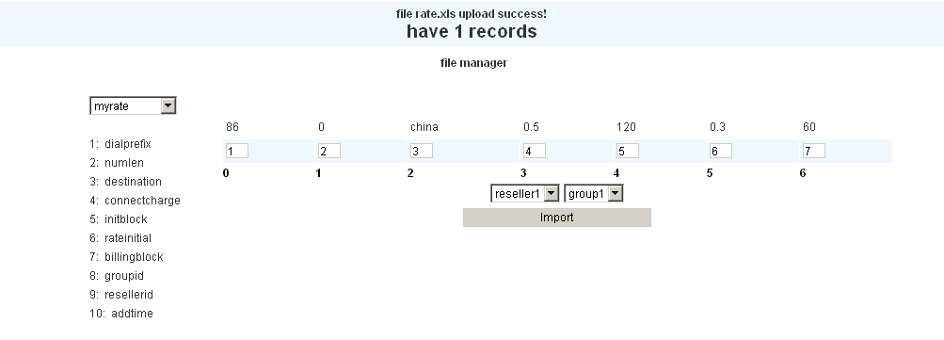
Then select the reseller and group for this rate, just click the ‘Import’ button to finish importing.

***CDR***
This item uses to view clid CDR.
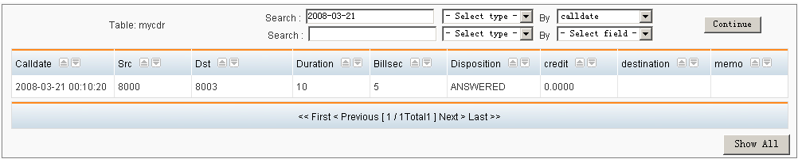
Enter this page you can view all CDR of clid belong to you.

Search:
You can search the CDR in this table, fill the content you want to search in the blank fields following the ‘Search:’, and select the search type (=, <,>, like) and field, click the continue button to search and display result.

***Booth management***
If you login as groupadmin or operator user, you will see the booth management interface, such as following figure:
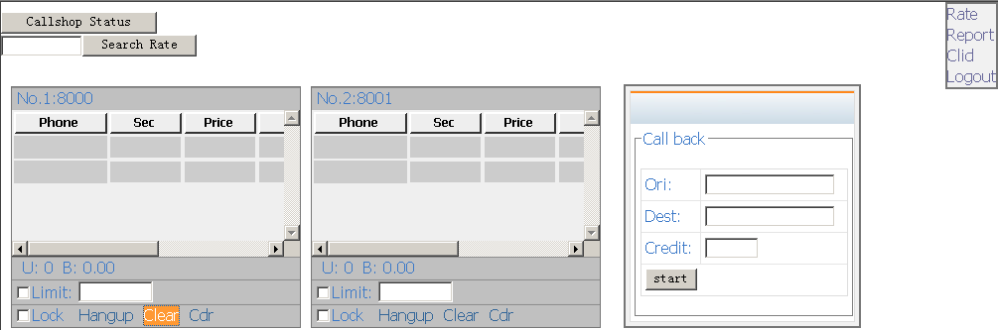

Calling:
When a customer is calling, you can view it real-time in booth box, such as following figure:
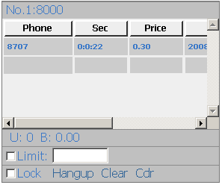
Set credit limit:
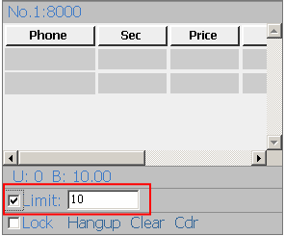
You can set the credit limit for this custom in the booth box, just fill the credit amount in blank field and checked the ‘Limit’ check box, when the cost of this call more than credit amount, the call will be hung up forced.
Lock a clid:
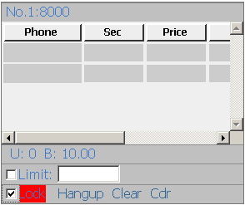
You can set the credit limit for this custom in the booth box, just checked the ‘Lock’ check box, and then the color of ‘Lock’ will turn to red, now, this clid can’t dial to any destination.
Hang up a calling:
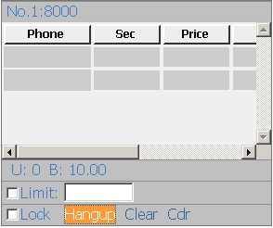
You can click the ‘Hangup’ button in booth box to hang up the current call forced.
Clear a Booth:
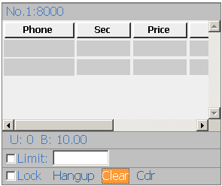
When a customer finished one or many calls and have already paid to you, you can click the ‘Clear’ button to finish this booth.
Viewing CDR:
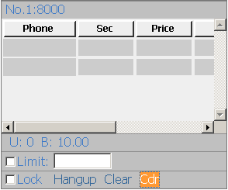
You can click the ‘Cdr’ button to view CDR of this clid:
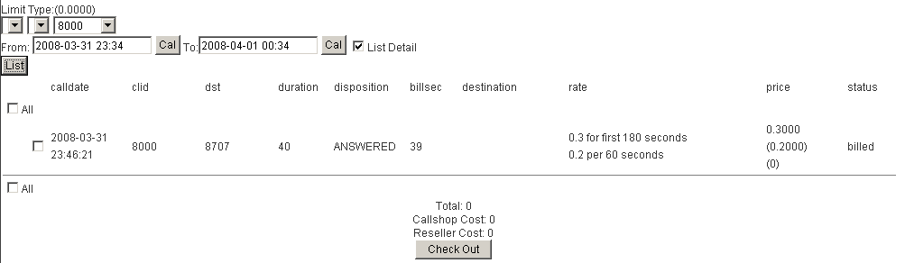
Callback:
If the current login account can use call back function, you can see a callback box in this page.
When you want to use call back, you just fill the ‘Ori’ and the ‘Dest’ number in call back box, and then click the ‘start’ button; now, a callback process will be created, then a new booth box for callback will appear in page. You can set credit amount for the callback.
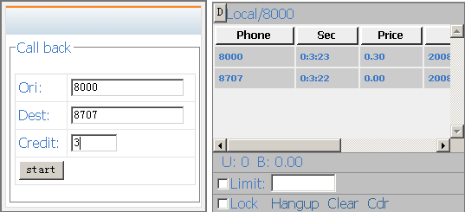
Click the ‘D’ button on callback booth box to delete it when this callback booth finished.

