# READ BEFORE RUNNING YOLO BYPASS HEC-RAS2D MODEL

## Introduction

Hello and thank you for your interest in our model. We would ask that you familiarize yourself with HEC-RAS 2D interface before beginning any investigation or experimentation into our particular application of the model. Please be sure that you understand the requisite input files, HEC-RAS warnings and errors, and have read this document before you start manipulating the model files.

This project was built in HEC-RAS 5.0.3 and it is recommended that you use this version or earlier.

## Terrain

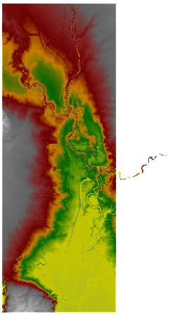Due to file size limitations by GitHub, the terrain file has been uploaded into ## TIFF tiles titled July2016_2m#.tif where # is 0 through 20. The schematic for these tiles can be seen here:

|  |  |  |
| --- | --- | --- |
| **0** | **1** | **2** |
| **3** | **4** | **5** |
| **6** | **7** | **8** |
| **9** | **10** | **11** |
| **12** | **13** | **14** |
| **15** | **16** | **17** |
| **18** | **19** | **20** |

In order to use the terrain tiles, you need to create a new terrain file using RAS Mapper.

Once Mapper is open, right click on the Terrain tree in the contents pane and select “Create New Terrain…”

*If prompted, set the spatial reference to the file named: NAD_1983_UTM_Zone_10N.prj

In the window that pops up, add the 21 tiles using the button. The order should not matter here.

Uncheck Create Stitches, .

Once all the tiles are added, select a location for your terrain file, and a filename and then press .

This process will take quite a bit of time, depending on the speed of your computer.

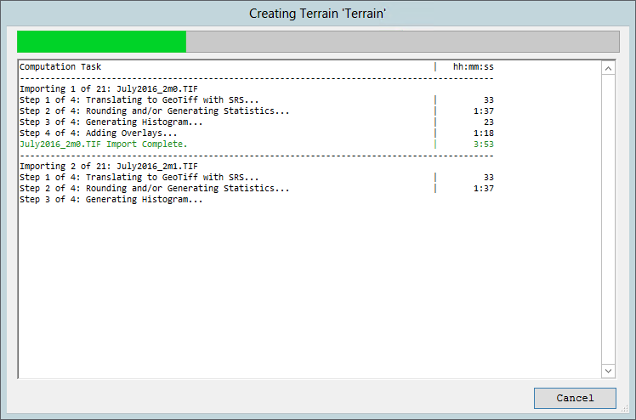You should see a window that is similar to the following:

Once the file is built, there will be an hdf file and 21 component parts. The files will be yourfilename.July2016_2m1.hdf, yourfilename.July2016_2m2.hdf, etc.

This final hdf file will be the Terrain file that is used for the RAS project.

## Plans / Simulation Periods

The current version of the model has 1 plan corresponding to a simulation period.

|  |  |  |
| --- | --- | --- |
| **Plan Title** | **Start Date/Time** | **End Date/Time** |
| February 2009 | 05FEB2009 00:00 | 31MAR2009 00:00 |

Before running a plan, go to RAS Mapper and right click on the geometry associated with the plan you’re running and select Compute 2D Elements. This computes all of the element relationships in each cell in the 2D Flow Areas.

## Boundary Condition Data

It is important to note that if you are to run a simulation for a period which is not included or already set by the plans listed above, that a couple of things need to happen.

In either case, the Georgiana Slough boundary condition time series needs to be adjusted to match the simulation period desired. Because of the nature of this boundary, the flows are at times negative. RAS does not like to begin a simulation with negative inflows. In order to remedy this situation, complete the following steps:

* Open the Georgiana Slough boundary condition editor
  + Select “Read from DSS”
  + Click “Plot/Tabulate Data”
    - Select the entire Flow column and copy it
    - Close the tabulated window
  + Select “Use Manual Data”
  + Paste the data into the manual entry table
  + Delete the first row and change the flow to 1 m3/s
  + Copy the first row and select the next 6 rows and paste
    - This should leave 5 blank rows after the first row
  + Select “Fill missing values linearly”