Windows command line operations, from standard keyboard input.

**Input screen: - welcome screen**

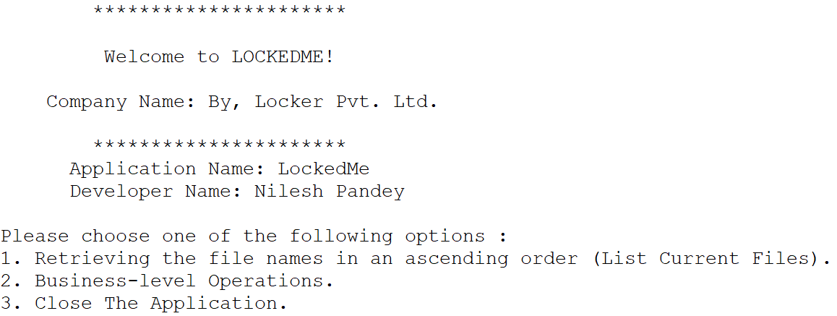

**output screen: -1 Display all Files (In Ascending Order).**

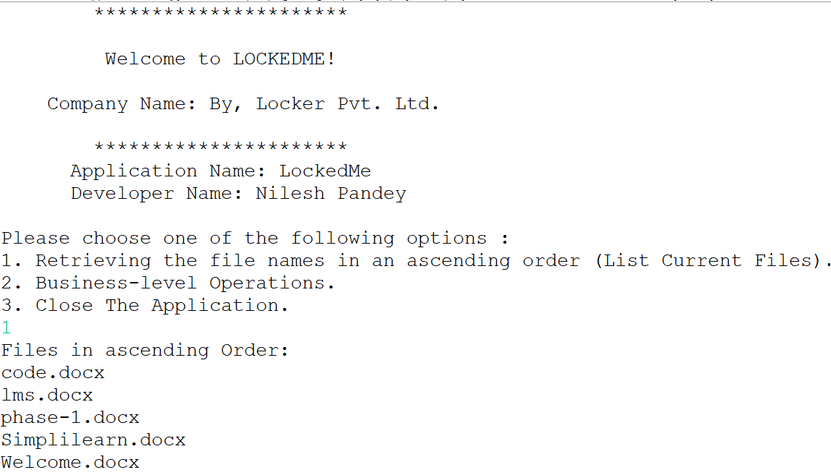

**output screen: -2 (**Add a new file in given projectFilesPath)

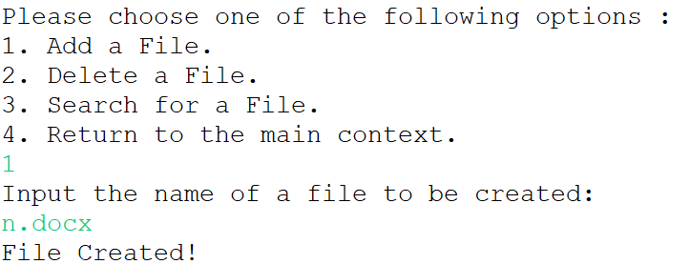

**output screen: -3(**Delete a file**)**

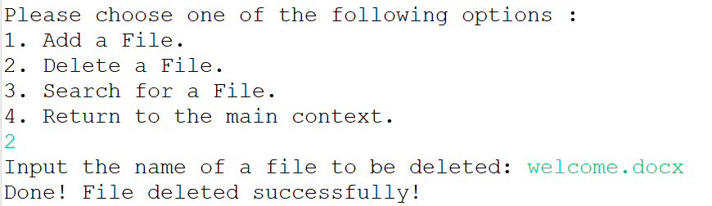

**output screen: -4(**Search a file.**)**

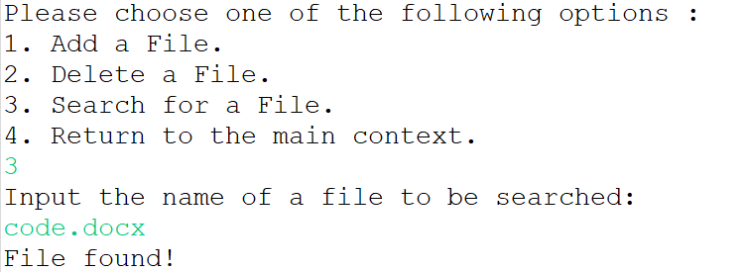

**output screen: -5(**File not found.**)**

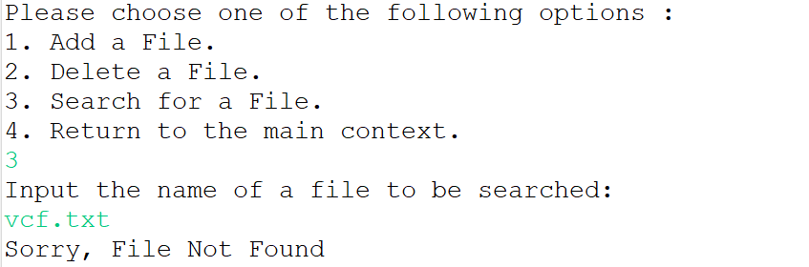

**output screen: -6(**Exit from current context.**)**

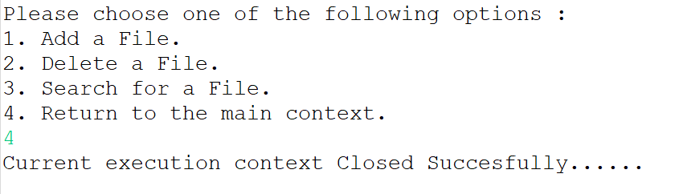

**output screen: -7(**Exit from application.**)**

