# Project Details:

This project aims to design and develop a backend administrative portal for the

Learner’s Academy using Java EE technologies. I developed it as a project of phase 2 for the Become a back-end expert course. The goal of this project is to apply servlet, jsp and JDBC concepts.

# Product Backlog:

1. Create database and tables.
2. Connect the database to the project.
3. Create models classes.
4. Create a database utility class to retrieve data.
5. Create JSP files for all pages of the project.
6. Create a servlet to get requests and send responses to the JSP files.
7. Debug and Test the project.

# Technologies and tools Used

* Servlet: to do the business logic and works a controller for the project.
* JSP: to handle the presentation view.
* SQL: to create and manage the database.
* JDBC: to make operations on the database for the project.
* Eclipse: to write and run the code.
* Tomcat: to run and deploy servlet application.

# Flowcharts of The Application:

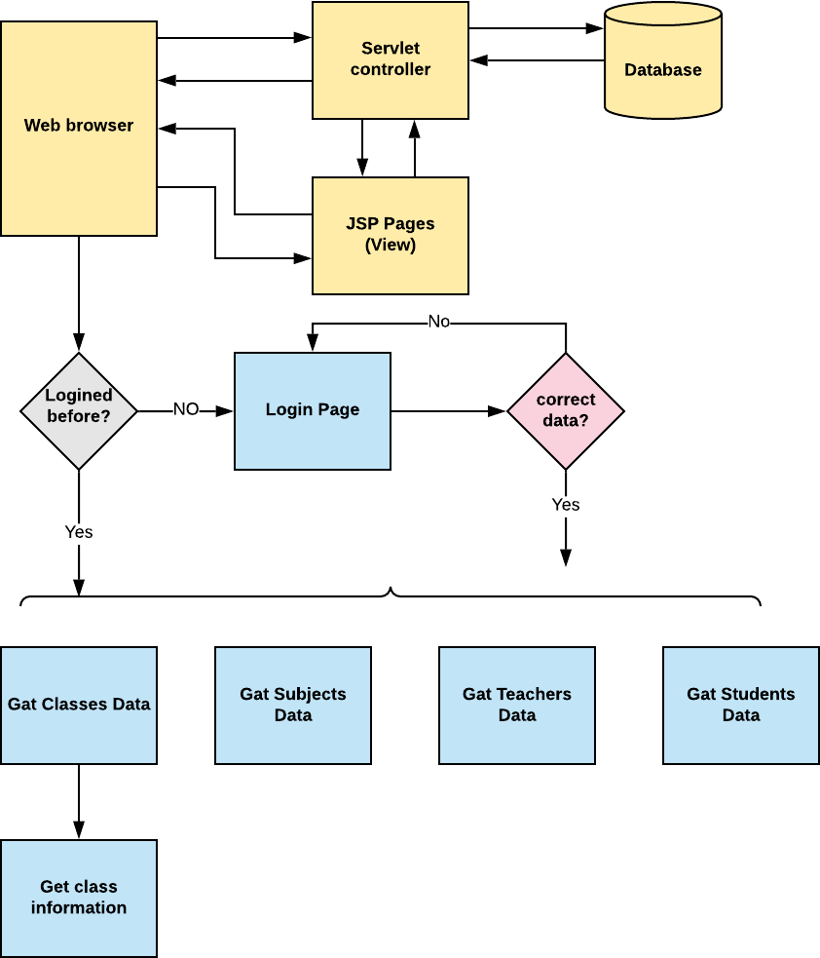

**Core concepts used in the project:**

* Object-Oriented: used to create and model objects for users and their credentials.
* Databases: used to store and retrieve data.
* Data Sources: used to define a set of properties required to identify and access the database.
* Collections: used some collections such arraylist to store collection of data.
* Exception Handling: used to catch problems that arises in the code especially in I/O

blocks.