**Screenshots**

Home Page:

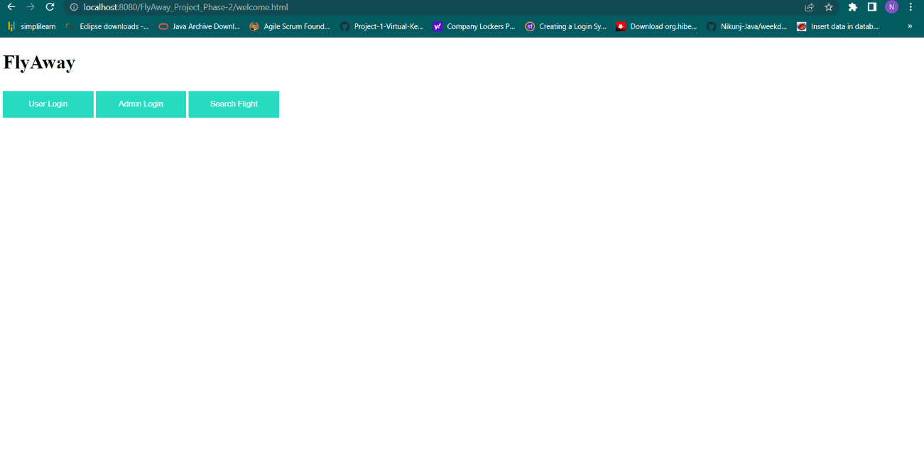

User Page:

1. User Login Page:

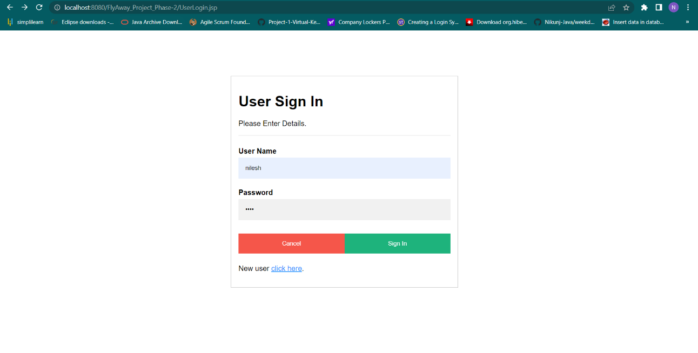

1. Search Flight:

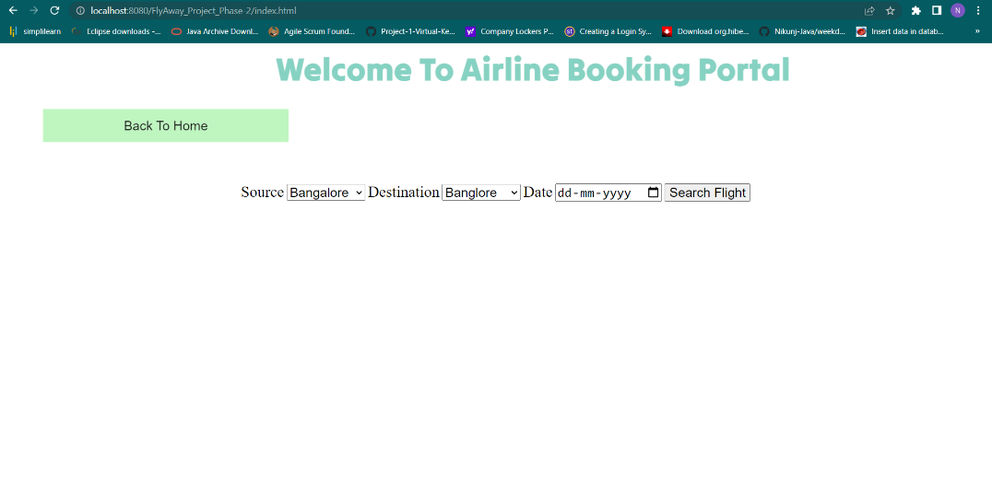

1. List Flight & Click on Book Flight:

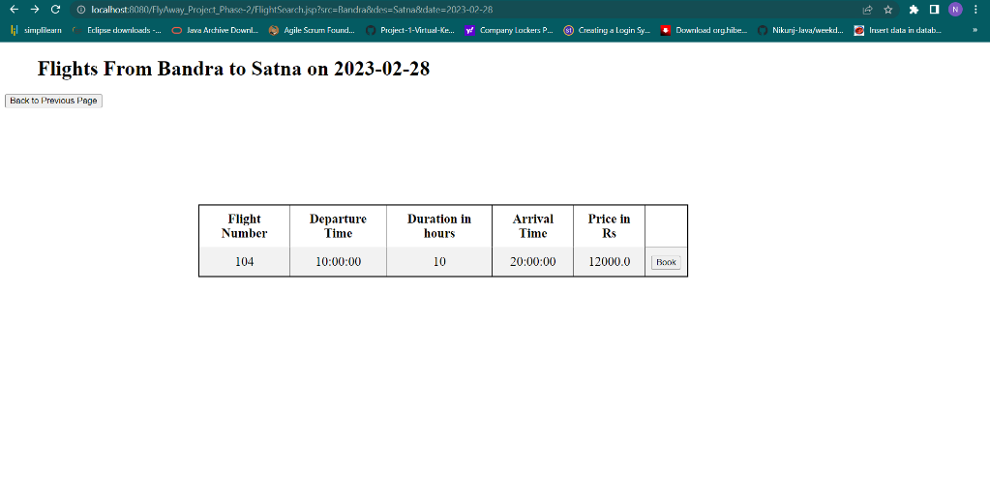

1. Passenger Details and Process payment:

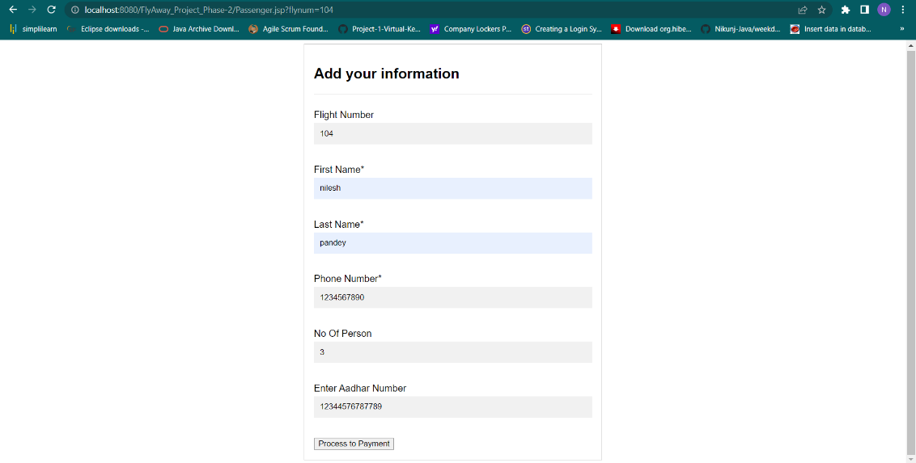

1. Payment Details and Booking Details:

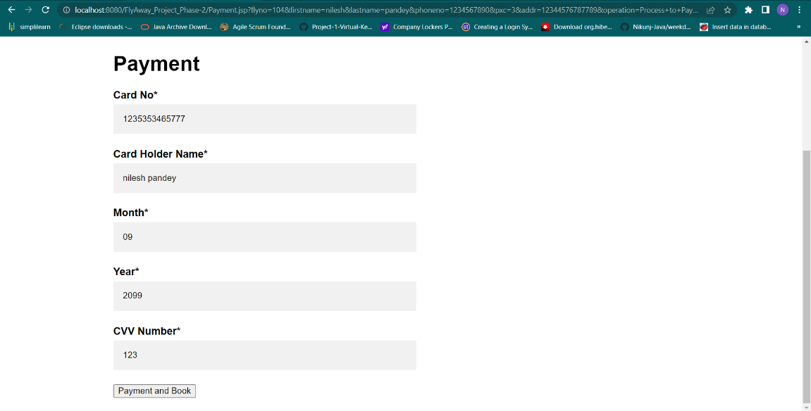

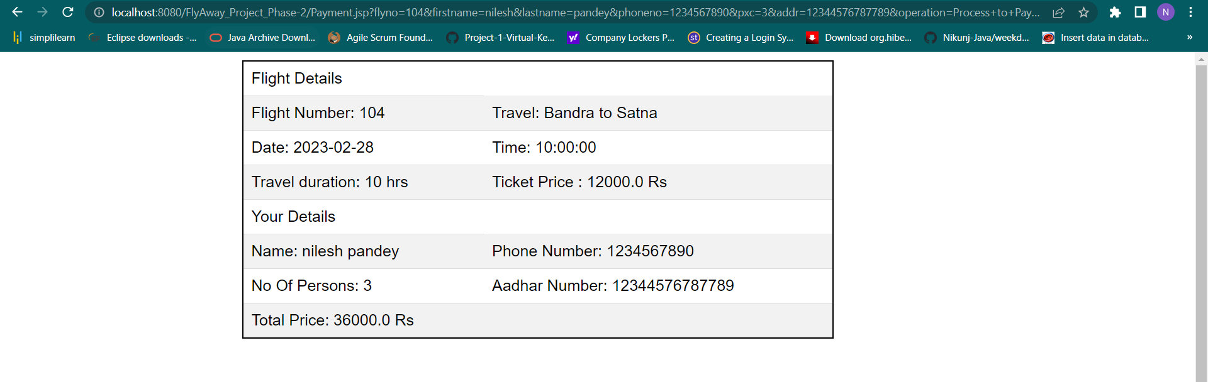

1. Booked Flight Successfully:

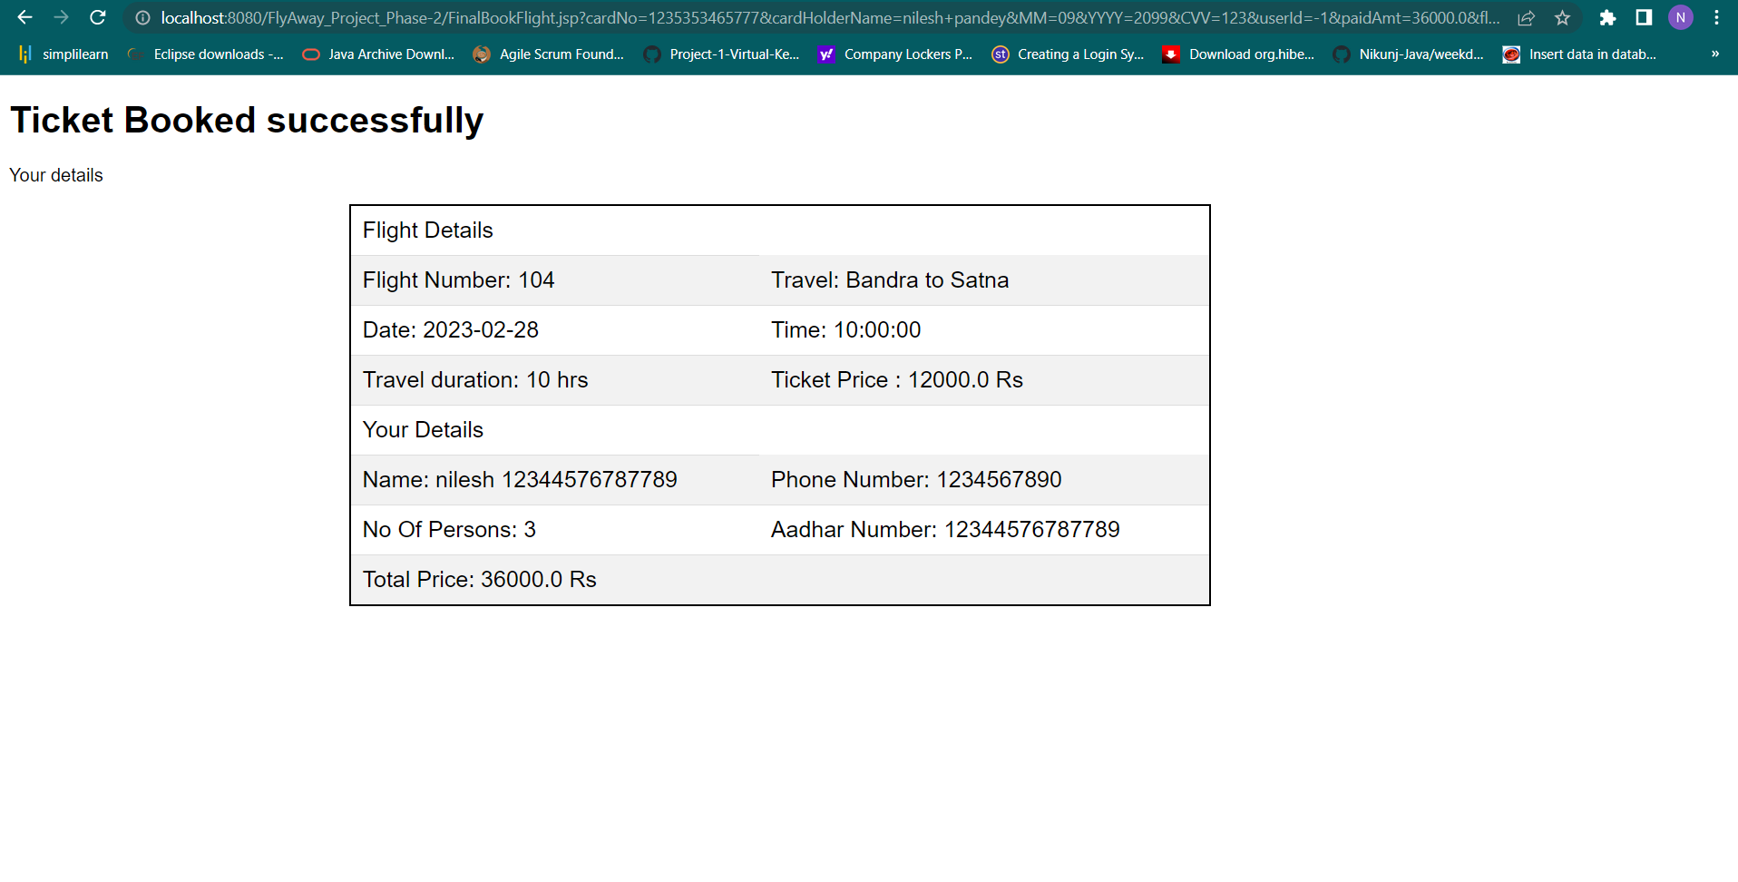

1. User Sign Up Page And after sign up user successfully signup:

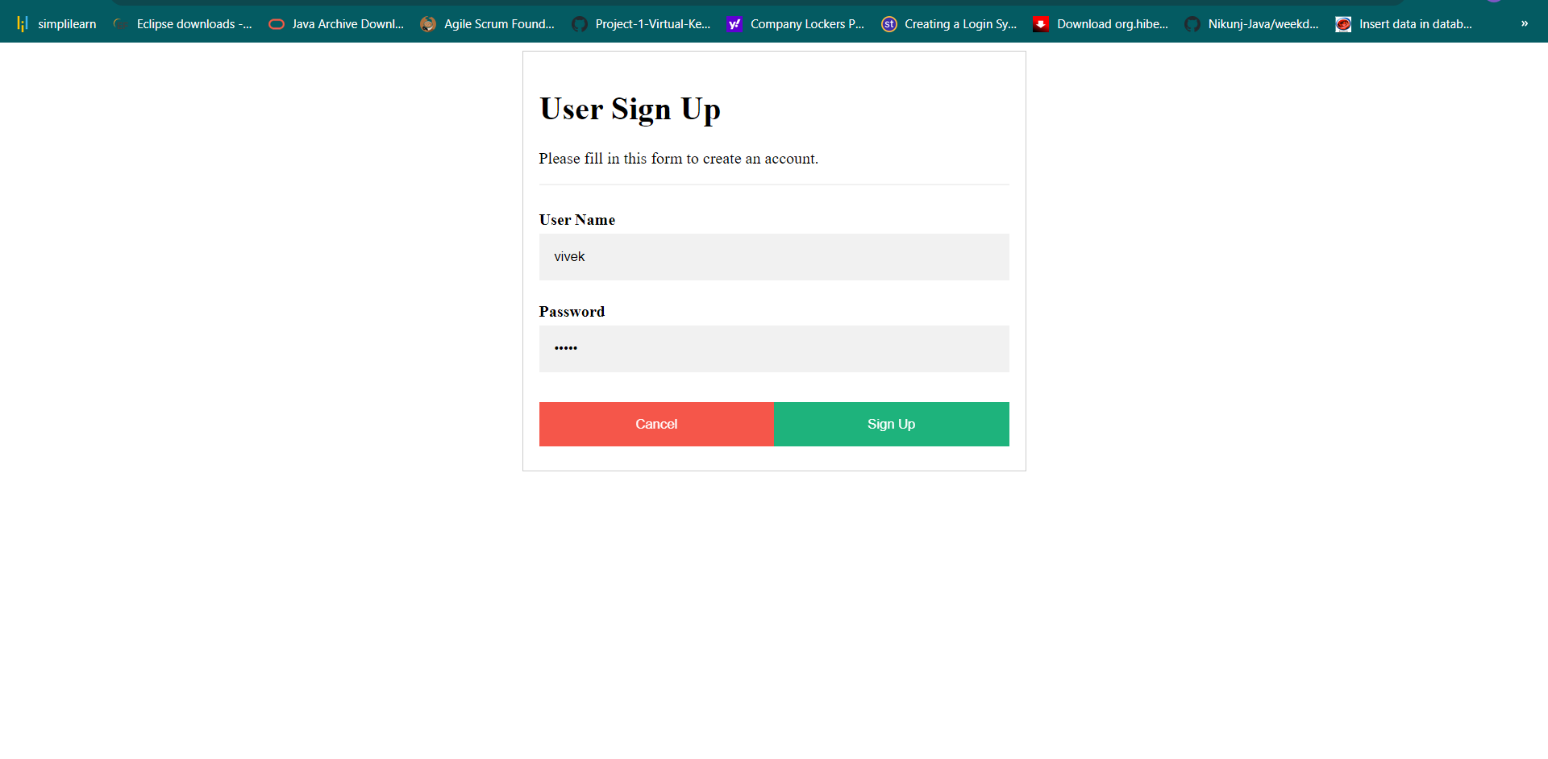Admin Page:

1. Admin Login and after clicking sign in admin successfully login:

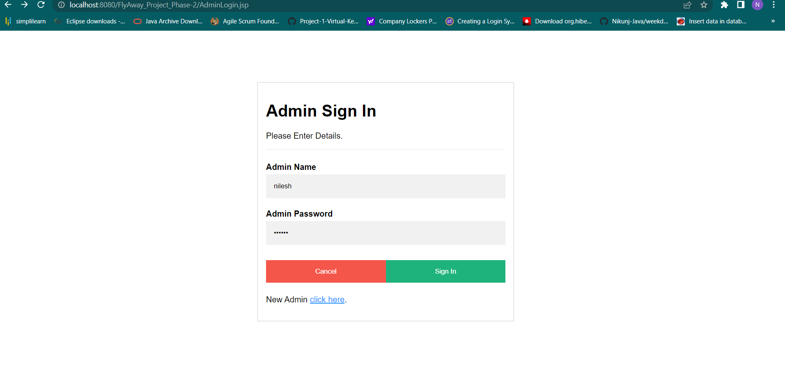

1. Admin Home Page:

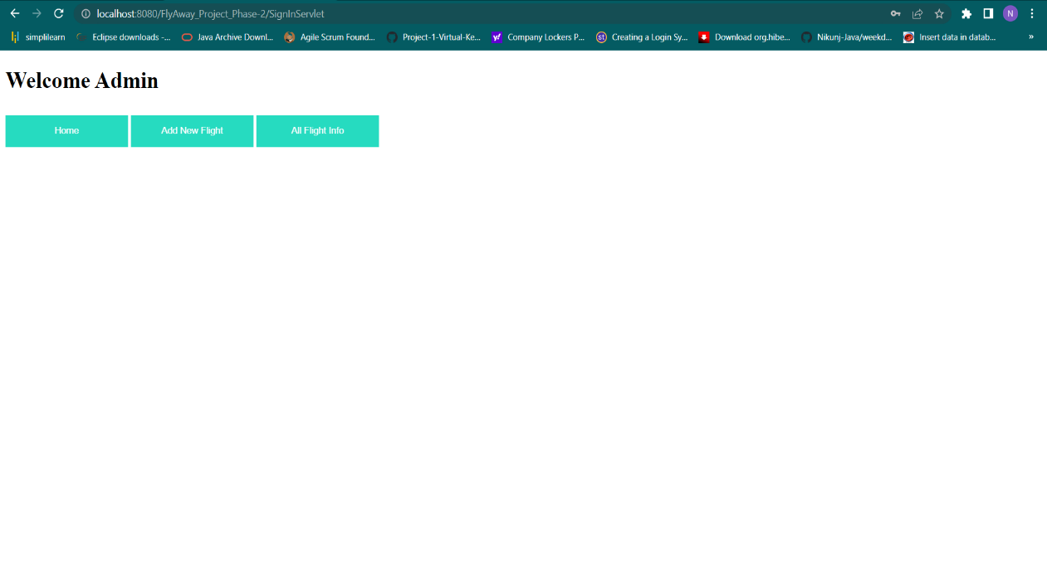

1. Add New Flight:

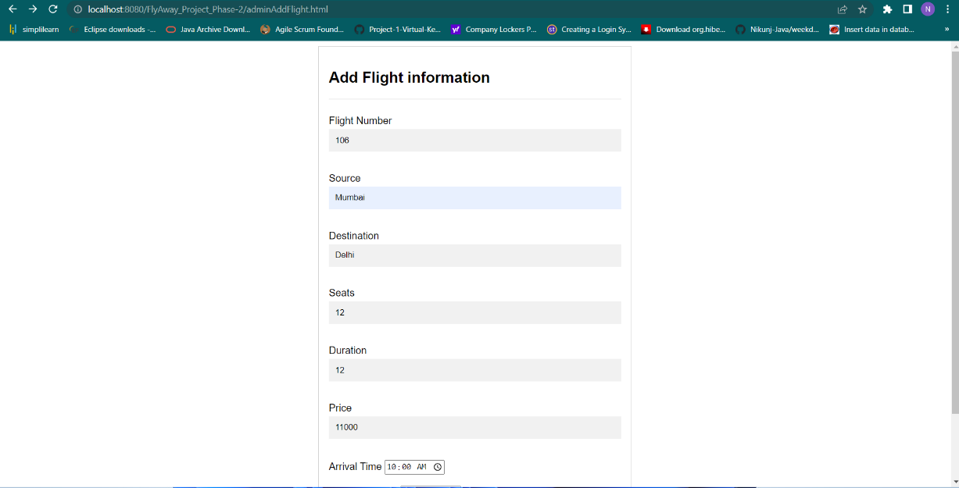

1. List Flight:

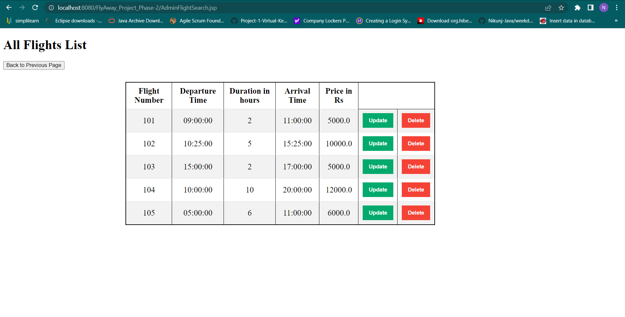

1. Data Added Successfully:

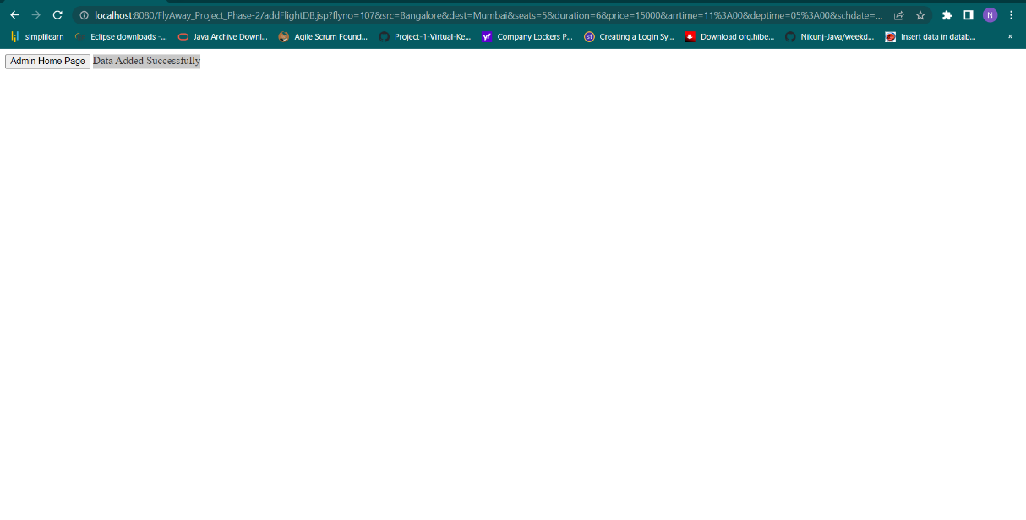

1. Update Flight:

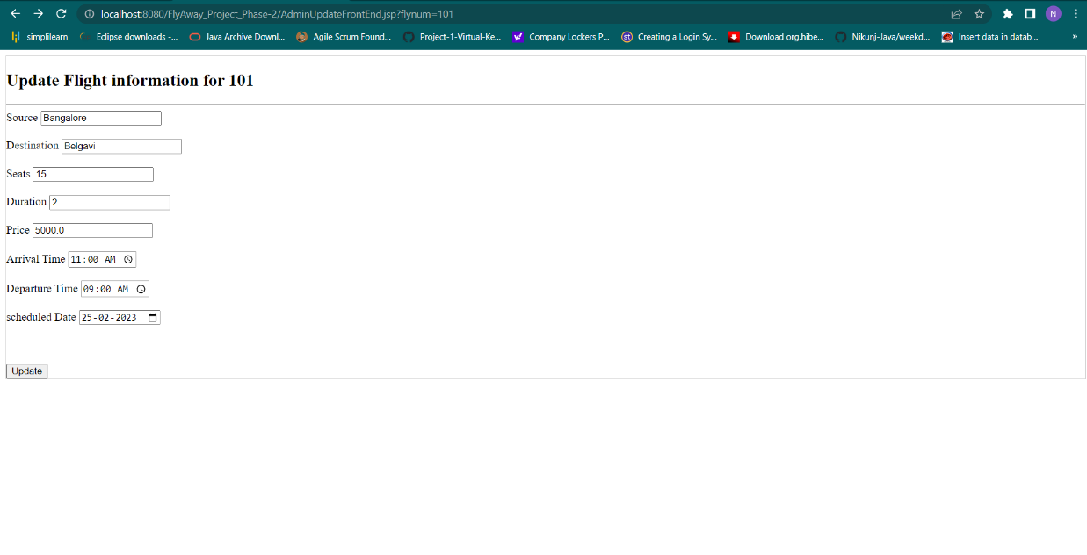

1. Data Updated Successfully:

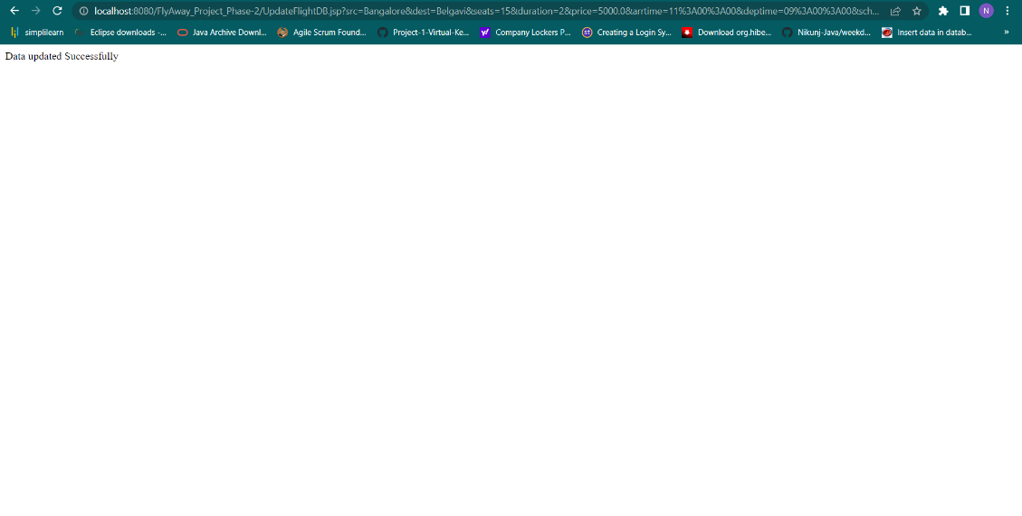

1. Data Deleted Successfully:

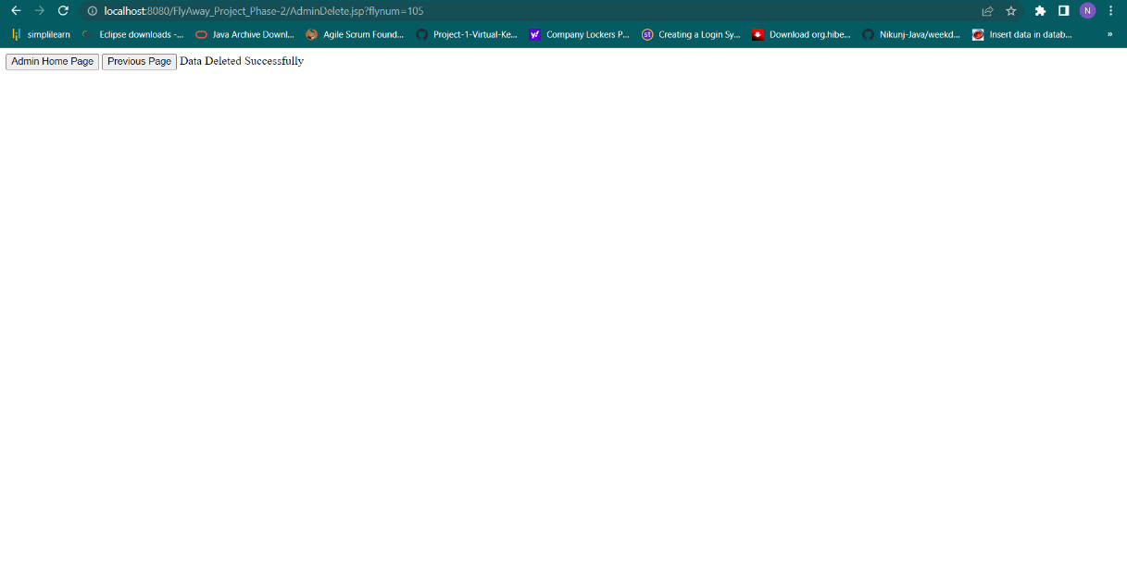

1. Admin Sign Up and after clicking sign Up admin successfully Sign Up:

