Homework 4

Nick Sparks & Shelby Vanhooser

Python code for this assignment is included in HW4.py

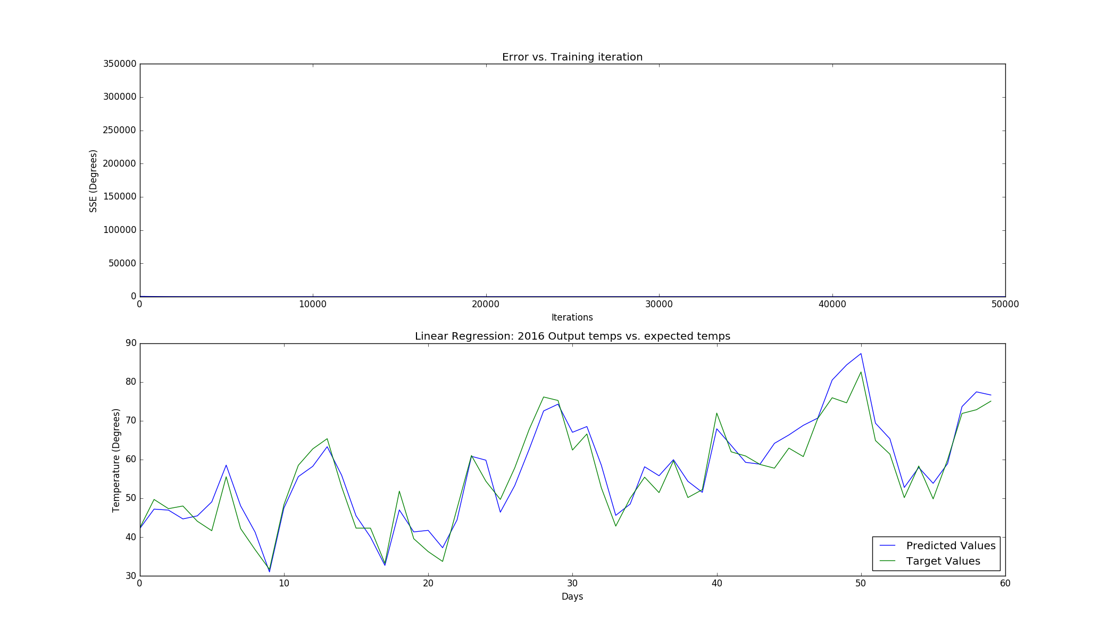

For linear regression, we chose to incorporate a technique of a decaying alpha value over the iterations of the network in order to expedite the process of convergence, should the weight values chosen for our initial net be far from their end points. This was done by allowing the selection of a *decay_rate* value indicating the number of iterations the net should execute before dividing the current *alpha* by 2.

In practice, a starting *alpha of* 1 x 10^-7 was stable enough to allow for convergence after 50,000 iterations, and the above plot shows the error rate over iterations (quick convergence is observed) and the resultant predicted values on the 2016 data set.

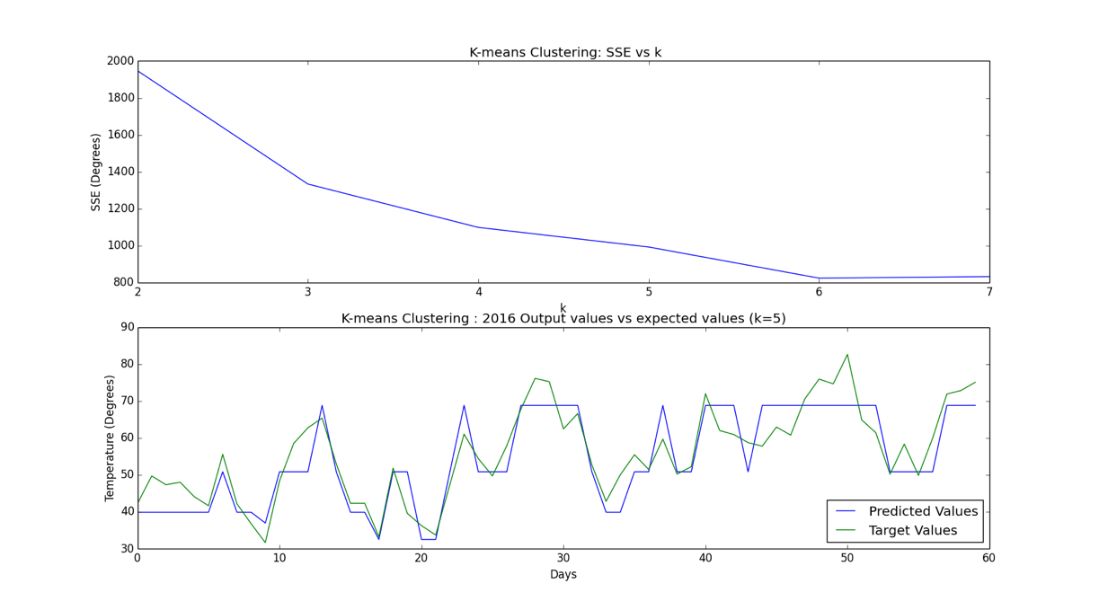

For the 2016 temperature prediction, a k of 5 was selected. Based on the error graph, 5 appears to be near the knee of the curve, so additional clusters will provide increasingly inconsequential marginal benefits to accuracy. Additional clusters will also require more processing time, so a value near the knee of the curve seemed to be a good choice.