Connect

**By**

19BCA139 Ranjit Rajput

19BCA151 Neh Patel

Under Guidance

of

Internal Guide

Bhargav Vyas

Submitted to



Smt. Chandaben Mohanbhai Patel Institute of Computer Applications

CHARUSAT

Changa

May/2021



[Accredited with Grade A by NAAC,  
 Accredited with Grade A by KCG](https://www.charusat.ac.in/)

CHAROTAR UNIVERISTY OF SCIENCE & TECHNOLOGY

Changa

**Acknowledgement**

Knowledge in itself is a continuous process. At this moment of our substantial enhancement, we rarely find words to express our gratitude towards those who were constantly involved with us.

The completion of any inter disciplinary project depends upon coordination, cooperation and combined efforts of several resources of knowledge, creativity, skill, energy and time. The work being accomplished now, we feel our sincerest urge to recall and knowledge through these lines, trying our best to give full credit wherever it deserves.

We would like to thank our project guide **Bhargav Vyas** and Dean & Principal **Dr. Atul Patel** who advised and gave us moral support through the duration of our project. Without their constant encouragement we could not have been able to achieve what we have.

It’s our good fortune that we had support and well wishes of many. We are thankful to all and those names which have been forgotten to acknowledge here but contributions have not gone unnoticed.

With Sincere Regards,

**Ranjit Rajput (19BAC139)**

**Neh Patel (19BAC151)**

**Table of Contents**

|  |  |  |  |
| --- | --- | --- | --- |
| **Sr. No** |  | **Subject** | **Page Number** |
| **1** |  | **Project Profile** | **4-5** |
| **2** |  | **Introduction to tools** | **5-7** |
| **3** |  | **System Study** | **9** |
|  |  | Existing System | **9** |
|  |  | Proposed System | **9** |
|  |  | Scope of the Proposed System | **10** |
|  |  | Aim and Objective of the Proposed System | **11** |
|  |  | Feasibility Study | **12** |
|  |  | Operational Feasibility | **12** |
|  |  | Technical Feasibility | **12** |
|  |  | Economical Feasibility | **12** |
| **4** |  | **System Analysis** | **13** |
|  |  | Requirements Specification (along with System Modules) | **14-16** |
|  |  | Use Case Diagram | **17** |
|  |  | Activity Diagram | **18-19** |
| **5** |  | **System Design** | **19-30** |
|  |  | **Tables** | **19-21** |
|  |  | **Screen Shots** | **21-30** |
| **6** |  | **System Testing** | **31-32** |

Project Profile

* **Project Profile**

**Project Name:** Connect

**Type of Application:** Web Based Application

**Project Description:** Connect is web application. Our application will allow people to connect with each other and share their post among their friends and family. Further more companies can display their advertisements and the users can view those advertise and through this the companies can expand their business.

**Team Size:** 2 Members

**Front End: Bootstrap 4.5, CSS 3,**

**Back End: PHP, HTML, MySql**

**Tools used:** Microsoft visual studio code, MySql

Introduction to tools

* **Introduction to Tools**
* **Front End Tool:**



**Microsoft visual studio:** Visual Studio Code is a source-code editor made by Microsoft for Windows, Linux and macOS.[9] Features include support for debugging, syntax highlighting, intelligent code completion, snippets, code refactoring, and embedded Git. Users can change the theme, keyboard shortcuts, preferences, and install extensions that add additional functionality.

In the Stack Overflow 2021 Developer Survey, Visual Studio Code was ranked the most popular developer environment tool, with 70% of 82,000 respondents reporting that they use it.



* **Back End Tool:**

**Sql server management tool**: MySQL is an open-source relational database management system (RDBMS). Its name is a combination of "My", the name of co-founder Michael Widenius's daughter, and "SQL", the abbreviation for Structured Query Language. A relational database organizes data into one or more data tables in which data types may be related to each other; these relations help structure the data. SQL is a language programmers use to create, modify and extract data from the relational database, as well as control user access to the database. In addition to relational databases and SQL, an RDBMS like MySQL works with an operating system to implement a relational database in a computer's storage system, manages users, allows for network access and facilitates testing database integrity and creation of backups.

System Study

**Existing System:**

* The existing application will look more attractive and it will be the more user friendly.
* It has more useful features.
* The data will be more secure.

**Proposed System:**

* In our application user has to register themselves to get access in our system.
* Users can upload their photos.
* Advertisement companies can upload their advertise for their business enhancement.
* User will see advertise.

**Scope of the Proposed System:**

* Keep data safe
* Users can view their posts/pictures in their feed.
* Advertisement companies can share their advertise.

**Aim and Objective of the Proposed System:**

**AIM:** User can post and others can view. And advertisement companies can post their advertise for their business enhancement.

**Objective of proposed system:**

* User can post and others can view.
* Advertisement companies can post their advertise for their business enhancement.
* Users can like the post and write comments on the post.
* Advertisement companies can share post with choosing appropriate plans.

**Feasibility Study:**

The main objective of the feasibility study is to test the Technical,

Operational and Economical feasibility for adding new modules and debugging

old running system. All system is feasible if they are unlimited resources and

infinite time.

* Operational Feasibility
* Technical Feasibility
* Economical Feasibility

**Operational Feasibility:**

|  |  |
| --- | --- |
| **Customer** | **Advertisement** |
| Register | Register |
| Post their pictures | Post advertises |
| Like and comment | Choose any plan |

**Technical Feasibility:**

(Minimum)

* Processor : Pentium 4- 2.4 GHZ
* Hard disk : 10 GB (Free)
* Ram : 2GB
* Front End : Visual Studio Code
* Middle Ware : Visual Studio Code
* Back End : MY- SQL
* Tools used : Microsoft office Visio 2007

**Economical Feasibility:**

* As per budget

System Analysis

**2.2 System Requirement**

**Requirement Specification:**

* **Actors:**
  + **User**
  + **Advertisement**
* **System Module:**
  + **User**
    - Register
    - Login
    - Upload post
    - Like and comment
    - Search people
    - View post
    - View advertise
  + **Advertise**
    - Register
    - Login
    - Post advertises
    - Choose appropriate plan
* **Register:** User & Advertisement companies both have to register first in all register fields if anything is missing then proper message will be displayed. If everything is okay then both have to verify their account by entering PIN that will be in email inbox. If pin is wrong then again correct or empty then message will be displayed otherwise, they are redirected to login screen.
* **Login:** User & Advertisement companies both have to login first if email id was incorrect then message will be displayed ‘user is not registered’ and if password was wrong then message will be displayed ‘invalid password’ and if email & password is correct respective dashboard will be displayed.
* **View post (User):** After logging into system User can first redirected to *posts* module in this module user will view post that are uploaded by others.
* **Upload post (User):** User can share their post by uploading picture with caption about the post.
* **Post advertises (Advertisement):** Advertisement companies can upload advertise for business enhancement with choosing appropriate plan.
* **Write review (User):** User can share review by giving like and make a comment on post.
* **Search people (User):** User can find peoples by searching their name.

**Use case Diagram**

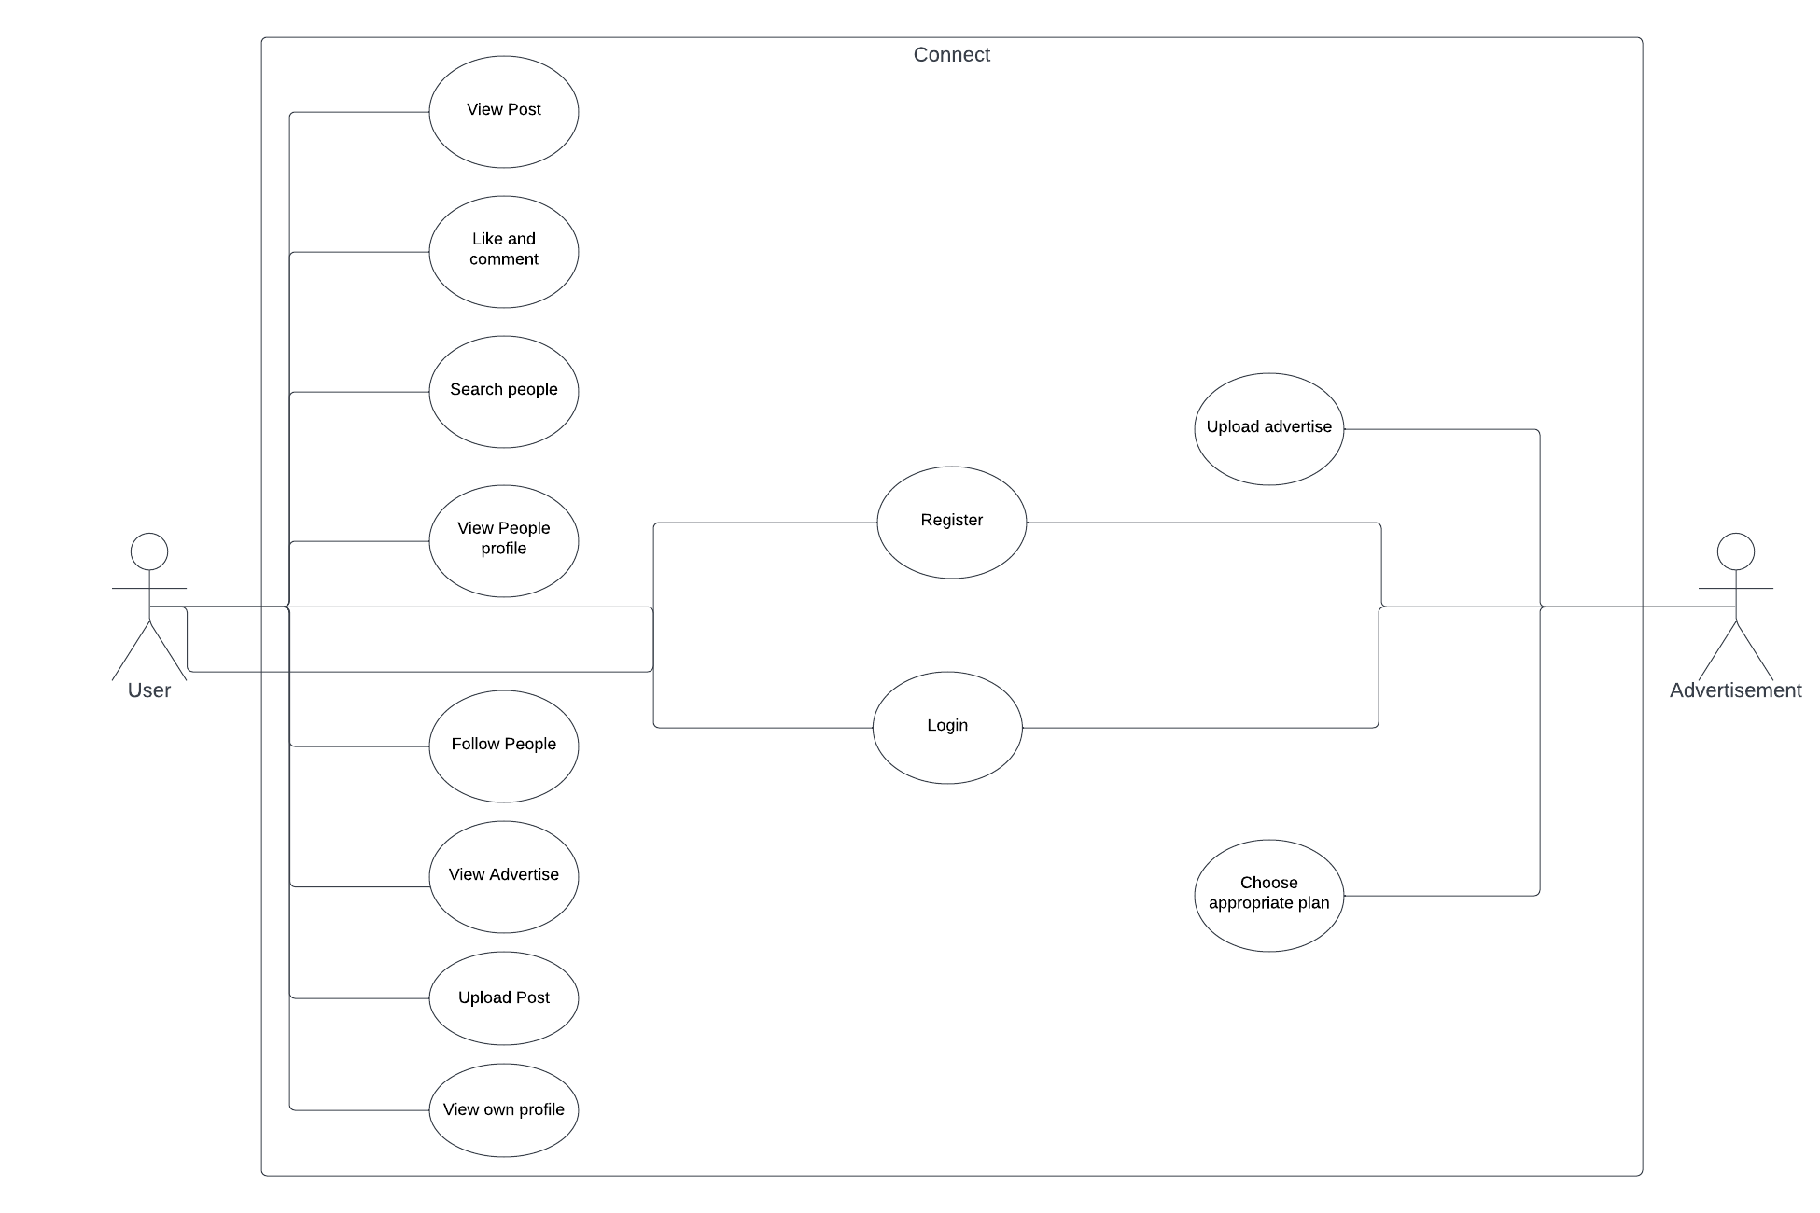

**Activity Diagram:**

**User**

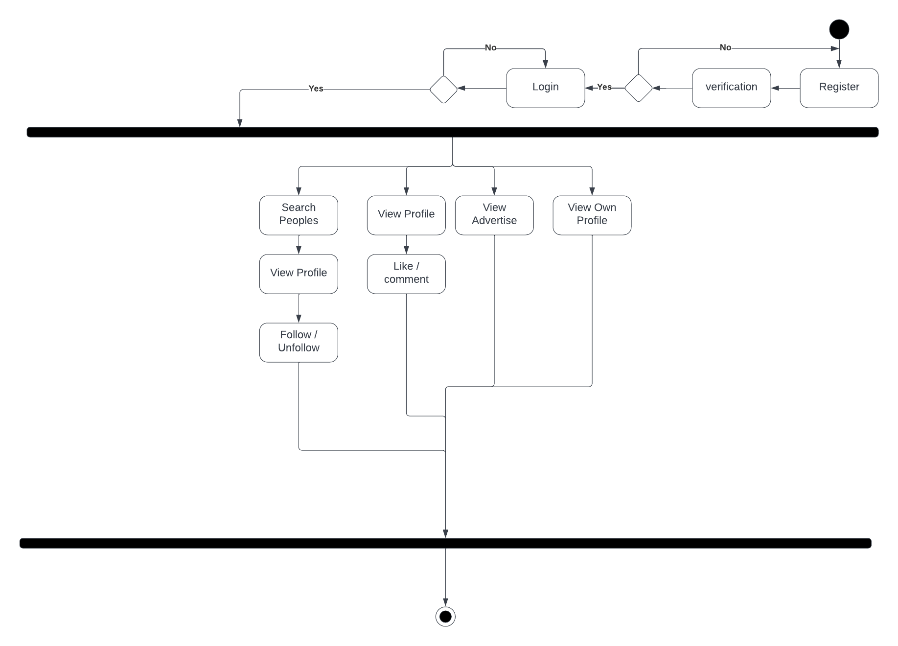

**Advertisement**

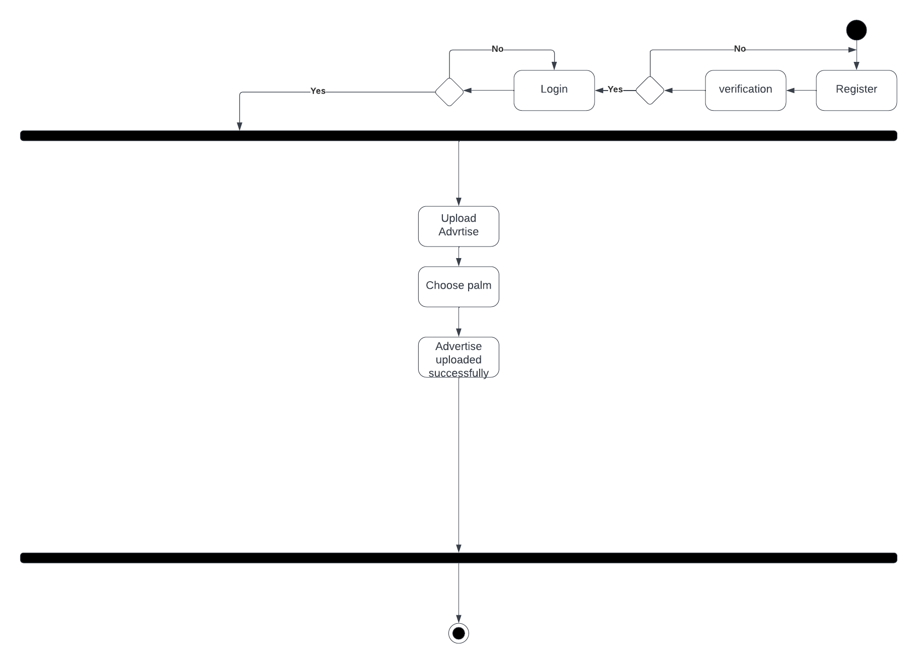

System Design

**Data Dictionary**

|  |  |  |  |
| --- | --- | --- | --- |
| **USERS** | | | |
| **Field Name** | **Type** | **Size** | **Constant** |
| USERID | INT | - | PRIMARY KEY |
| FIRSTNAME | VARCHAR | 50 | NOT NULL |
| LASTNAME | VARCHAR | 50 | NOT NULL |
| EMAIL | VARCHAR | 60 | NOT NULL |
| PASSWORD | VARCHAR | 60 | NOT NULL |
| CONFIRMPASSWORD | VARCHAR | 60 | NOT NULL |
| BIRTHDATE | DATE | - | NOT NULL |
| GENDER | VARCHAR | 6 | NOT NULL |
| STATE | VARCHAR | 30 | NOT NULL |
| INTRESTINGAREA | VARCHAR | 15 | NOT NULL |

|  |  |  |  |
| --- | --- | --- | --- |
| **LOGIN** | | | |
| **Field Name** | **Type** | **Size** | **Constant** |
| ID | INT | - | PRIMARY KEY |
| EMAIL | VARCHAR | 50 | NOT NULL |
| PASSWORD | VARCHAR | 50 | NOT NULL |
| ROLE | CHAR | 1 | NOT NULL |
| PIN | INT | 6 | NOT NULL |
| ISVERIFIED | CHAR | 1 | NOT NULL |

|  |  |  |  |
| --- | --- | --- | --- |
| **POST** | | | |
| **Field Name** | **Type** | **Size** | **Constant** |
| POSTID | INT | - | PRIMARY KEY |
| EMAIL | VARCHAR | 50 | NOT NULL |
| DESCRIPTION | VARCHAR | 50 | NOT NULL |
| POSTNAME | VARCHAR | 50 | NOT NULL |

|  |  |  |  |
| --- | --- | --- | --- |
| **LIKES** | | | |
| **Field Name** | **Type** | **Size** | **Constant** |
| ID | INT | - | PRIMARY KEY |
| POSTID | INT | - | NOT NULL |
| PERSONEMAIL | VARCHAR | 50 | NOT NULL |

|  |  |  |  |
| --- | --- | --- | --- |
| **FOLLOWES** | | | |
| **Field Name** | **Type** | **Size** | **Constant** |
| ID | INT | - | PRIMARY KEY |
| POSTID | INT | - | NOT NULL |
| PERSONEMAIL | VARCHAR | 50 | NOT NULL |

|  |  |  |  |
| --- | --- | --- | --- |
| **COMMENTS** | | | |
| **Field Name** | **Type** | **Size** | **Constant** |
| ID | INT | - | PRIMARY KEY |
| COMMENT | VARCHAR | 50 | NOT NULL |
| POSTID | INT | 3 | NOT NULL |
| PERSONEMAIL | VARCHAR | 50 | NOT NULL |

|  |  |  |  |
| --- | --- | --- | --- |
| **ADVERTISERS** | | | |
| **Field Name** | **Type** | **Size** | **Constant** |
| COMPANYID | INT | - | PRIMARY KEY |
| COMPANYNAME | VARCHAR | 50 | NOT NULL |
| EMAIL | VARCHAR | 50 | NOT NULL |
| PASSWORD | VARCHAR | 50 | NOT NULL |
| CONFIRMPASSWORD | VARCHAR | 50 | NOT NULL |
| PRODUCTCATEGORY | VARCHAR | 50 | NOT NULL |

|  |  |  |  |
| --- | --- | --- | --- |
| **ADVERTISE** | | | |
| **Field Name** | **Type** | **Size** | **Constant** |
| COMPANYID | INT | - | PRIMARY KEY |
| EMAIL | VARCHAR | 50 | NOT NULL |
| PLAN | INT | 1 | NOT NULL |
| STARTDATE | DATE | - | NOT NULL |
| ENDDATE | DATE | - | NOT NULL |
| TITLE | VARCHAR | 20 | NOT NULL |
| IMAGE | VARCHAR | 50 | NOT NULL |
| BUTTONLINK | VARCHAR | 50 | NOT NULL |
| COMPANYNAME | VARCHAR | 50 | NOT NULL |
| INTRESTINGAREA | VARCHAR | 50 | NOT NULL |
| GENDER | VARCHAR | 6 | NOT NULL |
| AGEGROUP | VARCHAR | 10 | NOT NULL |
| LOCATION | VARCHAR | 10 | NOT NULL |
| TOTALDAYS | INT | - | NOT NULL |
| TOTALPRICE | INT | - | NOT NULL |
| ISACTIVE | CHAR | 1 | NOT NULL |
| PRICE | INT | - | NOT NULL |

**Screen Layouts:**

1. **Home page**

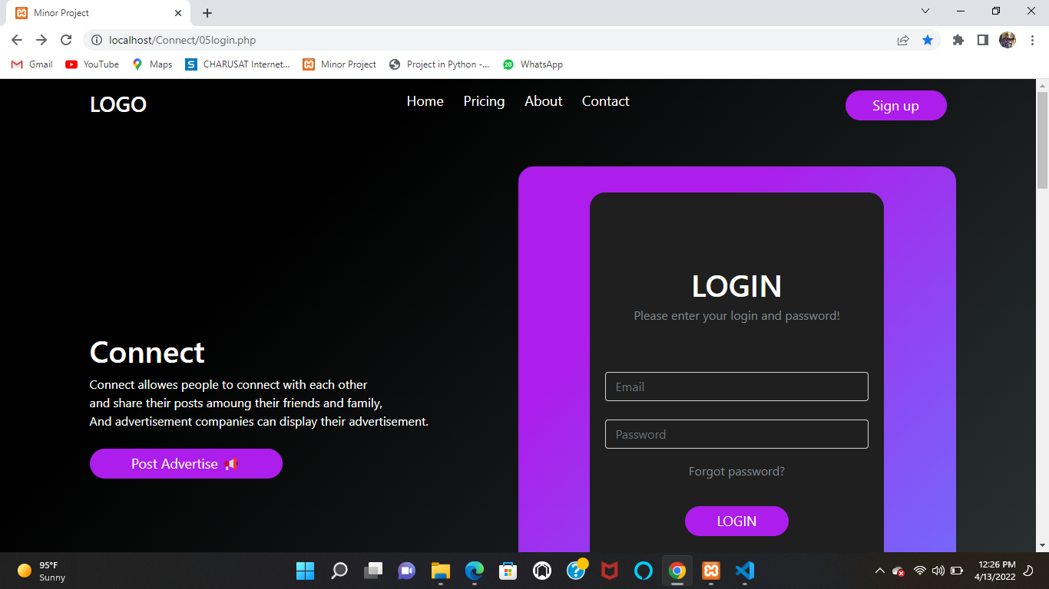

1. **Customer Registration**

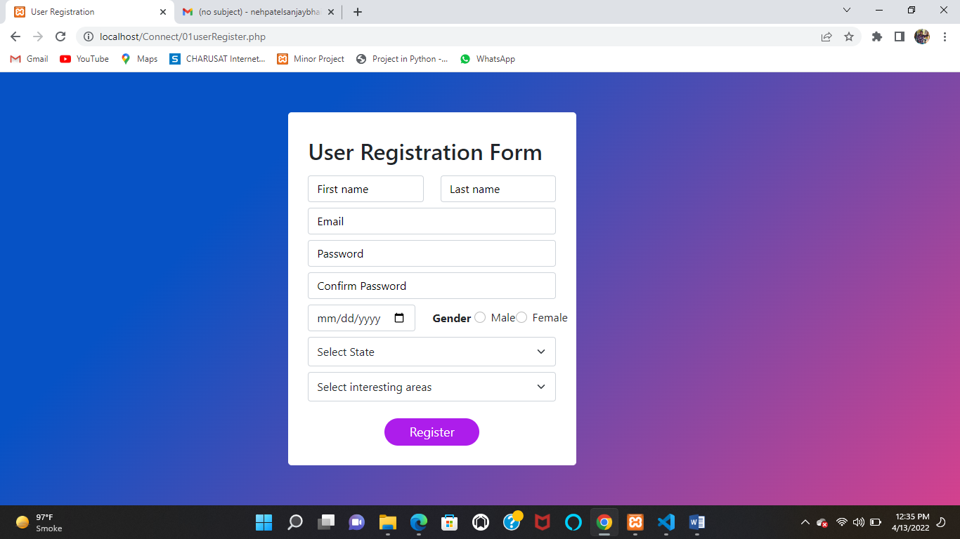

1. **Customer Email Authentication:**

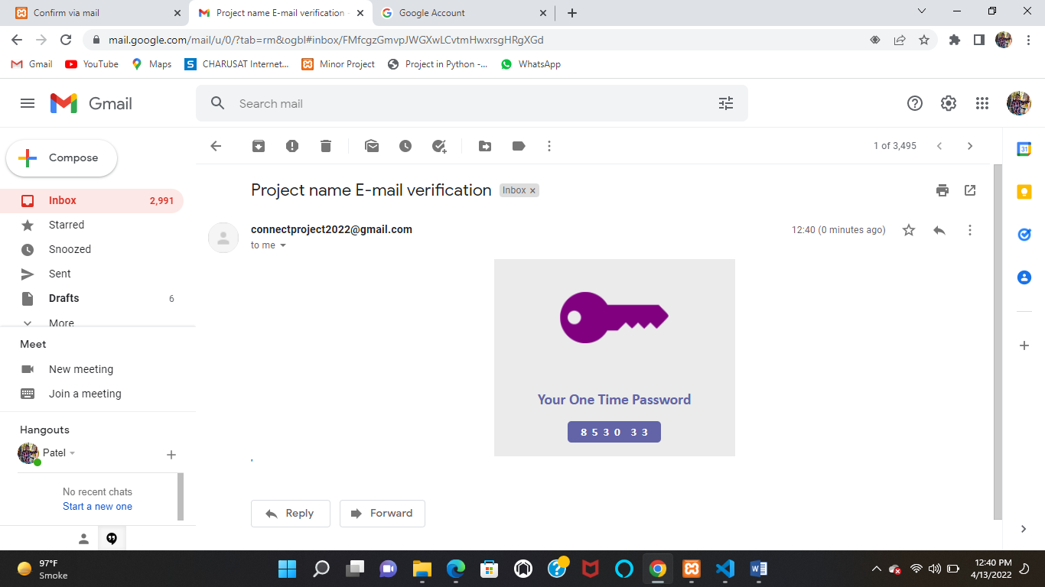

1. **Registration PIN Page**

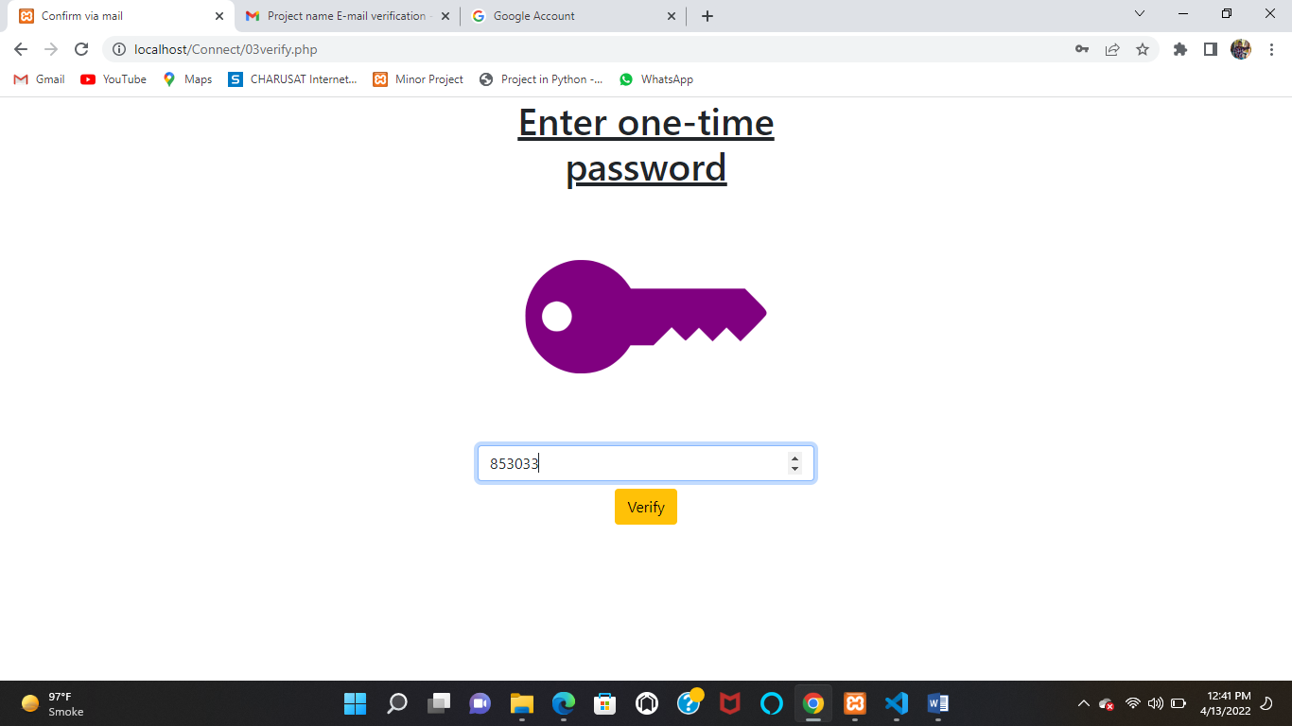

1. **Posts page**

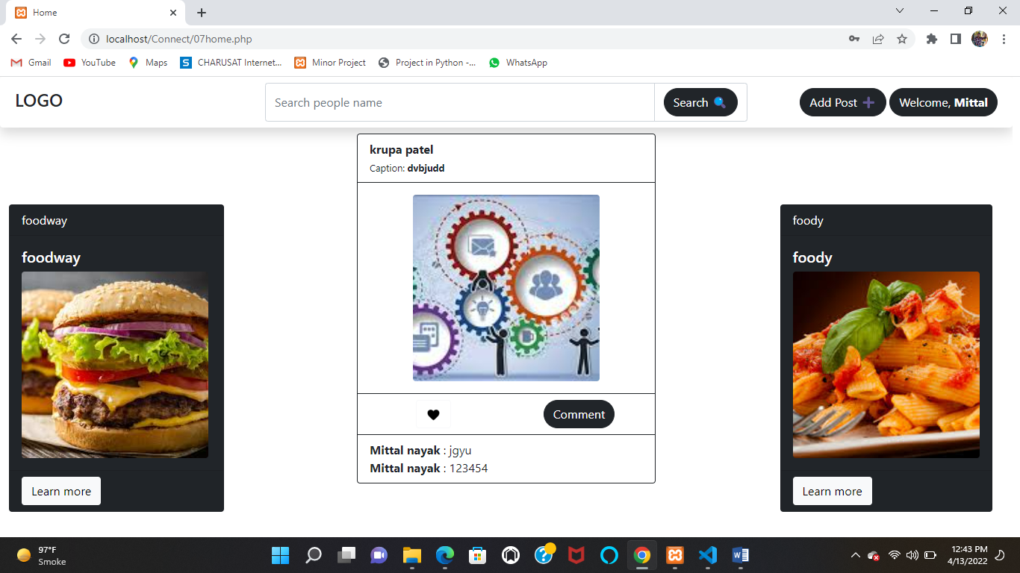

1. **Search Pages**

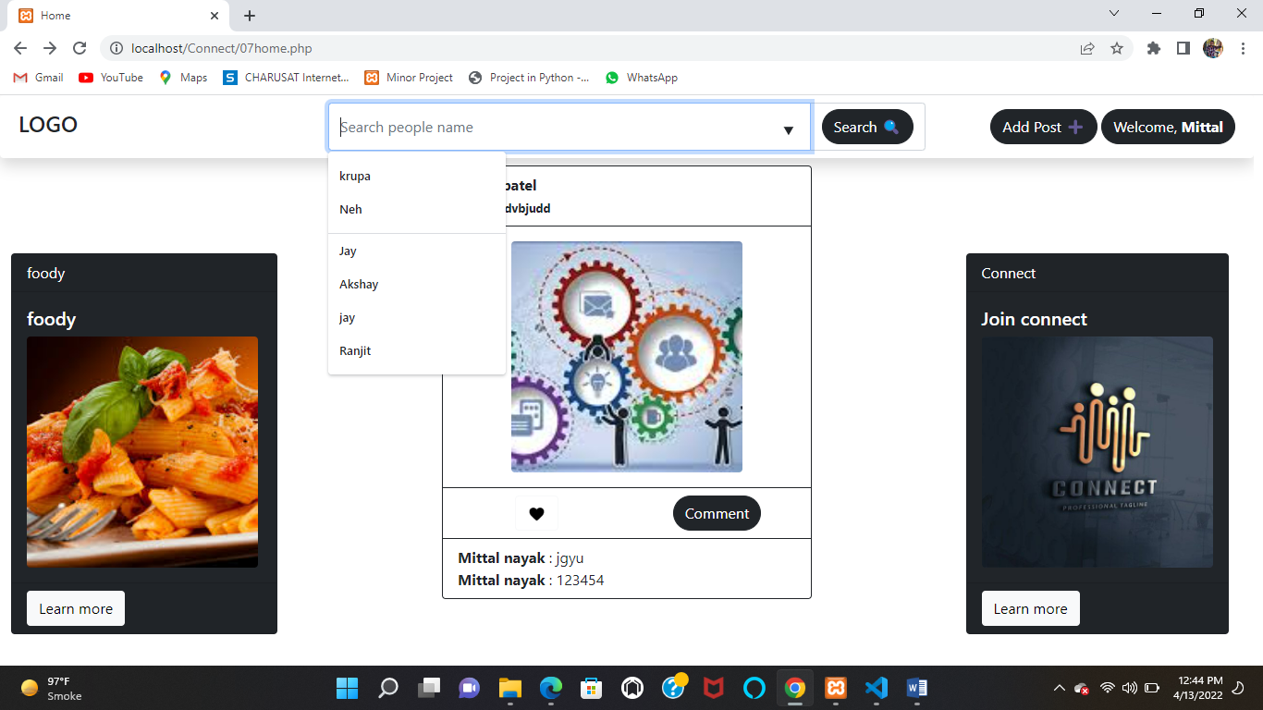

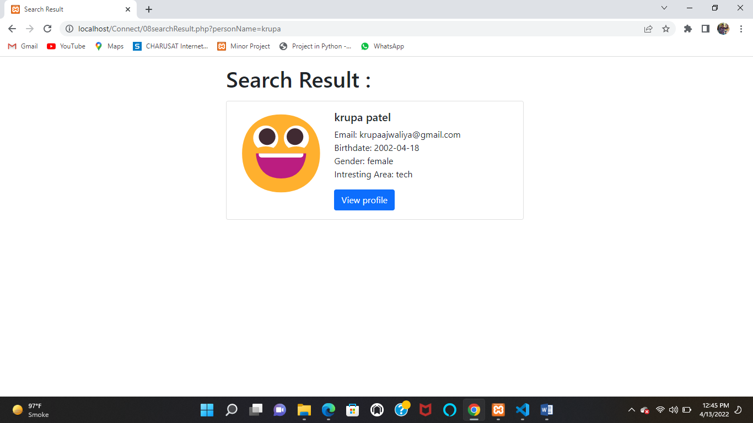

1. **Another user profile**

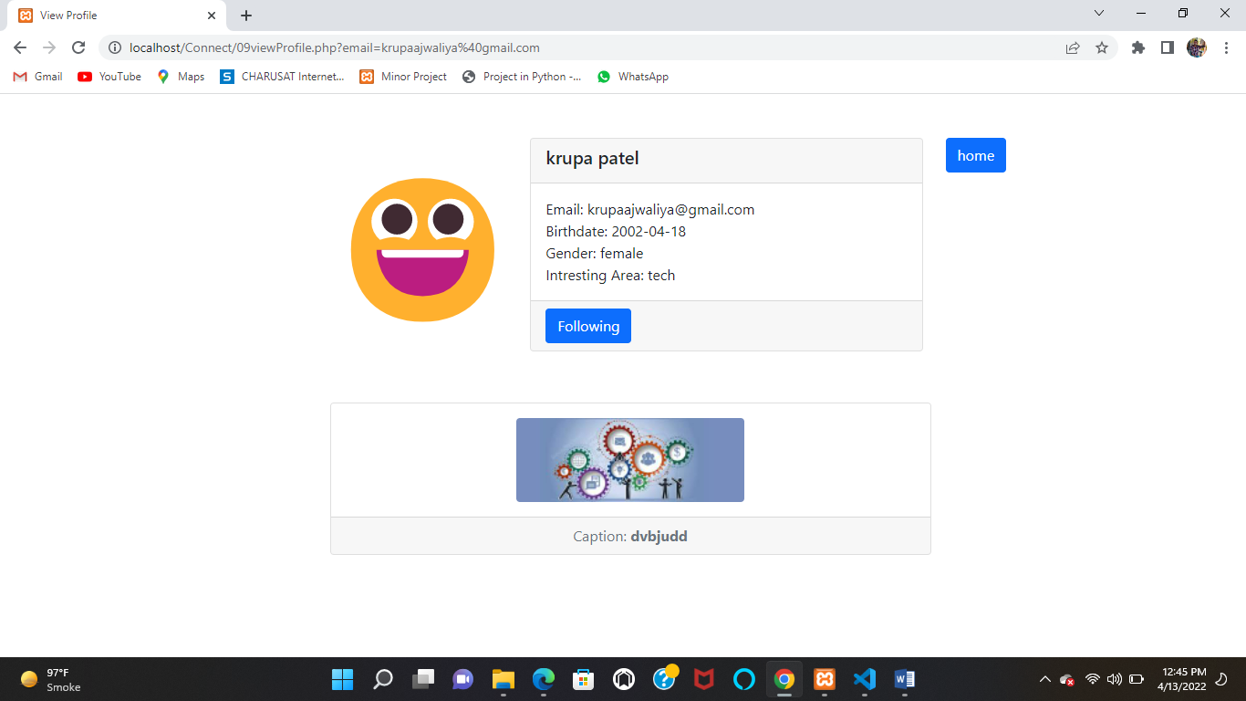

1. **Add post page**

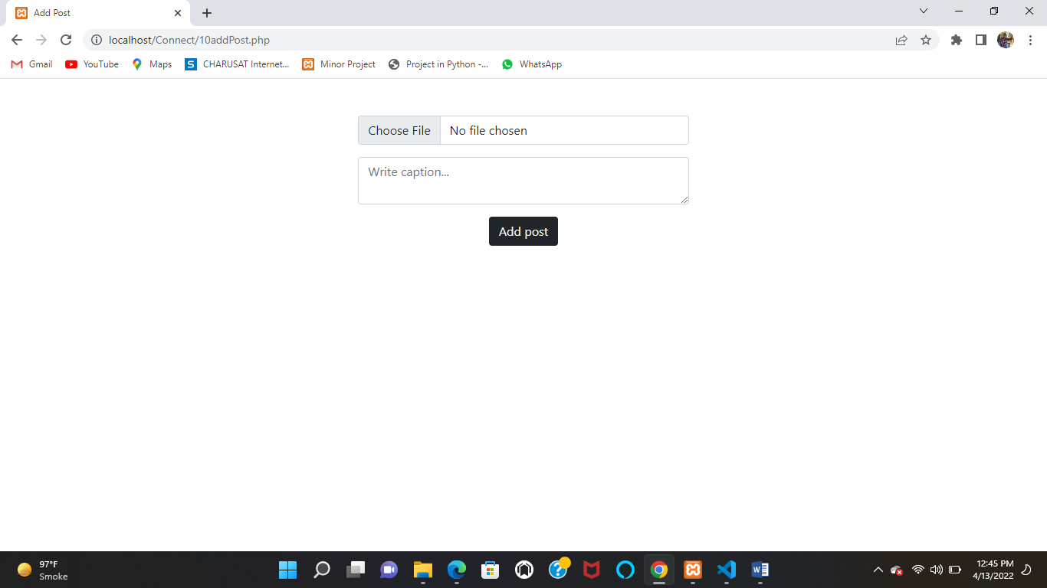

1. **User profile**

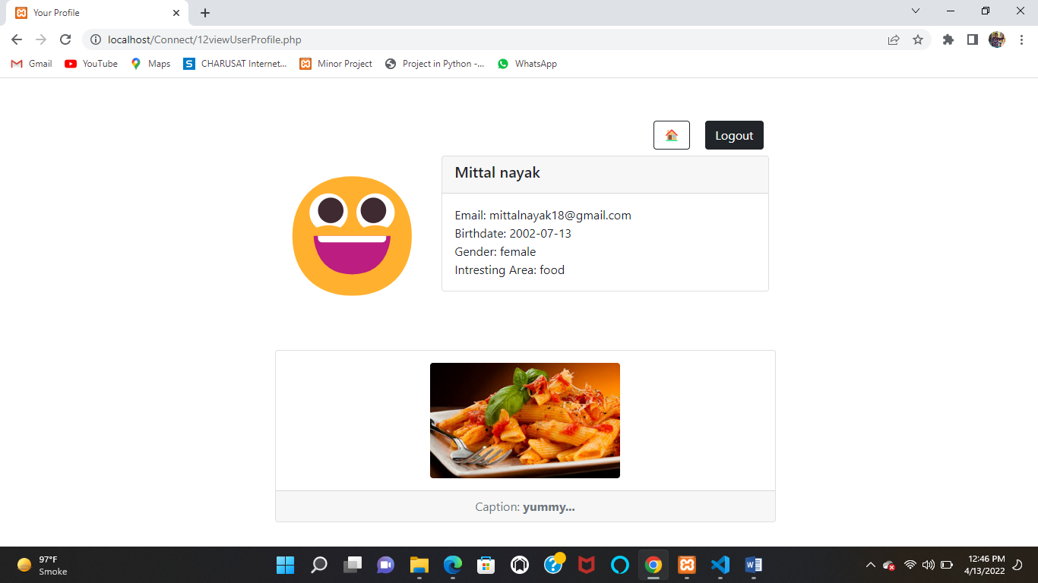

1. **Advertisement Registration page**

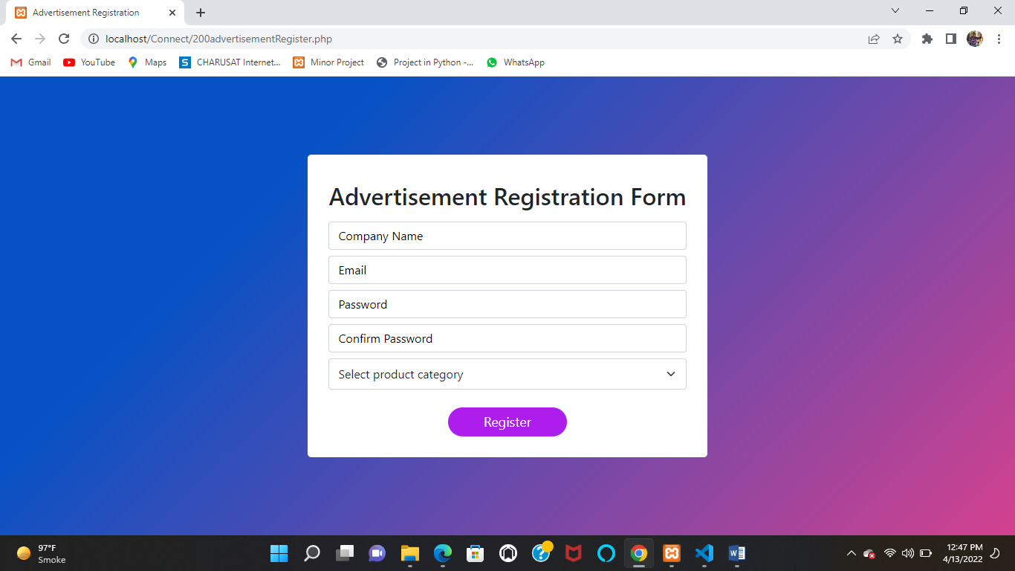

1. **Advertisement home**

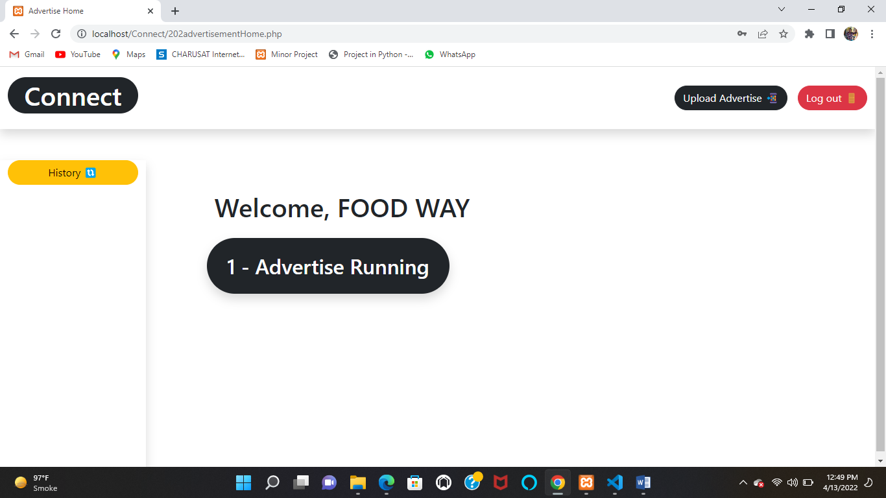

1. **Plans screen page**

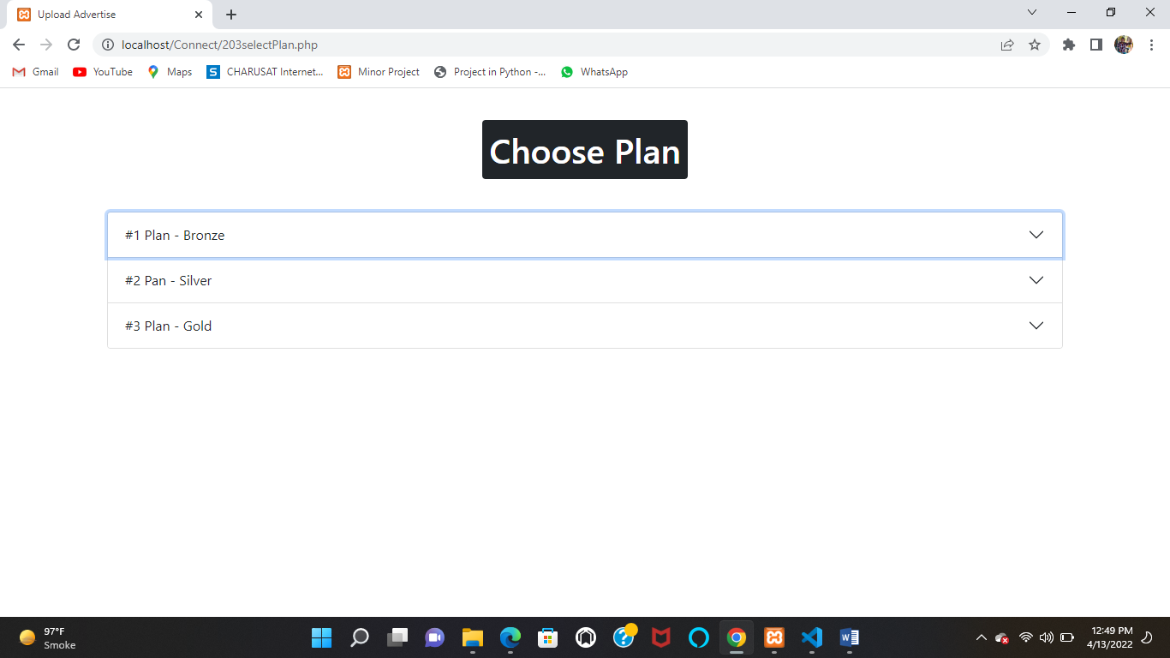

1. **Plan – 1**

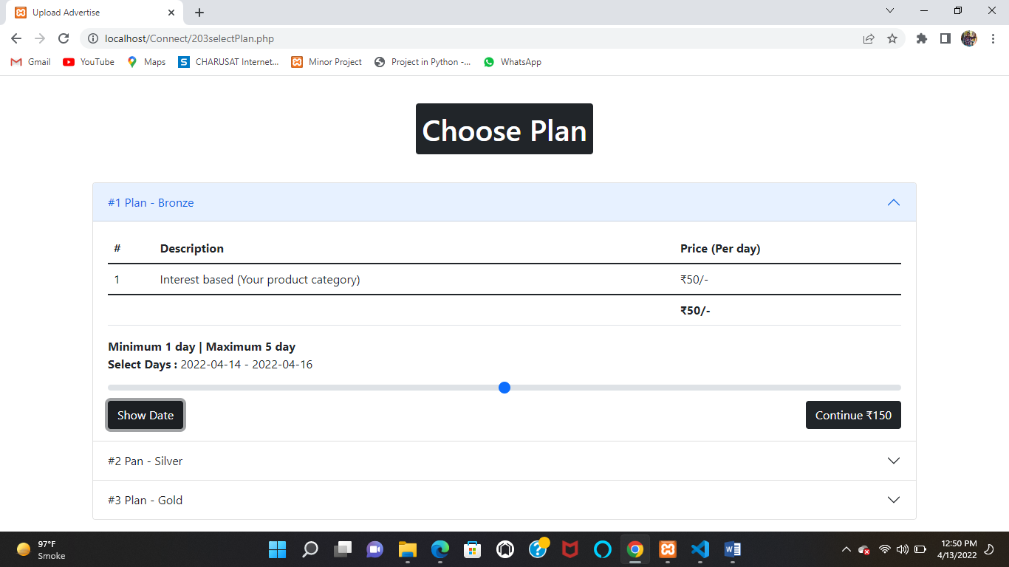

1. **Plan – 2**

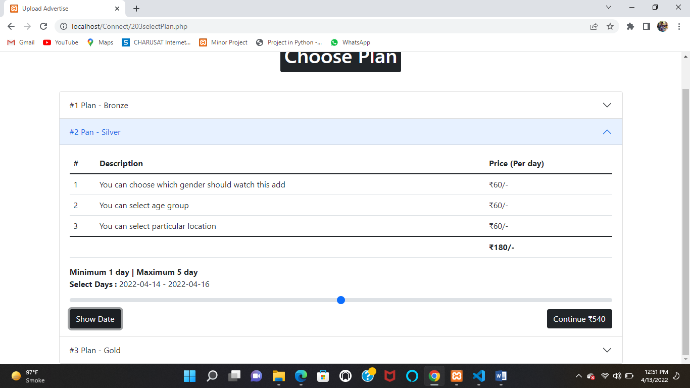

1. **Plan – 3**

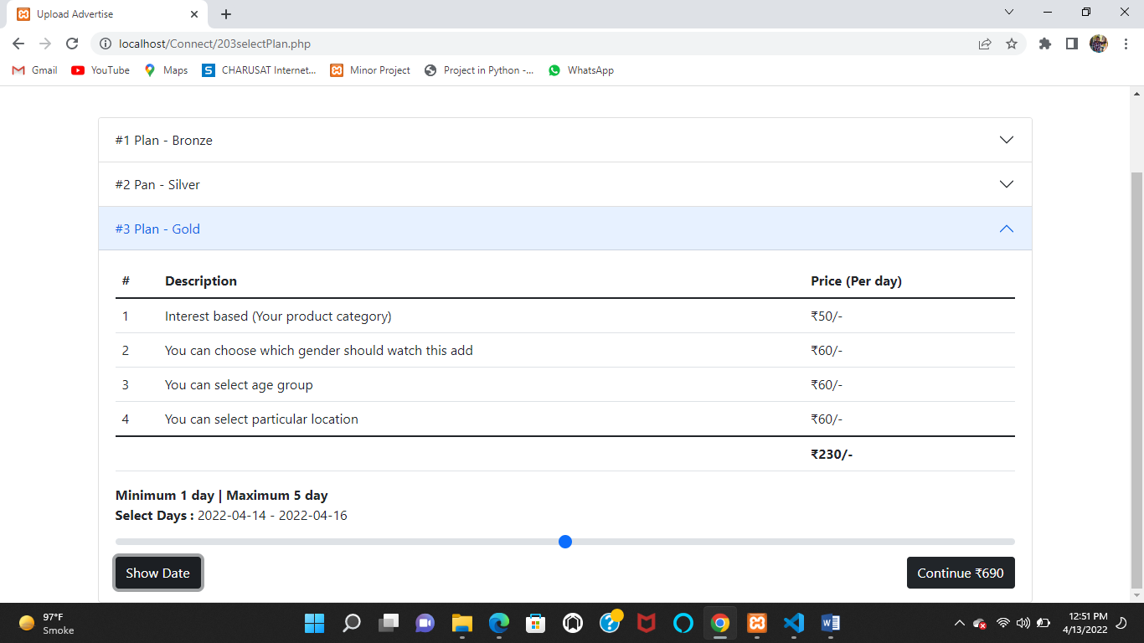

1. **Upload Advertisement page**

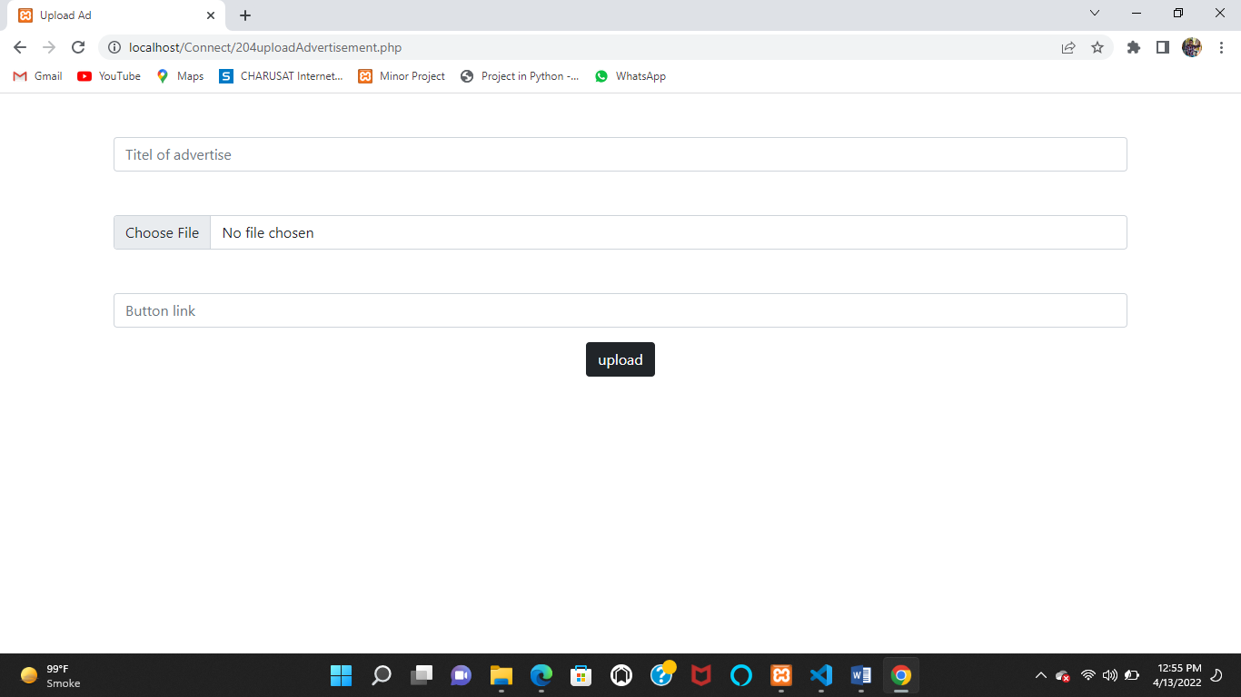

System Testing

* **Testing Strategies:**
  + Unit testing:
    - Unit testing carried out in this application to check that each unit of the application works without error, which was successful.
  + System testing:
    - The entire application is tested to check that the application meets the requirements which is mentioned in this document, which was successful.
  + Integrating testing:
    - This testing check that each program module is connected with the respective actor, which was successful,