# Add User Page

## Adding user

1. After filling the fields. Press the **Save** buttons and the data will be automatically added and saved.

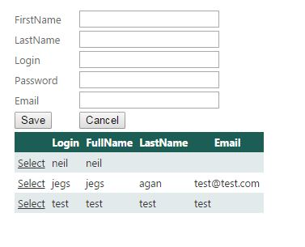

## Editing Existing User

1. Click the **Select** button beside the record you want to edit.
2. The data will be loaded in the fields above the table.
3. Edit the data you want to update.
4. Click **Save** button, the data then will be updated.

# Customer Profile

## Adding Customer

1. Fill the fields.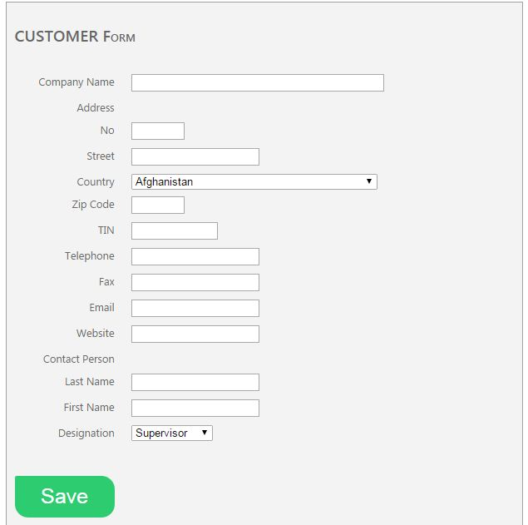
2. Press the **Save** button.
3. The saved customer profile will appear on the table below.

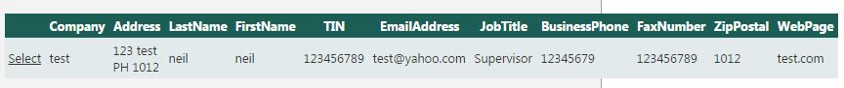

# Suppliers Form

## Adding Supplier

1. Fill the fields.

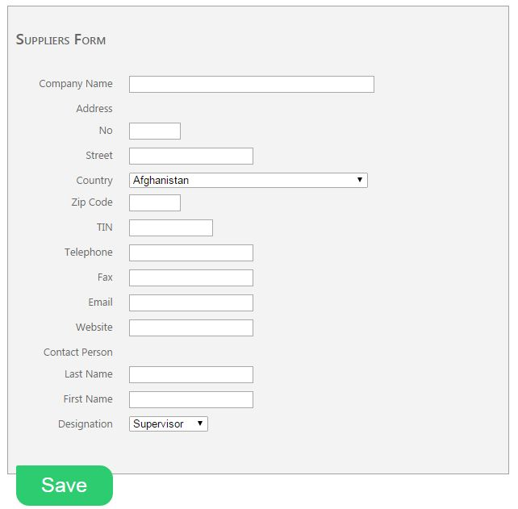

1. Press the **Save** button.
2. The saved supplier profile will appear on the table below.

