**Microsite Creative Brief**

Nathan Springman

4-8-21

Project: The Organ

https://en.wikipedia.org/wiki/Pipe_organ

1. Project overview

The goal of the website really is just informational. I’m wondering if there’s a better way to present graphics/images/interactivity(?) to make the history and construction more engaging.

1. Resources

There is plenty of copy on the Wikipedia page, <https://en.wikipedia.org/wiki/Pipe_organ>. Google and YouTube of course have a wealth of images and other resources.

1. Audience

I suppose the audience is really most anyone. If it’s informational/educational, perhaps focusing on more than elementary school science, but of course not to alienate anyone.

1. Message/Tone/Visual Style

Putting these together since I think they’ll be closely related. Again, if we’re going educational, it should probably be somewhat professional. However, I think with whatever diagrams/visuals are used, can hopefully liven up the history and explanations. The Wikipedia article just seems like a wall of text to me.

I think there’s of course an association with the pipe organ and churches, and this would be one style to lean into—somehow emulating gothic architecture, blackletter fonts, etc. It’s hard to find an exact website, but this vibe:

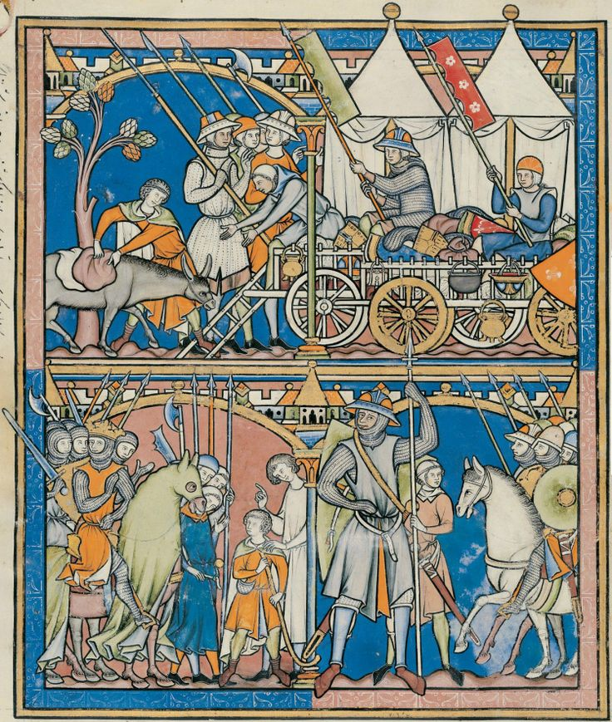

Although, I would think a perhaps more interesting route would be to modernize it—making the presentation playful, engaging, colorful.

<https://www.bonnaroo.com/>

This is definitely too ‘hippie’ for what I’m thinking, but more interesting buttons, colors, type I think could be fun to play with here. The organ seems old and dusty, and hopefully there’s room to change that here.

<https://www.gucci.com/us/en/>

Their actual design is pretty clean/simple, but the placement of elements and such colorful images (or at least as of now) make it less formal to me.