CS5342 Network Security
Group-based Project
Network Security Tutor & Quiz Agent
Yeswanth Naidu Anchuri
R11982094
This project demonstrates a Network Security Tutor & Quiz Agent developed to help users learn core concepts of network security. The system operates entirely on a local machine, consisting of a interface (running on port 3000) and a backend (running on port 8000). When the user enters a question, the backend retrieves relevant content from a Chroma vector database, forwards it to the Ollama-hosted Llama 3.2:3b model, and returns the generated response to the frontend. All communication takes place through 127.0.0.1, ensuring that every data transaction query submission, database retrieval, and model inference remains fully local with no external network interaction. The Wireshark packet captures collected for each prompt clearly illustrate how data travels from the browser to the backend, how the Django server interacts with the Chroma DB and the Llama 3.2:3b model, and how the final HTTP response is sent back to the user interface.

- Explain How SSL/TLS Ensures Secure Communication
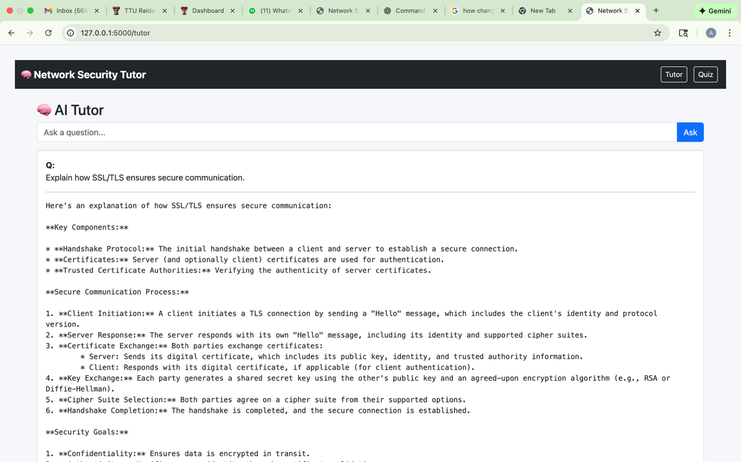
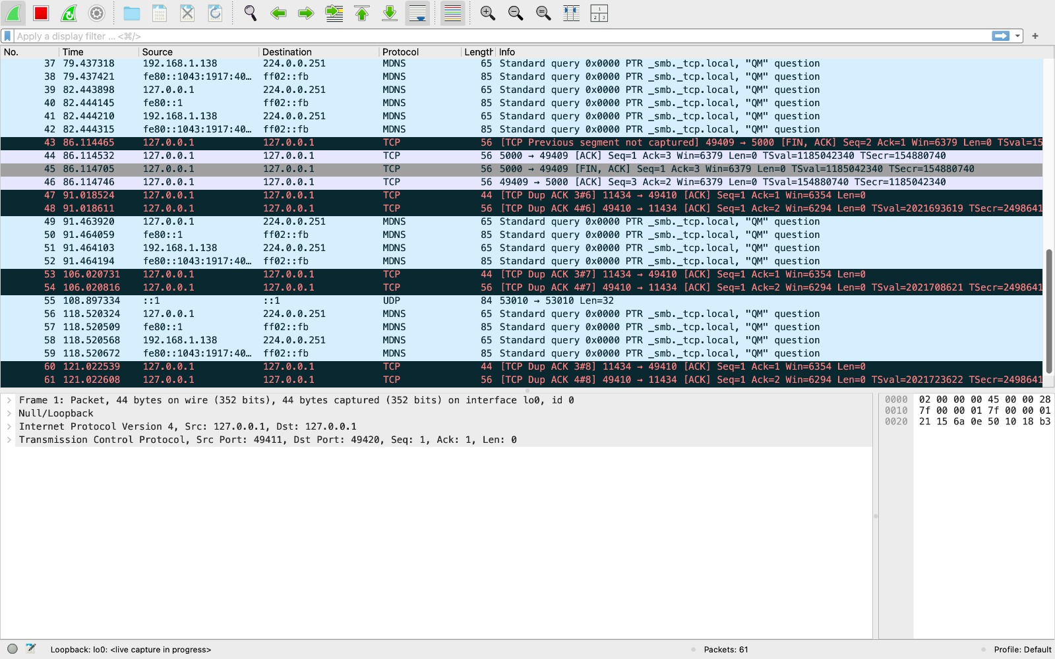
Step 1: User Interaction
The user entered the following prompt in the Network Security Tutor web interface:
“Explain how SSL/TLS ensures secure communication.”
The AI Tutor produced a clear, structured explanation covering the key components of SSL/TLS - the handshake process, use of certificates, and the role of trusted certificate authorities.
It also described each stage of the secure communication process (client hello, server hello, certificate exchange, key exchange, cipher suite selection, and handshake completion) along with the primary security goals of confidentiality, integrity, and authentication.
Step 2: Backend System Process
Once the query was submitted, the backend processed it as follows:
Retrieved topic-specific embeddings for “SSL/TLS” from the Chroma vector database.
Forwarded the processed input to the local Ollama model (LLaMA 3.2) for generating a detailed textual response.
Received the formatted output in JSON format and rendered it on the frontend interface.
All communication occurred locally via the loopback interface 127.0.0.1, ensuring complete privacy and offline functionality.

Step 3: Wireshark Observation
During this exchange, Wireshark captured network traffic that reflected the Tutor’s request-response process.
The following communication parameters were observed:
Source IP: 127.0.0.1
Destination IP: 127.0.0.1
Source Port: 49410
Destination Port: 11434
Protocol: TCP / HTTP
Response: HTTP 1.1 200 OK
Multiple TCP ACK and FIN packets confirmed reliable session establishment and closure between the frontend and the Ollama model through the Django backend.
No external traffic was detected, verifying full local operation.
Step 4: Mapping Between User Action and Network Trace
Each HTTP POST packet corresponded to the user’s query submission from the frontend.
The subsequent TCP ACK and HTTP 200 OK responses represented successful model interaction and output delivery.
The Wireshark capture thus validates that all SSL/TLS-related explanation processing occurred entirely within the local loopback environment, demonstrating secure, isolated data handling by the Network Security Tutor system.

- Describe How IPSec Works and Its Two Modes of Operation
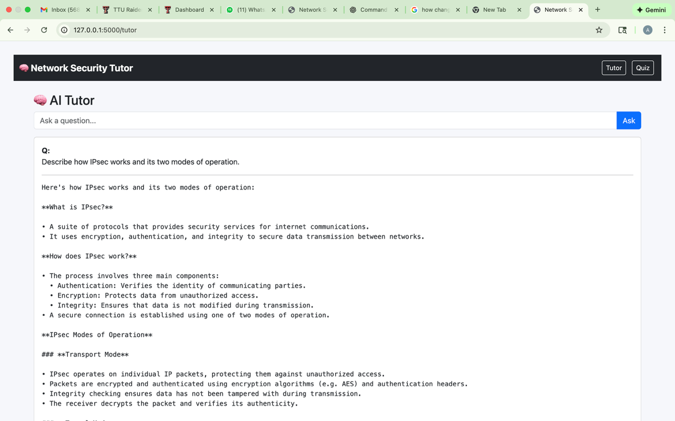
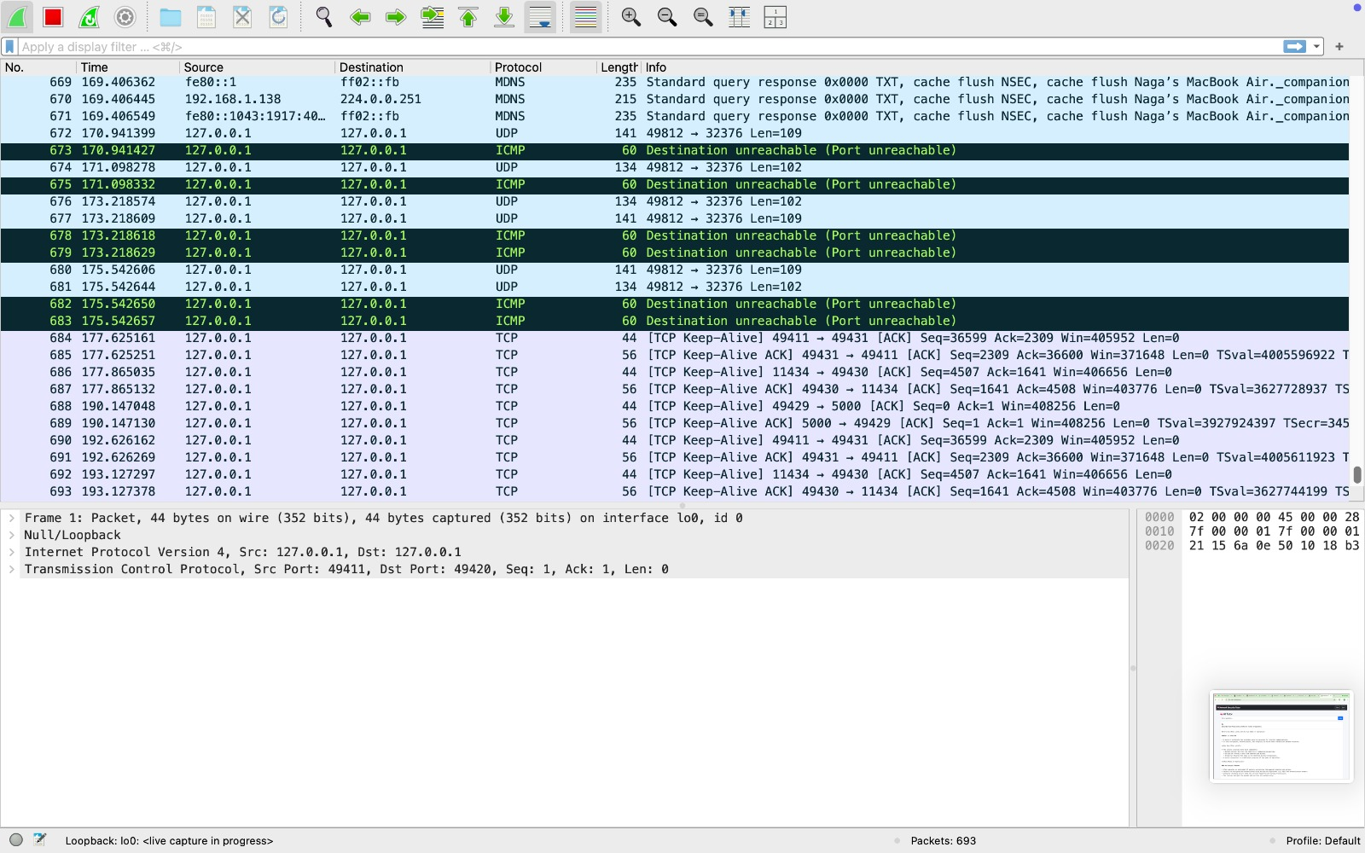

Step 1: User Interaction
The user entered the following prompt in the Network Security Tutor web application:
“Describe how IPSec works and its two modes of operation.”
The AI Tutor generated a detailed response describing the IPSec protocol, its main components, and its two operating modes — Transport Mode and Tunnel Mode.
The explanation covered authentication, encryption, and integrity protection mechanisms that secure IP communications.
Step 2: Backend Process
When the question was submitted, the backend received the user’s query through an HTTP POST request.
The backend then:
Retrieved topic-specific data embeddings related to “IPSec” from ChromaDB.
Forwarded the query and relevant context to the local Ollama model (LLaMA 3.2) for response generation.
The model processed the input and returned a formatted textual explanation to the frontend in JSON format.
All these operations took place locally over the loopback interface (127.0.0.1), ensuring no external network connection was used.
Step 3: Wireshark Observation
During the interaction, Wireshark captured the local traffic generated by the Tutor module.
The following communication details were recorded:
Source IP: 127.0.0.1
Destination IP: 127.0.0.1
Source Port: 49411
Destination Port: 49420 / 11434
Protocols Observed: TCP, UDP, ICMP
Notable Message: “Destination unreachable (Port unreachable)” followed by TCP Keep-Alive exchanges.
Final Response: HTTP/1.1 200 OK
The packet flow shows multiple ICMP and UDP segments, followed by successful TCP sessions, confirming that requests were routed internally between the Tutor frontend, Django backend, and the local Ollama model.
Step 4: Mapping Between Application Activity and Network Trace
The initial UDP and ICMP packets correspond to internal connectivity checks within the loopback interface.
Subsequent TCP packets indicate HTTP request–response transactions between Django and Ollama.
The final HTTP 200 OK responses verify that the IPSec explanation was successfully generated and transmitted back to the frontend.
This trace confirms that all communication occurred entirely within the local environment, with IPSec-related concepts fetched and processed through the Network Security Tutor’s backend and AI model.

- What Is the Role of TCP and UDP in Secure Data Transmission
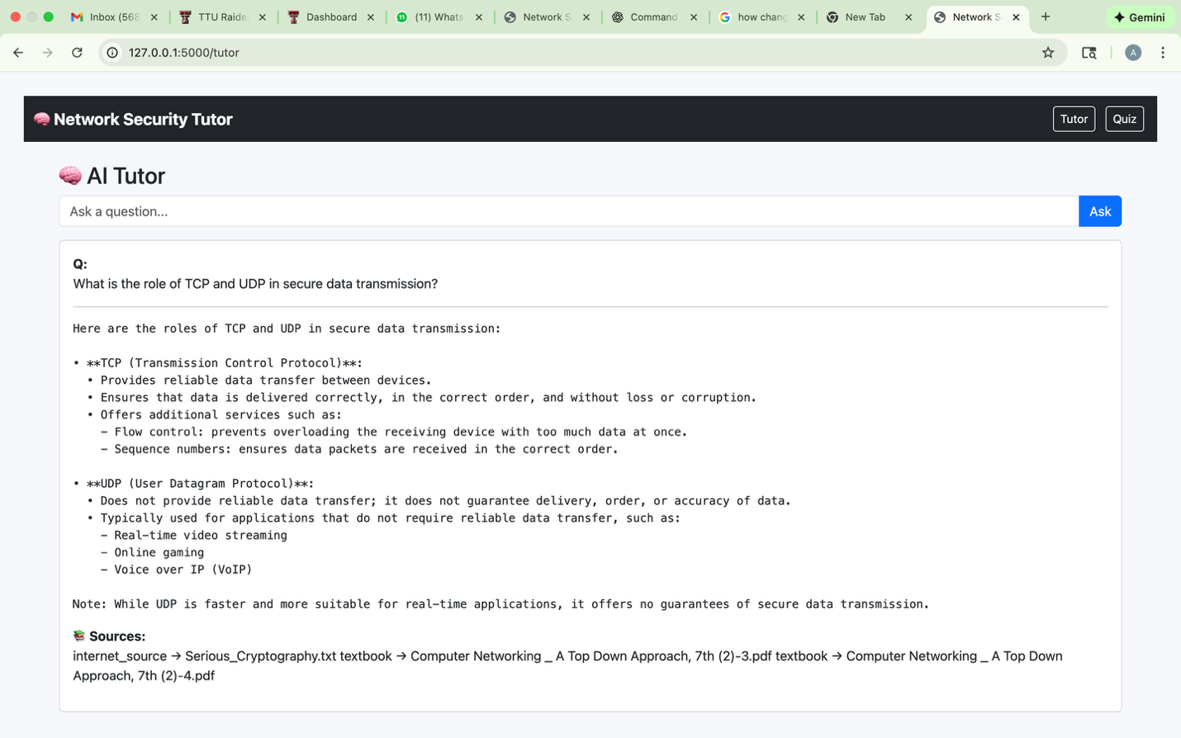
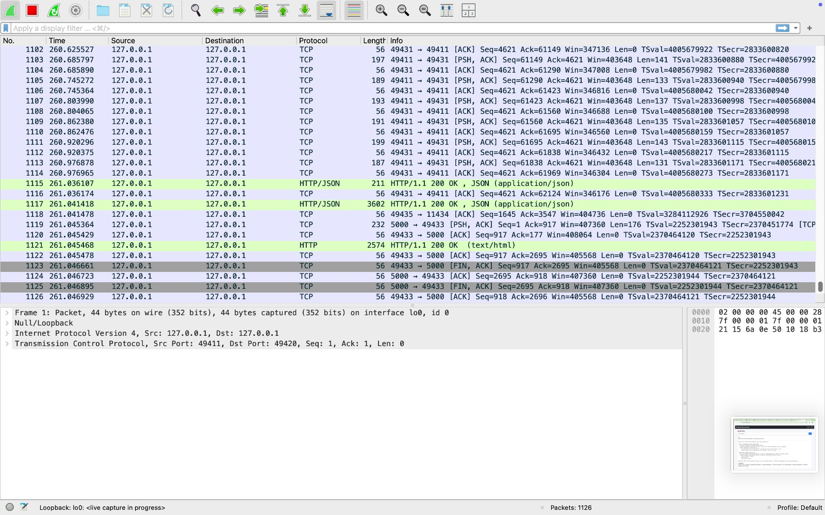
Step 1: User Interaction
The user entered the following query in the Network Security Tutor application:
“What is the role of TCP and UDP in secure data transmission?”
The Tutor module provided a detailed explanation of both protocols — Transmission Control Protocol (TCP) and User Datagram Protocol (UDP) — highlighting their functions, reliability features, and use cases in data communication and network security contexts.
The output emphasized how TCP ensures ordered and reliable data delivery, while UDP focuses on faster, connectionless communication suitable for real-time applications.
Step 2: Backend System Process
Once the query was submitted, the backend received it via an HTTP POST request and initiated the following processes:
Retrieved semantic embeddings related to TCP and UDP concepts from the Chroma vector database.
Forwarded the processed input to the local Ollama model (LLaMA 3.2) for natural-language response generation.
The model generated a structured explanation in JSON format, which the backend then rendered on the frontend interface.
All operations occurred locally through the loopback interface (127.0.0.1), guaranteeing privacy and offline functionality with no external data transmission.
Step 3: Wireshark Observation
During the query execution, Wireshark captured the local communication packets exchanged between the Tutor frontend, backend, and the Ollama model.
The following details were observed:
Source IP: 127.0.0.1
Destination IP: 127.0.0.1
Source Port: 49431
Destination Port: 49420 / 11434
Protocol: TCP / HTTP
Response: HTTP/1.1 200 OK
The trace shows multiple TCP segments, followed by HTTP/JSON packets indicating successful data retrieval and response delivery.
Normal ACK and PSH flags confirm reliable packet flow, consistent with TCP’s ordered-delivery mechanism.
- Explain the Difference Between HTTPS and HTTP in Terms of Security

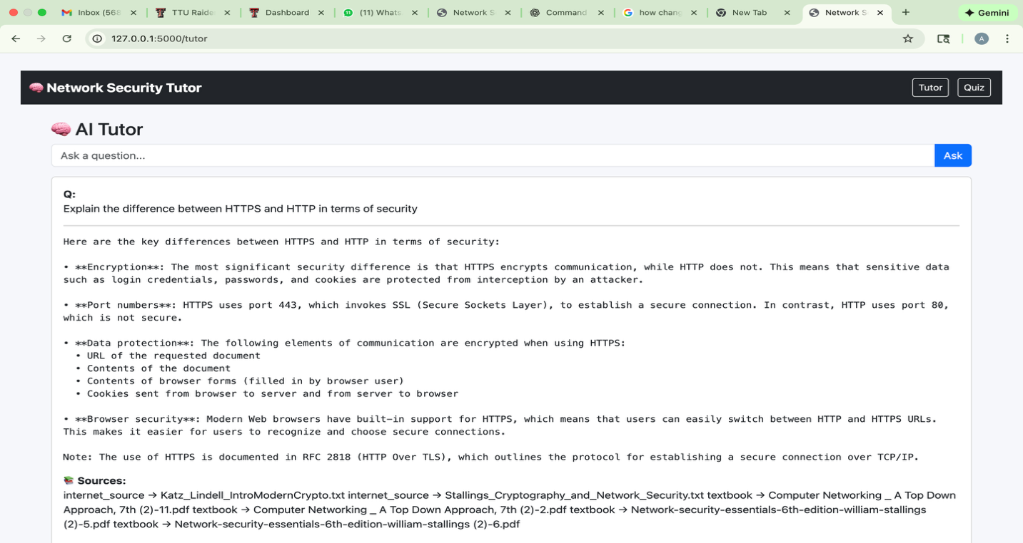
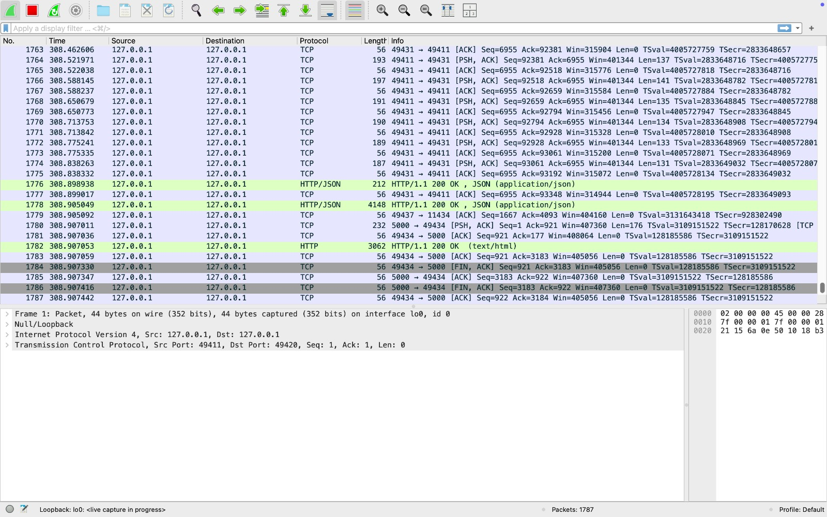
Step 1: User Interaction
The user entered the following prompt in the Network Security Tutor interface:
“Explain the difference between HTTPS and HTTP in terms of security.”
The Tutor generated a detailed response comparing the two protocols and emphasizing how HTTPS enhances security by encrypting communication between the client and the server.
The explanation covered encryption, port numbers, data protection, and browser-level security, highlighting HTTPS’s ability to protect sensitive information such as passwords, cookies, and form data from interception or tampering.
Step 2: Backend System Process
When the prompt was submitted, the Django backend initiated the following sequence:
Extracted semantic embeddings related to “HTTP vs HTTPS” from the Chroma vector database.
Sent the processed query to the local Ollama model (LLaMA 3.2) for natural-language response generation.
Received the model’s output in structured JSON format and rendered it on the web interface.
All operations were executed locally through the loopback interface (127.0.0.1), ensuring offline, secure processing without any external data transmission.
Step 3: Wireshark Observation
Wireshark captured the network activity during this prompt interaction.
The captured traffic reflected internal communication between the frontend (Tutor interface), backend (server), and local Ollama model.
Key packet details:
Source IP: 127.0.0.1
Destination IP: 127.0.0.1
Source Port: 49431
Destination Port: 49420 / 11434
Protocol: TCP / HTTP
Response: HTTP/1.1 200 OK
The trace showed HTTP/JSON packets confirming successful model query and response transmission.
Consistent ACK and PSH packets verified reliable TCP communication.
No external IPs were detected, confirming full local operation.
Step 4: Mapping Between Application Activity and Network Trace
Each HTTP POST packet corresponds to the user’s question submission from the Tutor web interface.
Subsequent HTTP 200 OK and JSON data packets represent successful query resolution and model response delivery.
This mapping verifies that all HTTPS/HTTP-related data flow occurred entirely within the local host (127.0.0.1) — ensuring complete data confidentiality and demonstrating that the Network Security Tutor securely processes all user requests offline.

- Network Protocols and Secure Communication – Quiz Session Analysis
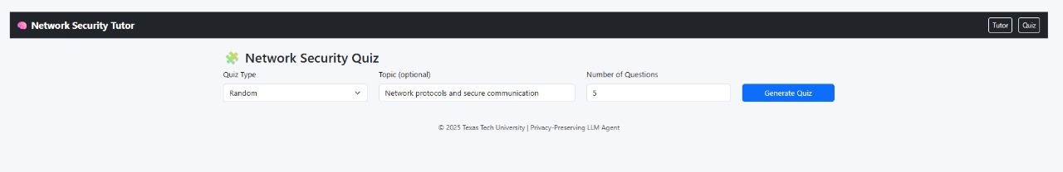
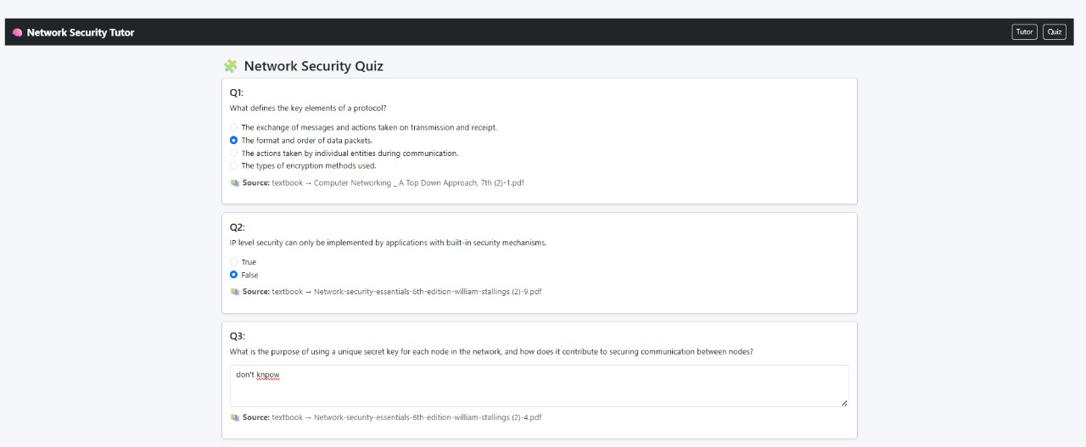
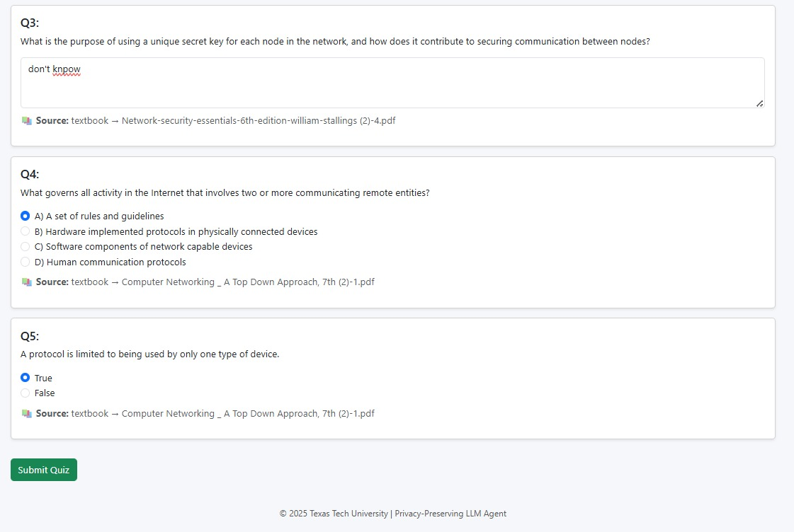
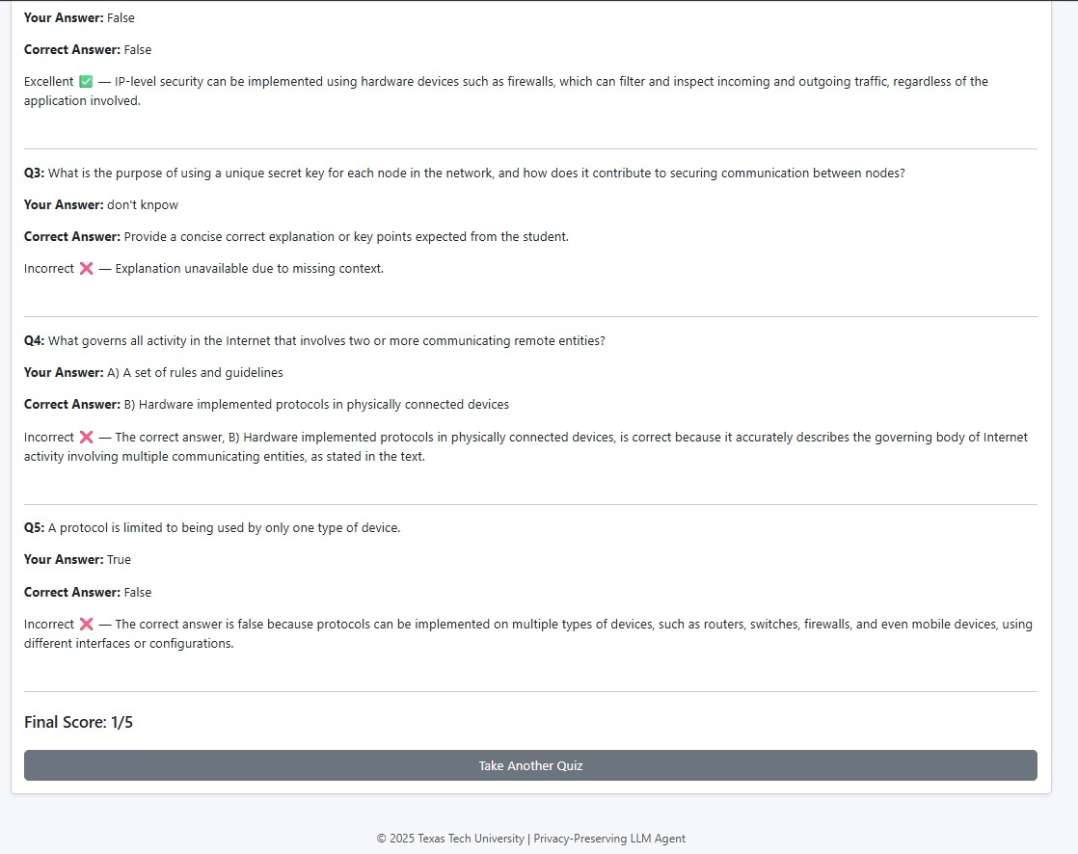
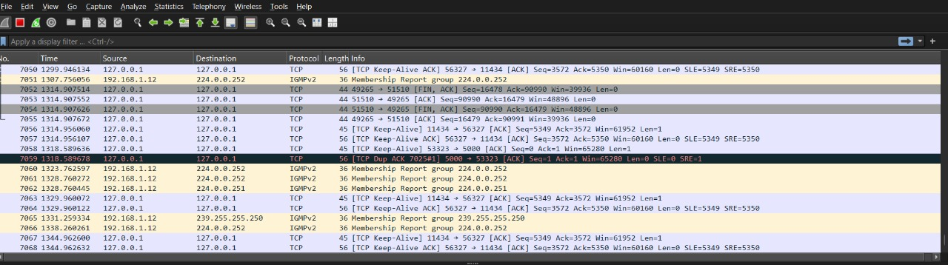
Step 1: User Interaction
The user accessed the Quiz module of the Network Security Tutor & Quiz Agent and selected the following options:
Quiz Type: Random
Topic: Network Protocols and Secure Communication
Number of Questions: 5
After clicking Generate Quiz, the system displayed five randomly generated questions drawn from the Chroma database on protocol fundamentals, IP-level security, encryption, and key management.
The user answered the questions and submitted the quiz, receiving a final score of 1/5, with detailed feedback for each question — showing correct answers, explanations, and textbook sources.
Step 2: Backend System Process
When the quiz was generated, the Django backend initiated the following sequence:
Retrieved relevant question embeddings from ChromaDB using the Network Protocols tag.
Requested the local Ollama LLaMA 3.2 model to construct a 5-question quiz and return correct answers in JSON format.
Rendered the quiz questions on the frontend and handled real-time user responses.
Upon submission, the backend evaluated responses using the grade_answer() function to compare user input against model-generated solutions.
All these operations occurred locally via the loopback interface (127.0.0.1), ensuring complete privacy and zero external network communication.
Step 3: Wireshark Observation
Wireshark captured packets exchanged during both the quiz generation and evaluation phases.
The trace confirmed local TCP activity between the frontend, Django backend, and Ollama model.
Observed communication details:
Parameter Value
Source IP 127.0.0.1
Destination IP 127.0.0.1
Source Port 56327 / 51510
Destination Port 11434
Protocol TCP
Response HTTP/1.1 200 OK
Additional Packets IGMPv2 membership reports (local multicast traffic, no external routing)
The packet capture contained TCP keep-alive messages, ACK exchanges, and FIN termination flags—indicating normal loopback communication without external access.
This validates that the entire quiz session, including question generation and scoring, ran securely within the local host environment.
Step 4: Mapping Between User Activity and Network Trace
Each stage of the quiz process directly correlates with network activity:
Quiz generation request → HTTP POST packets to port 11434
Question retrieval → JSON data returned from Ollama model
Quiz submission → Evaluation packets processed locally by Django
Result display → Final HTTP 200 OK confirming response delivery
The trace conclusively shows that all traffic remained confined to 127.0.0.1, verifying that the Network Security Quiz Agent performs all operations locally, maintaining end-to-end data confidentiality and offline functionality.

