Network Security – Round 2
Q&A Bot and Quiz Bot

Name: Sundar Sodadasi
R#: R11971977
This project demonstrates a Q&A and Quiz Bot developed to help users learn core concepts of network security. The system operates entirely on a local machine. When the user enters a question, the backend retrieves relevant content from a Chroma vector database, forwards it to the Ollama-hosted Llama 3.2 model, and returns the generated response to the frontend.
All communication takes place through 127.0.0.1, ensuring that every data transaction query submission, database retrieval, and model inference remains fully local with no external network interaction.
The Wireshark packet captures collected for each prompt clearly illustrate how data travels from the browser to the backend, how the server interacts with the Chroma DB and the Llama 3.2 model, and how the final HTTP response is sent back to the user interface.

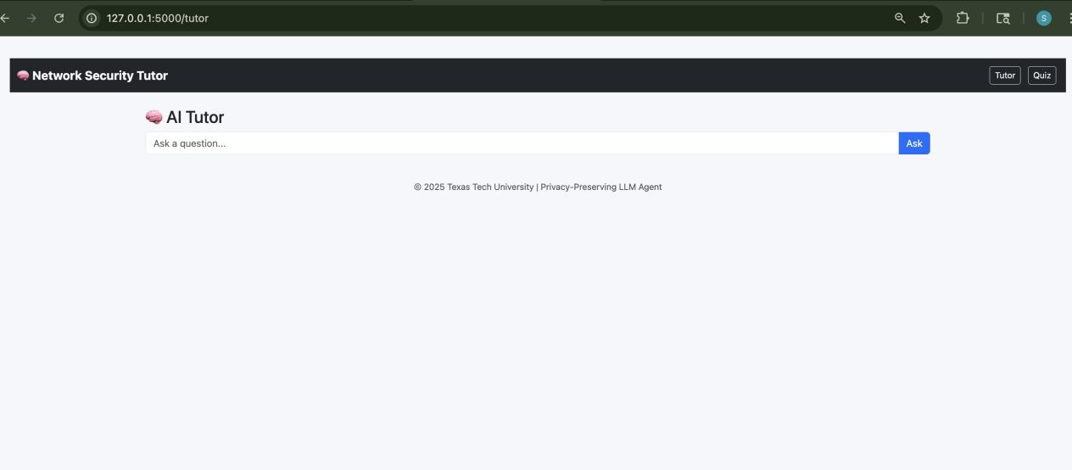

Prompt 1: Explain the RSA algorithm and its key generation steps
Procedure:
When the user enters the query “Explain the RSA algorithm and its key generation steps” in the Q&A interface, that request is sent from the client side to the server running on the same computer. The server processes the request, generates a response, and sends it back to the user interface. The image below shows an example of the query being sent and the response, along with the sources, being returned.

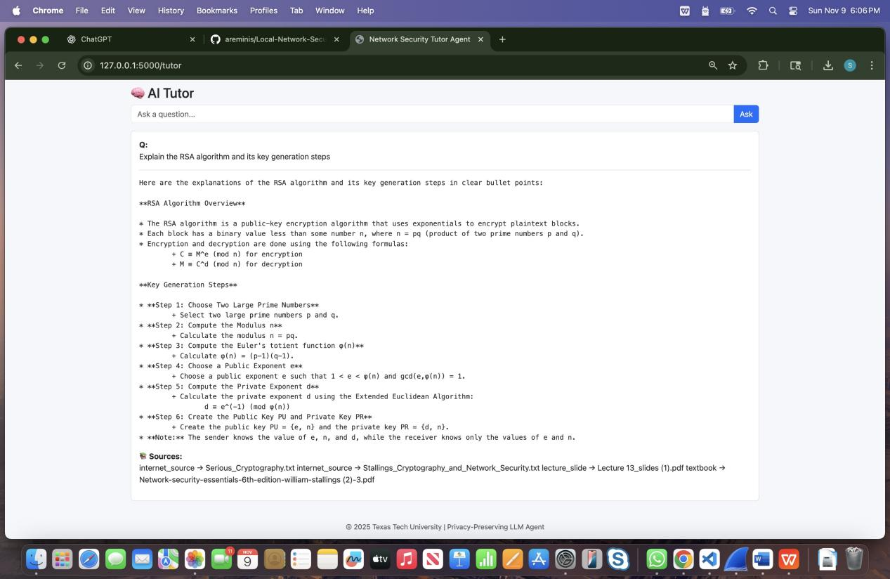

Wireshark observation:
- Source IP: 127.0.0.1
- Destination IP: 127.0.0.1
- Source Port: 50781
- Destination Port: 5000
- Protocol: TCP

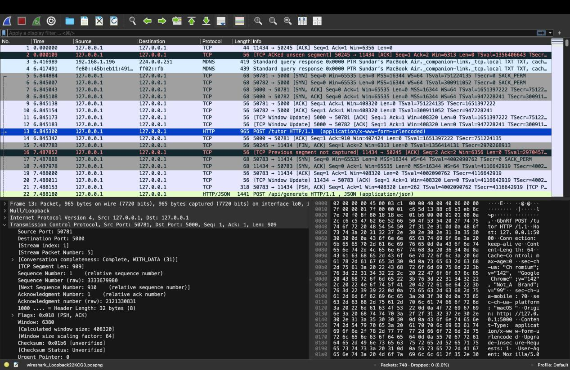
The connection starts with the usual TCP handshake (SYN → SYN/ACK → ACK).
After the connection is made, the browser sends an HTTP POST request that contains the user’s question in JSON format.
In the packet details, we can clearly see the question:
“Explain the RSA algorithm and its key generation steps.”
Once the server receives the question:
- Sends the question to the Chroma database to look up useful information.
- The server then sends the question and retrieved info to the Ollama local model, which creates the final answer.
- The server sends the answer back to the web interface as an HTTP response.
In Wireshark, the returned packet shows HTTP/1.1 200 OK, meaning everything worked successfully.

Prompt 2: Compare AES and DES in terms of structure and key size
Procedure:
When the user enters the query “Compare AES and DES in terms of structure and key size” in the Q&A interface, that request is sent from the client side to the server running on the same computer. The server processes the request, generates a response, and sends it back to the user interface. The image below shows an example of the query being sent and the response, along with the sources, being returned.

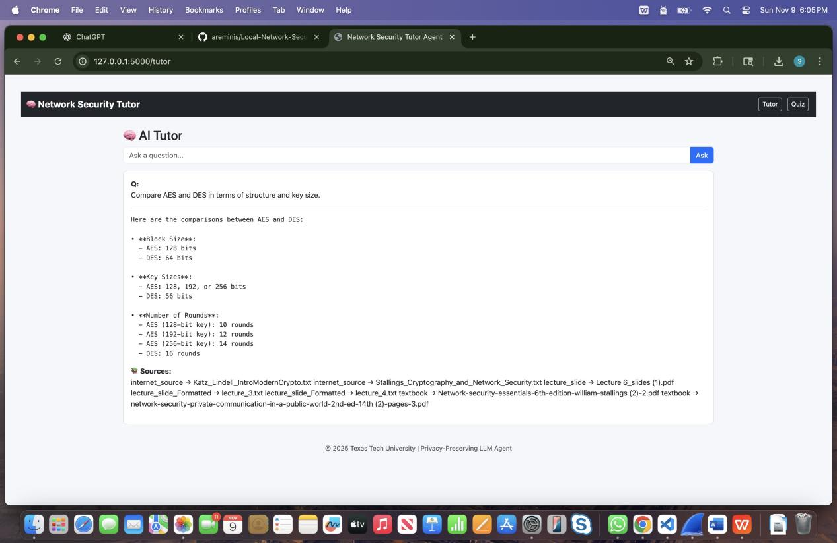
Wireshark:
- Source IP: 127.0.0.1
- Destination IP: 127.0.0.1
This shows that the communication is done only locally.
- Source Port: 50832
- Destination Port: 5000
- Protocol: TCP
The connection starts with the TCP handshake (SYN → SYN/ACK → ACK).
After the connection is made, the browser sends an HTTP POST request that contains the user’s question in JSON format.
In the packet details, we can clearly see the question:
“Compare AES and DES in terms of structure and key size.”
Once the server receives the question: server sends the question to the Chroma database to look up useful information.
- The server then sends the question and retrieved info to the Ollama local model, which creates the final answer.
- The server sends the answer back to the web interface as an HTTP response.
In Wireshark, the returned packet shows HTTP/1.1 200 OK, meaning everything worked successfully.

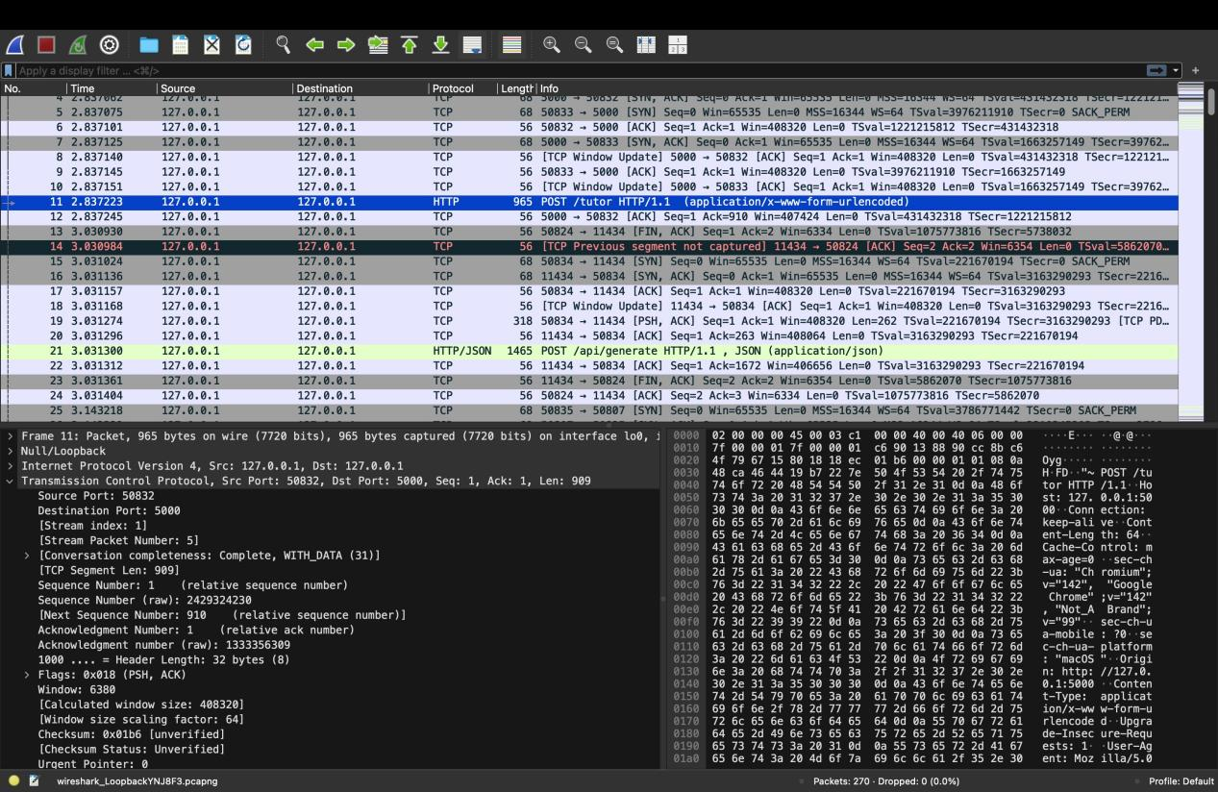

Prompt 3: What is Diffie–Hellman key exchange and how does it establish a shared secret?
Procedure:
When the user enters the query “What is Diffie–Hellman key exchange and how does it establish a shared secret?” in the Q&A interface, that request is sent from the client side to the server running on the same computer. The server processes the request, generates a response, and sends it back to the user interface. The image below shows an example of the query being sent and the response, along with the sources, being returned.

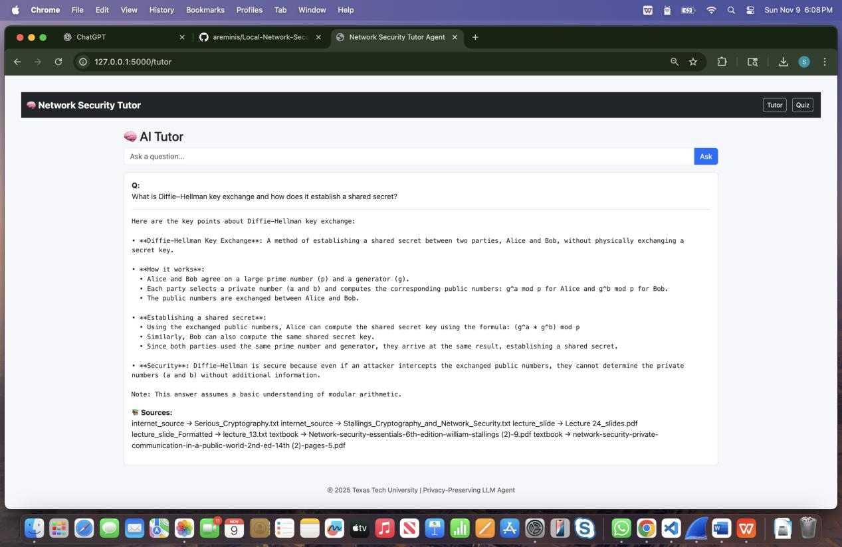

Wireshark:
- Source IP: 127.0.0.1
- Destination IP: 127.0.0.1
This shows that the communication is done only locally.
- Source Port: 50903
- Destination Port: 5000
- Protocol: TCP
The connection starts with the TCP handshake (SYN → SYN/ACK → ACK).
After the connection is made, the browser sends an HTTP POST request that contains the user’s question in JSON format.
In the packet details, we can clearly see the question:
“What is Diffie–Hellman key exchange and how does it establish a shared secret?”
Once the server receives the question:
- server sends the question to the Chroma database to look up useful information.
- The server then sends the question and retrieved info to the Ollama local model, which creates the final answer.
- The server sends the answer back to the web interface as an HTTP response.
In Wireshark, the returned packet shows HTTP/1.1 200 OK, meaning everything worked successfully.
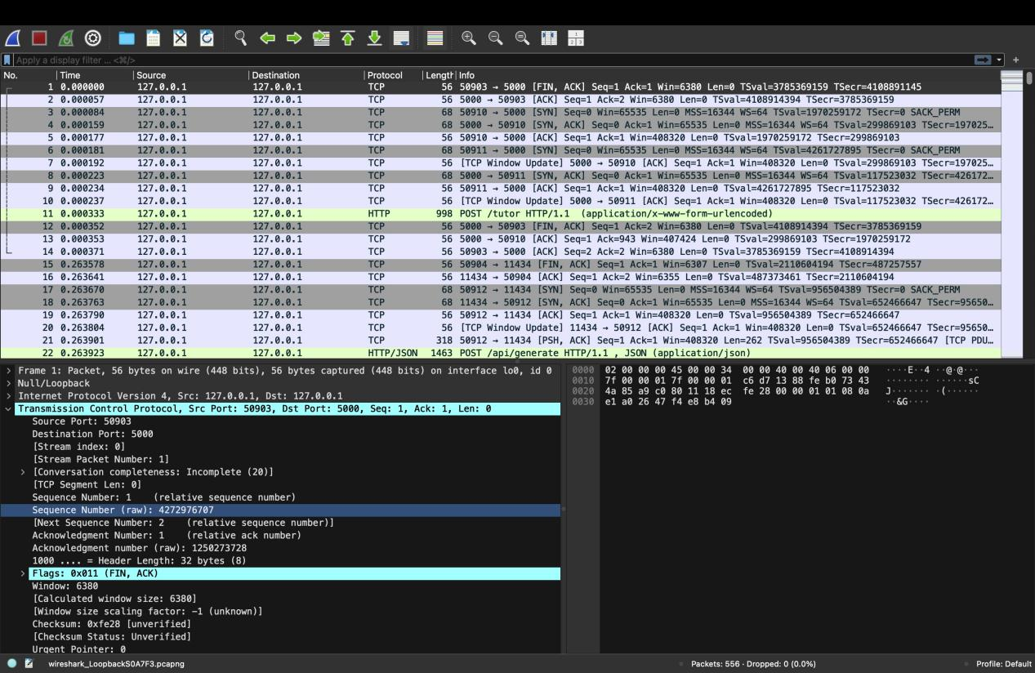

Prompt 4: Explain the purpose and working of stream ciphers
Procedure:
When the user enters the query “Explain the purpose and working of stream ciphers” in the Q&A interface, that request is sent from the client side to the server running on the same computer. The server processes the request, generates a response, and sends it back to the user interface. The image below shows an example of the query being sent and the response, along with the sources, being returned.

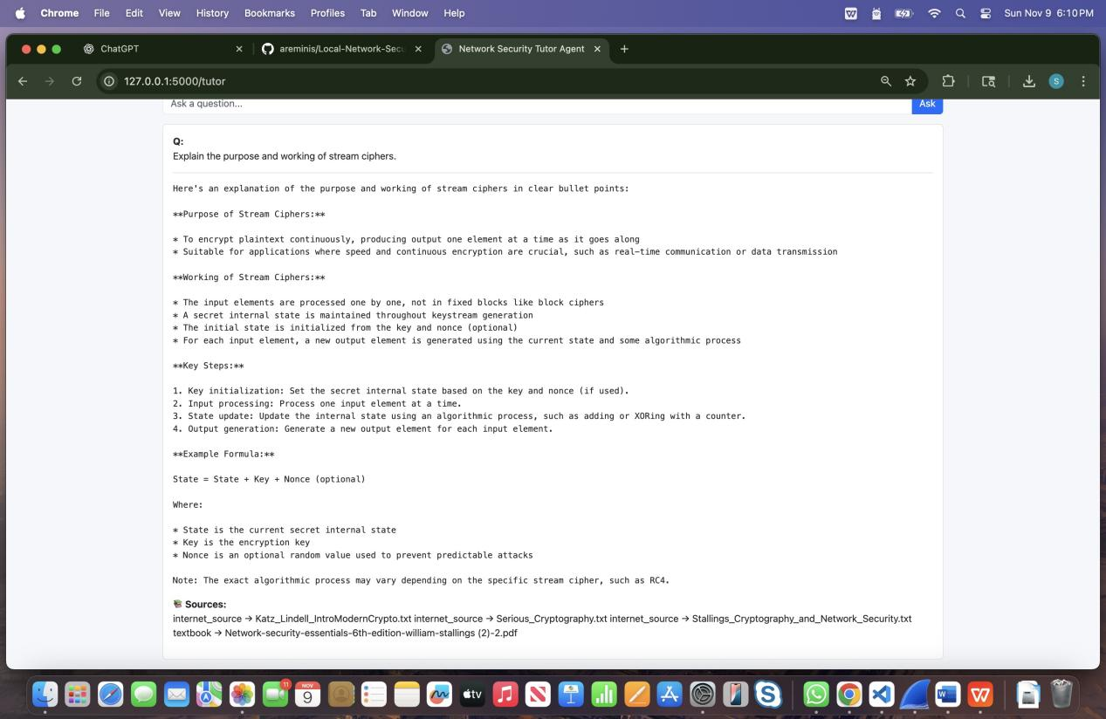

Wireshark:
- Source IP: 127.0.0.1
- Destination IP: 127.0.0.1
This shows that the communication is done only locally.
- Source Port: 50911
- Destination Port: 5000
- Protocol: TCP
The connection starts with the TCP handshake (SYN → SYN/ACK → ACK).
After the connection is made, the browser sends an HTTP POST request that contains the user’s question in JSON format.
In the packet details, we can clearly see the question:
“Explain the purpose and working of stream ciphers.”
Once the server receives the question:
- server sends the question to the Chroma database to look up useful information.
- The server then sends the question and retrieved info to the Ollama local model, which creates the final answer.
- The server sends the answer back to the web interface as an HTTP response.
In Wireshark, the returned packet shows HTTP/1.1 200 OK, meaning everything worked successfully.

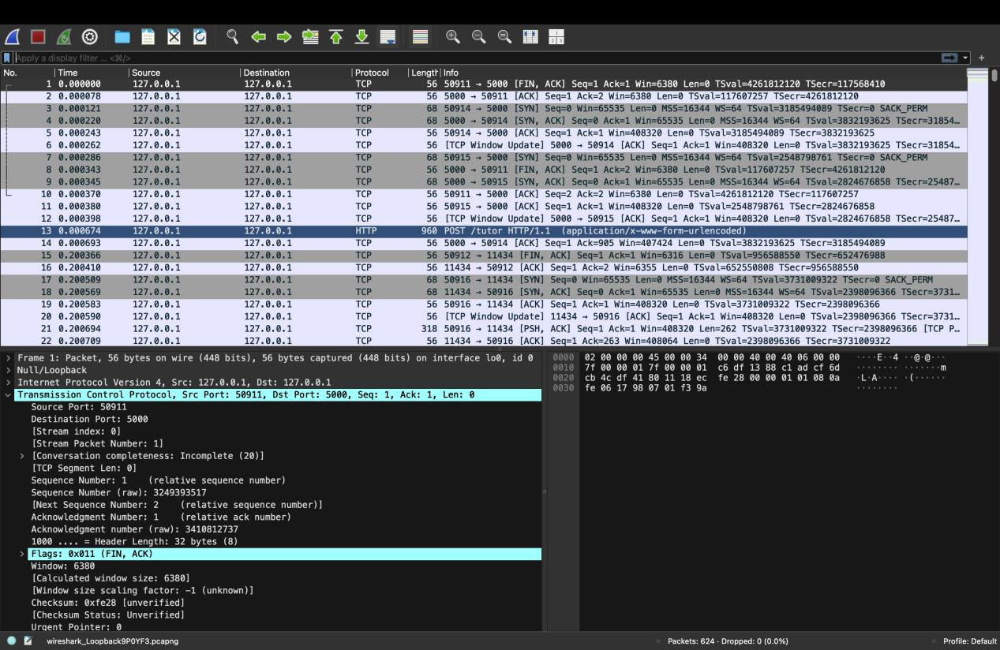

Prompt 5: Quiz Lab

When the user opens the Quiz Lab interface, they begin by entering their quiz preferences such as the number of questions, difficulty level, and topic of interest. In this case, the user selected the topic “Encryption Algorithms” with 5 questions and pressed the Generate Quiz button.

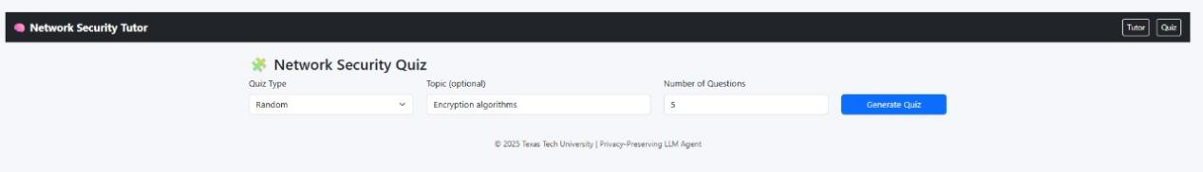

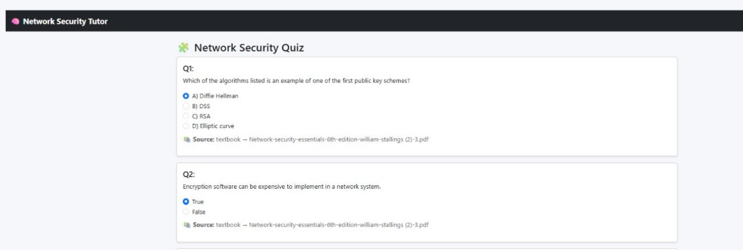

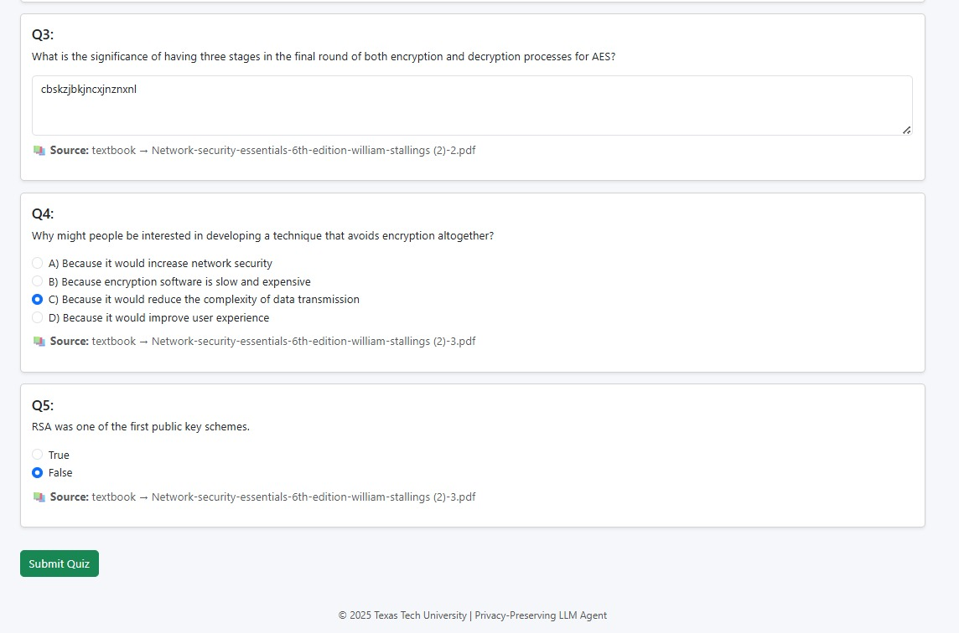

Once the user initiates the quiz generation, this request is sent from the frontend (port 3000) to the server backend. The backend retrieves the relevant teaching materials such as textbook content or lecture slides stored inside the Chroma vector database. The retrieved context, along with the quiz configuration parameters, is then passed to the Llama 3.2 model running locally on Ollama for quiz creation.

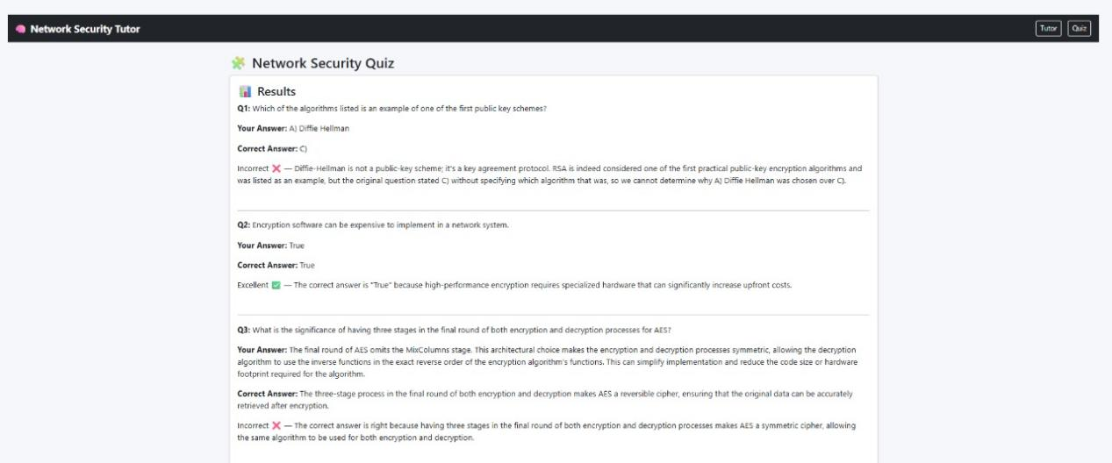

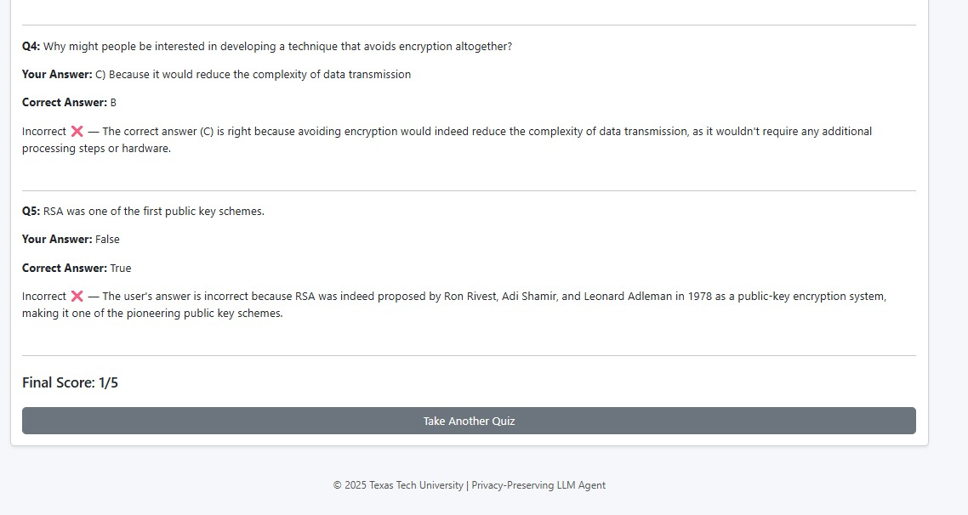
Wireshark:
- Source IP: 127.0.0.1
- Destination IP: 127.0.0.1
This indicates that the entire communication between the browser, server backend, and Llama 3.2 model is happening locally within the same system.
- Source Port: 61268 (temporary client port)
- Destination Port: 5000 (backend port)
The client browser uses a dynamically assigned port to connect to the server server on port 5000.
- Protocol: TCP and HTTP
The packet sequence shows a typical TCP three-way handshake:
- SYN → SYN/ACK → ACK establishes the connection between the client and backend.
- HTTP GET /quiz HTTP/1.1 indicates that the frontend is requesting the Quiz interface or initiating a quiz generation request.
- HTTP/1.1 200 OK confirms that the server backend successfully responded and delivered the quiz data to the frontend.
Following this, the trace records the exchange of multiple TCP ACK packets, representing data acknowledgment between the two endpoints.
Once the quiz data is received and rendered in the frontend, a series of HTTP POST requests occur later for quiz submission and grading, handled by the /api/quiz/grade endpoint.
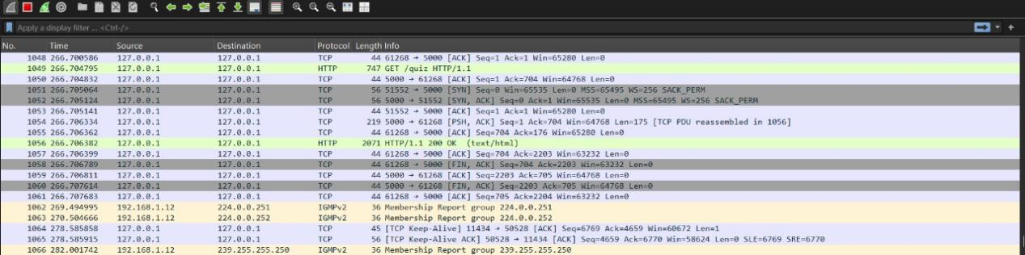
Additionally, IGMPv2 Membership Report packets can be seen, which are part of routine multicast group maintenance on the local network interface and not related to the Q&A or quiz communication.
The entire captured session demonstrates that:
- All traffic is confined to 127.0.0.1, confirming local operation.
- The HTTP exchange concludes with a successful 200 OK status, validating that the quiz generation and communication between frontend, backend, and Ollama (Llama 3.2) model occurred without any errors.

