# Survey example (screenshots of static factor)

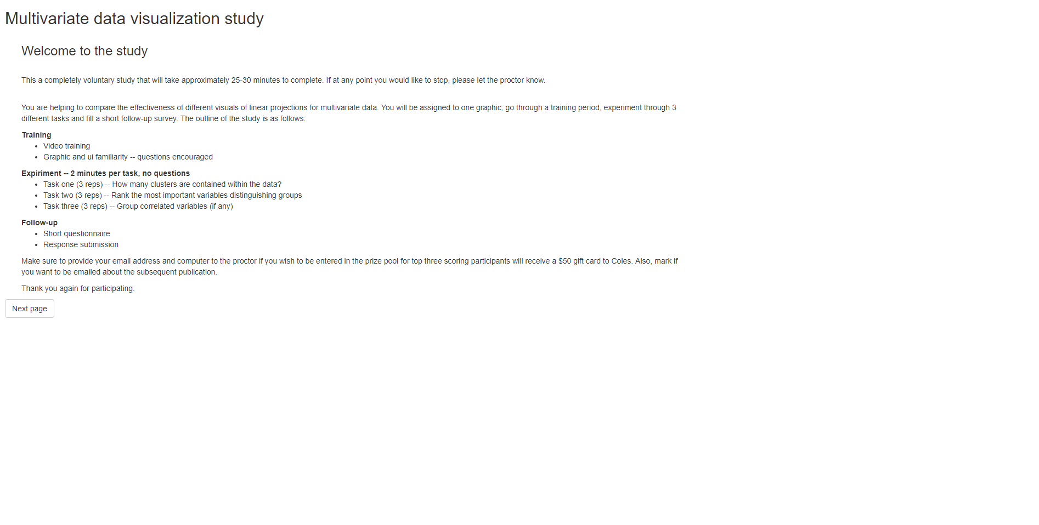

Introduction page

Participant will:

* Read about the study
* Learn the structure
* Proceed to next page

Training (task 1 of 2)

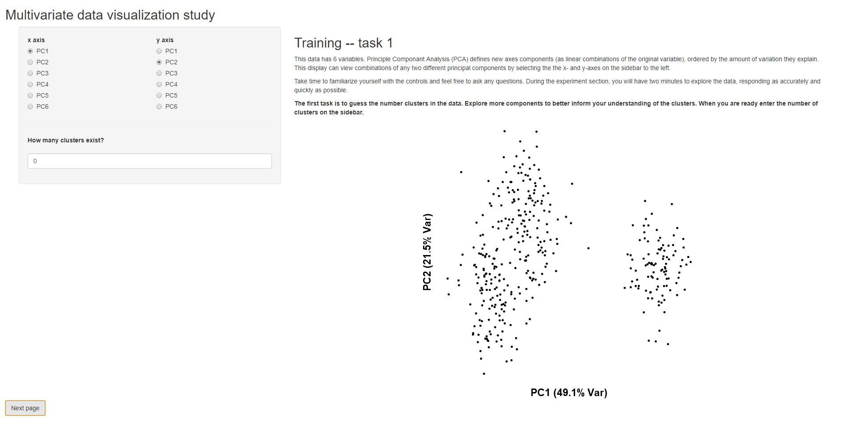Participant will:

* Read about task 1
* Familiarize with UI
* Ask questions as needed
* Proceed to next page

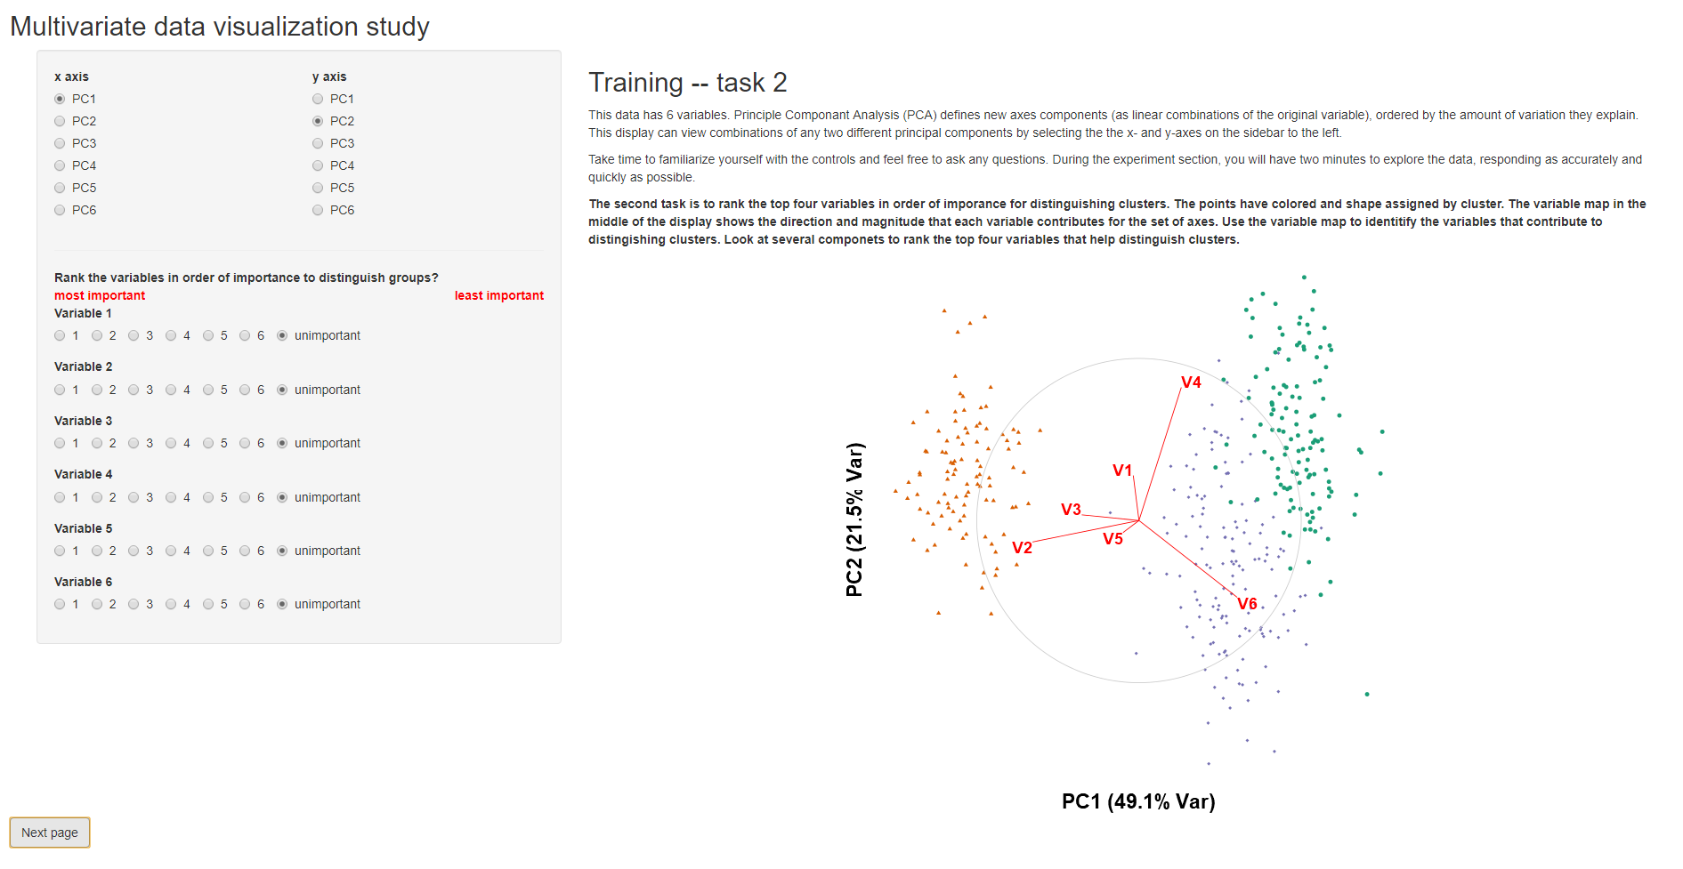Training (task 2 of 2)

Participant will:

* Read about task 1
* Familiarize with UI
* Ask questions as needed
* Proceed to next page

Task 1 (x3 reps)

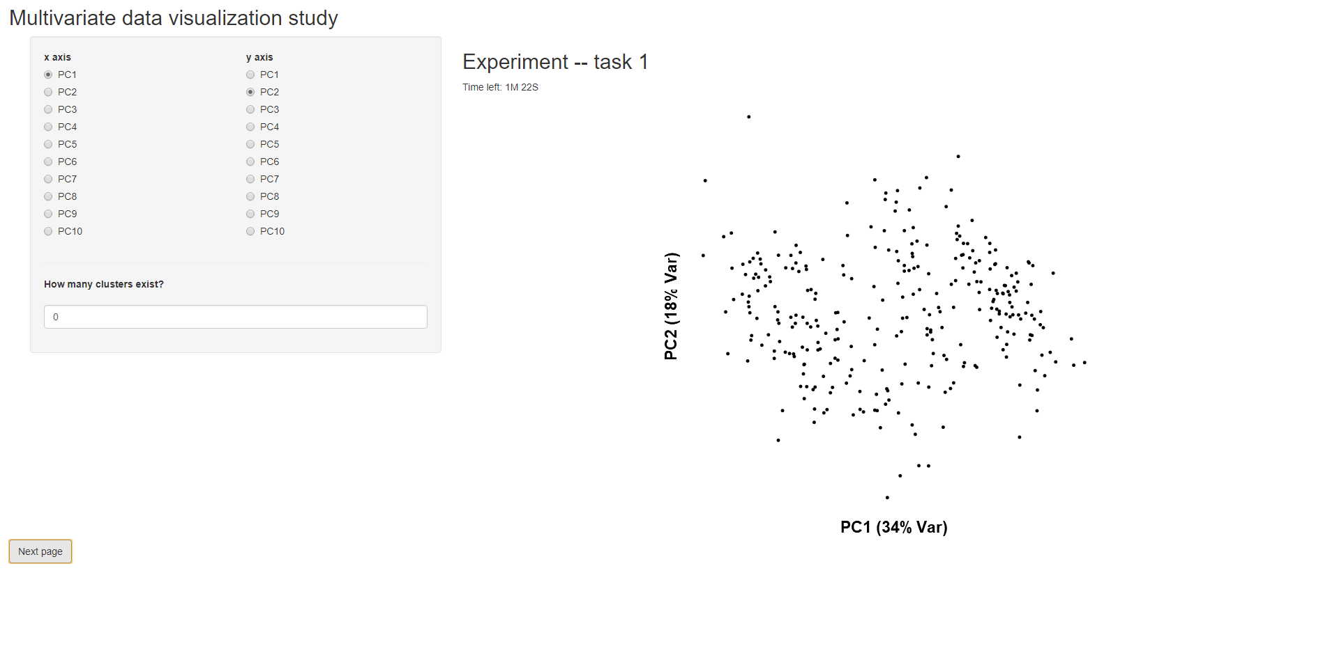Participant will:

* Apply previous training to estimate the number of clusters in data
* Response and time recorded automatically
* Repeat for 3 repetitions
* Proceed to next page

Task 2 (x3 reps)

Participant will:

* 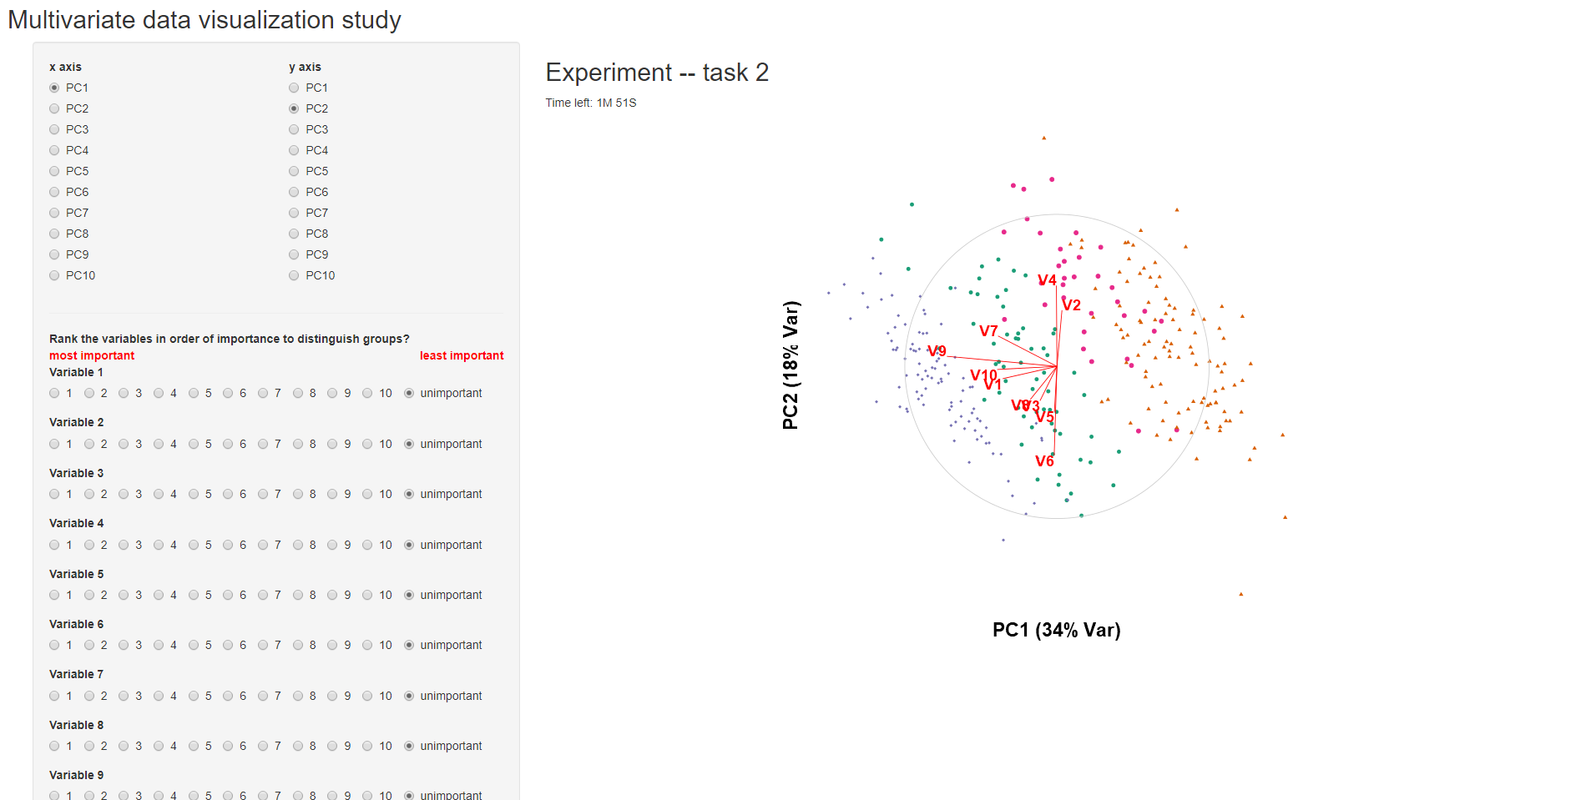Apply previous training to rate variable importance for separating 2 clusters
* Response and time recorded automatically
* Repeat for 3 repetitions
* Proceed to next page

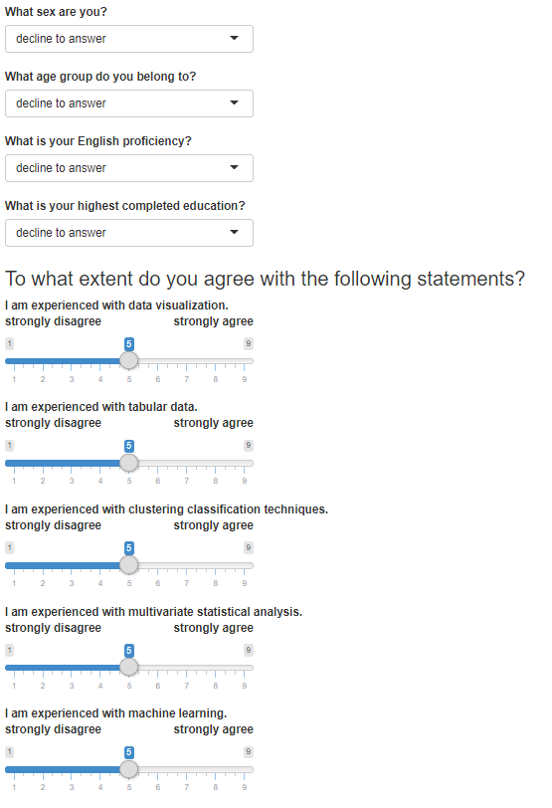Follow up survey (top)

Participant will:

* Provide demographic, and other information that may help control for task outcomes
* Response and time recorded automatically
* Click the save button

Follow up survey (bottom)

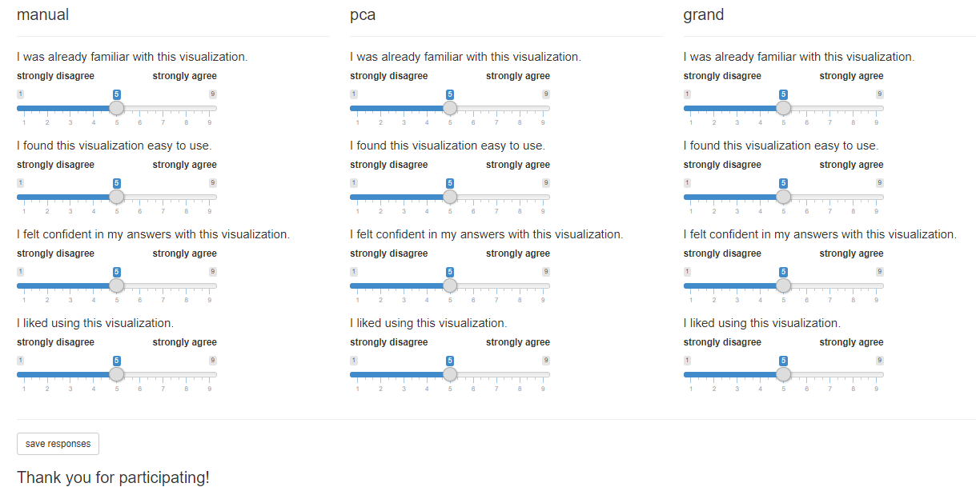Participant will:

* Provide demographic, and other information that may help control for task outcomes
* Response and time recorded automatically
* Click the save button