# Survey example (screenshots of static factor)

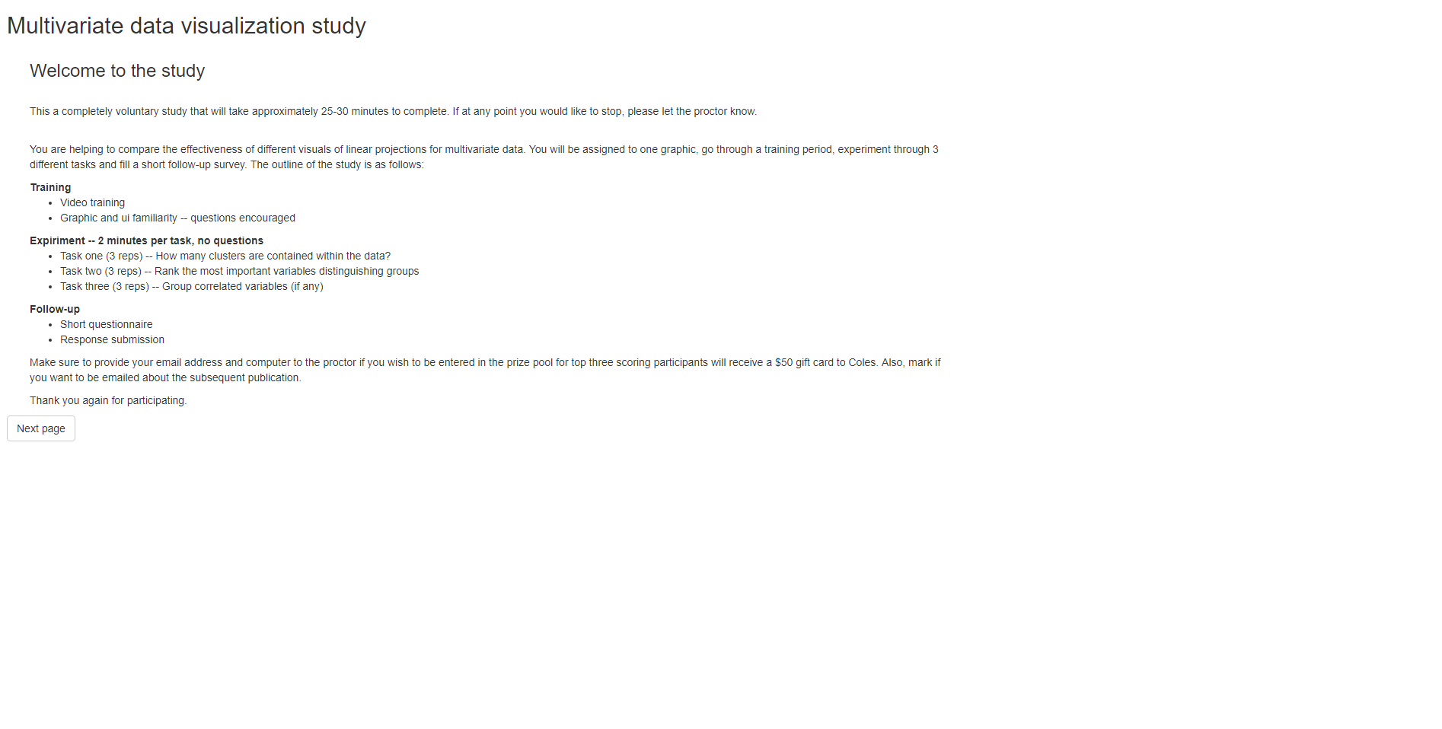

Introduction page,

Participant will:

* Read about the study
* Learn the structure
* Proceed to next page

Training (1/3)

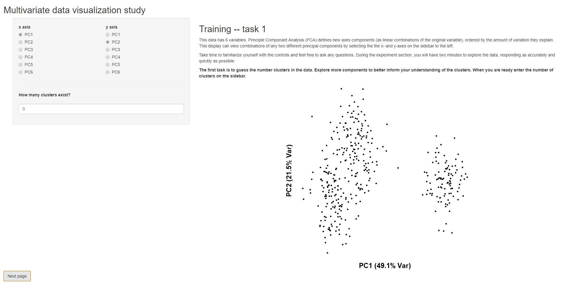Participant will:

* Read about task 1
* Familiarize with UI
* Ask questions as needed
* Proceed to next page

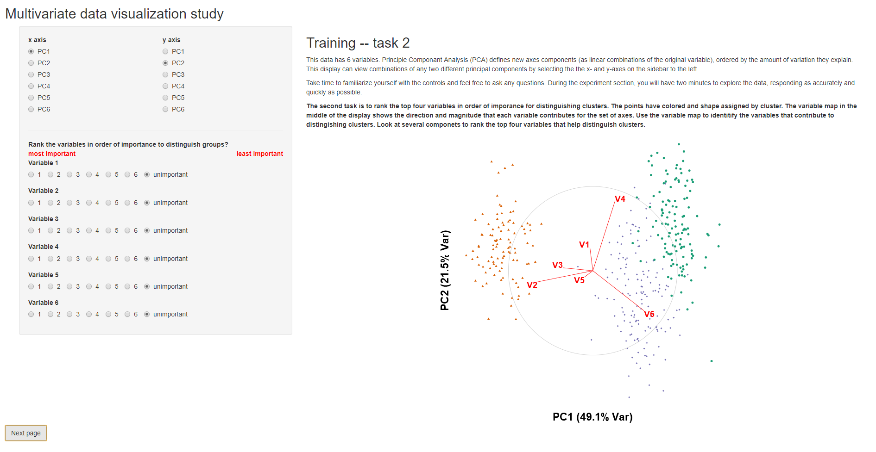Training (2/3)

Participant will:

* Read about task 1
* Familiarize with UI
* Ask questions as needed
* Proceed to next page

Training (3/3)

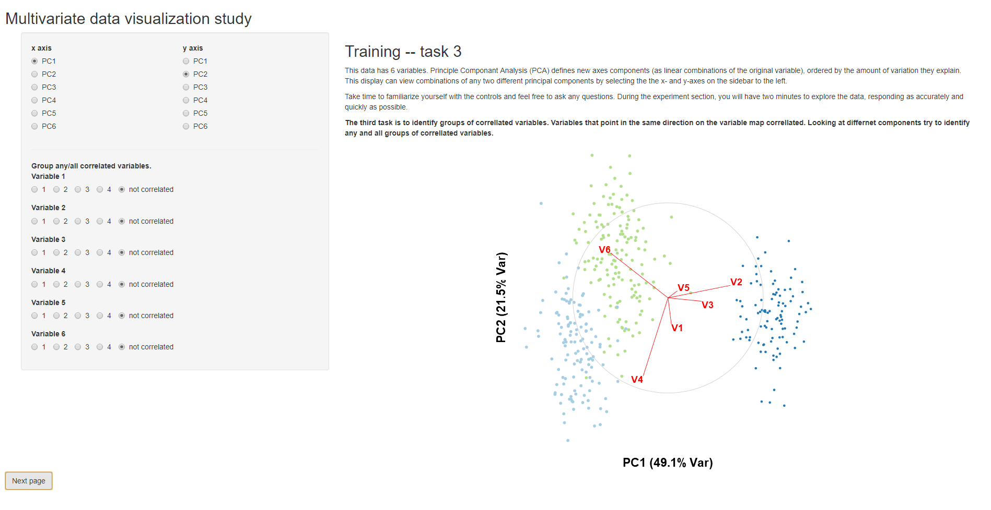

Participant will:

* Read about task 3
* Familiarize with UI
* Ask questions as needed
* Proceed to next page

Task 1 (x3 reps)

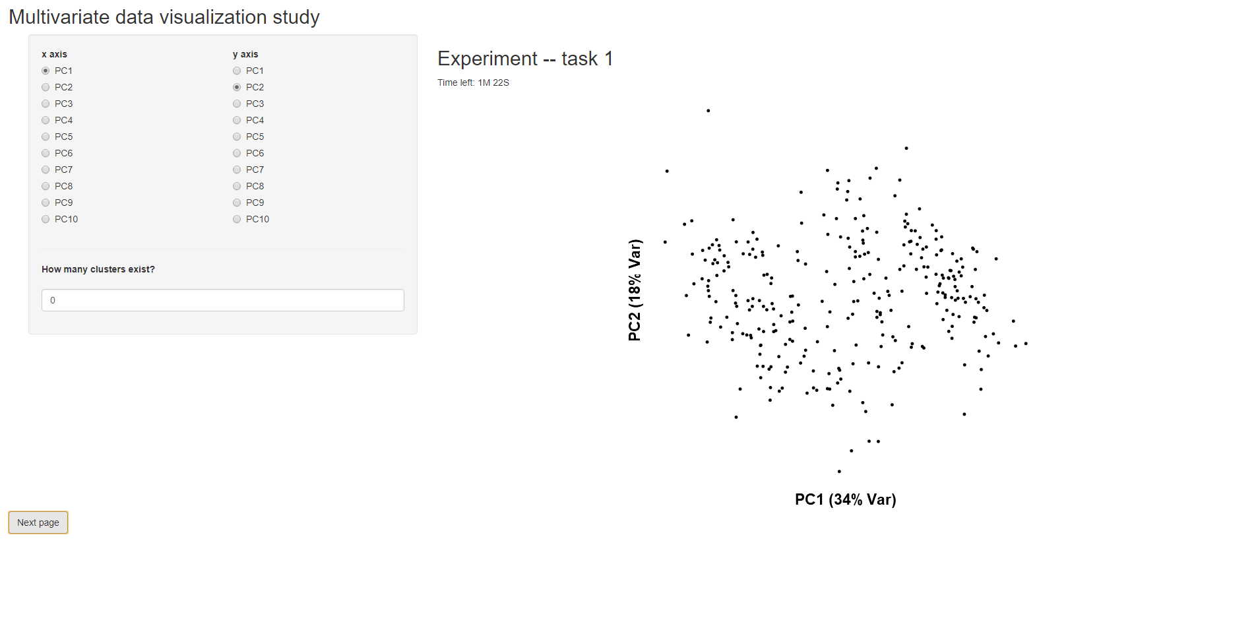Participant will:

* Apply previous training to estimate the number of clusters in data
* Response and time recorded automatically
* Repeat for 3 repetitions
* Proceed to next page

Task 2 (x3 reps)

Participant will:

* 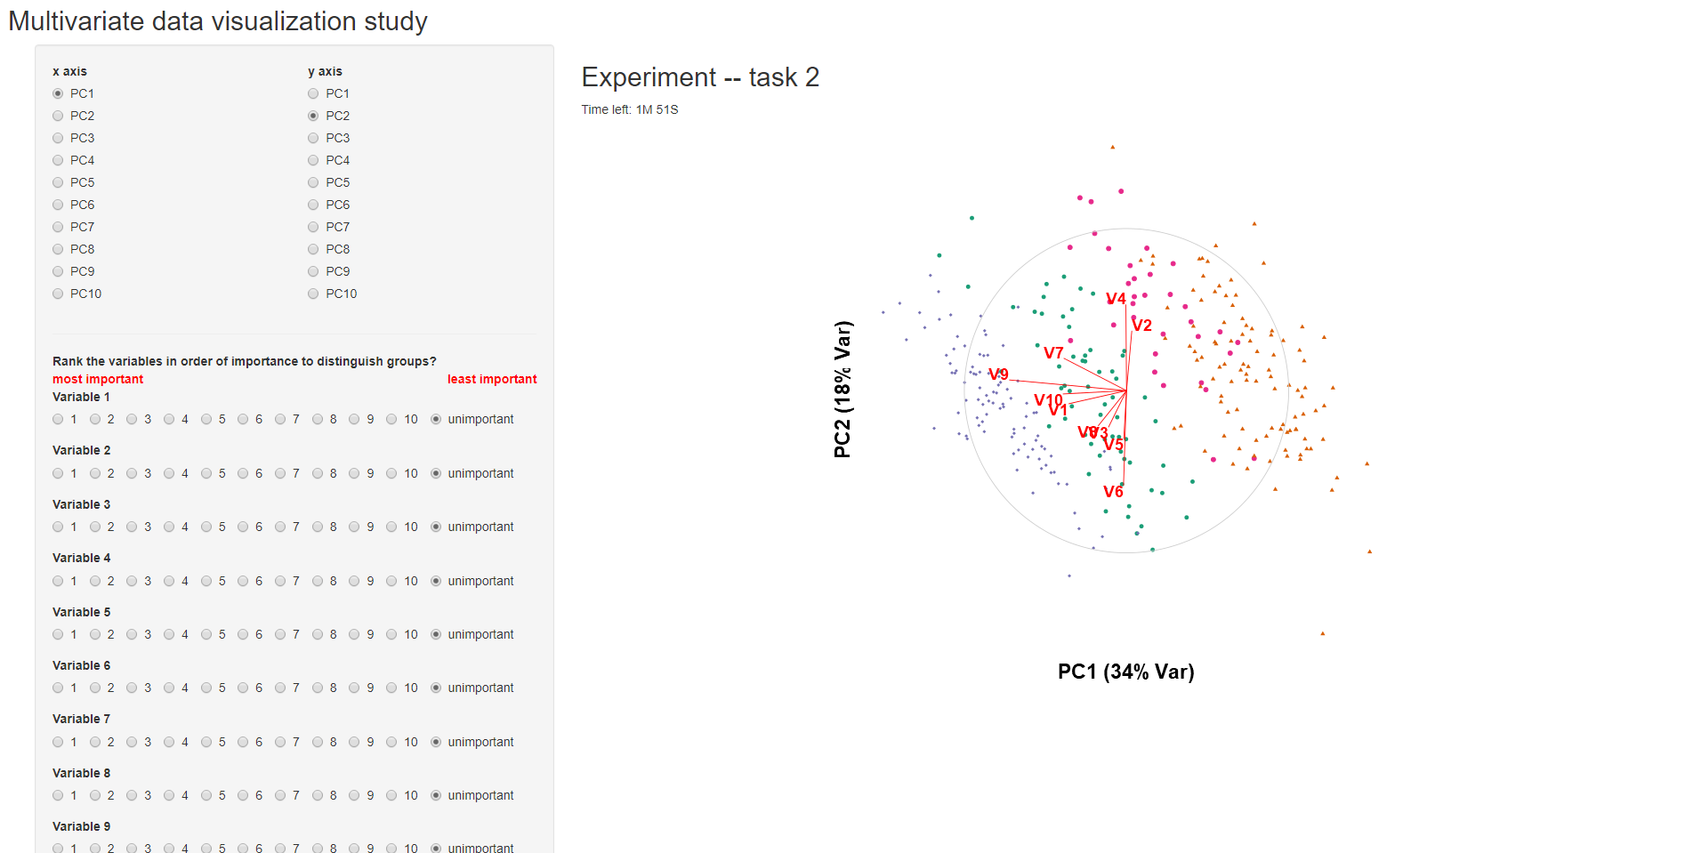Apply previous training to rank order of variable importance.
* Response and time recorded automatically
* Repeat for 3 repetitions
* Proceed to next page

Task 3 (x3 reps)

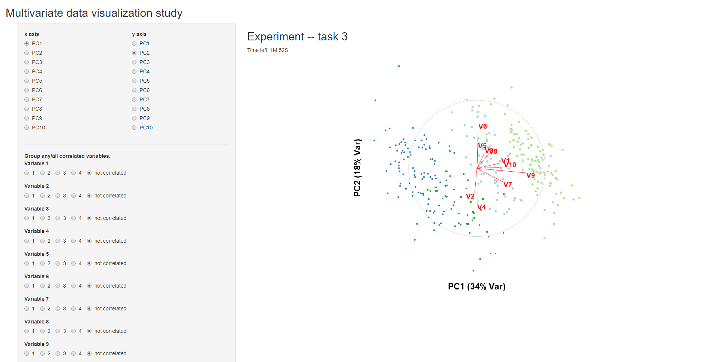Participant will:

* Apply previous training to identify any/all correlated variables.
* Response and time recorded automatically
* Repeat for 3 repetitions
* Proceed to next page

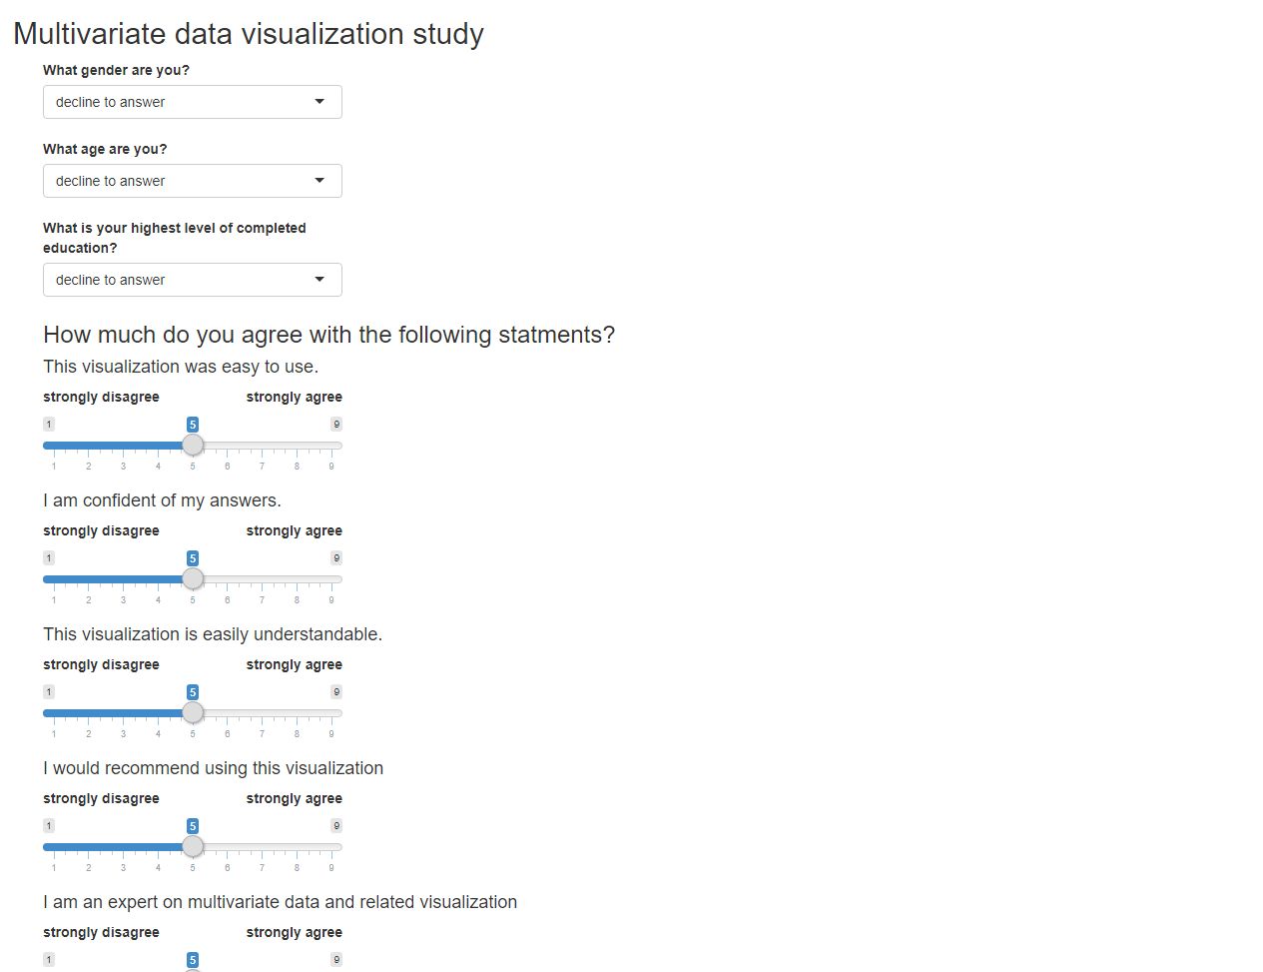Task 3 (x3 reps)

Participant will:

* Apply previous training to identify any/all correlated variables.
* Response and time recorded automatically
* Click the save button
* Prompted to tell the proctor they have completed the study.