**Al-Azhar University – Gaza**



**FACULTY OF ENGINEERING AND INFORMATION TECHNOLOGY**

**Department of Software Engineering**

**Software Engineering**

**Final Exam**

**Prepared By:**

**انتصار خالد البنا**

**20170295**

**Supervised By:**

**Dr. Yousef abou Sultan**

**SEMESTER II 2019/2020**

**Q1 Explain organizational life cycle?**

**Organizational life cycle** is an important model because it is premise that requirements, opportunities, and threats both inside and outside the business firm will vary depending on the stage of development in which the firm finds itself.

**The organizational life cycle has five phases**

**Ph 1 creative expansion leadership crisis**

Creative expansion leads to a leadership crisis .

More sophisticated and more formalized management practices need to be adopted. If the founders are unable or unwilling to accept this responsibility, they must hire someone who can, and give this person significant authority.

**Ph 2 directional expansion autonomy crisis**

Directional expansion leads to a crisis of autonomy.

Lower level managers must be given more authority if the organization is to continue to grow.

**Ph 3 expansion through delegation control crisis**

Expansion through delegation (evolutionary phase) leads to a crisis of control (revolutionary phase).

This occurs when autonomous employees who prefer to operate without interference from the rest of the organization clash with business owners and managers who perceive that they are losing control of a diversified company.

**Ph 4 expansion through coordination red tape crisis**

Expansion through coordination (evolutionary phase) leads to a crisis of [red tape](https://en.wikipedia.org/wiki/Red_tape) (revolutionary phase).

Coordination techniques like product groups, formal planning processes, and corporate staff become, over time, a bureaucratic system that causes delays in decision-making and a reduction in innovation.

**P 5 expansion through collaboration**

Is characterized by the use of teams, a reduction in corporate staff, matrix-type structures, the simplification of formal systems, an increase in conferences and educational programs, and more sophisticated information systems.

**___________________________________________________________**

**Q2 Explain the relation between strategy implementation and job design?**

Strategy is any long term plan, that focuses on the competitive strength of an organisation. Job Design specify the tasks or works necessary to perform in order to meet strategic objectives.

Every job design is developed with alignment to the formulated Strategies; In other words, creating a strategy job design fit, to execute the strategic plans in order to effectively achieve goals with relevant Activities and jobs.

Job Design is related to the strategy implementation, in a way that best fits the requirements of deploying the competencies and capabilities for meeting the requirements of the business by focusing on attaining strategic goals.

**___________________________________________________________**

**Q3 Explain Global Driving forces of Change in Org. at 21st Century?**

**1- Demographic**  workers will have longer work lives, and young workers have different expectations.

**2-Globalization of labor**  It is expected that 50% of employees in transnational companies will be from developing countries.

**3-The rise of new customer**  highly educated, high level of income and familiar of information technology, he will loyal to value rather than brands.

**4-Torrid/extreme Technological growth**  The technological will continue to be major driver of org. change and transformation.

**5-The global separate centers of innovation**

**6-The new knowledge based economy will be driven by rapid innovation in technology.**

**___________________________________________________________**

**Q4 Draw the Comprehensive Strategic Management Model?**

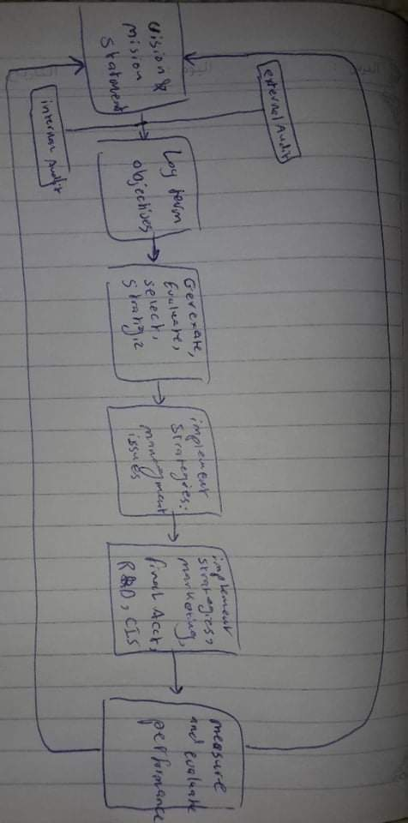

**Q5 list the main of**

1. **Components of Mission**

1-Customers

2-Products or services

3-Markets

4-Technology

5-Survival, Growth, and profitability

6-Physiology

7-Self –Concepts

8-Concern for public image

9-Concern for employees

1. **Characteristics of a Mission**

1-Define what the organization is

2-Broad enough to allow for creative growth

3-Distinguish the firm from all others

4-Serve as framework to evaluate current activities

5-Stated clearly so that it is understood by all

6-Board in scope

7-Generate range of feasible strategic alternatives

8-Not excessively specific

9-Reconcile interests among diverse stakeholders

10-finely balanced between specificity and generality

1. **General Environment Components**

**1- Economic**

**2-Sociocultural**

**3-Global**

**4-Technological**

**5-Political/legal**

**6-Demographic**

1. **Components of the External Environmental Analysis?**

**1-Scanning**

**2-Monitoring**

**3-Forecasting**

**4-Assessing**

**___________________________________________________________**

**Q6 discuss The Five Forces of Competition Model?**

**Threat of new entrants.** This force determines how easy (or not) it is to enter a particular industry. Threat of new entrants is high when:

* Low amount of capital is required to enter a market;
* Existing companies can do little to retaliate;
* Existing firms do not possess patents, trademarks or do not have established brand reputation;
* There is no government regulation;
* Customer switching costs are low (it doesn’t cost a lot of money for a firm to switch to other industries);
* There is low customer loyalty;
* Products are nearly identical;
* Economies of scale can be easily achieved.

**Bargaining power of suppliers.** Strong bargaining power allows suppliers to sell higher priced or low quality raw materials to their buyers. Suppliers have strong bargaining power when:

* There are few suppliers but many buyers;
* Suppliers are large and threaten to forward integrate;
* Few substitute raw materials exist;
* Suppliers hold scarce resources;
* Cost of switching raw materials is especially high.

**Bargaining power of buyers.** Buyers have the power to demand lower price or higher product quality from industry producers when their bargaining power is strong. Lower price means lower revenues for the producer, while higher quality products usually raise production costs. Buyers exert strong bargaining power when:

* Buying in large quantities or control many access points to the final customer;
* Only few buyers exist;
* Switching costs to other supplier are low;
* They threaten to backward integrate;
* There are many substitutes;
* Buyers are price sensitive.

**Threat of substitutes.** This force is especially threatening when buyers can easily find substitute products with attractive prices or better quality and when buyers can switch from one product or service to another with little cost.

**Rivalry among existing competitors.** This force is the major determinant on how competitive and profitable an industry is. Rivalry among competitors is intense when:

* There are many competitors;
* Exit barriers are high;
* Industry of growth is slow or negative;
* Products are not differentiated and can be easily substituted;
* Competitors are of equal size;

**___________________________________________________________**

**Q7 Draw Strategic management Model?**

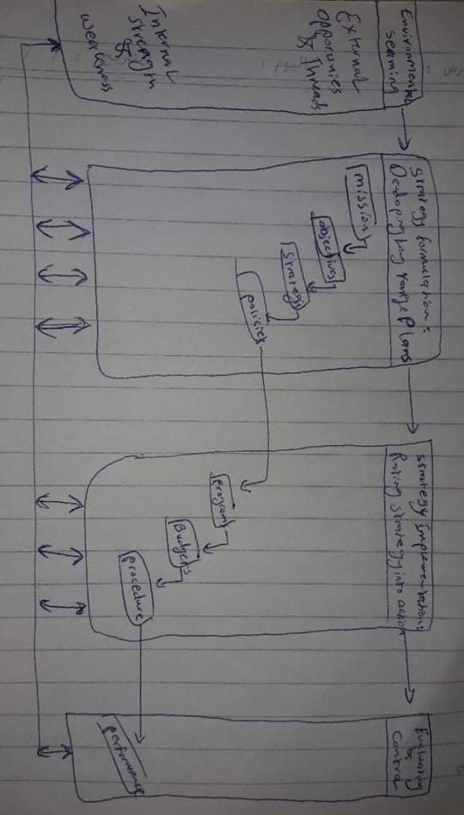

**Q8 Explain the main Review Bases of Strategy?**

**Develop a Revised Evaluation Framework Matrix**

How have competitors reacted to our strategies?

How have competitors’ strategies changed?

Have major competitors’ strengths and weaknesses changed?

Why are competitors making certain strategic changes?

Why are some competitors’ strategies more successful than others?

How far can our major competitors be pushed before retaliating?

How could we more effectively cooperate with our competitors?

How satisfied are our competitors with their present market positions and profitability?

**Key Questions in Evaluating Strategy**

Are our internal strengths still strengths?

Have we added other internal strengths?

Are our internal weaknesses still weaknesses?

Do we now have other internal weaknesses?

Are our external opportunities still opportunities?

Are there now external opportunities?

Are our external threats still threats?

Are there now other external threats?

Are we vulnerable to a hostile takeover?

**___________________________________________________________**

**Q9 Write a sample of strategy for local firm include clear mission and vision?**

**الشركة العربية الفلسطينية للاستثمار**

### **رؤيا الشركة:**

### نتطلع إلى توفير باقة متكاملة من المنتجات والخدمات ذات القيمة والجودة العالية، بحيث تسهم في إحداث فرق نوعي ومستدام في السوق. وبالتالي اتخاذ استثماراتنا الوضع القيادي بنظر المستهلك مما سيتيح لموظفي الشركة والمستثمرين فيها والمجتمعات التي تعمل بها الشركة بالازدهار.

### **رسالة الشركة:**

### تحقيق النجاح التجاري والمالي من خلال الاستثمار في الشركات الرائدة في السوق، وبالتالي النّهوض بالمجتمع من حيث الموارد والمهارات والتنمية الاقتصادية عن طريق:

### توفير منتجات وخدمات فائقة الجودة.

### توظيف كوادر بشرية مؤهلة وذات خبرة، والعمل على توفير فرص لهم تمكّنهم من النمو والتطور.

### تطبيق أنظمة عمل فعالة بشكل مستمر تتوافق مع كافة جوانب دورة الأعمال للشركة.

### المحافظة على قاعدة مالية متينة تؤدي إلى المزيد من النمو.

### تعزيز الشراكة مع صناع القرار بالمنطقة لإحداث تغيير ملموس في المجتمع الفلسطيني.