Database : collection of data stored in a computer system and usually controlled by database management system (DBMS).

DBMS => **Database Management System** : t is software designed to manage and organize databases.

**SQL => Structured Query Language :** programming language for managing relational database data -> command (insert,delet,use,update).

Relational Databases: Use a structured data model where data is organized into tables consisting of rows and columns.

Non-relational Databases: They can be categorized into various types:

Document Databases/tree

Mysql=>RDBMS

RDBMS => Relational Database Management System/ **Open Source/** software designed to manage and organize databases

**Data type**

### * **String Data Types (**

CHAR store char from 0/255

Varchar (num, special characters

TEXT

ENUM one value

Set two/three value

BLOB binary

### * **Numeric Data Types (**

### **BIT=> like (010101011)**

### **BOOLEAN=> true =1, false=0**

### **INT => like (08756576) store int num**

### **DOBLE** **=> like (74.544.5) )**

Date yy/mm/dd=> birth_date DATE => 19/5/1999

Time h/m/s=> start_time =>12:00:00

Primary kay unique => A primary key must be unique within its respective table(user_id INT PRIMARY KEY)

NULL Constraint: Not required

NOT NULL Constraint: required/ EX=> emp_name VARCHAR(100) NOT NULL,

**Auto-Increment** is a feature that automatically generates a unique numeric value for each new row added to a table EX student_id INT AUTO_INCREMENT PRIMARY KEY

CREATE DATABASE StudentDB;

//

CREATE TABLE Students(

id int PRIMARY KEY AUTO_INCREMENT,

name VARCHAR(100) NOT null,

email VARCHAR(100),

enrollment_date DATE

);

//

INSERT INTO students (`id`, `name`, `email`, `enrollment_date`) VALUES (1, 'momen', 'ex@gmail.com', '1999-05-19');

//

UPDATE students set email='nsreen@gmail.com' WHERE id =1 ;

//

DELETE FROM students;

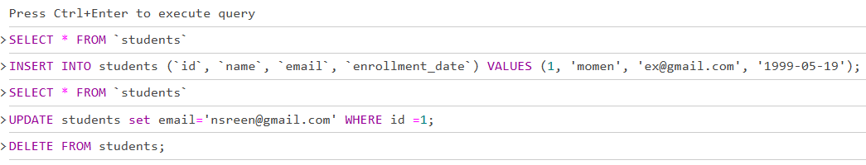

USE Student;

//

CREATE TABLE Employees(

emp_id INT primary key AUTO_INCREMENT,

emp_name VARCHAR(100) NOT null,

emp_position VARCHAR(100),

hire_date DATE

);

//

CREATE TABLE Managers(

manag_id INT primary key AUTO_INCREMENT,

manag_name VARCHAR(100) NOT null,

manag_position VARCHAR(100),

hire_date DATE );

//

INSERT INTO managers (`manag_id`, `manag_name`, `manag_position`) VALUES (1, 'salama', 'managment');

//

UPDATE managers SET emp_position = 'leader' WHERE manag_id = 1;

//

DELETE FROM managers;