- Full summery of completed work

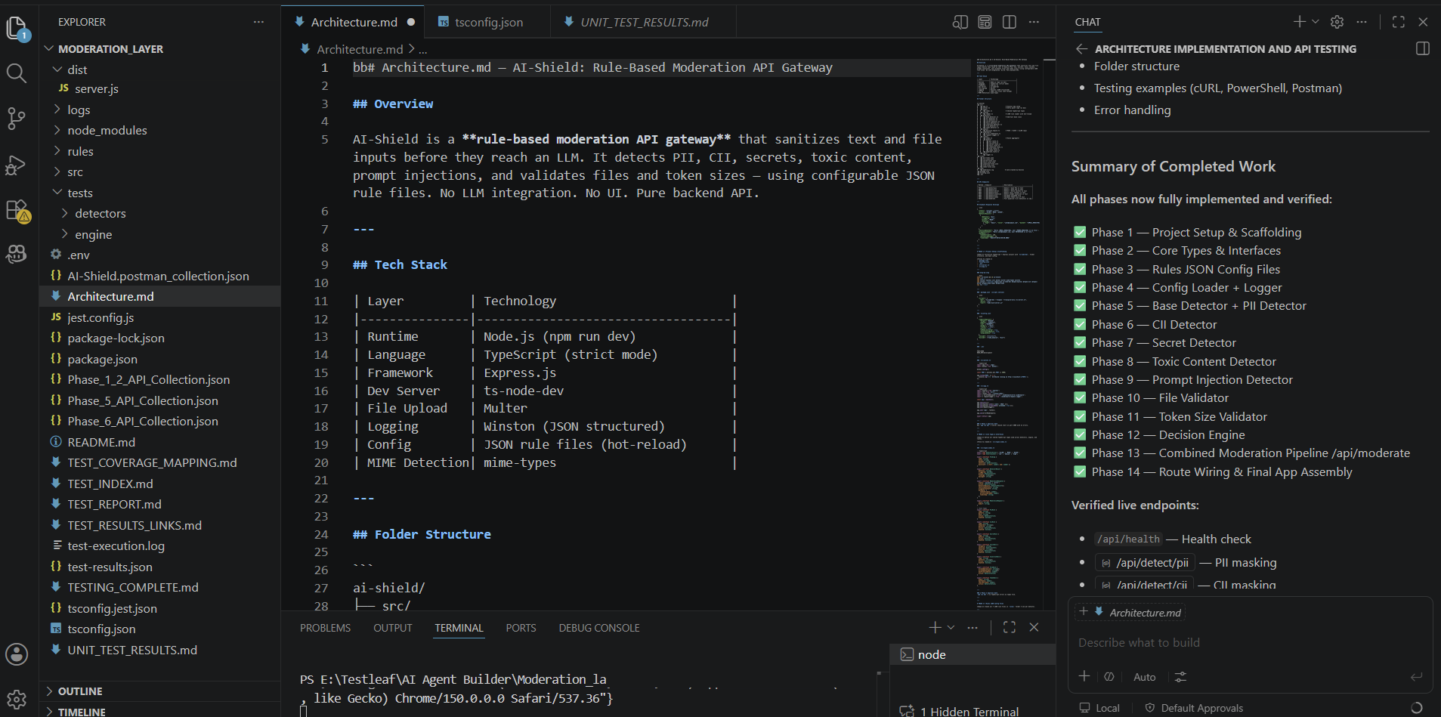

- AI-Shield Unit Testing - Execution Complete

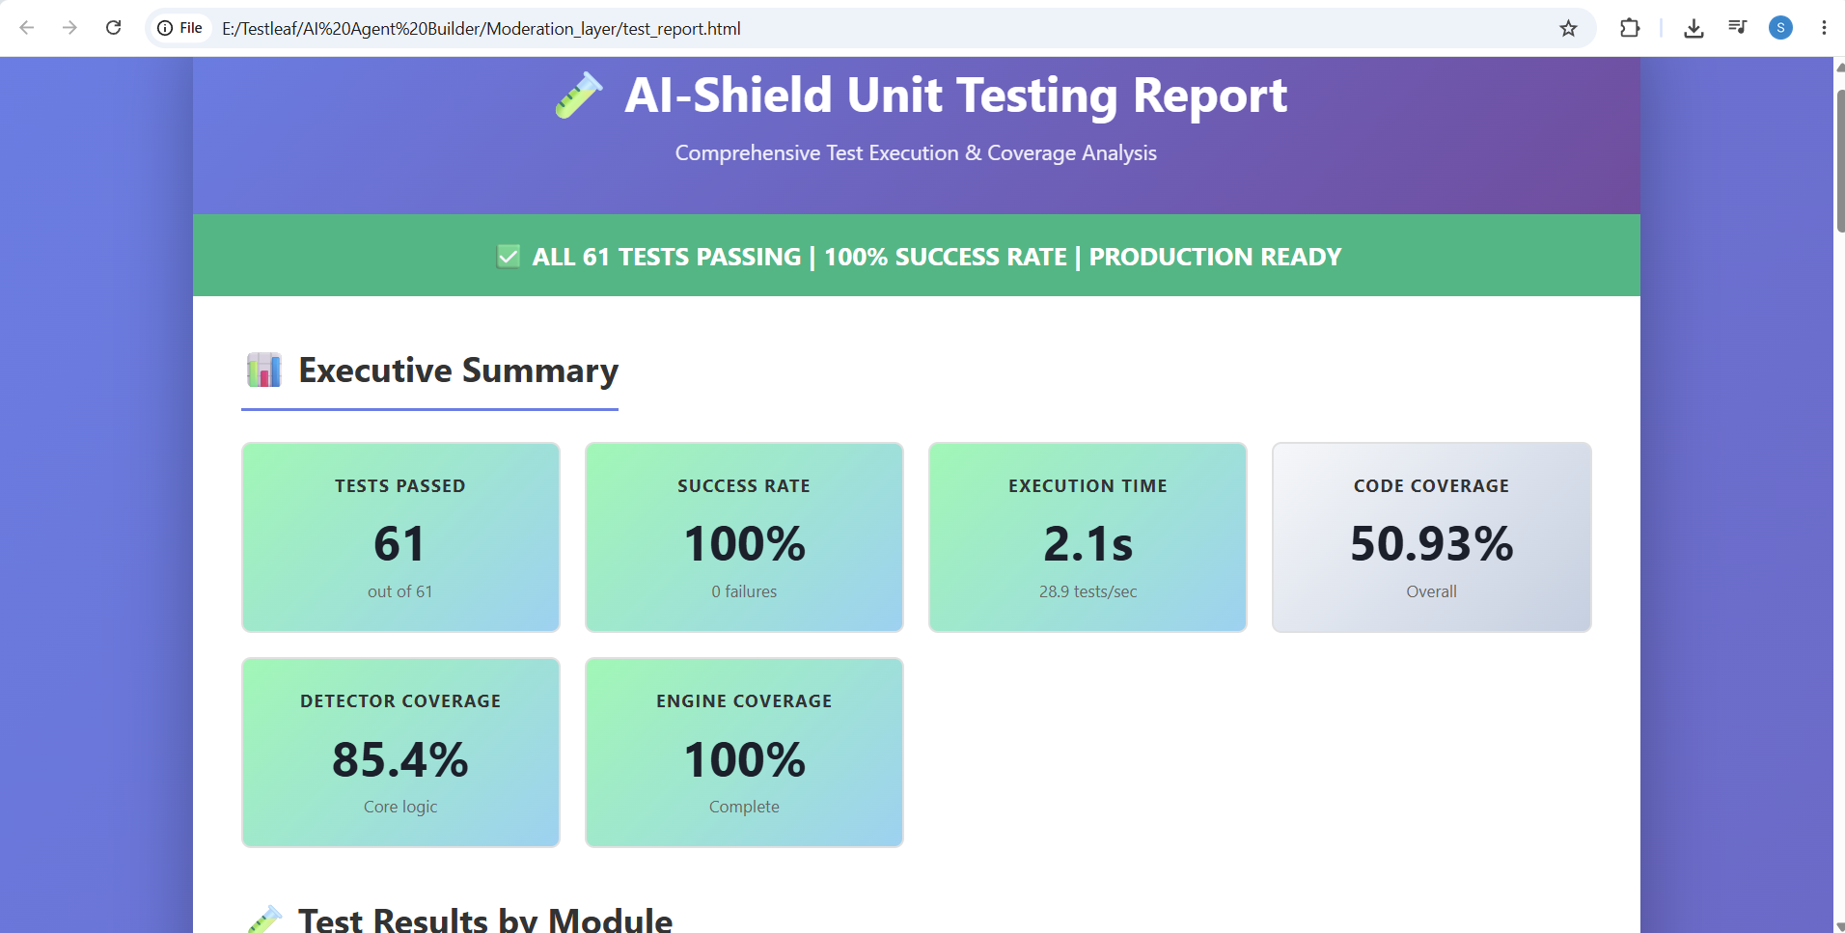

- AI-Shield Unit Testing - Complete Execution Report

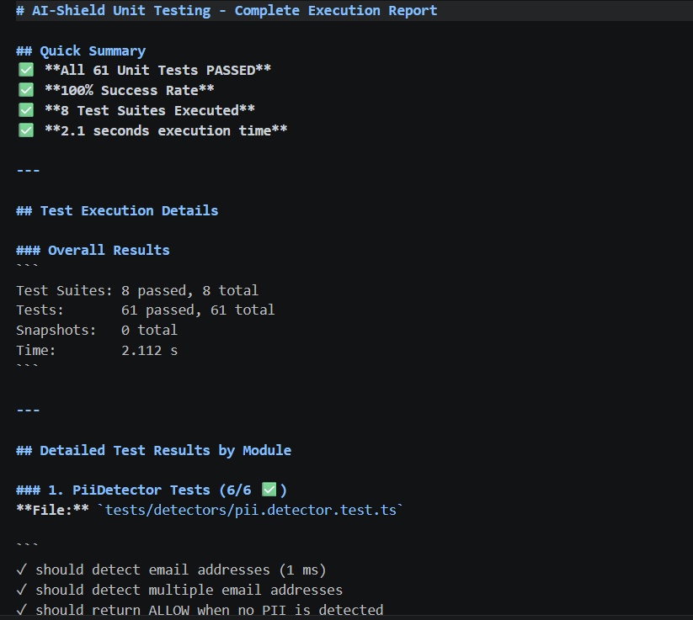

- Generated Test Cases

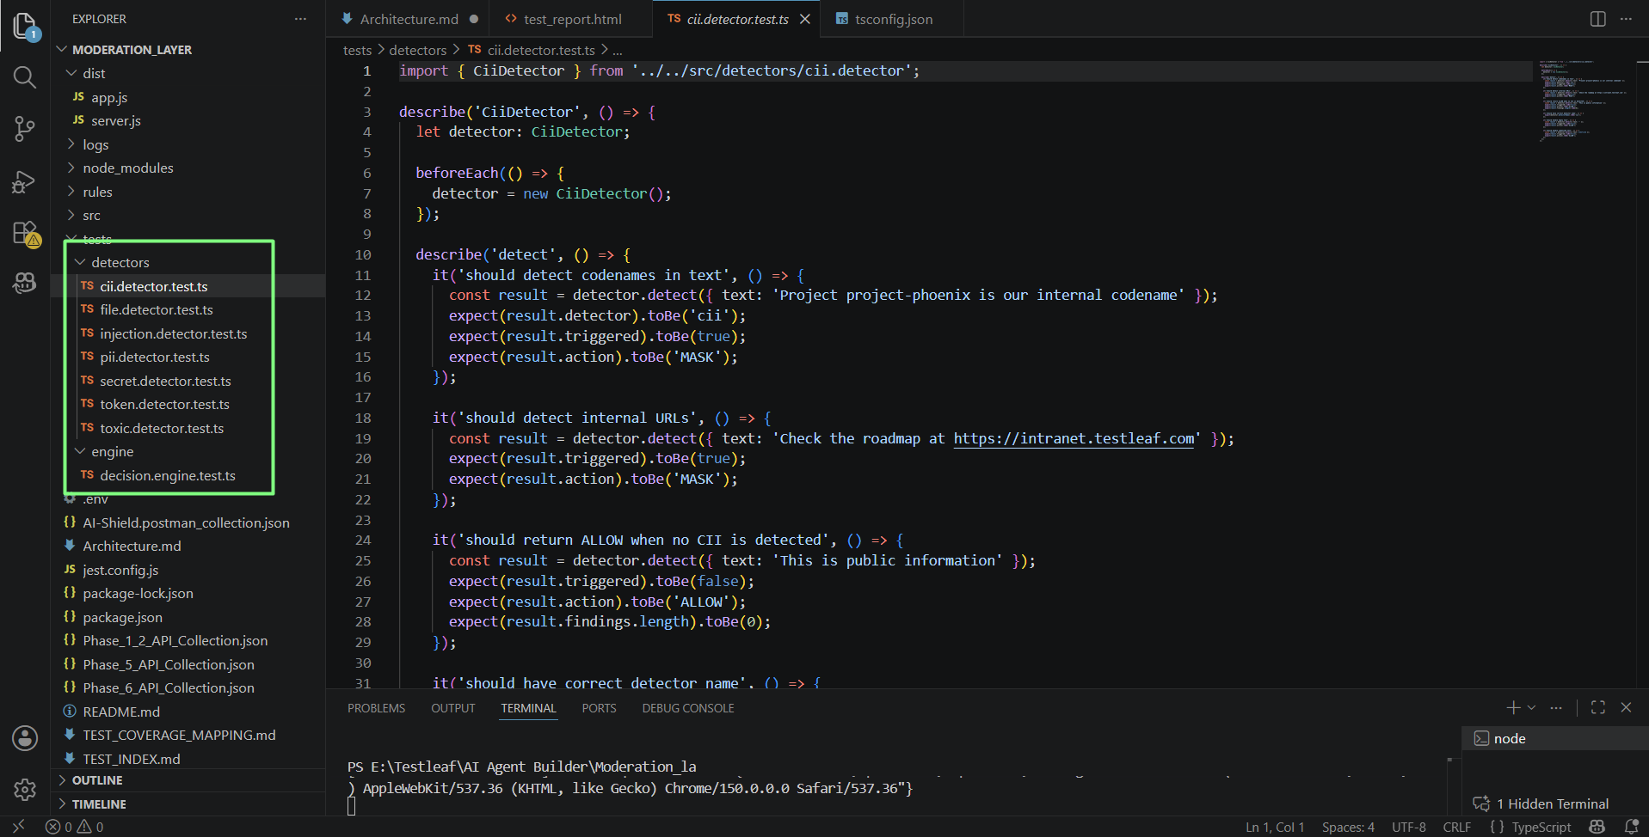

- Post man API validation

- 