Test case generator custom chat agent

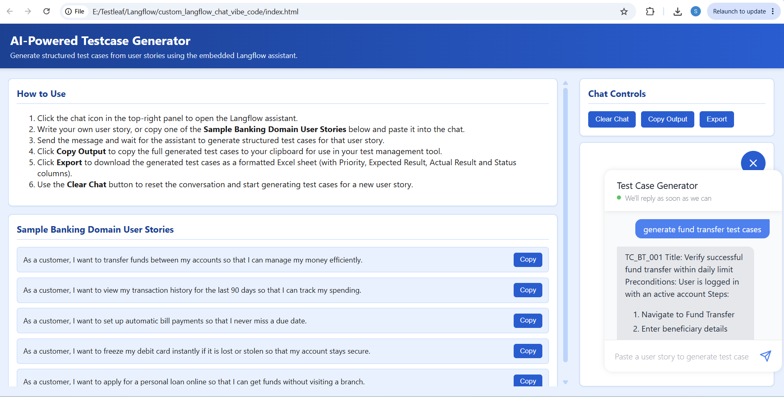

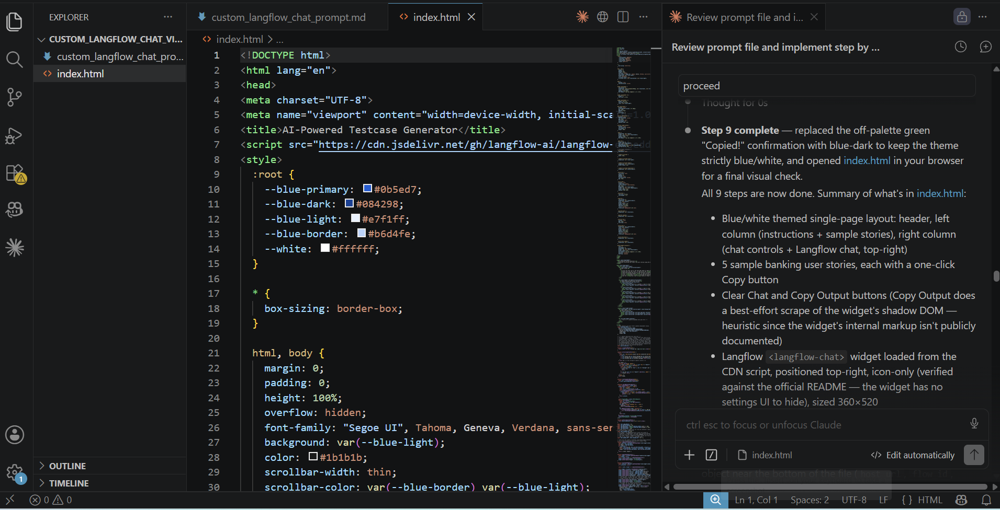

Exported generated test cases:
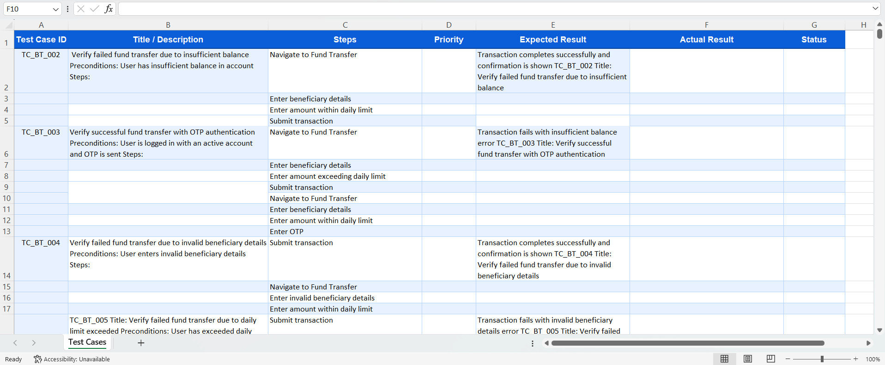

Coped Test cases:
I/P: generate fund transfer test cases
O/P:
TC_BT_001
Title: Verify successful fund transfer within daily limit
Preconditions: User is logged in with an active account
Steps:
1. Navigate to Fund Transfer
2. Enter beneficiary details
3. Enter amount within daily limit
4. Submit transaction
Expected Result: Transaction completes successfully and confirmation is shown

TC_BT_002
Title: Verify failed fund transfer due to insufficient balance
Preconditions: User has insufficient balance in account
Steps:
1. Navigate to Fund Transfer
2. Enter beneficiary details
3. Enter amount exceeding daily limit
4. Submit transaction
Expected Result: Transaction fails with insufficient balance error

TC_BT_003
Title: Verify successful fund transfer with OTP authentication
Preconditions: User is logged in with an active account and OTP is sent
Steps:
1. Navigate to Fund Transfer
2. Enter beneficiary details
3. Enter amount within daily limit
4. Enter OTP
5. Submit transaction
Expected Result: Transaction completes successfully and confirmation is shown

TC_BT_004
Title: Verify failed fund transfer due to invalid beneficiary details
Preconditions: User enters invalid beneficiary details
Steps:
1. Navigate to Fund Transfer
2. Enter invalid beneficiary details
3. Enter amount within daily limit
4. Submit transaction
Expected Result: Transaction fails with invalid beneficiary details error

TC_BT_005
Title: Verify failed fund transfer due to daily limit exceeded
Preconditions: User has exceeded daily limit
Steps:
1. Navigate to Fund Transfer
2. Enter beneficiary details
3. Enter amount exceeding daily limit
4. Submit transaction
Expected Result: Transaction fails with daily limit exceeded error

