With vibe coding implement the playwright/typescript

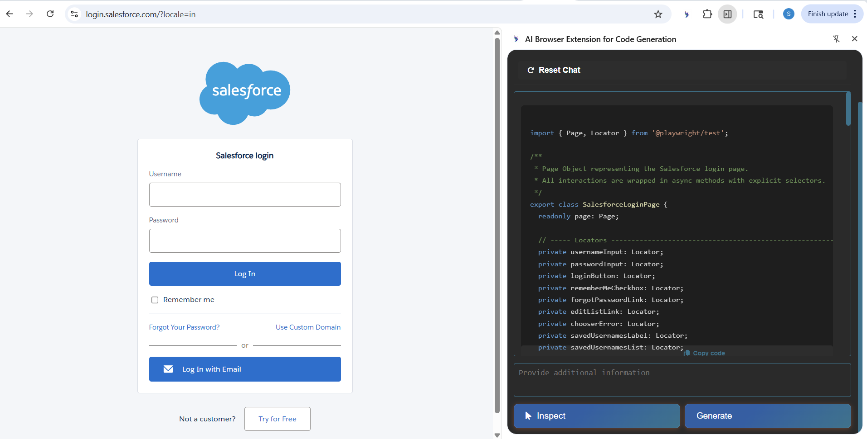

import { Page, Locator } from '@playwright/test';

/**
* Page Object representing the Salesforce login page.
* All interactions are wrapped in async methods with explicit selectors.
*/
export class SalesforceLoginPage {
readonly page: Page;

// ----- Locators ---------------------------------------------------------
private usernameInput: Locator;
private passwordInput: Locator;
private loginButton: Locator;
private rememberMeCheckbox: Locator;
private forgotPasswordLink: Locator;
private editListLink: Locator;
private chooserError: Locator;
private savedUsernamesLabel: Locator;
private savedUsernamesList: Locator;
private editSaveButton: Locator;
private editCancelButton: Locator;
private customDomainLink: Locator;
private customDomainInput: Locator;
private customDomainContinue: Locator;
private customDomainBack: Locator;
private domainError: Locator;

constructor(page: Page) {
this.page = page;

// Initialize locators (explicit, stable selectors)
this.usernameInput = page.locator('#username');
this.passwordInput = page.locator('#password');
this.loginButton = page.locator('input[type="submit"]#Login');
this.rememberMeCheckbox = page.locator('#rememberUn');
this.forgotPasswordLink = page.locator('#forgot_password_link');
this.editListLink = page.locator('#edit');
this.chooserError = page.locator('#chooser_error');
this.savedUsernamesLabel = page.locator('#chooser_label');
this.savedUsernamesList = page.locator('#idlist > li');
this.editSaveButton = page.locator('#hint_save_edit');
this.editCancelButton = page.locator('#hint_back_edit');
this.customDomainLink = page.locator('#mydomainLink');
this.customDomainInput = page.locator('#mydomain');
this.customDomainContinue = page.locator('#mydomainContinue');
this.customDomainBack = page.locator('#hint_back_domain');
this.domainError = page.locator('#domain_error');
}

// ------------------------------------------------------------------------
// Basic login actions
// ------------------------------------------------------------------------
async fillUsername(username: string): Promise<void> {
await this.usernameInput.fill(username);
}

async fillPassword(password: string): Promise<void> {
await this.passwordInput.fill(password);
}

async toggleRememberMe(checked: boolean): Promise<void> {
const isChecked = await this.rememberMeCheckbox.isChecked();
if (isChecked !== checked) {
await this.rememberMeCheckbox.click();
}
}

async clickLogin(): Promise<void> {
await this.loginButton.click();
}

async login(username: string, password: string, rememberMe = false): Promise<void> {
await this.fillUsername(username);
await this.fillPassword(password);
await this.toggleRememberMe(rememberMe);
await this.clickLogin();
}

// ------------------------------------------------------------------------
// Helper links
// ------------------------------------------------------------------------
async clickForgotPassword(): Promise<void> {
await this.forgotPasswordLink.click();
}

async openCustomDomainDialog(): Promise<void> {
await this.customDomainLink.click();
await this.page.waitForSelector('#mydomainContainer', { state: 'visible' });
}

// ------------------------------------------------------------------------
// Custom domain flow
// ------------------------------------------------------------------------
async fillCustomDomain(domain: string): Promise<void> {
await this.customDomainInput.fill(domain);
}

async submitCustomDomain(): Promise<void> {
await this.customDomainContinue.click();
}

async cancelCustomDomain(): Promise<void> {
await this.customDomainBack.click();
}

async getCustomDomainError(): Promise<string | null> {
if (await this.domainError.isVisible()) {
return await this.domainError.textContent();
}
return null;
}

// ------------------------------------------------------------------------
// Saved usernames (Login Hint) flow
// ------------------------------------------------------------------------
async openSavedUsernamesChooser(): Promise<void> {
// The chooser is shown automatically on page load; ensure it is visible.
await this.page.waitForSelector('#chooser', { state: 'visible' });
}

async getSavedUsernamesCount(): Promise<number> {
return await this.savedUsernamesList.count();
}

async getSavedUsernamesLabel(): Promise<string> {
return (await this.savedUsernamesLabel.textContent())?.trim() ?? '';
}

async clickSavedUsernameByIndex(index: number): Promise<void> {
const item = this.savedUsernamesList.nth(index);
await item.click();
}

async clickEditSavedUsernames(): Promise<void> {
await this.editListLink.click();
await this.page.waitForSelector('#manager', { state: 'visible' });
}

async saveEditedUsernames(): Promise<void> {
await this.editSaveButton.click();
// After saving the chooser becomes visible again
await this.page.waitForSelector('#chooser', { state: 'visible' });
}

async cancelEditedUsernames(): Promise<void> {
await this.editCancelButton.click();
await this.page.waitForSelector('#chooser', { state: 'visible' });
}

async getChooserErrorMessage(): Promise<string | null> {
if (await this.chooserError.isVisible()) {
return await this.chooserError.textContent();
}
return null;
}

// ------------------------------------------------------------------------
// Miscellaneous utilities
// ------------------------------------------------------------------------
async isCapsLockWarningVisible(): Promise<boolean> {
return await this.page.isVisible('#pwcaps');
}

async getPageTitle(): Promise<string> {
return await this.page.title();
}
}

