Assignment 2 of Day 2 –

Adding connect jira button and Integrating Jira feature with vibe coding
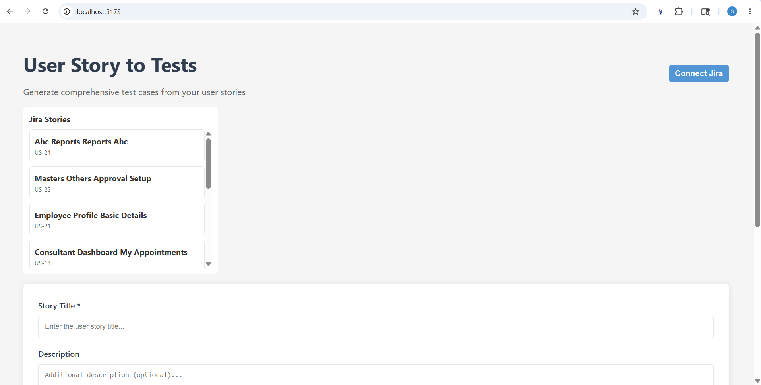

Generating Test Cases from User story
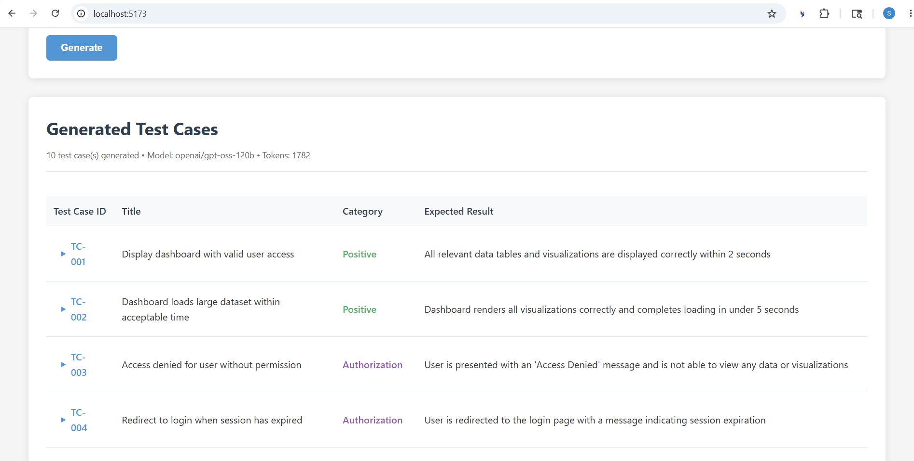

Adding feature file button with vibe coding and generating feature file from the user stories

