Assignment

- Data in .Jsonl format
- Uploading the dataset in storage
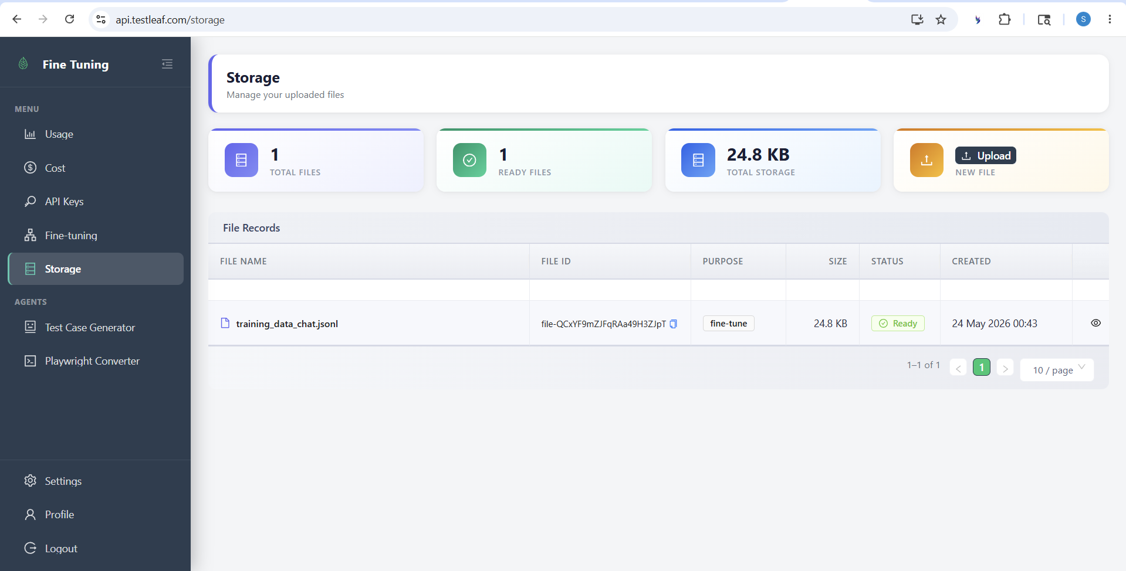
- Fine tuning is not working. Its reached its limit for now. It will be done tomorrow. 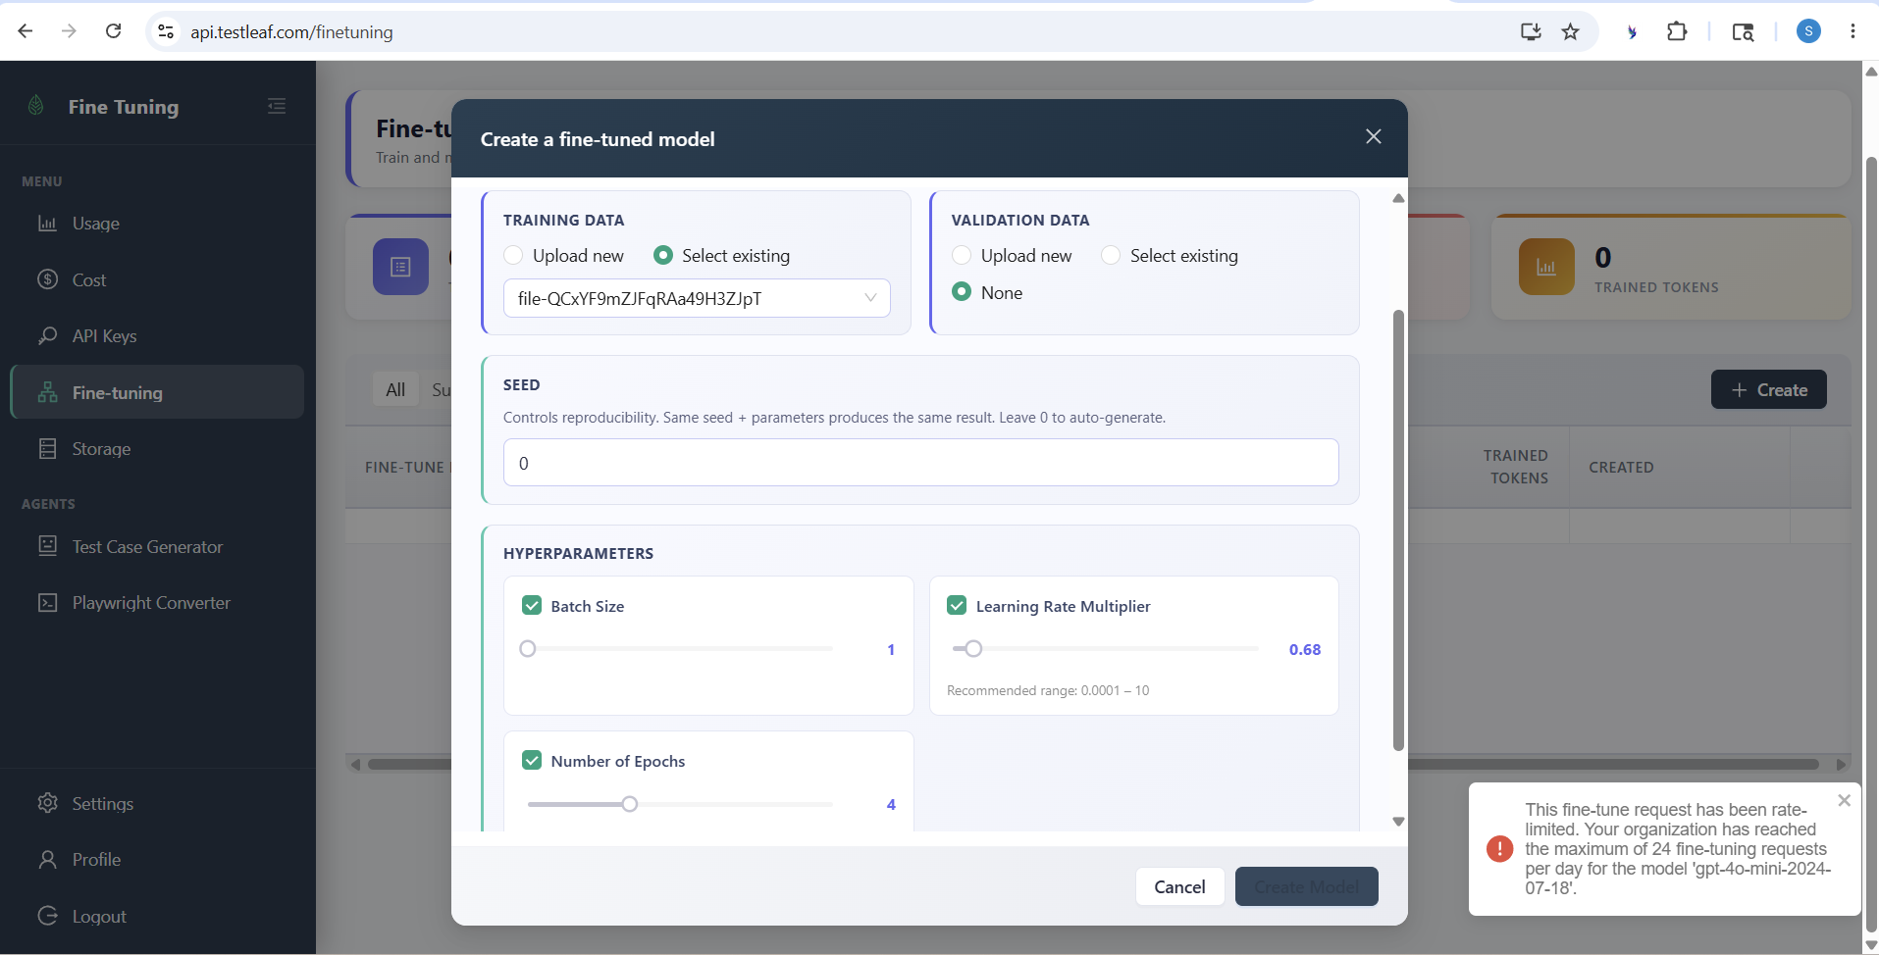
- Implementing const modelsByProvider in Popup.js of AI extension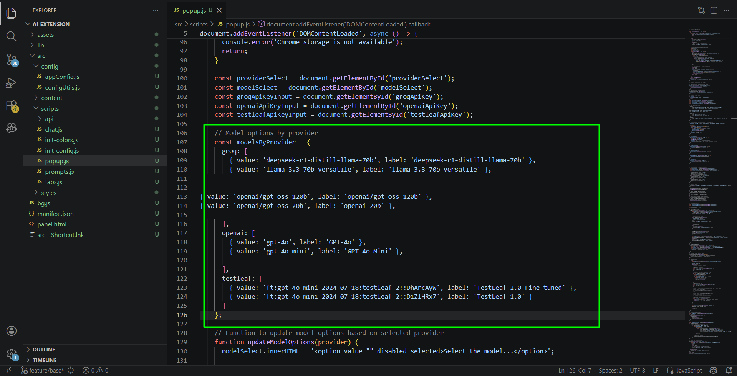
- Test Leaf API key is created and added in the extension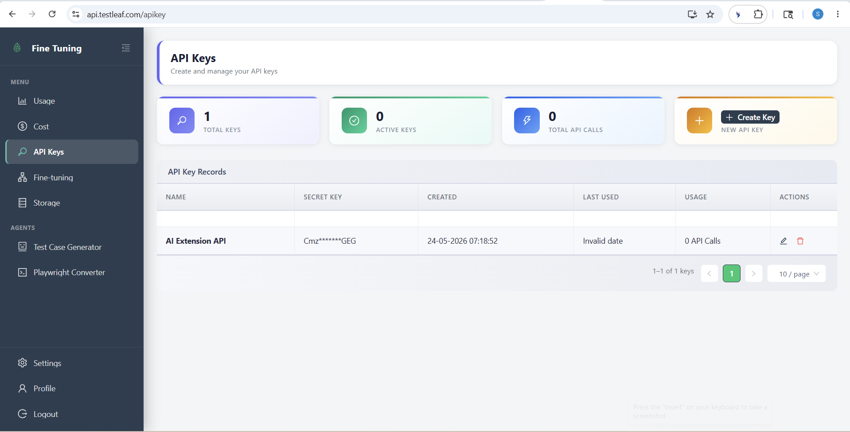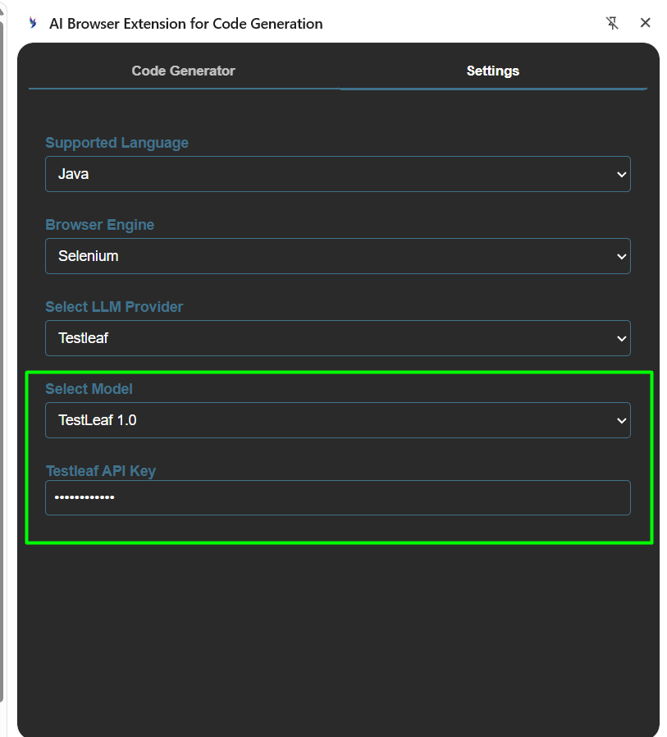

All the process are completed except for fine tuning. It will be done once the LLM is again available Hopefully on 25th May.

