Assignment

- Data in .Jsonl format
- Uploading the dataset in storage
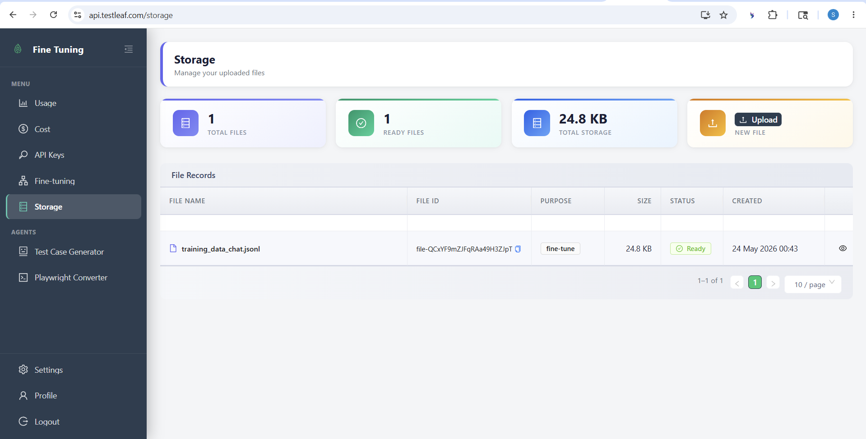
- Fine tuning 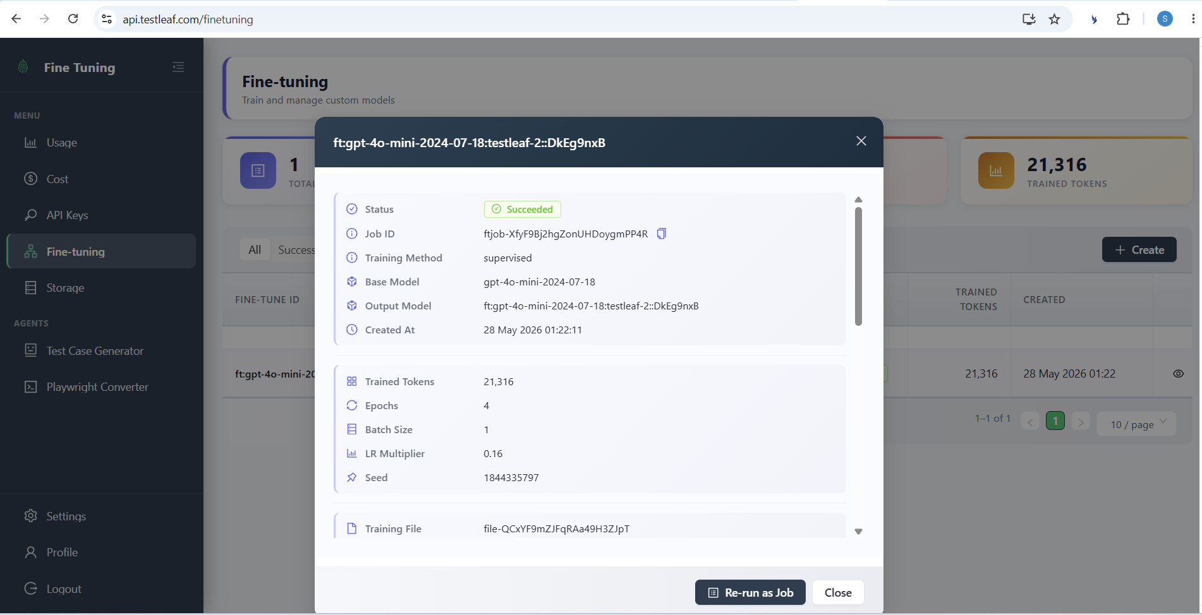
- Implementing const modelsByProvider in Popup.js of AI extension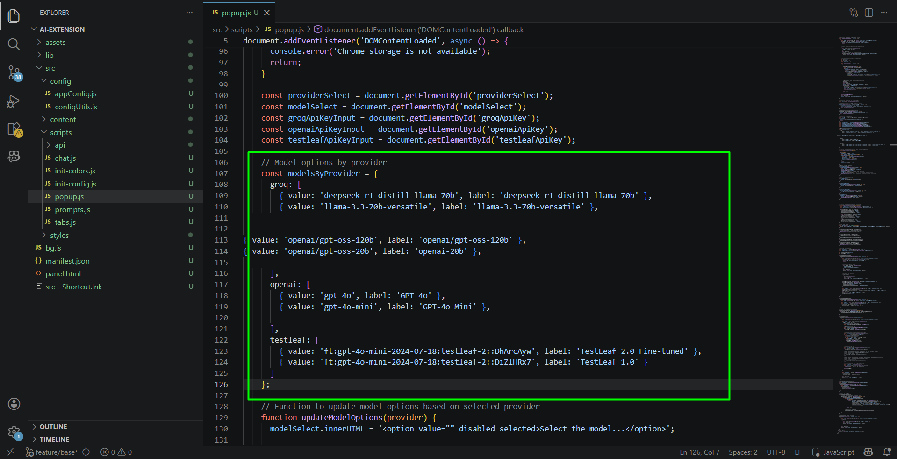

- Test Leaf API key is created and added in the extension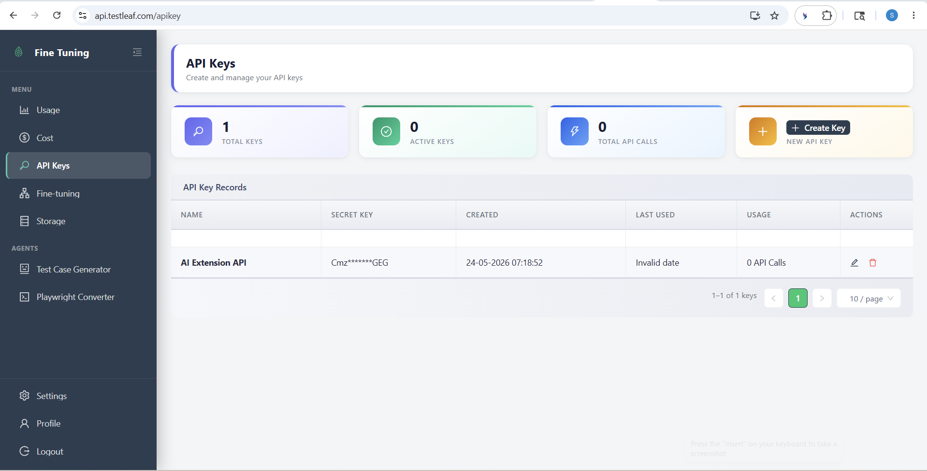

- Generation of Feature File and Page class after using fine tuning 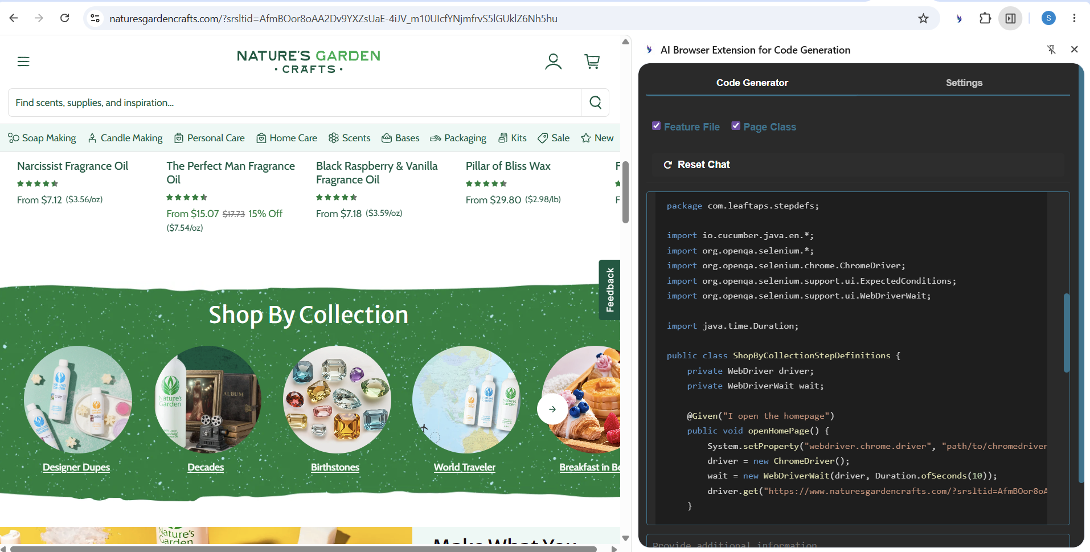

Feature: Shop By Collection Section

Scenario: Verify the visibility of Shop By Collection section
Given I open the homepage
Then I should see the Shop By Collection section

Scenario Outline: Verify the presence of collection tiles
Given I open the homepage
Then I should see the collection tile for "<collectionName>"

Examples:
| collectionName |
| Designer Dupes |
| Decades |
| Birthstones |
| World Traveler |
| Breakfast in Bed |
| Welcome to Brazil |

package com.leaftaps.stepdefs;

import io.cucumber.java.en.*;
import org.openqa.selenium.*;
import org.openqa.selenium.chrome.ChromeDriver;
import org.openqa.selenium.support.ui.ExpectedConditions;
import org.openqa.selenium.support.ui.WebDriverWait;

import java.time.Duration;

public class ShopByCollectionStepDefinitions {
private WebDriver driver;
private WebDriverWait wait;

@Given("I open the homepage")
public void openHomePage() {
System.setProperty("webdriver.chrome.driver", "path/to/chromedriver");
driver = new ChromeDriver();
wait = new WebDriverWait(driver, Duration.ofSeconds(10));
driver.get("https://www.naturesgardencrafts.com/?srsltid=AfmBOor8oAA2Dv9YXZsUaE-4iJV_m10UIcfYNjmfrvS5lGUklZ6Nh5hu");
}

@Then("I should see the Shop By Collection section")
public void verifyShopByCollectionSection() {
wait.until(ExpectedConditions.visibilityOfElementLocated(By.id("shopify-section-template--21126988562654__featured_categories_mQ6YaG")));
WebElement section = driver.findElement(By.id("shopify-section-template--21126988562654__featured_categories_mQ6YaG"));
assert section.isDisplayed() : "Shop By Collection section is not visible";
}

@Then("I should see the collection tile for {string}")
public void verifyCollectionTile(String collectionName) {
wait.until(ExpectedConditions.visibilityOfElementLocated(By.xpath("//h3[contains(text(),'" + collectionName + "')]")));
WebElement tile = driver.findElement(By.xpath("//h3[contains(text(),'" + collectionName + "')]"));
assert tile.isDisplayed() : "Collection tile for " + collectionName + " is not visible";
}

@After
public void tearDown() {
if (driver != null) {
driver.quit();
}
}
}

