Assignment 2

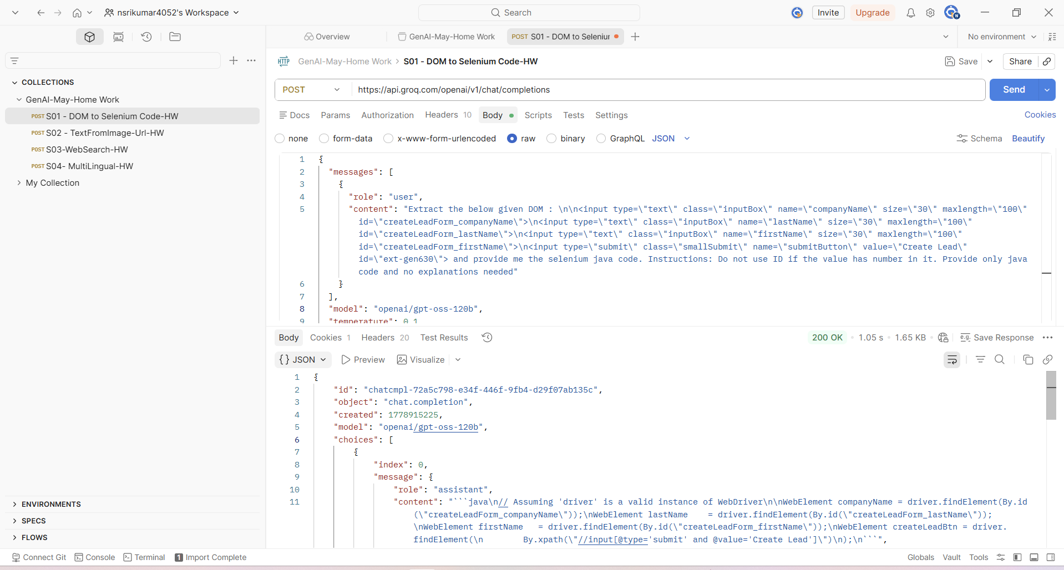
// Assuming 'driver' is a valid instance of WebDriver

WebElement companyName = driver.findElement(
By.id("createLeadForm_companyName")
);

WebElement lastName = driver.findElement(
By.id("createLeadForm_lastName")
);

WebElement firstName = driver.findElement(
By.id("createLeadForm_firstName")
);

WebElement createLeadBtn = driver.findElement(
By.xpath("//input[@type='submit' and @value='Create Lead']")
);
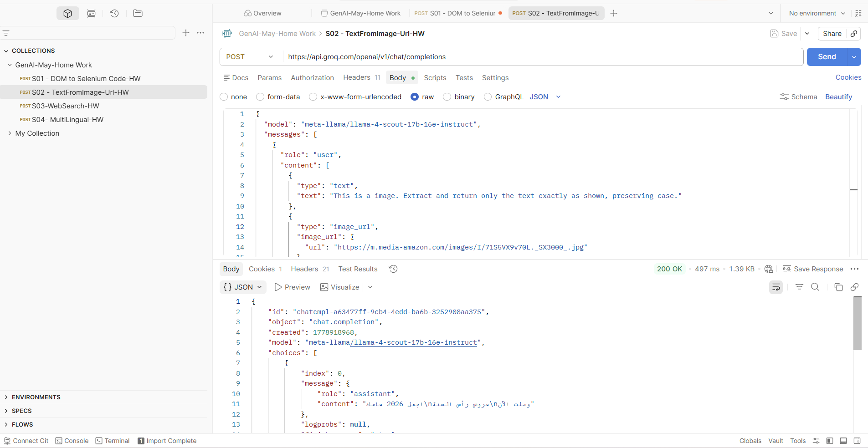

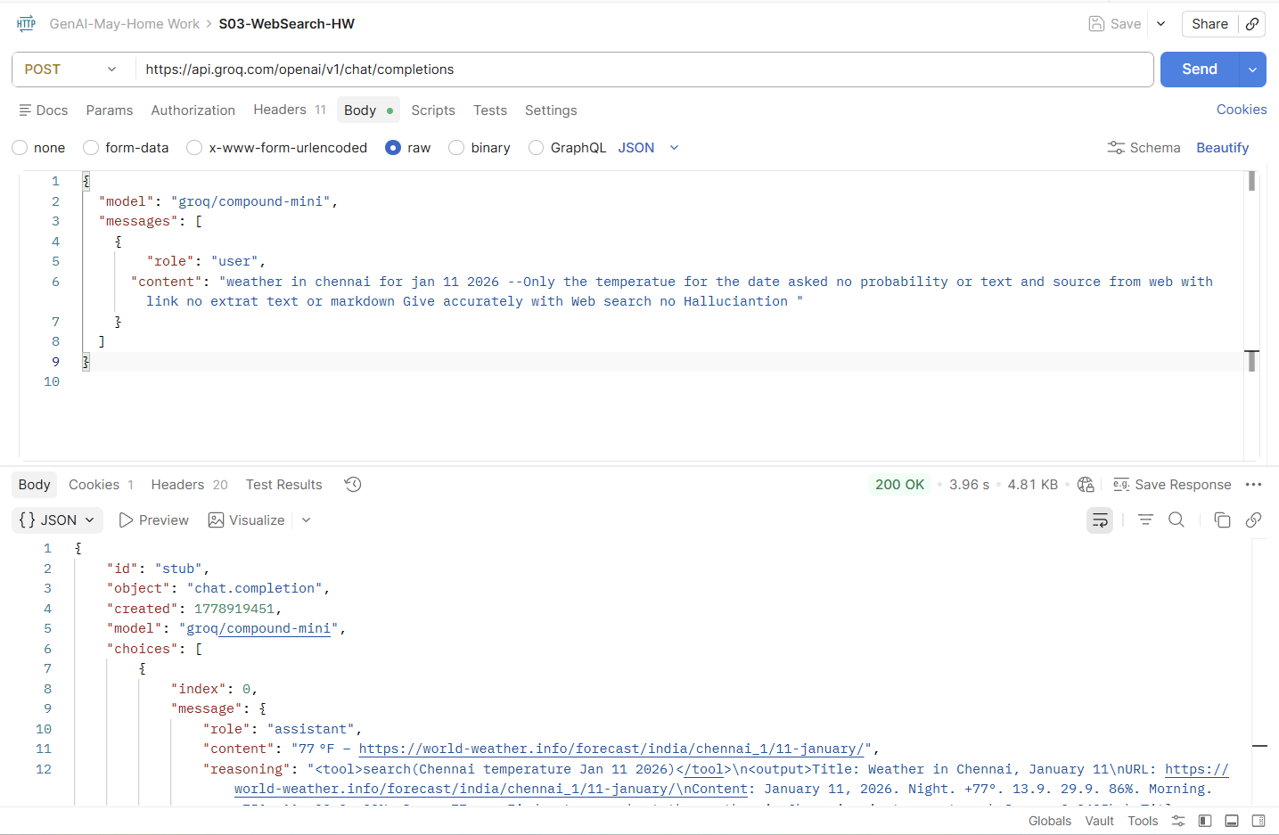
Hourly Temperature in January 2026 at Chennai International Airport

• Red line → High temperature
• Faint blue line → Low temperature
• Shaded bands → 25th–75th and 10th–90th percentile ranges

Temperature Scale:
• 15°F → Frigid
• 32°F → Freezing
• 45°F → Very Cold
• 55°F → Cold
• 65°F → Comfortable
• 75°F → Warm
• 85°F → Hot
• 95°F → Sweltering

Weather Conditions:
• Jan 1 → Rain, Light Rain, Drizzle, Mist
• Jan 2–8 → Haze, Mist
• Jan 9 → Drizzle, Haze, Mist
• Jan 10 → Light Drizzle, Haze, Mist
• Jan 11 → Light Drizzle, Mist
• Jan 12 → Heavy Drizzle, Haze, Mist
• Jan 13 → Haze, Mist
• Jan 14 → Haze, Fog, Mist, Smoke
• Jan 15 → Haze, Mist, Shallow Fog
