Integrating Langchain TC generator with Moderation Layer

MODERATION_ENABLED=true
Block request
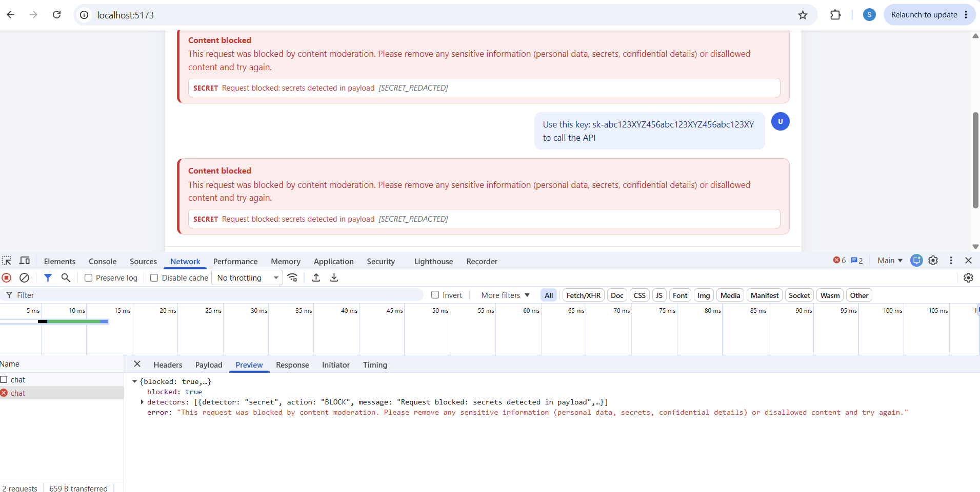
MASK Request
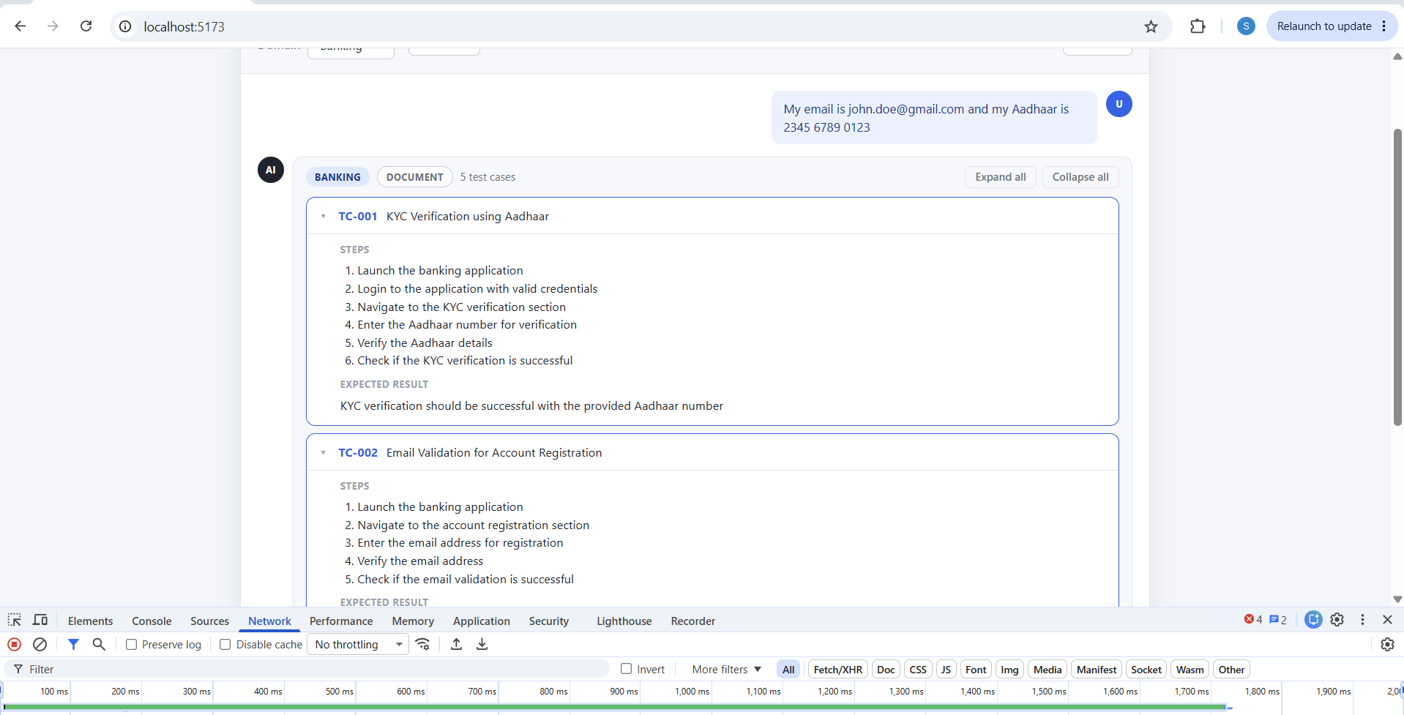

MODERATION_ENABLED=false
MASK Request :
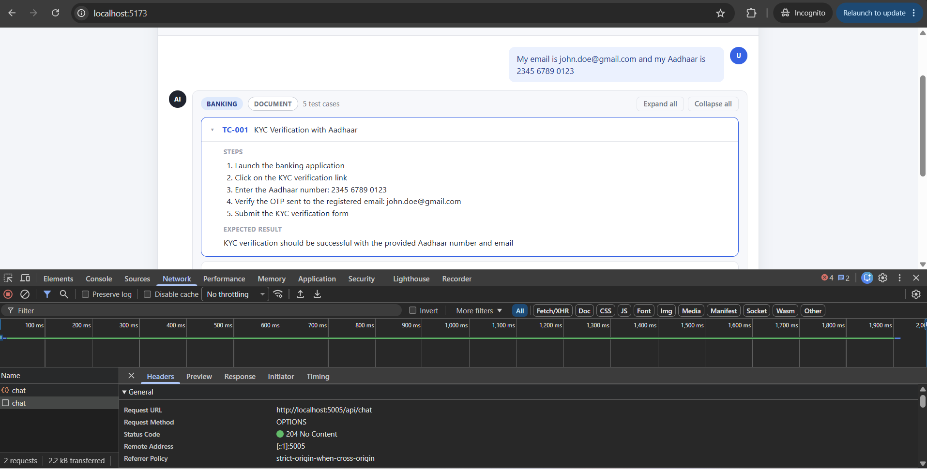

Block request
