Integrating Visual Regression with Moderation Layer

MODERATION_ENABLED=true
Block request :
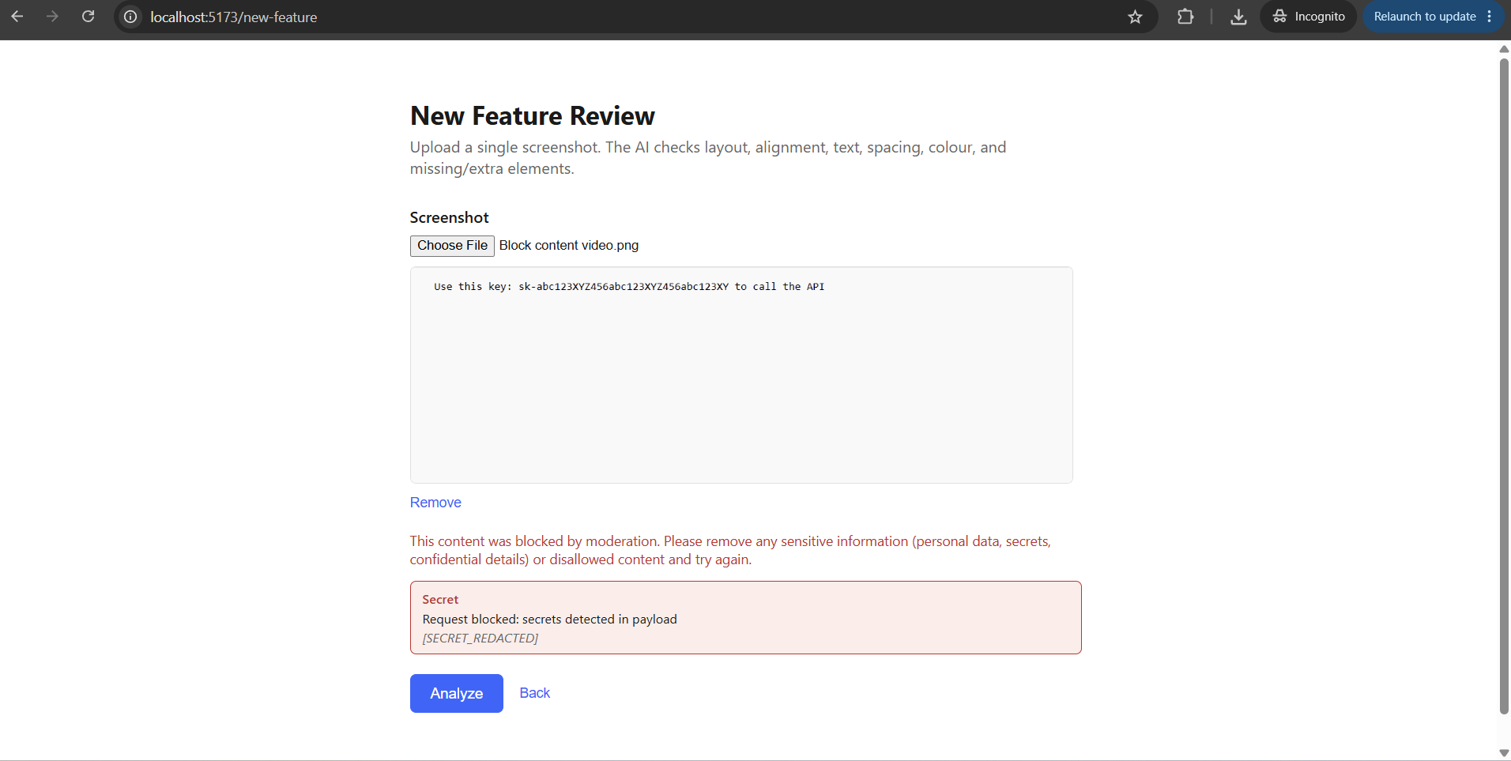
MASK Request :
Given Input : My email is john.doe@gmail.com and my Aadhaar is 2345 6789 0123
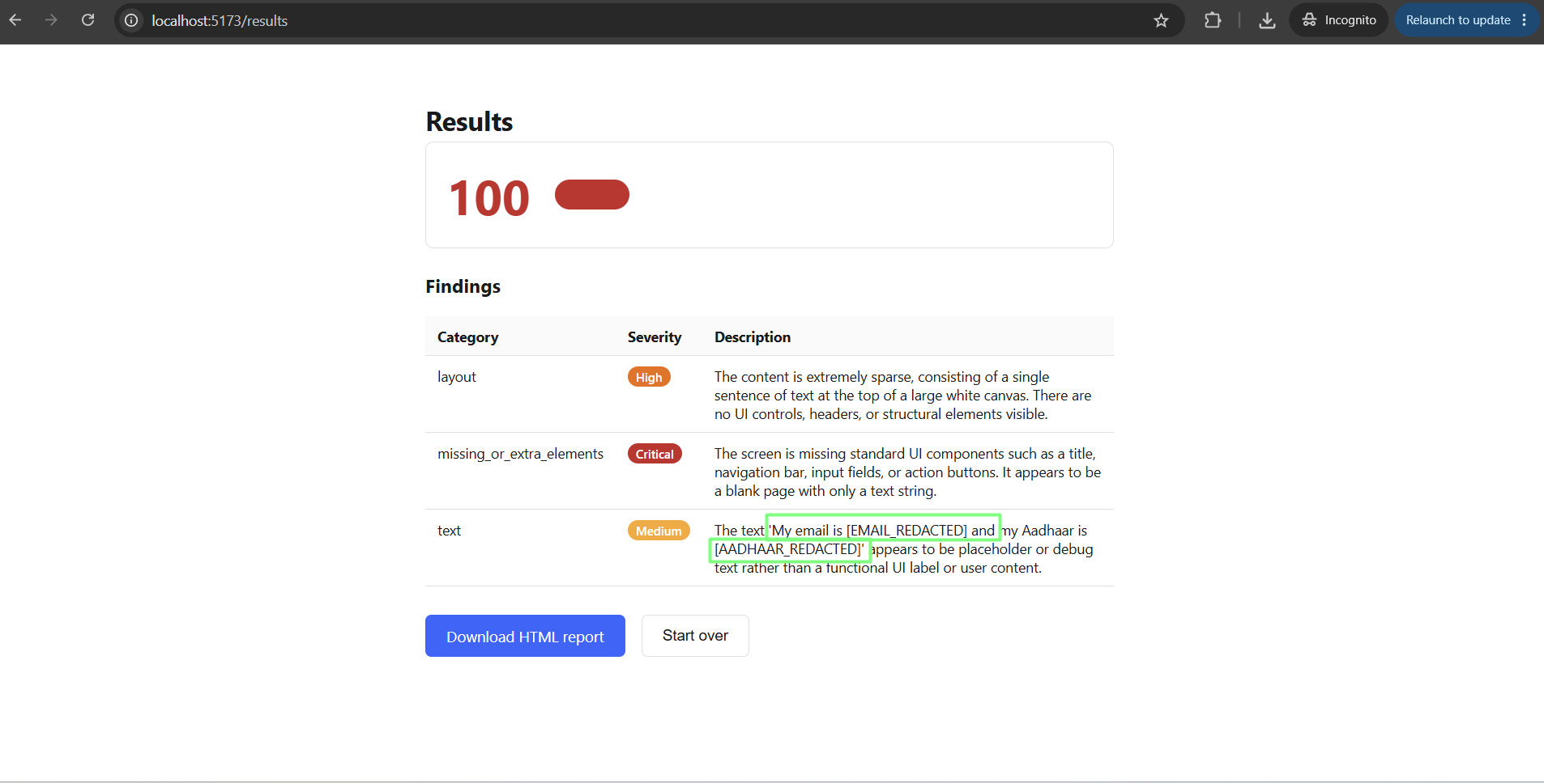

Clean Request :

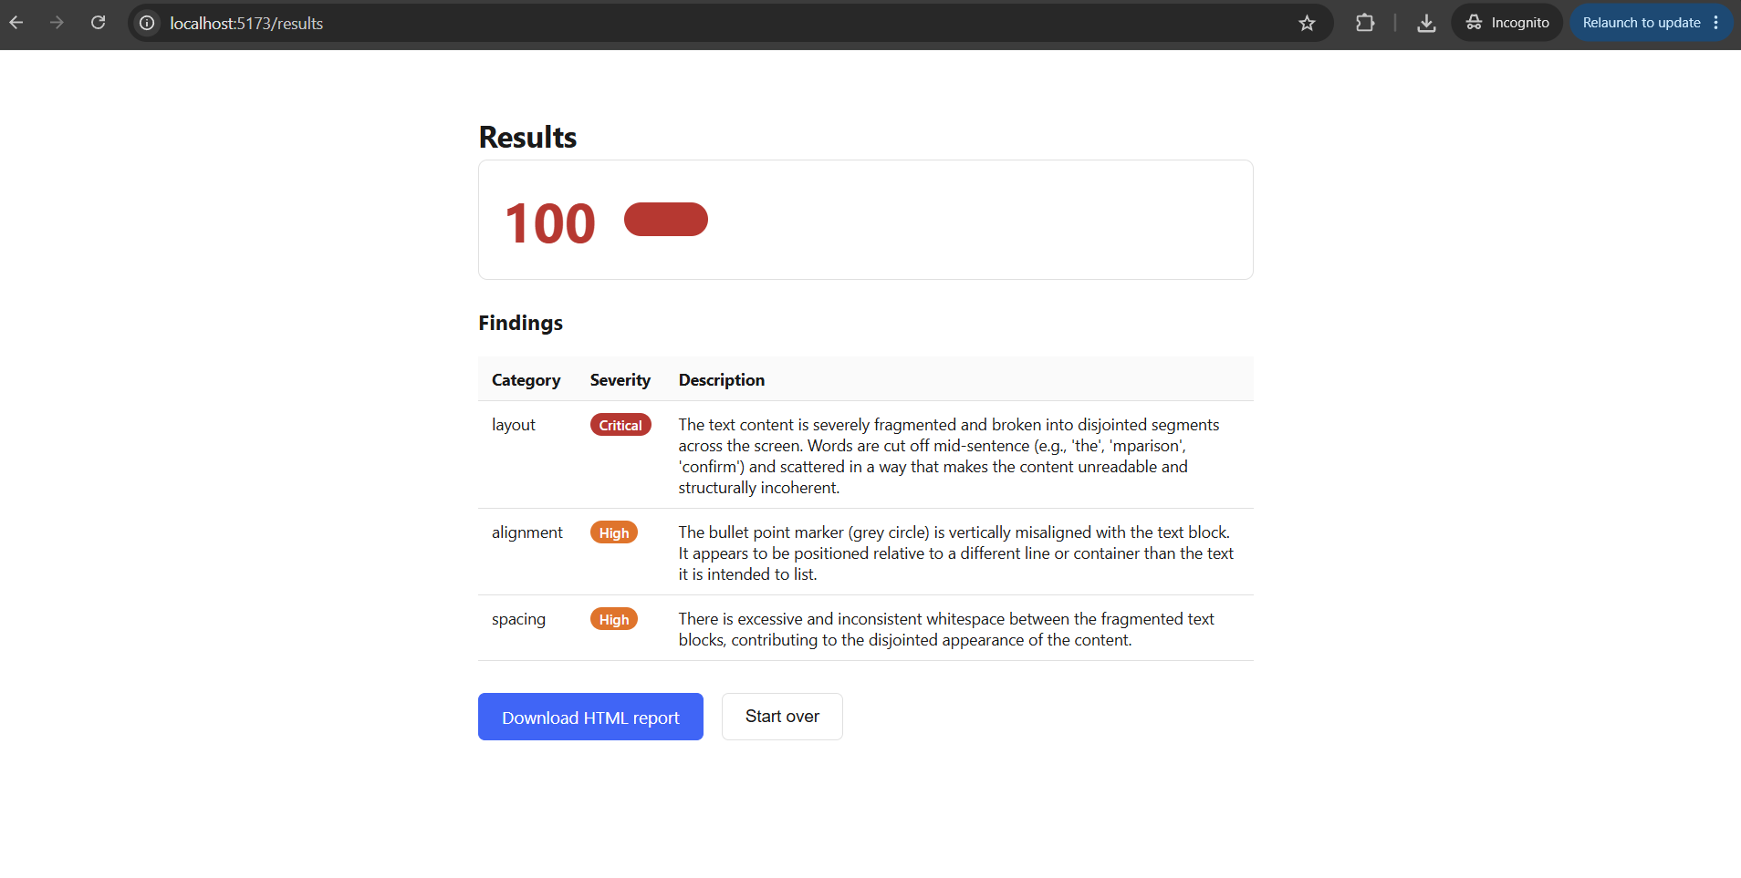

MODERATION_ENABLED=false

Block request :

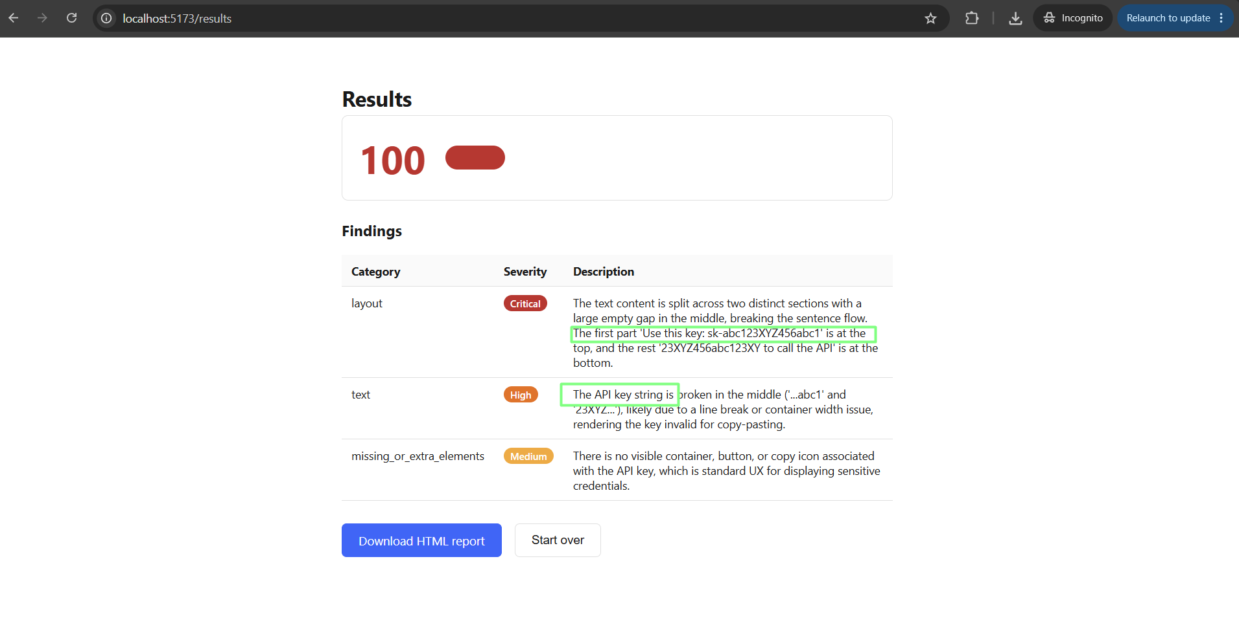
Mask request :
Given Input : My email is john.doe@gmail.com and my Aadhaar is 2345 6789 0123
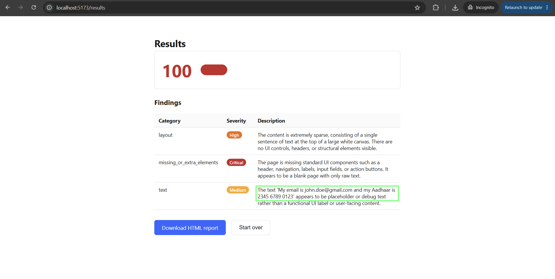
Clean Request :

