Project 2
  - ‘‘I have neither given nor received unauthorized assistance on this assignment.’’ – nsrilalith

Task 4:

Question 1:
- Descriptions of each function:
  - vSchedulerInit(): Executes the prvInitTCBArray function.
    - prvInitPCBArray(): Initialized a xTCBArray, which contains a number of ExtendedTCB structs all initialized to null values, and then updates the xInUse value in each TCB to pdFalse.
  - vSchedulerPeriodicTaskCreate(): Takes arguments necessary to initialize the ExtendedTCBArray struct.
    - Starts a taskENTER_CRITICAL() to stop interrupts
    - Initializes a pointer to a struct extendedTCB with alias SchedTCB
    - Find index for an empty entry in xTCBArray and returns the index if an array is empty or -1 if not
    - Then if an index is returned, we create a new SchedTCB in the particular index of of xTCBArray
    - We initialize each parameter passed in the arguments
    - Then we change the x.InUse member to pdTrue for that particular entry using pxNewTCB
    - Then we do member initialization based on the Scheduling policy
    - Then we handle what happens when an error is detected in execution deadline
    - Then we handle what happens when an error is detected in execution time.
  - vSchedulerStart(): This starts the schedular
    - prvsetFixedPriorities():
            - This function iterates through each task in the xTCBArray
            - It then adjusts and assigns the highest priority to the struct which has the least execution time (This is in case of RMS)
    - prvcreateSchedulerTask():
      - Schedules each task based on the index of the elements in the xTCBArray
    - Then we recreate the tasks with new priorities using prvCreateAllTasks()
    - Finally The Scheduler Starts

- Flow Chart:
No External Function is called for vSchedulerPeriodicTaskDelete()
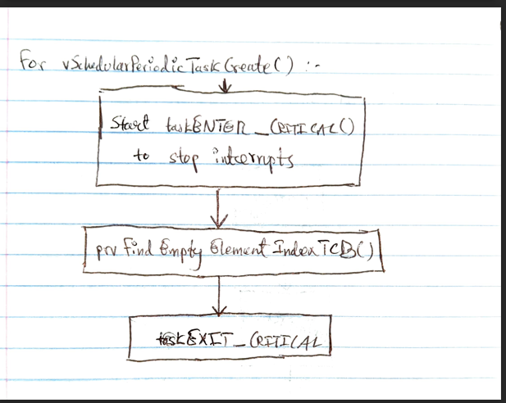
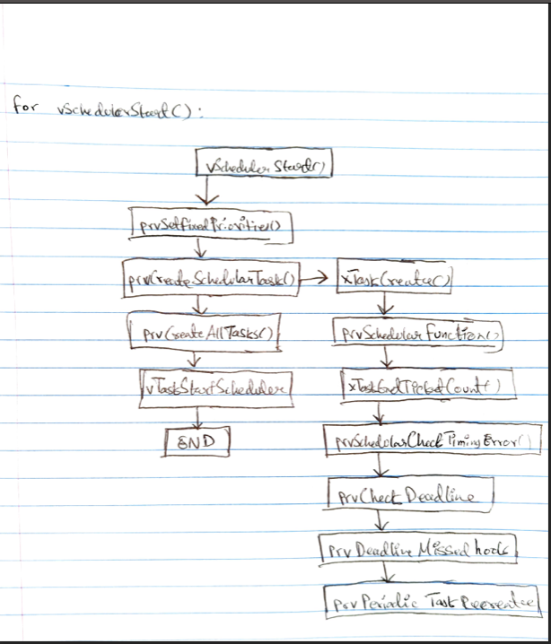

Question 2:
- Line 138: /* Iterate through xTCBArray and check each iteration if xInUse is pdFalse */
/* Upon finding the pdFalse in xInUse, return that iteration index */
- Line 146 /* delete the TCB with the given Index value*/
- Line 161: /* start a pointer to this task by using the current task handle */
- Line 176: /*Check if the task exceeded its deadline*/
- Line 221: /* Initialize All Other Arguments like such*/
- Line 230: /* Obtain Priority, execution times and Deadlines of tasks*/
- Line 237: /* Obtain Priority, execution times and Deadlines of tasks*/
- Line 257: /* Necessary pre-delete configurations*/
- Line 275: provide the necessary parameters as defined in xTaskCreateFunctions
- Line 303: /* if xPreviousShortest is less that Shortest then move exchange the values in variables*/
- Line 307: /*If xShortest belongs to this array, then move priority++ */
- Line 325 : recreate task using same TaskHandle
- Line 329: Then create the task and return it
- Line 330: /* Then create the task and return it*/
- Line 345: pass in the taskHandle of task to delete
- Line 351: /* get appropriate parameters from pxTCB and reset the timer in the recreated task*/
- Line 360: /* Check if deadline is missed before calling below function*/
- Line 393: /* Initialize arguments here*/
- Line 399: /*Check by initializing the next function*/
- Line 437: /*Implement logic to periodally check task for all timing errors*/

