Daily Naruvi Hospitals Report - 2026-11-07

Generated on: 2026-11-07 23:07:14
Source: Naruvi Hospitals, Vellore - https://www.naruvihospitals.com/

Full content of the FACILITIES page:

logo
360360 tour
360Quick Appointment
360Find a Doctor
About Us
Facilities
Medical Services
International Patients
Insurance
Careers
Academics
Life At Naruvi
Events
BMWA Reports
Resources
Contact Us
Home
ChervonLeft
Facilities
Facilities at Naruvi Hospitals
Unmatched care, delivered through world-class services.
page header image
South Asia’s first ever Robotic Hybrid Operation Theatre
Hybrid operation theatres are the way forward for Cardiac, Neuro, Plastic and transplant surgeries. These are very rare, as not many institutions have the know-how, talent and facilities for it, unlike Naruvi Hospitals.
Service image
Service imageService image
End-to-end Interventional Pulmonology Services
In our tireless pursuit of accuracy, safety and efficacy, we are proud to offer a whole range of services for lung and lung-related disorders at our high-end Interventional Pulmonology department.
ROSA Neurosurgical Robot and Epilepsy Monitoring Unit
A sophisticated piece of French technology called the "ROSA Robot" is used for epilepsy surgeries. This is also India's only third such installation. In delicate cases such as epilepsy surgery, this system's improved precision, dexterity, and visualisation come in very handy.
Interventional & Endo-Vascular Radiology
Another differentiator of Naruvi Hospitals is our Division of Radiology. We offer on-site radiologists for General Radiology and interventions, while specialised radiology, which is organ or subspecialty specific, is handled by a highly specialised group of 75 radiologists.
Modular OTs from Germany
Our operation theatre complex is completely modular and is sourced from HT Labor, the world’s best modular manufacturer. Coupled with a laminar flow system, it is a major step in controlling infection.
OT image 1PlusIcon
Our signature touch
Beyond technologically advanced facilities, our services provide a one-of-a-kind experience at Naruvi Hospitals
Signature ImageplusIcon
In-house clean
laundry
Our in-house laundry, completely imported from GERBAU, Spain, is one of the top large scale laundry solutions in the world. Naruvi Hospitals has a 100% clean laundry that strictly adheres to barrier washing techniques. Linen, which is a strong vector for communicable diseases in a hospital, is therefore rendered clinically clean and safe for patients
Signature ImageplusIcon
100% paper- and film-free
Naruvi Hospitals is 100% paper- and film-free, and we take great measures to ensure our technology only breeds more efficient services. All the patient data is safely stowed away in highly secure and sophisticated servers, with disaster recovery systems in place
Signature ImageplusIcon
Critical Care beds with
individual cabins
The ICU beds are physically separated with glass partitions, and the use of curtains are strictly disallowed. This is yet another precaution to keep cross infection between patients, down to the barest minimum possible at Naruvi Hospitals. Across various aspects, we’ve paid attention to variables and ensured a system is in place to minimise cross infection.
Signature ImageplusIcon
End-to-end Radiology
services
From the Digital X-Ray to the latest and most sophisticated 3T MRI (with in-bore experience), the Radiology Department is studded with the best ultrasonography machines, 128 slice Cardiac CT scan, 3D digital mammography, the latest DEXA scan and a ROBOTIC CATH machine installed in the OT for intra-op imaging, including CBCT.
Signature ImageplusIcon
End-to-end laboratory
services
Equipped with auto-analysers and the most sophisticated equipment, our laboratories - Biochemistry, Clinical Pathology, Microbiology and Histopathology/Molecular Biology - are capable of handling almost all the commonly done investigations, regardless of their complexity. In addition, all the laboratories have EQAS to ensure reliable and consistent reporting.
Signature ImageplusIcon
Zone specific air
conditioning
Mixing of air across different areas of the hospital makes way for the spread of infection within the hospital. With 130+ separate zones of air-conditioning and dedicated air handling units for each separate zone, the chances of infection spreading within the hospital is kept to a minimum. The air-conditioning system at Naruvi Hospitals also conforms to ASHRAE standards.
Signature ImageplusIcon
Pharmacy
Our pharmacy plays a pivotal role in ensuring our patients and their caretakers have a hassle-free experience at Naruvi Hospitals. The pharmacists work closely with our healthcare team to develop medication management plans for patients, especially those with complex medical conditions or multiple medications.
Signature ImageplusIcon
CAHO certified sterilisation department
The Central Sterile Supply Department (CSSD) is fully equipped by CISA, Italy. One of the top-end sterilisation solutions in the world, the entire CSSD has been designed, equipped and installed by CISA. CAHO, the apex body for accredited hospitals in India, has certified our CSSD in the first attempt.
Signature ImageplusIcon
Blood Donation
At Naruvi Hospitals, this process is carried out in a private and confidential manner. The donor is asked to answer a brief questionnaire about their health history and sign a consent form. The entire donation process takes about 6 to 8 minutes and is carried out by highly skilled staff.
Hotels Nearby
Hotels around Naruvi Hospitals that share our principles for care.
leftArrowrightArrow
For tele-consultation call
+91 87540 83522
For offline-consultation
Book an Appointment
button-arrow-type-2
Medical Services
Know More
Medical Services
Get the care you deserve.
Find a Doctor
logo
About Us
Facilities
Medical Services
International Patients
Insurance
Life at Naruvi
Resources
Contact Us
Terms & Condition
Privacy Policy
Cookie Policy
Subscribe to our newsletter
Your email address
Copyright © 2026 Naruvi Hospitals. All rights reserved.
WhatsAppState-of-the-Art Facilities | Naruvi Hospitals
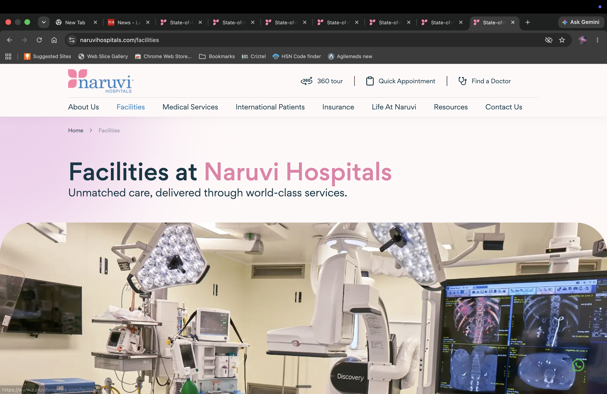
Comment: Useful snapshot of Naruvi Hospitals' facilities

