This document analyzes the planning search agents which are used to solve deterministic logistics planning problems for an Air Cargo transport system.

Problem Setup:

Given 3 Problems in Air Cargo Domain with below schema and initial & goal states.
Air Cargo Schema:
Action(Load(c, p, a),
PRECOND: At(c, a) ∧ At(p, a) ∧ Cargo(c) ∧ Plane(p) ∧ Airport(a)
EFFECT: ¬ At(c, a) ∧ In(c, p))
Action(Unload(c, p, a),
PRECOND: In(c, p) ∧ At(p, a) ∧ Cargo(c) ∧ Plane(p) ∧ Airport(a)
EFFECT: At(c, a) ∧ ¬ In(c, p))
Action(Fly(p, from, to),
PRECOND: At(p, from) ∧ Plane(p) ∧ Airport(from) ∧ Airport(to)
EFFECT: ¬ At(p, from) ∧ At(p, to))

Initial and Goal States:

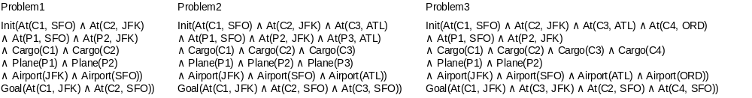
Above goal states can be reached using plans with different lengths. But below one is the optimal plan with lengths Problem1 Cargo = 6 ,Problem2 Cargo = 9 and Problem3 Cargo = 12.

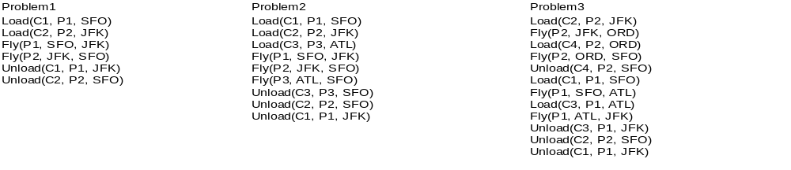

Performance of Uninformed Non-Heuristic search agents:

We used different uninformed search agents which doesn't hold any additional information about the states. They perform the blind search by generating the successive child nodes ,comparing with the goal states by performing goal state test.

Below is the results of three cargo problems using different uninformed search agents.

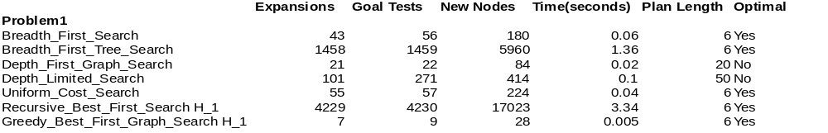
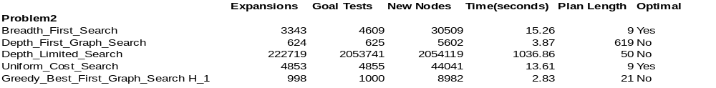

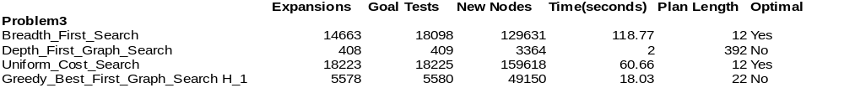

Note:For Problem2,we have excluded Breadth_First_Tree_Search
,Recursive_Best_First_Search H_1
and Greedy_Best_First_Graph_Search H_1 as their collection time is exceeding 15min.
Same is the reason for excluding Breadth_First_Tree_Search,Depth_Limited_Search,Recursive_Best_First_Search H_1 and Greedy_Best_First_Graph_Search H_1 for Problem3.

Desired Criteria of an agent:
Any agent which performs less number of expansions,goal tests ,generates less number of new nodes and takes less time is desirable.

Problem1:
- Breadth_First_Search,Breadth_First_Tree_Search,Uniform_Cost_Search,
Recursive_Best_First_Search H_1,Greedy_Best_First_Graph_Search H_1 are optimal.
- Of these, Breadth_First_Search,Uniform_Cost_Search and Greedy_Best_First_Graph_Search H_1 satisfies the desired agent criteria.
- Even though Depth_First_Graph_Search
and Depth_Limited_Search takes less time and memory but doesn't provide optimal solution.
- Breadth_First_Tree_Search and Recursive_Best_First_Search H_1 performs more number of expansions,goal tests and generates more number of new nodes even though they provide optimal plan.
Problem2:
- Breadth_First_Search and Uniform_Cost_Search are optimal but they generates more number of expansions ,goal tests and new nodes compared to Depth_First_Graph_Search.
- Even though Depth_First_Graph_Search
takes less time and memory but doesn't provide optimal solution.
- Depth_Limited_Search doesn't satisfy any single criteria of desired agent.
- Even though Greedy_Best_First_Graph_Search H_1 takes less time but it doesn't provide optimal solution.
Problem3:
- Breadth_First_Search and Uniform_Cost_Search are optimal but they generates more number of expansions ,goal tests and new nodes compared to Depth_First_Graph_Search.
- Even though Depth_First_Graph_Search
takes less time and memory but doesn't provide optimal solution.
- Even though Greedy_Best_First_Graph_Search H_1 takes less time and memory compared to Breadth_First_Search and Uniform_Cost_Search but it doesn't provide optimal solution.

Recommendation:
Based on above results,if memory and time is the criteria,use Greedy_Best_First_Graph_Search H_1 as against Depth_First_Graph_Search as it performed well in solving Problems 1 and 2 and Depth_First_Graph_Search performed well in solving only Problem3.
If optimal solution is the criteria,use Breadth_First_Search as against Uniform_Cost_Search because Breadth_First_Search takes less memory and time compared to Uniform_Cost_Search.

Below is from section 3.47 of Artificial Intelligence: A Modern Approach(3rd edition)

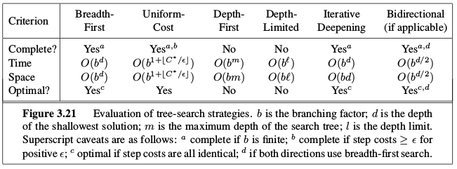

Performance of Informed Heuristic Search Agents:
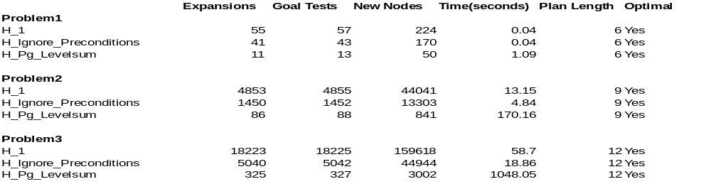
H_1 :A* Search with constant 1 heuristic.
H_Ignore_Preconditions:A* Search with ignored Preconditions heuristic.
This heuristic estimates the minimum number of actions that must be

carried out from the current state in order to satisfy all of the goal

conditions by ignoring the preconditions required for an action to be

executed.
H_Pg_Levelsum:A* Search with level sum.
This heuristic uses a planning graph representation of the problem

state space to estimate the sum of all actions that must be carried

out from the current state in order to satisfy each individual goal

condition.

From the above results,it is clear that all informed heuristic search agents provide optimal solutions.
H_Ignore_Preconditions performed well compared to H_Pg_Levelsum.
H_1 and H_Ignore_Preconditions almost take same time in solving Problem1.
H_Pg_Levelsum takes less memory but more time compared to H_Ignore_Preconditions.
H_Ignore_Preconditions takes more memory but less time compared to H_Pg_Levelsum.

Uninformed Vs Informed Heuristic Search Agents:

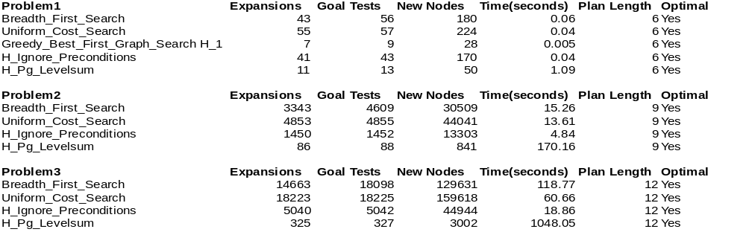

From the above results,it is clear that A* Search with ignored Preconditions heuristic outperforms the uninformed Breadth First Search both in terms of memory and time.

Therefore, A* Search with ignored Preconditions heuristic is the best overall solution for the Air Cargo problem.

Conclusion:
Above results clearly mentions that the informed search agents with well designed custom heuristics out performs the uninformed search agents both in terms of memory and time.

