|  |
| --- |
|  |
| **Localizing a SCUBA Diver Using Active Sonar** |
|  |

**Rich GuilmainNabin Sharma**

Georgia Tech Georgia Tech

*rguilmain@gatech.edu* *nsharma@gatech.edu*

**1 Problem Description**

The threat of an underwater terrorist attack is a concern of the maritime industry, port law enforcement, and luxury and high-profile vessel owners alike. Prevention of such attacks needs to start with the reliable detection of sub-surface threats such as SCUBA and closed-circuit re-breather (CCR) divers. Because these threats are below the water’s surface, traditional detection methods such as radar and visual surveillance are unavailable, making active sonar technology the most effective approach to date. However, because of the inherent noise of the underwater acoustic environment—often rife with mechanical noise, reflective debris, and environmental marine activity—current sonar methods are often inconsistent. Better processing methods are required to manage this low signal-to-noise ratio while still localizing the range and bearing of threatening divers at tactically significant ranges.

Given the noisy range and bearing measurements from an active sonar receiver, the goal is to estimate the range of the target to the sensor, the bearing of the target to the sensor, and the heading direction that the target is moving in. Due to relatively unstable propagation environment, underwater targets like SCUBA divers might not be detected for all measurement steps even if relatively noisier measurements are accepted as valid ones. This leads to the requirement of more robust localization schemes so that we don't lose valid targets just because we missed corresponding measurements intermittently.

**2 Hypothesis and Project Approach**

Figure Figureshows a typical diver localization scenario.

Figure Figure shows the block diagram of the sonar system which provides measurements to our diver localization algorithm.

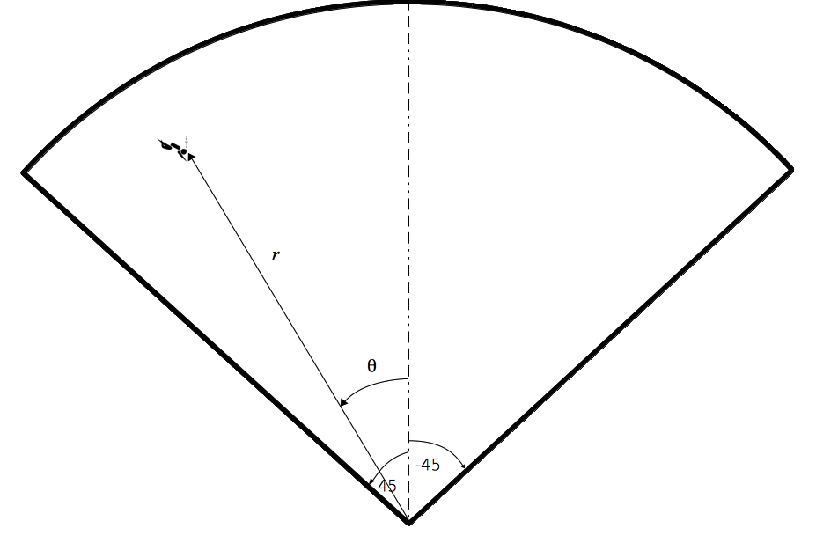

Figure 1: Basic graphical representation of a typical diver localization scenario. Sonar measurements provide the range (r) of the target (or diver) from the sonar sensor and bearing (ө) from the sonar sensor axis represented by dashed line. The angular span of the sensor field-of-view is 90 degrees.

**

*Figure* 2*: Block diagram of active sonar system used to obtain diver measurements.*

**3 Implementation Details**

Text …

**4 Technical Specifications**

Text ...

**5 Analysis of Results**

Text ...

**6 Conclusion**

Text ...

**Acknowledgments**

Text ...